**Highlights:**

* To create template-driven forms in Angular
* Understanding the usage of ngForm

**Demo Steps:**

**Problem Statement:**Create a user login form as a template-driven form with two fields - username and password and a submit button, which submits the entered data.

***Step 1:*** Create a component called Login using the following command.

1. ng generate component Login

***Step 2:*** Replace the below code in **login.component.html** to create a login form with two input fields i.e. **userName**and **password**to be entered by the user, along with a **Login** button for form submission.

1. <br />
2. <div class="row text-center">
3. <div class="col-md-6 offset-md-3">
4. <div class="card">
5. <div class="card-header bg bg-info text-dark">
6. <h4>User Login</h4>
7. </div>
8. <div class="card-body">
9. <form> *<!-- Line 9 -->*
10. <div class="form-group">
11. <label for="uName">User Name:</label>
12. <input type="text" id="uName" class="form-control" required name="userName" />
13. </div>
14. <div class="form-group">
15. <label for="pwd">Password:</label>
16. <input type="password" id="pwd" class="form-control" required name="password" />
17. </div>
18. <div class="form-group">
19. <button class="btn btn-info" type="submit">Login</button>
20. </div>
21. </form>
22. <div *ngIf="errorMessage!=null">
23. <span class="text-danger font-weight-bold">{{errorMessage}}</span>
24. </div>
25. <div *ngIf="successMessage!=null">
26. <span class="text-success font-weight-bold">{{successMessage}}</span>
27. </div>
28. </div>
29. </div>
30. </div>
31. </div>

In Angular, **ngForm**is a directive used in a form tag to obtain the following valuable information

1. It gives the values from different form fields.
2. It indicates whether the state of form is valid or invalid.

For using ngForm directive as well as to get access to all the features of forms in Angular, **FormsModule** needs to be imported in **AppModule**and added to the ***imports*** array

***Step 3:*** Write the code given below in **app.module.ts** to import and include Forms module in imports array inside the **@NgModule** decorator so that it can be used by the components of the application.

1. import { BrowserModule } from '@angular/platform-browser';
2. import { NgModule } from '@angular/core';
3. import { FormsModule } from '@angular/forms'; */* Line 3 */*
4. import { AppComponent } from './app.component';
5. import { LoginComponent } from './login/login.component';
6. @NgModule({
7. declarations: [AppComponent, LoginComponent],
8. imports: [BrowserModule, FormsModule], */* Line 9 */*
9. providers: [],
10. bootstrap: [AppComponent]
11. })
12. export class AppModule { }

**Line 3:** Import **FormsModule**from **@angular/forms** module

**Line 8:** Add **FormsModule**in the ***imports*** array to make it available to the entire module

***Step 4:*** Install bootstrap

1. npm install bootstrap --save

***Step 5:***Include **boostrap.min.css** file in **angular.json**file as shown below

1. ...
2. "styles": [
3. "src/styles.css",
4. "node_modules/bootstrap/dist/css/bootstrap.min.css"
5. ],
6. ...

***Step 6:*** Modify **Line 9** in **login.component.html** and add **ngForm** directive in the form tag and assign a reference variable to it as shown below.

1. <form #loginForm="ngForm" (ngSubmit)="verify()">

* ***#loginForm*** is a template variable of form binded with ngForm. **loginForm** is an instance of ngForm directive which represents the entire login form.
* In Angular forms, whenever the user clicks on the submit button, **ngSubmit** event is fired which invokes the event handler method i.e. **verify()**

***Step 7:*** Create a method **verify()** in ***LoginComponent***class as shown below.

1. import { Component, OnInit } from '@angular/core';
2. @Component({
3. selector: 'app-login',
4. templateUrl: './login.component.html',
5. styleUrls: ['./login.component.css']
6. })
7. export class LoginComponent implements OnInit {
8. errorMessage: any;
9. successMessage: any;
10. userName: string="";
11. password: string="";
12. constructor() { }
13. ngOnInit() { }
14. verify() {
15. this.errorMessage = null;
16. this.successMessage = null;
17. if (this.userName == 'admin' && this.password == 'admin123') {
18. this.successMessage = "User logged in successfully";
19. }
20. else {
21. this.errorMessage = "User authentication failed";
22. }
23. console.log("User Name:", this.userName)
24. console.log("Password:", this.password)
25. }
26. }

***Step 8:*** Save the files and run the application.

* Provide User Name as ***admin***
* Provide Password as ***admin123***
* Click the **Login**button

You can observe the following output

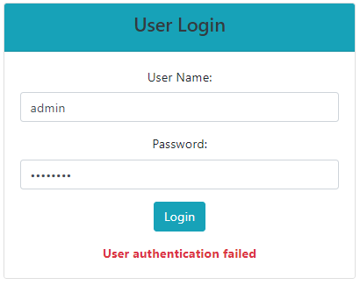

***Step 9:*** Open the developer's tool window in your browser. You can observe the following

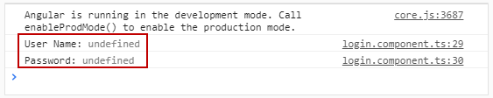

This is because the login form controls are not registered with ngForm directive. In order to make two input controls i.e., email and password belong to ngForm directive **ngModel**directive is used. Next, we will learn about **ngModel.**