**Highlights:**

* To create template driven forms in Angular
* To use ngModel directives and submit forms using ngSubmit

**Demo Steps:**

Each input element need to have ngModel directive to become part of ngForm.

***Step 1:*** Modify **login.component.html** to add **ngModel**directive in both the input controls i.e.**userName** and **password**as shown below.

1. <br />
2. <div class="row text-center">
3. <div class="col-md-6 offset-md-3">
4. <div class="card">
5. <div class="card-header bg bg-info text-dark">
6. <h4>User Login</h4>
7. </div>
8. <div class="card-body">
9. <form #loginForm="ngForm" (ngSubmit)="verify()">
10. <div class="form-group">
11. <label for="uName">User Name:</label>
12. <input type="text" id="uName" class="form-control" required [(ngModel)]="userName" name="userName" />
13. </div>
14. <div class="form-group">
15. <label for="pwd">Password:</label>
16. <input type="password" id="pwd" class="form-control" required [(ngModel)]="password" name="password" />
17. </div>
18. <div class="form-group">
19. <button class="btn btn-info" type="submit">Login</button>
20. </div>
21. </form>
22. <div *ngIf="errorMessage!=null">
23. <span class="text-danger font-weight-bold">{{errorMessage}}</span>
24. </div>
25. <div *ngIf="successMessage!=null">
26. <span class="text-success font-weight-bold">{{successMessage}}</span>
27. </div>
28. </div>
29. </div>
30. </div>
31. </div>

**Line 10, 13:** In order to provide the name of the form control instance which needs to be attached to ngForm object, the value provided to the name attribute will be used to identify individual form-control instances.

***Step 2:*** Save **login.component.html**. Execute the application by entering the username and password in the login form and click on the Login button.

* Provide **username**as ***admin***
* Provide **password**as ***admin123***
* Click the **Login**button

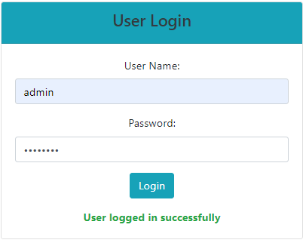

***Step 3:*** Press **F12** and observe the console tab logs for both the input controls i.e. for email and password.

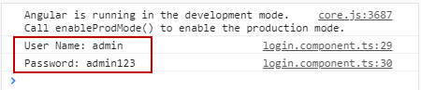

Next we will see, how Angular can *perform****validations*** by *tracking the state*of the form controls and applying appropriate class to the form controls.