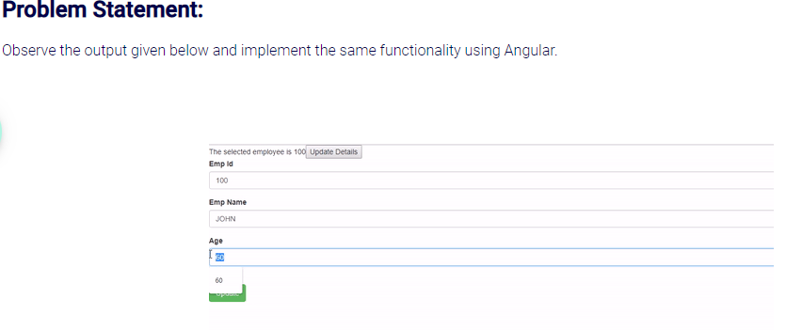

You can use the below JSON data and access it with an Angular service.

1. [
2. {
3. "empId": 100,
4. "empName": "Emp1",
5. "age": 60,
6. "gender": "M",
7. "hobbies": [
8. "cricket",
9. "football"
10. ],
11. "address": "Mysore"
12. },
13. {
14. "empId": 101,
15. "empName": "Emp2",
16. "age": 25,
17. "gender": "F",
18. "hobbies": [
19. "chess",
20. "reading"
21. ],
22. "address": "Bangalore"
23. },
24. {
25. "empId": 102,
26. "empName": "Emp3",
27. "age": 45,
28. "gender": "M",
29. "hobbies": [
30. "cricket",
31. "reading"
32. ],
33. "address": "Chennai"
34. }
35. ]