What Is Promise in Angular?

Promises in [Angular](https://www.infragistics.com/products/ignite-ui-angular) provide an easy way to execute asynchronous functions that use callbacks, while emitting and completing (resolving or rejecting) one value at a time. When using an Angular Promise, you are enabled to emit a single event from the API. Then, the controller (or the directive) takes on, registering up to three callbacks – success, error, and/or notifications.

There are four states of the Angular Promise:

* fulfilled - action is fulfilled
* rejected - action failed
* pending - action hasn’t succeeded or failed yet
* settled - action is either fulfilled or rejected

Something to remember is that Angular Promise is more passive compared to the Observable and cannot be cancelled once it is started. In other words, when you pass the callback to the Promise constructor (controller or directive), it will either resolve or reject the function.

Now, there are several disadvantages with the Angular Promise.

* Promises aren’t cancellable and you have to wait until the callback returns error or success.
* Not suitable for centralized and predictable error handling as errors are sent to the child promise.
* They don’t provide any operations.
* Promises execute an async value only once.
* Cannot be used for multiple values over time.
* They become hard to manage with larger applications.
* They cannot be retried.

How To Create Promises in Angular?

To create a promise in Angular we just need to use 'new Promise(function)' syntax. The promise constructor takes function as a parameter and that inner function takes resolve and reject as a params.

Let’s see how this looks in the code snippet below.

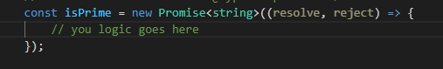

Now that we know how to create an Angular Promise, we will use it to implement a very simple scenario. The created Promise will help us validate whether the number is prime or not.

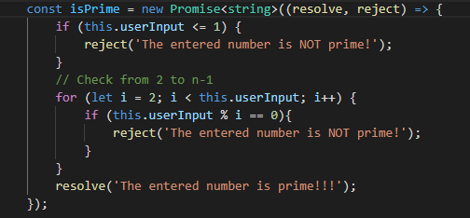

And finally, to put our method in use, we will handle the Promise in the following way.

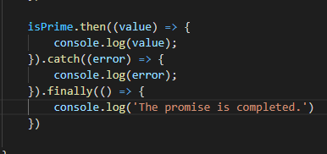

**Npm install –g http**

import { Component } from "@angular/core";

import { HttpClient } from "@angular/common/http";

@Component({

selector: "app-root",

templateUrl: "./app.component.html",

styleUrls: ["./app.component.css"]

})

export class AppComponent {

outputdata;

title = "Angular Promises Example";

API_KEY = "e40d07f00b094602953cc3bf8537477e";

constructor(private httpClient: HttpClient) {}

ngOnInit() {

console.log("Angular 10 Promises");

this.fetchDataAsPromise()

.then((data) => {

console.log(JSON.stringify(data));

this.outputdata=JSON.stringify(data);

})

.catch((error) => {

console.log("Promise rejected with " + JSON.stringify(error));

});

}

fetchDataAsPromise() {

return this.httpClient

.get(

`https://newsapi.org/v2/top-headlines?sources=techcrunch&apiKey=${this.API_KEY}`

)

.toPromise();

}

}

import { BrowserModule } from '@angular/platform-browser';

import { NgModule } from '@angular/core';

import { AppComponent } from './app.component';

import { HttpClientModule } from "@angular/common/http";

@NgModule({

declarations: [

AppComponent

],

imports: [

BrowserModule,

HttpClientModule

],

providers: [],

bootstrap: [AppComponent]

})

app.component.html

{{ outputdata }}