**ProblemStatement:**

**To do:**

1. Run the previous demo.
2. Provide the URL as *localhost:4200/demo*

**Observation:**

* No component gets loaded

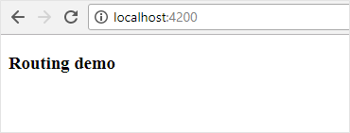

* Press F12 and observe the error stack in Developer tools window

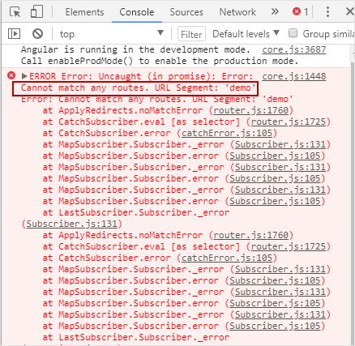

* This is because, you have not provided *demo*as a route path in **app-routing.module.ts**file.

1. const routes: Routes = [
2. { path: '', redirectTo: 'login', pathMatch:'full' },
3. { path: 'login', component: LoginComponent},
4. { path: 'bookList', component: BookComponent },
5. { path: 'book/:id', component: BookDetailComponent,canActivate:[LoginGuardService]}
6. ];

**To do:**

1. Let us make a modification in the json value provided for routes in **app-routing.module.ts**file.

1. const routes: Routes = [
2. { path: 'login', component: LoginComponent},
3. { path: 'bookList', component: BookComponent },
4. { path: 'book/:id', component: BookDetailComponent,canActivate:[LoginGuardService]},
5. { path: '**', redirectTo: 'login', pathMatch:'full' }
6. ];

2. Save the file and run the application.

3. Provide the URL as *localhost:4200/demo, localhost:4200/about/1*

**Observation:**

* Providing any invalid URL, redirects the route to login page.
* **Line 5:** '**' is called as catch-all, which redirects to the specified module when the desired route is not present. Make sure to provide this at the end after specifying all the routes. Other wise the '**' matches all the URLs and redirects to the specified component. This will be a logical error in the application.