While running unit test cases for Angular application, you can even create code coverage reports using a tool called **Istanbul.**

Code coverage reports allows us to see any part of the code which is not properly tested by our unit test cases

To generate a code coverage report, run the following command

1. ng test --code-coverage

Once the tests execution are done, a new folder with name 'coverage' will get created in the project folder. Open coverage folder and run index.html page which will display the report with the source code and code coverage values.

Using code coverage percentages, you can estimate how much of our code is tested.

Following is a sample of code-coverage report

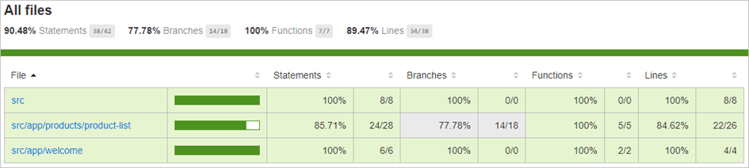

Now let's learn how to build and deploy the angular application.

**ProblemStatement:**

After creating the test cases for AngularTest application, check the percentage of code coverage.

**To do:**

1. Run the AngularTest application on VS Code IDE through the following command.

1. ng test --code-coverage

2. On successful execution, the Karma page open in your default browser as shown

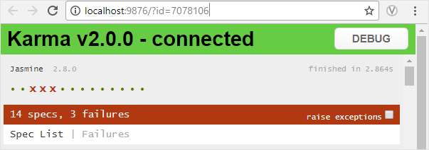

**Observation:**

1. In the Explorer pane of the VS Code you can observe that a new folder named **Coverage** is created.

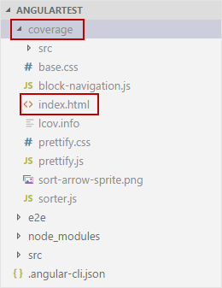

2. Run the **index.html** file using the Live server. You can see the code coverage report for your application

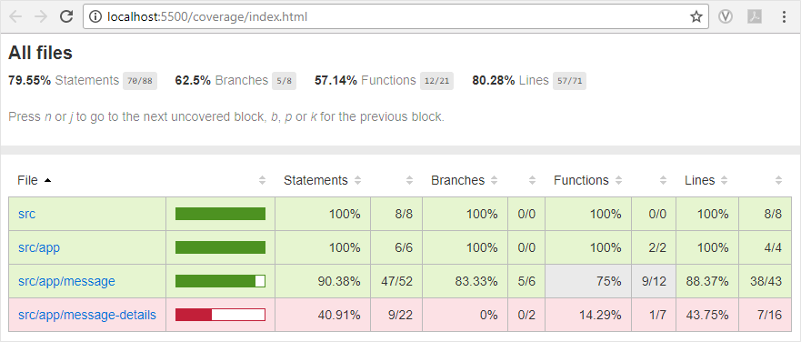

Now that we have learnt how to test our angular applications. Let us now learn how to style our angular application using different libraries like angular material and prime ng.