Set up Jenkins from scratch and create and run an Angular pipeline — all in about five minutes. Don’t worry if you’re not familiar with Angular. The same principles hold for Vue, React, Python, Java, and other languages. So get comfy because we’re about to start.

The structure of the article will be as follows:

* Setting up Jenkins
* Creating a Jenkinsfile
* Creating a pipeline

**Setting Up Jenkins**

If you’re already familiar with Jenkins, feel free to skip this part.

In this section, we’ll go over the installation steps for macOS and Linux as shown on [the Jenkins website](https://www.jenkins.io/doc/book/installing/). You can also find information on getting started on a Windows machine.

First, let’s create a network for Jenkins:

docker network create jenkins

Add two volumes to share Docker client TLS certificates and persist Jenkins data. This way, no data is lost when you shut down your PC or server, for example. Keep in mind that if you do remove these volumes, data will be lost permanently.

docker volume create jenkins-docker-certs

docker volume create jenkins-data

The following four commands bring the Docker container up:

docker image pull docker:dind

docker container run --name jenkins-docker \  
 --restart unless-stopped \  
 --detach \  
 --privileged --network jenkins \  
 --network-alias docker \  
 --env DOCKER_TLS_CERTDIR=/certs \  
 --volume jenkins-docker-certs:/certs/client \  
 --volume jenkins-data:/var/jenkins_home \  
 --publish 2376:2376\  
 docker:dinddocker image pull jenkinsci/blueocean

docker container run --name jenkins-blueocean \  
 --restart unless-stopped \  
 --detach \  
 --network jenkins \  
 --env DOCKER_HOST=tcp://docker:2376 \  
 --env DOCKER_CERT_PATH=/certs/client \  
 --env DOCKER_TLS_VERIFY=1 \  
 --volume jenkins-data:/var/jenkins_home \  
 --volume jenkins-docker-certs:/certs/client:ro \  
 --publish 8080:8080 \  
 --publish 50000:50000 \

jenkinsci/blueocean

Jenkins is now running on [http://localhost:8080,](http://http/localhost:8080,) but you have to do one more tricky step: You have to unlock Jenkins. The initial password can be found inside a folder of the Jenkins CI blue ocean Docker container. I’ll show you how to retrieve this. When you try this yourself, make sure you specify the right docker [UUID](https://medium.com/better-programming/what-is-a-uuid-and-how-are-they-generated-17f0acbd7233).

**docker container ps**4ec29afb280f jenkinsci/blueocean  
1ce11b131265 docker:dind

**docker container exec 4ec29afb280f cat /var/jenkins_home/secrets/initialAdminPasswordbd95aa5131a142b690795fa9427287a8**

In the next step, you can configure the plug-ins you want to install. I’ll leave that up to you. I installed the Cobertura (for Java) and Locale plug-ins and got rid of Subversion. After they are installed, you have to create an admin user.

In the last step, you have to set a Jenkins URL (e.g. [http://localhost:8080](http://localhost:8080/)), but I did not bother to change it. In the end, Jenkins restarts and is completely installed. That took us literally only a couple of minutes.

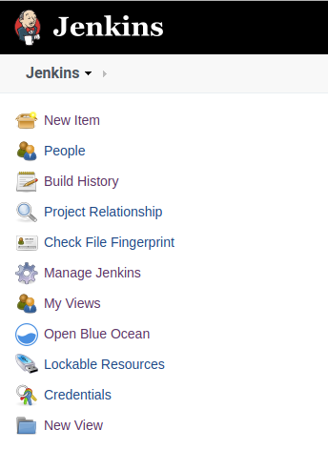

The Jenkins user interface

**Creating a Jenkinsfile**

Let’s face it, there are tons of possible ways to define a great pipeline. This will only be a simple example. It would be great to hear if you have suggestions for an improved pipeline. Don’t hesitate to leave a comment at the end of the article!

First of all, it’s important to specify a base Docker image to run our commands. At the time of writing, using the latest node Docker image felt like a good choice.

Next, we specify the stages to go over. In this configuration, the most recognizable development stages are specified:

* Install — To make sure we got every dependency installed without errors.
* Testing — Listing, unit tests. For this, we define two stages that can run in parallel. Feel free to add integration or end-to-end tests if you have that need.
* Build — Finally, there is still the possibility that our build fails. This is the last step before deploying the application.

Feel free to add additional steps. At this point, you have so much freedom. Deploy automatically or publish a Docker image that can be rolled out to a limited amount of users. That choice is yours. To conclude this section, let me share the pipeline with you. Put this inside a Jenkinsfile (no extension) in the root folder of your project:

Jenkinsfile

**Creating a Pipeline**

Open Jenkins on [http://localhost:8080](http://localhost:8080/) and create a new item. No need to do a lot here, actually. Let’s create a “Multibranch Pipeline.”

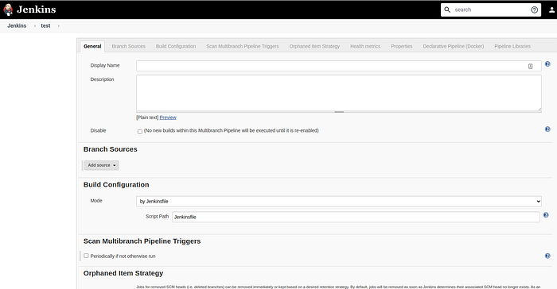

Create a Pipeline menu

A new menu opens. Here, you can add a description among many other things, but we’ll only cover the most important parts in this article. You should look for the section called “branch sources” and select Git. The next thing to do is pass in a project repository (e.g. [https://github.com/user/project-name.git](https://github.com/djFooFoo/dj-website.git)) and your credentials. That is sufficient.

Let’s add one more thing to make it an automatic pipeline. Let’s poll the GitHub repository for changes. Enable “Scan Multibranch Pipeline Triggers” and pass a reasonable interval. This will trigger a build (e.g. every minute) only when there are source code changes. That way, builds get triggered automatically. If one minute is too intensive, you can always lower the interval to check for changes later on.

Now go to <http://localhost:8080/blue/organizations/jenkins/pipelines> and run your first job if it’s not already running. Let me show you how this looks:

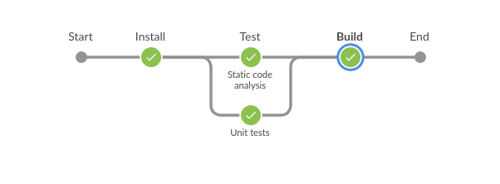

The pipeline was successful!