**Problem Statement :**

XYZ Pharma is a well-established pharmaceutical company manufacturing a wide variety of medicines. The company has a web application wherein a customer can learn about their company, the current R&D the company is working on, and the customers can search for the medicines manufactured either by the medicine's name.

**List of Softwares Required:**

* Node JS
* Angular
* Visual Studio Code IDE
* Open the given application code in VS Code IDE, open the integrated terminal and do**npm install.**You can also open the application folder inside Node Command Prompt and issue the command**npm install.**
* Now, install json-server using below command:

**npm install -g json-server**

* To start json-server use the below command in the terminal:

**json-server --watch db.json --4000**

* This will start the server at port 4000
* To run Angular application give **ng serve --open**

**1.Home Page:**

The below view should be displayed on the load of the HomeComponent.

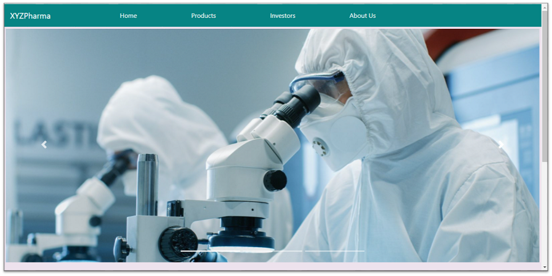

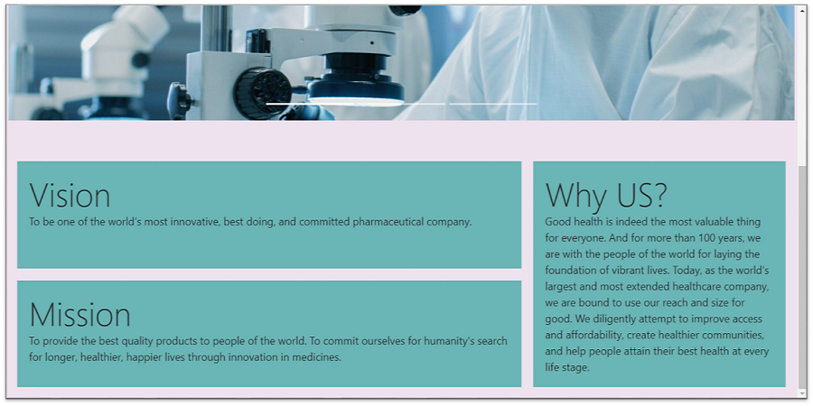

* The navigation bar should contain the Application name and the menu.
* On click of ‘**Products**’, the productsComponent should be loaded
* On click of ‘**Investors**, the investorsComponent should be loaded.
* On click of ‘**About Us**, the aboutusComponent should be loaded.

**2.Products Page:**

The below view should be displayed on the load of the productComponent.

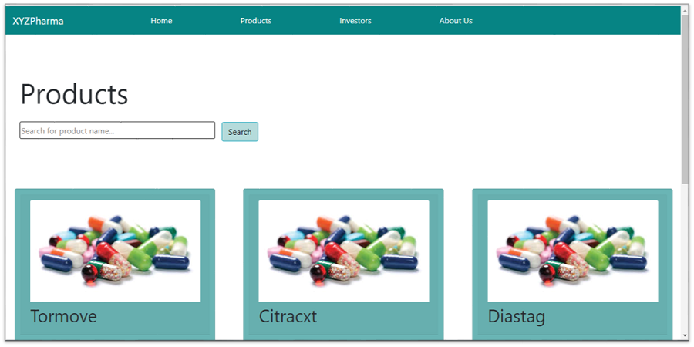

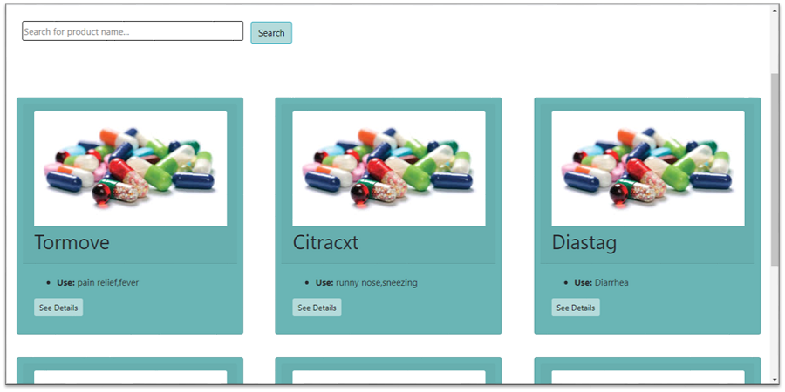

On the load of the page, a search field and list of products manufactured by the company should be displayed.

getAllProducts() should be called on load to fetch the details of all the products from the back-end using the HTTP method get.

* The search field enables the user to search for a medicine based on its name and will result in a display of the card of the specific medicine alone.
* In the card displayed for each medicine the below details should be present:
  + Image of the medicine
  + Name
  + Use
  + See Details button: On click of which the entire detail regarding the product will be displayed, by loading the productdetailComponent.
* viewDetails() method needs to be called when the 'See Details' button is clicked, in which navigation to product-detailComponent should be performed programmatically.
* If the searched name is not present, the below message should be shown:
* 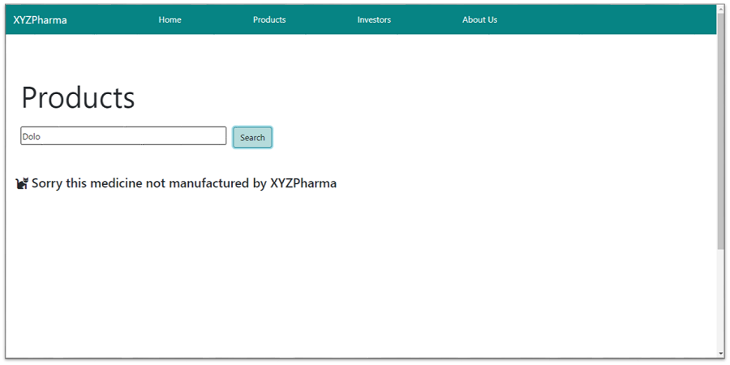

**3. Product Detail Page:**

The below view should be displayed on the load of the product-detail Component.

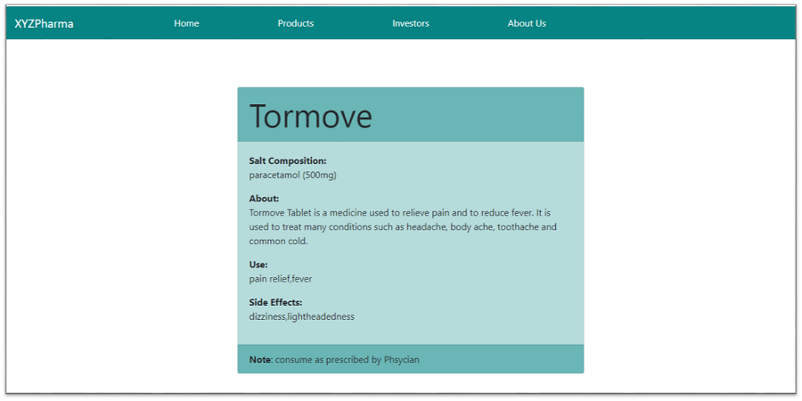

The entire detail regarding the product should be displayed as a card:

Details:

* Name
* Salt Composition
* About
* Use
* Side Effects

The footer should have a note as shown in the image reference.

**4. Investors Page:**

The below view should be displayed on the load of the investorsComponent.

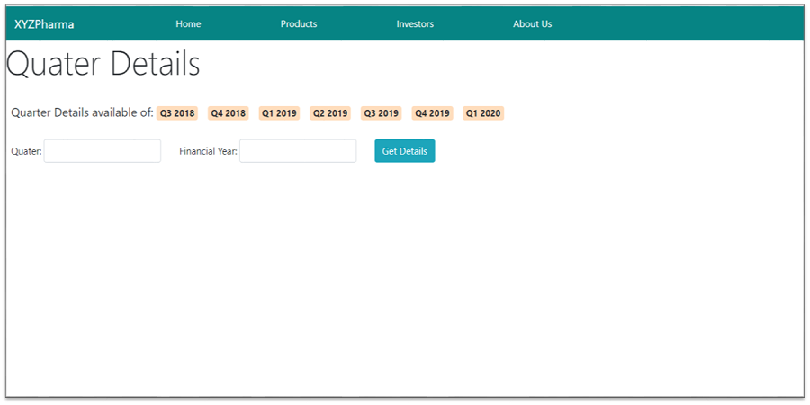

On load of the investors component, the quarter whose details are currently available should be displayed along with a search option which takes in the quarter and year whose details need to be shown.

Properties:

* quaterForm: FormGroup
* selecteQDetail: string
* showTable: Boolean
* errorMessage: string
* showError:Boolean

Form variables:

* quarter
* fyear

The quarter detail matching should be case-insensitive; this should be implemented as Custom Pipe: checkCasing.

On click of the **Get** **Details** button, the getQDetails() method should be called which in turn sends a get request to the back-end server to fetch the quarter detail. The below view should be rendered as a response.

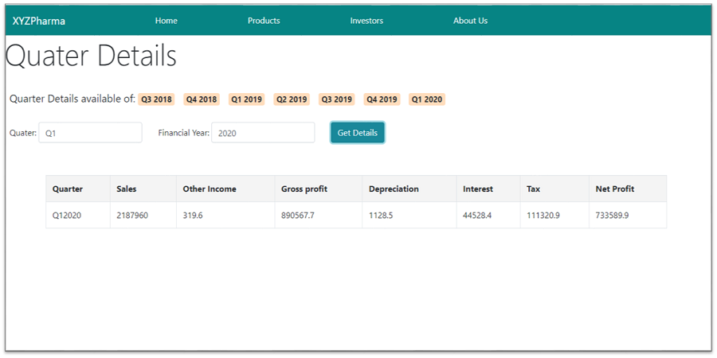

The details of the quarter opted should be displayed in table format.

If the details of the quarter searched is not available, the below view should be rendered.

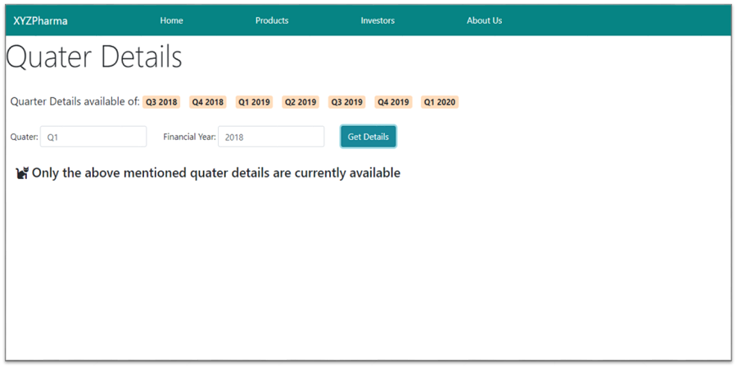

**5. About Us Page:**

The below view should be displayed on the load of the aboutusComponent.

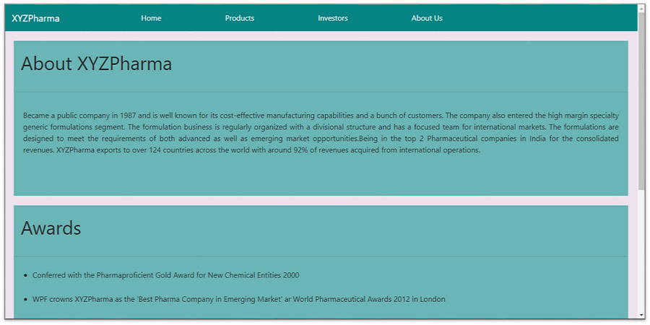

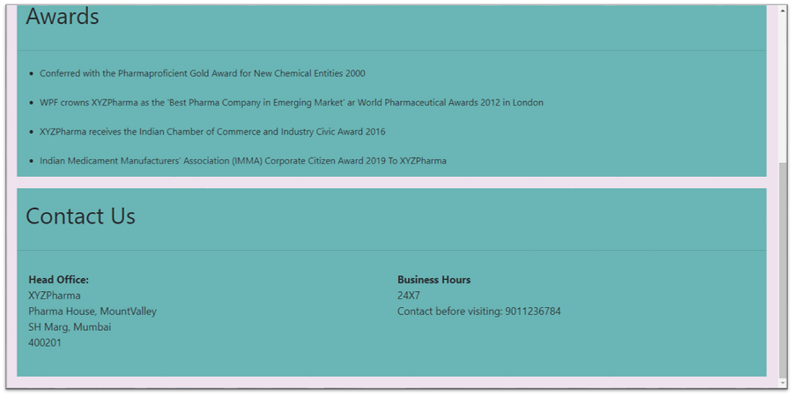

The page contains About the Company, the Awards won, and the Contact Details.