# MongoDB - Create Backup

In this chapter, we will see how to create a backup in MongoDB.

## Dump MongoDB Data

To create backup of database in MongoDB, you should use **mongodump**command. This command will dump the entire data of your server into the dump directory. There are many options available by which you can limit the amount of data or create backup of your remote server.

### Syntax

The basic syntax of **mongodump** command is as follows −

>mongodump

### Example

Start your mongod server. Assuming that your mongod server is running on the localhost and port 27017, open a command prompt and go to the bin directory of your mongodb instance and type the command **mongodump**

Consider the mycol collection has the following data.

>mongodump

The command will connect to the server running at **127.0.0.1** and port **27017** and back all data of the server to directory **/bin/dump/**. Following is the output of the command −

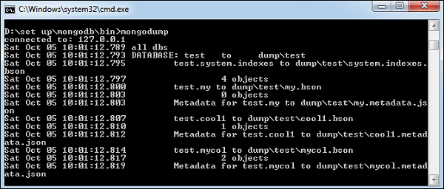

Following is a list of available options that can be used with the **mongodump**command.

|  |  |  |
| --- | --- | --- |
| **Syntax** | **Description** | **Example** |
| mongodump --host HOST_NAME --port PORT_NUMBER | This commmand will backup all databases of specified mongod instance. | mongodump --host tutorialspoint.com --port 27017 |
| mongodump --dbpath DB_PATH --out BACKUP_DIRECTORY | This command will backup only specified database at specified path. | mongodump --dbpath /data/db/ --out /data/backup/ |
| mongodump --collection COLLECTION --db DB_NAME | This command will backup only specified collection of specified database. | mongodump --collection mycol --db test |

## Restore data

To restore backup data MongoDB's **mongorestore** command is used. This command restores all of the data from the backup directory.

### Syntax

The basic syntax of **mongorestore** command is −

>mongorestore

Following is the output of the command −

