MongoDB - Replication

Replication is the process of synchronizing data across multiple servers. Replication provides redundancy and increases data availability with multiple copies of data on different database servers. Replication protects a database from the loss of a single server. Replication also allows you to recover from hardware failure and service interruptions. With additional copies of the data, you can dedicate one to disaster recovery, reporting, or backup.

Why Replication?

* To keep your data safe
* High (24*7) availability of data
* Disaster recovery
* No downtime for maintenance (like backups, index rebuilds, compaction)
* Read scaling (extra copies to read from)
* Replica set is transparent to the application

How Replication Works in MongoDB

MongoDB achieves replication by the use of replica set. A replica set is a group of **mongod** instances that host the same data set. In a replica, one node is primary node that receives all write operations. All other instances, such as secondaries, apply operations from the primary so that they have the same data set. Replica set can have only one primary node.

* Replica set is a group of two or more nodes (generally minimum 3 nodes are required).
* In a replica set, one node is primary node and remaining nodes are secondary.
* All data replicates from primary to secondary node.
* At the time of automatic failover or maintenance, election establishes for primary and a new primary node is elected.
* After the recovery of failed node, it again join the replica set and works as a secondary node.

A typical diagram of MongoDB replication is shown in which client application always interact with the primary node and the primary node then replicates the data to the secondary nodes.

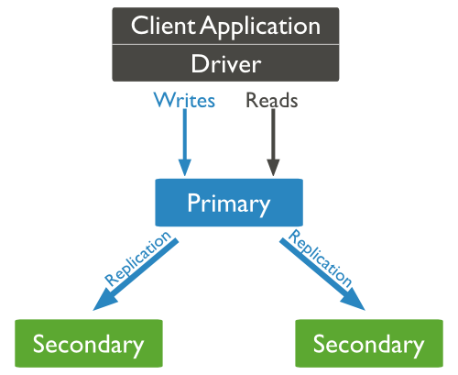

Replica Set Features

* A cluster of N nodes
* Any one node can be primary
* All write operations go to primary
* Automatic failover
* Automatic recovery
* Consensus election of primary

Set Up a Replica Set

In this tutorial, we will convert standalone MongoDB instance to a replica set. To convert to replica set, following are the steps −

* Shutdown already running MongoDB server.
* Start the MongoDB server by specifying -- replSet option. Following is the basic syntax of --replSet −

mongod --port "PORT" --dbpath "YOUR_DB_DATA_PATH" --replSet "REPLICA_SET_INSTANCE_NAME"

Example

mongod --port 27017 --dbpath "D:\set up\mongodb\data" --replSet rs0

* It will start a mongod instance with the name rs0, on port 27017.
* Now start the command prompt and connect to this mongod instance.
* In Mongo client, issue the command **rs.initiate()** to initiate a new replica set.
* To check the replica set configuration, issue the command **rs.conf()**. To check the status of replica set issue the command **rs.status()**.

Add Members to Replica Set

To add members to replica set, start mongod instances on multiple machines. Now start a mongo client and issue a command **rs.add()**.

Syntax

The basic syntax of **rs.add()** command is as follows −

>rs.add(HOST_NAME:PORT)

Example

Suppose your mongod instance name is **mongod1.net** and it is running on port **27017**. To add this instance to replica set, issue the command **rs.add()**in Mongo client.

>rs.add("mongod1.net:27017")

>

You can add mongod instance to replica set only when you are connected to primary node. To check whether you are connected to primary or not, issue the command **db.isMaster()** in mongo client.