Store Devtools provides developer tools and instrumentation for Store.

**Installation:-**

To use ngrx devtools, we first need to install **@ngrx/store-devtools:**

1. npm install @ngrx/store-devtools --save

**Setup:-**

Follow the given steps to configure the store devtools for chrome:

1. Add the **Redux Devtools Extension**to your chrome from the chrome web store.
2. In **app.module.ts**, add the module imports using **StoreDevtoolsModule.instrument**as shown below:
3. */* Add the following import statements to the file */*
4. import { StoreDevtoolsModule } from '@ngrx/store-devtools';
5. import { environment } from '../environments/environment';
6. */* Add the following code to imports array of AppModule */*
7. StoreDevtoolsModule.instrument({
8. maxAge: 25,
9. logOnly:environment.production
10. })

**maxAge:25**will ensure that the last 25 state changes data is maintained in the devtools.

**logOnly**will connect to the devtools extension in log-only mode.By default it is false, which enables all the extension features.

**Observe the Below output in Redux tab of chrome's dev tools:**

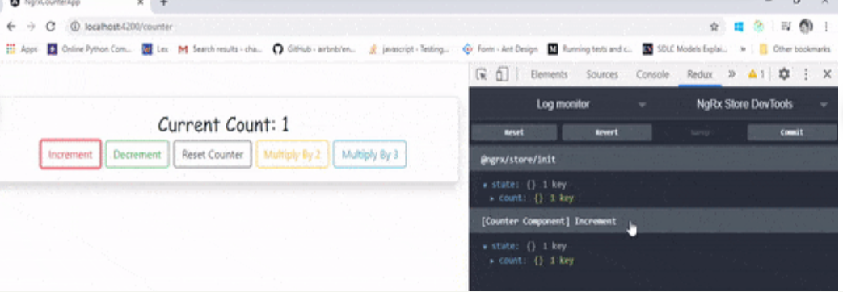

The devtools has many more other [options](https://ngrx.io/guide/store-devtools/config) available.