Duration : 4hrs

Create fullstack application to implement TODO CRUD operations

Implement angular with Reactive Forms, validations and http Client to design FrontEnd.

Implement Node,Express and Mongoose to design backend code.

Todo model :

Todo {

Id: String

Name: String

Priority: String //optional

Date: Date //optional

}

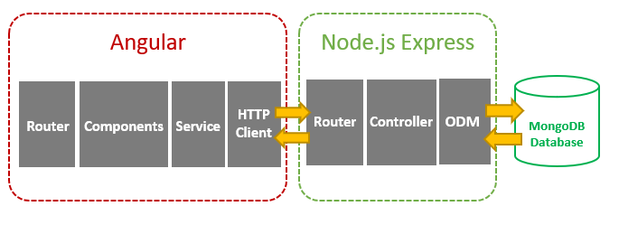

Application should be able to perform AddTodo(), UpdateTodo(),DeleteTodo(),List allTodos().

