**Problem Statement:**

BookMyMovie is an online website, through which the required number of tickets can be booked for a particular show. A maximum number of 15 tickets can be issued per booking. Implement the class BookMyMovie as per the class diagram given below:

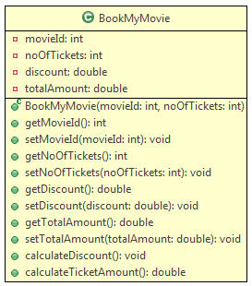

**Method Description:**

* **BookMyMovie(int movieId, int noOfTickets):** This constructor is used to initialize the instance variables with user provided values.
* **calculateDiscount():** This method is used to set the discount percentage for a particular booking based on the ***noOfTickets***issued and the ***movieId***. The condition for calculating the discount is given below:

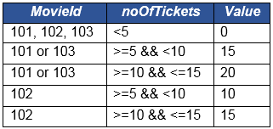

Note: In this above table, Value column stands for the discount percentage.

* **calculateTicketAmount():** This method is used to calculate the ticket amount after deducting the discount amount. It should call the method ***calculateDiscount()*** which sets the discount percentage. Then the ***totalAmount***should be calculated using the formula given below:
  + totalAmount = baseFare * noOfTickets – (baseFare * noOftickets * (discount/100))

The baseFare for a given movieId is given below:

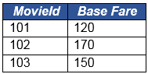

Once you implement the above class,

* Create a Tester class.
* Create objects of BookMyMovie class with the sample inputs given below.
* Invoke the **calculateTicketAmount()** for each of the object and verify with the sample output provided.

**Sample I/O:**

* **Input**(For BookMyMovie object 1):
  + *movieId*= 101
  + *noOfTickets*= 5
* **Output**(For BookMyMovie object 1): Total amount for booking: 510.0

* **Input**(For BookMyMovie object 2):
  + *movieId* = 102
  + *noOfTickets*= 4
* **Output**(For BookMyMovie object 2): Total amount for booking: 680.0

* **Input**(For BookMyMovie object 3):
  + *movieId*= 103
  + *noOfTickets* = 8
* **Output**(For BookMyMovie object3): Total amount for booking: 1020.0

* For any invalid *movieId*, the output should be,

1. Sorry! Invalid Movie ID!
2. Please check the Movie ID and enter once again.