By invoking the following Session methods, we can read data from the database table in terms of corresponding entity instance:

• **Object** **get(Class , Serializable idValue)**

An instance of the entity class can be retrieved with the given primary key value. If no such record is present in the database table or persistence context, the method returns **NULL** value.

• **Object** **load(Class** **class, Serializable** **idValue)**

Retrieves a proxy instance of the entity class with the given primary key value. If the requested row is unavailable in the database table, **ObjectNotFoundException** is thrown. When using load(), Hibernate does not hit the database but initializes the entity object by doing **lazy loading**(defer initialization of an object until the point at which it is needed). This enhances performance.

The below code snippet demonstrates the usage of **get()** to read the Customer entity record from the database.

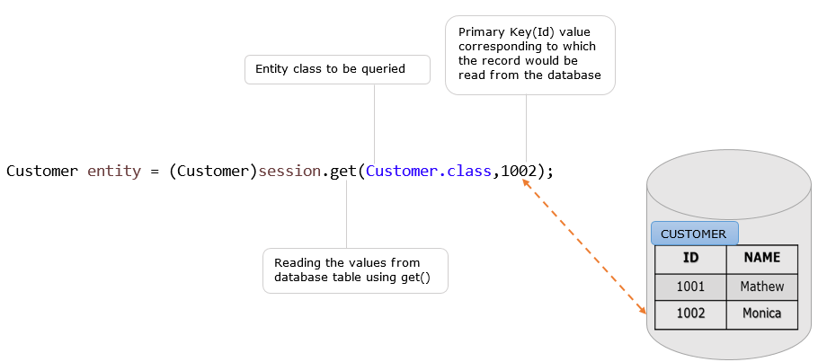

The same example of reading the customer record from the database can also be accomplished using the **load()** as below.

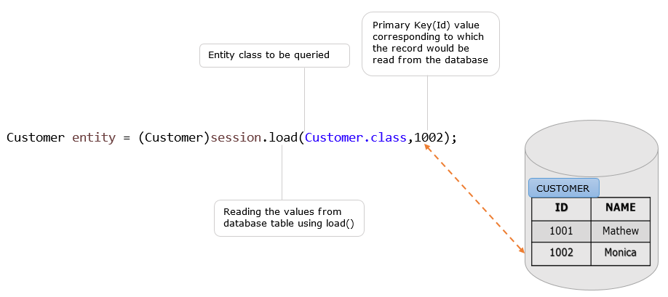

Let us modify the example on CRUD operations with **Read** operation. The below files need to be modified.

* ICustomer.java
* CustomerDAO.java
* ClientDemo.java

Following is the database table used in this example.

| Customer_Details | |
| --- | --- |
| **CUSTOMERID** | **CUSTOMERNAME** |
| 1000 | Mathew |
| 1002 | Monica |

Following are the modified files of **ICustomer.java** and **CustomerDAO.java**. The CustomerDAO.java class uses **get()** method to read the customer record based on customerId.

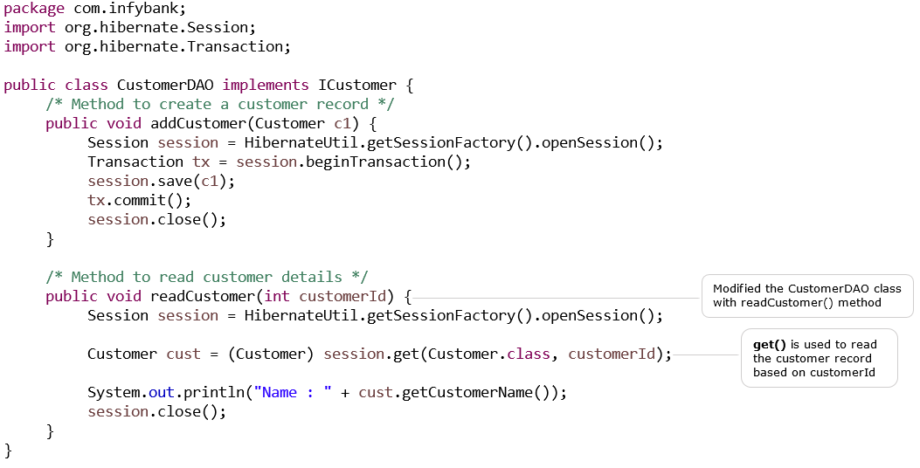

Following is the modified file of **ClientDemo.java** class. This class is used to **read** the customer details based on the customerId provided.

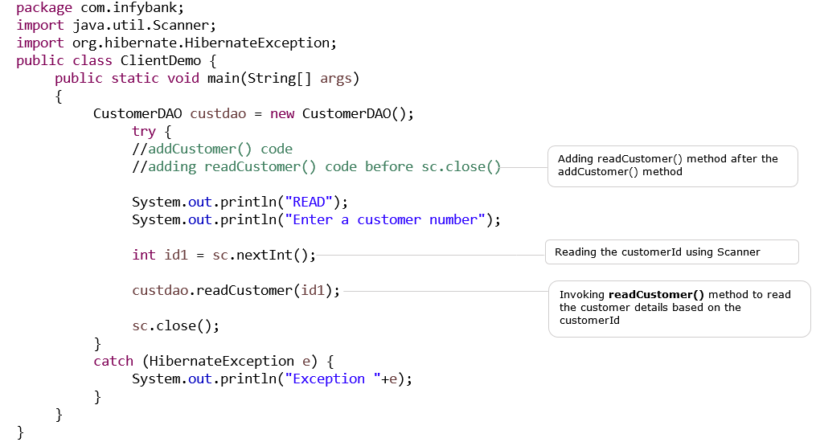

Following is the output of ClientDemo.java :

CREATE

Enter the Customer details

Enter the Customer number

1003

Enter the Customer name

Rahim

Hibernate: insert into Customer_Details (CUSTOMERNAME, CUSTOMERID) values (?, ?)

One record created

READ

Enter a customer number

1000

Hibernate: select customer0_.CUSTOMERID as CUSTOMERID0_0_, customer0_.CUSTOMERNAME as CUSTOMER2_0_0_ from Customer_Details customer0_ where customer0_.CUSTOMERID=?

Name: Mathew