In Hibernate, updating records in the database can be achieved in the following way:

* The Entity instance is obtained from the database using get() or load().
* Set the new values for the properties for the retrieved instance.
* Invoke void update(Object object).
* The changes are committed by an active transaction using the commit() method.

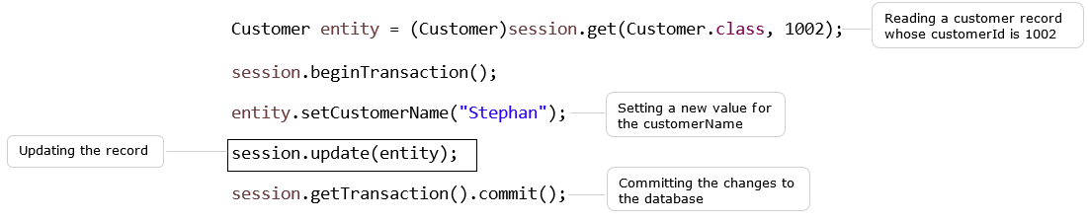

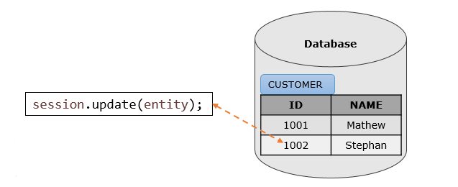

sIn Hibernate, saving or updating records in the database can be achieved by the saveOrUpdate() method also.

**void** **saveOrUpdate(Object object):**saveOrUpdate() method calls either save() or update() on the basis of identifier exists or not in the mapped table. This method internally invokes save(), if the object does not exist. This method internally invokes the update() method, if the object already exists.

Let us update the customer details of Infy Bank Customer with **saveOrUpdate()** method.

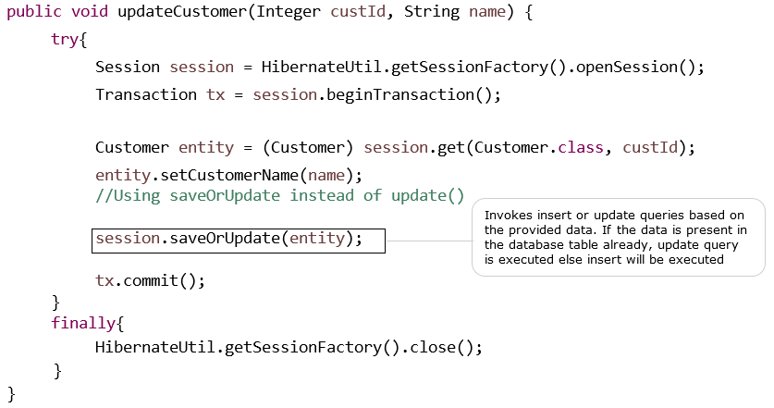

In the above code snippet, since an identifier is present in the database and the same has been read using get() method, Hibernate internally invokes update to change the customer name.

Let us modify the example on CRUD operations with **Update** operation. The below files need to be modified.

* ICustomer.java
* CustomerDAO.java
* ClientDemo.java

Following is the database table used in this example.

| Customer_Details | |
| --- | --- |
| **CUSTOMERID** | **CUSTOMERNAME** |
| 1000 | Mathew |
| 1002 | Monica |
| 1003 | Rahim |

Following is the modified file of **ICustomer.java**. The **updateCustomer()** method is used to update the customer name based on customerId.

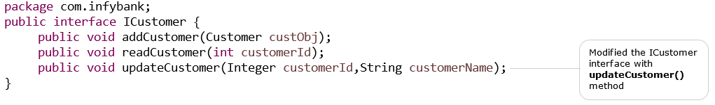

Adding **updateCustomer()** method to **CustomerDAO.java.**

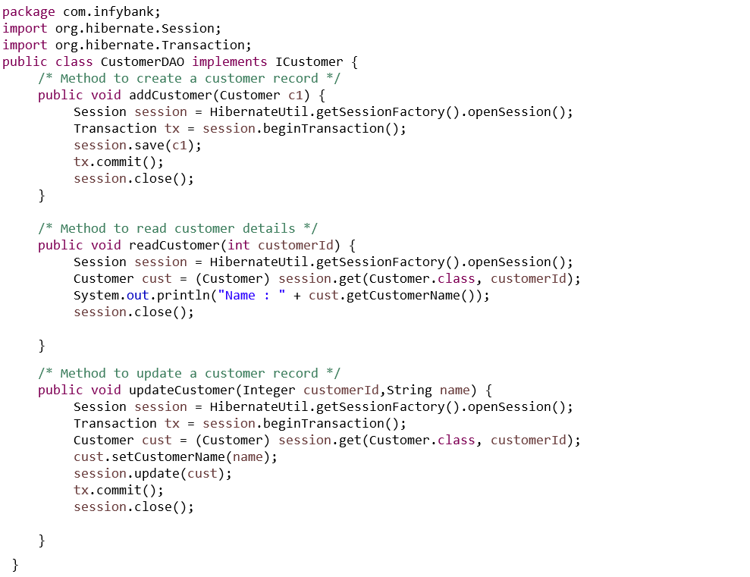

Following is the modified file of **ClientDemo.java** class. This class is utilized to **update** the customer name as per the customer id provided.

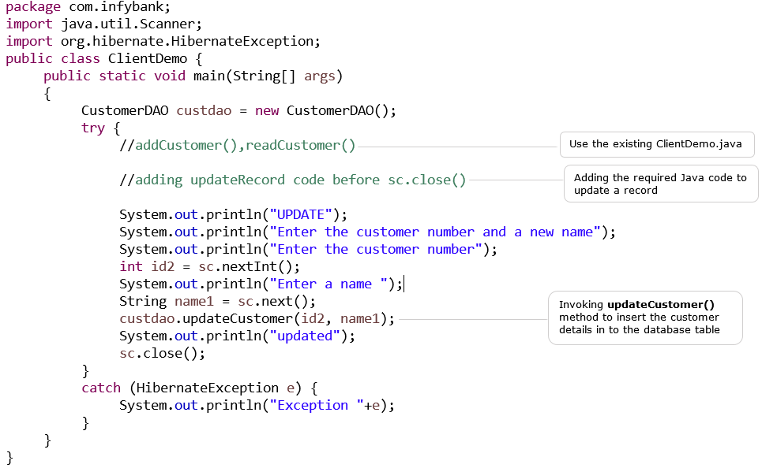

Following is the output of ClientDemo.java :

CREATE

Enter the Customer details

Enter the Customer number

1004

Enter the Customer name

Sindhu

Hibernate: insert into Customer_Details (CUSTOMERNAME, CUSTOMERID) values (?, ?)

One record created

READ

Enter a customer number

1003

Hibernate: select customer0_.CUSTOMERID as CUSTOMERID0_0_, customer0_.CUSTOMERNAME as CUSTOMER2_0_0_ from Customer_Details customer0_ where customer0_.CUSTOMERID=?

Name: Rahim

UPDATE

Enter the customer number and a new name

Enter the customer number

1000

Enter a name

Sakshi

Hibernate: select customer0_.CUSTOMERID as CUSTOMERID0_0_, customer0_.CUSTOMERNAME as CUSTOMER2_0_0_ from Customer_Details customer0_ where customer0_.CUSTOMERID=?

Hibernate: update Customer_Details set CUSTOMERNAME=? where CUSTOMERID=?

Updated

The updated database table is as follows:

| Customer_Details | |
| --- | --- |
| **CUSTOMERID** | **CUSTOMERNAME** |
| 1000 | Sakshi |
| 1002 | Monica |
| 1003 | Rahim |
| 1004 | Sindhu |