Records can be removed from the database table with the help of the delete method.

* The entity instance is retrieved from the database using **get() or load()**method.
* Invoke **void** **delete(Object object)**to remove the corresponding row from the database table.
* The changes are committed by an active transaction using the **commit()**method.

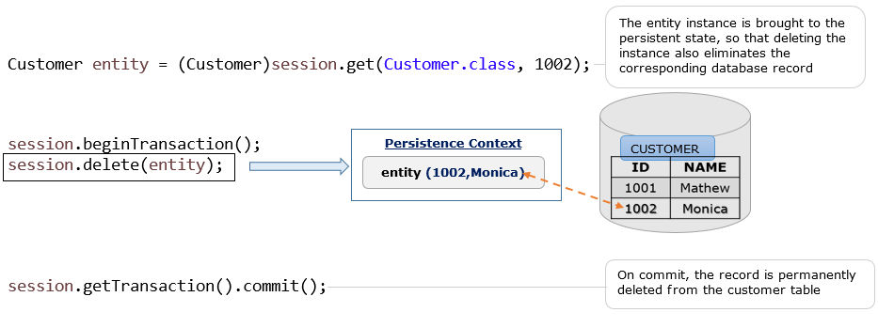

Let us modify the example on CRUD operations with the **delete** operation. The below files need to be modified.

* ICustomer.java
* CustomerDAO.java
* ClientDemo.java

Following is the database table used in this example.

| Customer_Details | |
| --- | --- |
| **CUSTOMERID** | **CUSTOMERNAME** |
| 1000 | Sakshi |
| 1002 | Monica |
| 1003 | Rahim |
| 1004 | Sindhu |

The following are the modified files of **ICustomer.java**. It is now updated with all the CRUD operations.

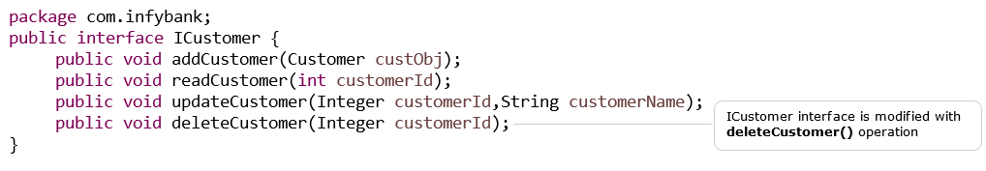

**CustomerDAO.java** is modified with **deleteCustomer()** method. Now it contains all the CRUD operations.

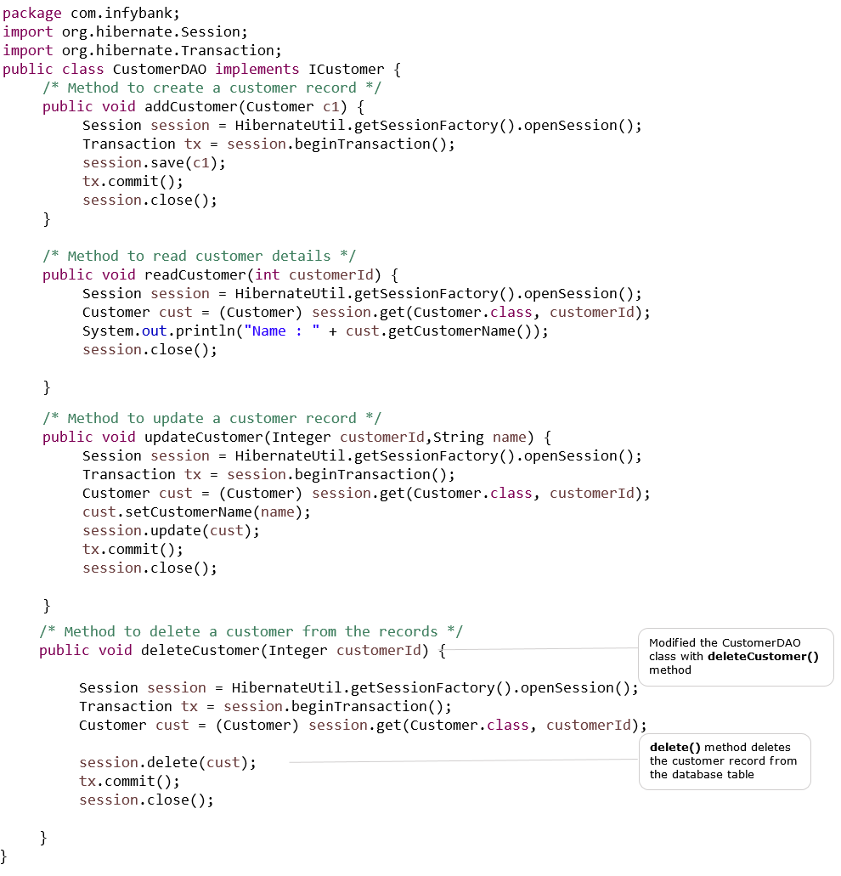

Following is the modified file of **ClientDemo.java** class. This class is used to **delete** the customer details based on the customer id provided.

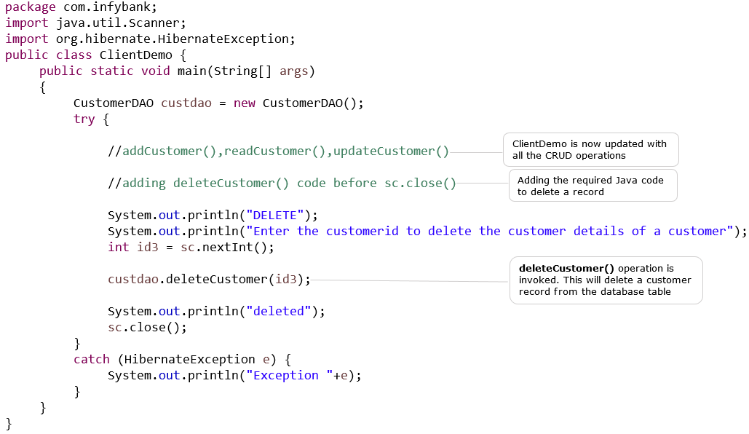

Following is the output of ClientDemo.java :

CREATE

Enter the Customer details

Enter the Customer number

1005

Enter the Customer name

Deepa

Hibernate: insert into Customer_Details (CUSTOMERNAME, CUSTOMERID) values (?, ?)

One record created

READ

Enter a customer number

1004

Hibernate: select customer0_.CUSTOMERID as CUSTOMERID0_0_, customer0_.CUSTOMERNAME as CUSTOMER2_0_0_ from Customer_Details customer0_ where customer0_.CUSTOMERID=?

Name: Sindhu

UPDATE

Enter the customer number and a new name

Enter the customer number

1003

Enter a name

Jithu

Hibernate: select customer0_.CUSTOMERID as CUSTOMERID0_0_, customer0_.CUSTOMERNAME as CUSTOMER2_0_0_ from Customer_Details customer0_ where customer0_.CUSTOMERID=?

Hibernate: update Customer_Details set CUSTOMERNAME=? where CUSTOMERID=?

Updated

DELETE

Enter the customerid to delete the customer details of a customer

1002

Hibernate: select customer0_.CUSTOMERID as CUSTOMERID0_0_, customer0_.CUSTOMERNAME as CUSTOMER2_0_0_ from Customer_Details customer0_ where customer0_.CUSTOMERID=?

Hibernate: delete from Customer_Details where CUSTOMERID=?

deleted

The updated database table.

| Customer_Details | |
| --- | --- |
| **CUSTOMERID** | **CUSTOMERNAME** |
| 1000 | Sakshi |
| 1003 | Jithu |
| 1004 | Sindhu |
| 1005 | Deepa |