**Problem Statement:**

Create a Movie Class and define it as a hibernate entity with an appropriate mapping table.

Create hibernate.cfg.xml file with the database credentials, required mapping classes and other required properties

Refer to the below class diagram for Movie class:

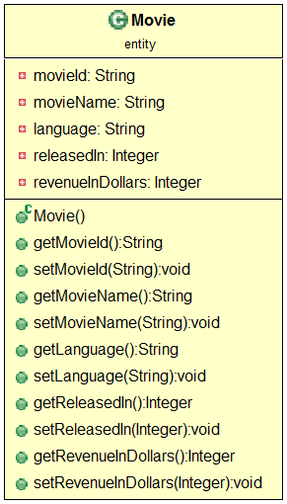

Implement the MovieDAO class methods based on the requirements mentioned below:



**Add Movie:**

Add new movie details using the given Movie object and return the movie id of the newly persisted record

**Delete Movie:**

Delete the movie details of the given movie id

**Update Movie:**

For the given movieId, update the corresponding revenue by incrementing it with 100000 dollars

**Get Movie Details:**

Retrieve the Movie details for the movie id given, populate into Movie bean object and return the same.

Implement a UserInterface class to demonstrate the CRUD operations

**Note:**

Use an appropriate database table to demonstrate this concept

Modify hibernate.cfg.xml to provide your database credentials

**Summary:** In this exercise, you learned to perform CRUD operations using Hibernate.