For implementing the requirement of providing Locker Facility to InfyBank's existing customers we will be using one to one association mapping feature of Hibernate.

InfyBank is introducing Locker Facility to its customers. A customer can open a locker and locker cannot be shared by more than one customer.

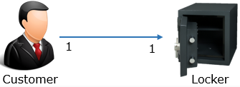

To implement this scenario we are using two tables CUSTOMER and LOCKER. The relationship between CUSTOMER and LOCKER has been defined as one to one mapping in the database by imposing a unique constraint on the foreign key column. The CUSTOMER and LOCKER tables are shown below:

|  |  |  |  |  |  |
| --- | --- | --- | --- | --- | --- |
| CUSTOMER | | | | | |
| **CUSTOMERID** | **CUSTOMERNAME** | **DATEOFBIRTH** | **ADDRESS** | **PHONENO** | **LOCKERID** |
| 7001 | William | 17-05-1995 | Kolkata | 9067767872 | LOC101 |

|  |  |  |
| --- | --- | --- |
| LOCKER | | |
| **LOCKERID** | **LOCKERTYPE** | **RENT** |
| LOC101 | Small | 1100 |