**Problem Statement:**

21st Century Jackle is a film corporation and it wants to keep track of the movie it distributes.

**Entity Classes:**

Implement the entity classes mentioned below:

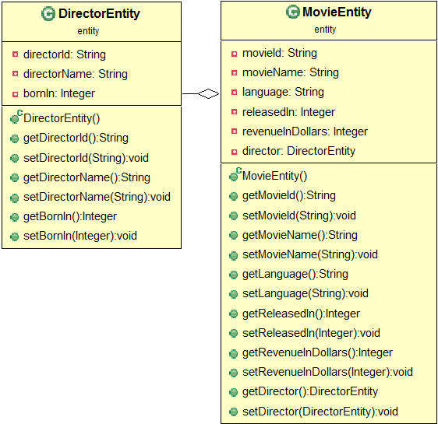

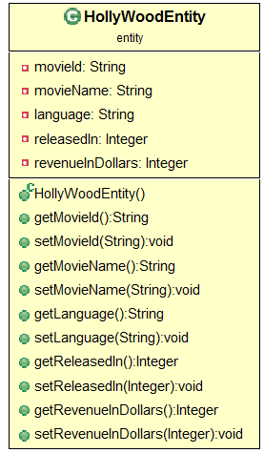

|  |  |  |
| --- | --- | --- |
| **NO** | **USE CASE** | **DESCRIPTION** |
| 1 | Get Movie Details | Display the details of the movies whose language matches the received value. |
| 2 | Get Movies for Director | Display the details of movies for the given director |
| 3 | Add Movies | Add records whose language is English to the new table 'Hollywood'. Use the Session API's save() method. |
| 4 | Update revenue | Increment the revenue of the received movie by 100000 dollars |
| 5 | Delete movie only | Delete the record corresponding to the movie name received. |
| 6 | Get Distinct Languages | Retrieve the list of distinct languages available in the database. |
| 7 | Get MovieName DirectorName | Retrieve the movie name and Director name for each movie and populate a list of the object array. The list is returned. |

**Note:**

Use the sample data provided below to test the functionalities.

Modify hibernate.cfg.xml to provide your database credentials

HQL_Director

|  |  |  |
| --- | --- | --- |
| **DIRECTOR ID** | **DIRECTOR NAME** | **BORN IN** |
| D101 | Chris Columbus | 1958 |
| D102 | Patrick Read Johnson | 1962 |
| D103 | Aamir Khan | 1965 |
| D104 | R. Balki | NULL |

HQL_Movie

|  |  |  |  |  |  |
| --- | --- | --- | --- | --- | --- |
| **MOVIE ID** | **MOVIE NAME** | **LANGUAGE** | **RELEASED IN** | **REVENUE IN DOLLARS** | **DIRECTOR ID** |
| M1001 | Home Alone | English | 1990 | 476700000 | D101 |
| M1002 | Home Alone | English | 1992 | 358900000 | D101 |
| M1003 | Baby's Day Out | English | 1994 | 16800000 | D102 |
| M1004 | Taare Zameen Par | Hindi | 2007 | 13000000 | D103 |
| M1005 | Paa | Hindi | 2009 | 4700000 | D104 |

**Summary of this exercise:**

Using HQL query to perform CRUD operation