**JAX-RS tutorial** is provides concepts and examples of JAX-RS API. This JAX-RS tutorial is designed for beginners and professionals.

There are two main implementation of JAX-RS API.

1. Jersey
2. RESTEasy

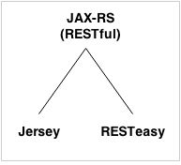

What is Web Service

A **Web Service** is can be defined by following ways:

* It is a client-server application or application component for communication.
* The method of communication between two devices over the network.
* It is a software system for the interoperable machine to machine communication.
* It is a collection of standards or protocols for exchanging information between two devices or application.

Let's understand it by the figure given below:

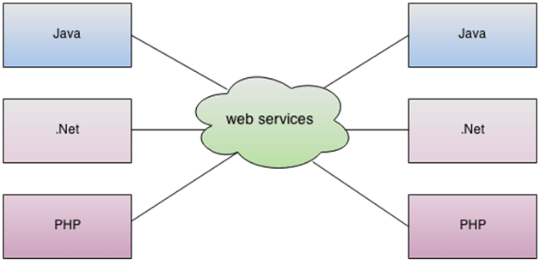

As you can see in the figure, Java, .net, and PHP applications can communicate with other applications through web service over the network. For example, the Java application can interact with Java, .Net, and PHP applications. So web service is a language independent way of communication.

Types of Web Services

There are mainly two types of web services.

1. SOAP web services.
2. RESTful web services.

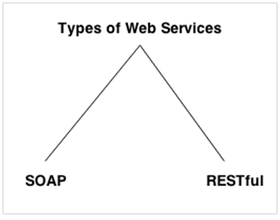

Web Service Features

XML-Based

Web services use XML at data description and data transportation layers. Using XML exclude any networking, operating system, or platform binding. Web services-based operation is extremely interoperable at their core level.

Loosely Coupled

A client of a web service is not fixed to the web service directly. The web service interface can support innovation over time without negotiating the client's ability to communicate with the service. A tightly coupled system means that the client and server logic are closely tied to one another, indicating that if one interface changes, then another must be updated. Accepting a loosely coupled architecture tends to make software systems more manageable and allows more straightforward integration between various systems.

Coarse-Grained

Object-oriented technologies such as Java expose their functions through individual methods. A specific process is too fine an operation to provide any suitable capability at a corporate level. Building a Java program from scratch needed the creation of various fine-grained functions that are then collected into a coarse-grained role that is consumed by either a client or another service.

Businesses and the interfaces that they prove should be coarse-grained. Web services technology implement a natural method of defining coarse-grained services that approach the right amount of business logic.

Ability to be Synchronous or Asynchronous

Synchronicity specifies the binding of the client to the execution of the function. In synchronous invocations, the client blocks and delays in completing its service before continuing. Asynchronous operations grant a client to invoke a task and then execute other functions.

Asynchronous clients fetch their result at a later point in time, while synchronous clients receive their effect when the service has completed. Asynchronous capability is an essential method in enabling loosely coupled systems.

Supports Remote Procedure Calls (RPCs)

Web services allow consumers to invoke procedures, functions, and methods on remote objects using an XML-based protocol. Remote systems expose input and output framework that a web service must support.

Component development through Enterprise JavaBeans (EJBs) and .NET Components has more become a part of architectures and enterprise deployments over a previous couple of years. Both technologies are assigned and accessible through a variety of RPC mechanisms.

A web function supports RPC by providing services of its own, equivalent to those of a traditional role, or by translating incoming invocations into an invocation of an EJB or a .NET component.

Supports Document Exchange

One of the essential benefits of XML is its generic way of representing not only data but also complex documents. These documents can be as simple as describing a current address, or they can be as involved as defining an entire book or Request for Quotation (RFQ). Web services support the transparent transfer of documents to facilitate business integration.

Web Service Components

There are three major web service components.

1. SOAP
2. WSDL
3. UDDI

SOAP

SOAP is an acronym for Simple Object Access Protocol.

SOAP is a XML-based protocol for accessing web services.

SOAP is a W3C recommendation for communication between applications.

SOAP is XML based, so it is platform independent and language independent. In other words, it can be used with Java, .Net or PHP language on any platform.

WSDL

WSDL is an acronym for Web Services Description Language.

WSDL is a xml document containing information about web services such as method name, method parameter and how to access it.

WSDL is a part of UDDI. It acts as a interface between web service applications.

WSDL is pronounced as wiz-dull.

UDDI

UDDI is an acronym for Universal Description, Discovery and Integration.

UDDI is a XML based framework for describing, discovering and integrating web services.

UDDI is a directory of web service interfaces described by WSDL, containing information about web services.

SOAP vs REST Web Services

There are many differences between SOAP and REST web services. The important 10 differences between SOAP and REST are given below:

|  |  |  |
| --- | --- | --- |
| **No.** | **SOAP** | **REST** |
| 1) | SOAP is a **protocol**. | REST is an **architectural style**. |
| 2) | SOAP stands for **Simple Object Access Protocol**. | REST stands for **REpresentational State Transfer**. |
| 3) | SOAP **can't use REST** because it is a protocol. | REST **can use SOAP** web services because it is a concept and can use any protocol like HTTP, SOAP. |
| 4) | SOAP **uses services interfaces to expose the business logic**. | REST **uses URI to expose business logic**. |
| 5) | **JAX-WS** is the java API for SOAP web services. | **JAX-RS** is the java API for RESTful web services. |
| 6) | SOAP **defines standards**to be strictly followed. | REST does not define too much standards like SOAP. |
| 7) | SOAP **requires more bandwidth** and resource than REST. | REST **requires less bandwidth** and resource than SOAP. |
| 8) | SOAP **defines its own security**. | RESTful web services **inherits security measures** from the underlying transport. |
| 9) | SOAP **permits XML** data format only. | REST **permits different** data format such as Plain text, HTML, XML, JSON etc. |
| 10) | SOAP is **less preferred** than REST. | REST **more preferred** than SOAP. |

JAX-RS Annotations

The **javax.ws.rs** package contains JAX-RS annotations.

|  |  |
| --- | --- |
| **Annotation** | **Description** |
| Path | It identifies the URI path. It can be specified on class or method. |
| PathParam | represents the parameter of the URI path. |
| GET | specifies method responds to GET request. |
| POST | specifies method responds to POST request. |
| PUT | specifies method responds to PUT request. |
| HEAD | specifies method responds to HEAD request. |
| DELETE | specifies method responds to DELETE request. |
| OPTIONS | specifies method responds to OPTIONS request. |
| FormParam | represents the parameter of the form. |
| QueryParam | represents the parameter of the query string of an URL. |
| HeaderParam | represents the parameter of the header. |
| CookieParam | represents the parameter of the cookie. |
| Produces | defines media type for the response such as XML, PLAIN, JSON etc. It defines the media type that the methods of a resource class or MessageBodyWriter can produce. |
| Consumes | It defines the media type that the methods of a resource class or MessageBodyReader can produce. |