Strategy Pattern

A Strategy Pattern says that "defines a family of functionality, encapsulate each one, and make them interchangeable".

The Strategy Pattern is also known as Policy.

Benefits:

* It provides a substitute to subclassing.
* It defines each behavior within its own class, eliminating the need for conditional statements.
* It makes it easier to extend and incorporate new behavior without changing the application.

Usage:

* When the multiple classes differ only in their behaviors.e.g. Servlet API.
* It is used when you need different variations of an algorithm.

Strategy Pattern in (Core Java API's) or JSE 7 API's:

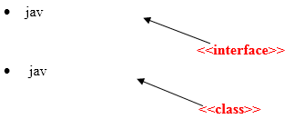

Strategy Pattern in (Advance Java API's) or JEE 7 API's:

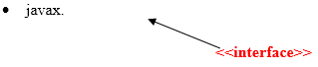

UML for Strategy Pattern:

