**Flux** is a programming concept, where the data is **uni-directional**. This data enters the app and flows through it in one direction until it is rendered on the screen.

Flux Elements

Following is a simple explanation of the **flux** concept. In the next chapter, we will learn how to implement this into the app.

* **Actions** − Actions are sent to the dispatcher to trigger the data flow.
* **Dispatcher** − This is a central hub of the app. All the data is dispatched and sent to the stores.
* **Store** − Store is the place where the application state and logic are held. Every store is maintaining a particular state and it will update when needed.
* **View** − The **view** will receive data from the store and re-render the app.

The data flow is depicted in the following image.

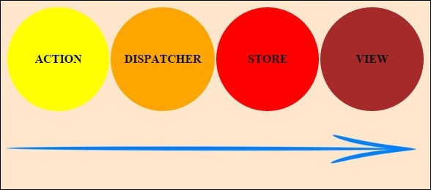

Flux Pros

* Single directional data flow is easy to understand.
* The app is easier to maintain.
* The app parts are decoupled.