React is a front-end library developed by Facebook. It is used for handling the view layer for web and mobile apps. ReactJS allows us to create reusable UI components. It is currently one of the most popular JavaScript libraries and has a strong foundation and large community behind it.

Prerequisites

To work with ReactJS, you need to have solid knowledge of **JavaScript, HTML5**, and **CSS**. Even though ReactJS doesn't use HTML, the JSX is similar so your HTML knowledge will be very helpful.

ReactJS is JavaScript library used for building reusable UI components. According to React official documentation, following is the definition −

React is a library for building composable user interfaces. It encourages the creation of reusable UI components, which present data that changes over time. Lots of people use React as the V in MVC. React abstracts away the DOM from you, offering a simpler programming model and better performance. React can also render on the server using Node, and it can power native apps using React Native. React implements one-way reactive data flow, which reduces the boilerplate and is easier to reason about than traditional data binding.

## **React Features**

* **JSX** − JSX is JavaScript syntax extension. It isn't necessary to use JSX in React development, but it is recommended.
* **Components** − React is all about components. You need to think of everything as a component. This will help you maintain the code when working on larger scale projects.
* **Unidirectional data flow and Flux** − React implements one-way data flow which makes it easy to reason about your app. Flux is a pattern that helps keeping your data unidirectional.
* **License** − React is licensed under the Facebook Inc.

**React Advantages**

* Uses virtual DOM which is a JavaScript object. This will improve apps performance, since JavaScript virtual DOM is faster than the regular DOM.
* Can be used on client and server side as well as with other frameworks.
* Component and data patterns improve readability, which helps to maintain larger apps.

## **React Limitations**

* Covers only the view layer of the app, hence you still need to choose other technologies to get a complete tooling set for development.
* Uses inline templating and JSX, which might seem awkward to some developers.
* In this chapter, we will show you how to set up an environment for successful React development. Notice that there are many steps involved but this will help speed up the development process later. We will need **NodeJS**, so if you don't have it installed, check the link from the following table.

|  |  |
| --- | --- |
| **Sr. No.** | **Software & Description** |
| 1 | **NodeJS and NPM**  NodeJS is the platform needed for the Cordova development. Checkout our **[NodeJS Environment Setup](https://www.tutorialspoint.com/nodejs/nodejs_environment_setup.htm" \t "_blank)**. |

## **Step 1 - Create the Root Folder**

* The root folder will be named **reactApp** and we will place it on **Desktop**. After the folder is created, we need to open it and create empty **package.json** file inside by running npm init from the **command prompt** and follow the instructions.
* C:\Users\username\Desktop>mkdir reactApp
* C:\Users\username\Desktop\reactApp>npm init

## **Step 2 - Install Global Packages**

* We will need to install several packages for this setup. We will need some of the **babel** plugins, so let's first install **babel** by running the following code in the **command prompt** window.
* C:\Users\username\Desktop\reactApp>npm install -g babel
* C:\Users\username\Desktop\reactApp>npm install -g babel-cli

## **Step 3 - Add Dependencies and Plugins**

* We will use **webpack** bundler in these tutorial. Let's install **webpack** and **webpack-dev-server**.
* C:\Users\username\Desktop\reactApp>npm install webpack --save
* C:\Users\username\Desktop\reactApp>npm install webpack-dev-server --save
* Since we want to use React, we need to install it first. The **--save** command will add these packages to **package.json** file.
* C:\Users\username\Desktop\reactApp>npm install react --save
* C:\Users\username\Desktop\reactApp>npm install react-dom --save
* As already mentioned, we will need some **babel** plugins, so let's install it too.
* C:\Users\username\Desktop\reactApp>npm install babel-core
* C:\Users\username\Desktop\reactApp>npm install babel-loader
* C:\Users\username\Desktop\reactApp>npm install babel-preset-react
* C:\Users\username\Desktop\reactApp>npm install babel-preset-es2015

## **Step 4 - Create the Files**

* Let's create several files that we need. It can be added manually or using the **command prompt**.
* C:\Users\username\Desktop\reactApp>touch index.html
* C:\Users\username\Desktop\reactApp>touch App.jsx
* C:\Users\username\Desktop\reactApp>touch main.js
* C:\Users\username\Desktop\reactApp>touch webpack.config.js
* Alternative way to create files that we need
* C:\Users\username\Desktop\reactApp>type nul >index.html
* C:\Users\username\Desktop\reactApp>type nul >App.jsx
* C:\Users\username\Desktop\reactApp>type nul >main.js
* C:\Users\username\Desktop\reactApp>type nul >webpack.config.js

## **Step 5 - Set Compiler, Server and Loaders**

* Open **webpack.config.js** file and add the following code. We are setting webpack entry point to be **main.js**. Output path is the place where bundled app will be served. We are also setting the development server to **8080** port. You can choose any port you want.
* And lastly, we are setting babel loaders to search for **js** files, and use **es2015**and **react** presets that we installed before.

### **webpack.config.js**

* var config = {
* entry: './main.js',
* output: {
* path:'/',
* filename: 'index.js',
* },
* devServer: {
* inline: true,
* port: 8080
* },
* module: {
* loaders: [
* {
* test: /\.jsx?$/,
* exclude: /node\_modules/,
* loader: 'babel-loader',
* query: {
* presets: ['es2015', 'react']
* }
* }
* ]
* }
* }
* module.exports = config;
* Open the **package.json** and delete **"test" "echo \"Error: no test specified\" && exit 1"** inside **"scripts"** object. We are deleting this line since we will not do any testing in this tutorial. Let's add the **start** command instead.
* "start": "webpack-dev-server --hot"
* Before the above step, it will required **webpack-dev-server**. To install **webpack-dev-server**, use the following command.
* C:\Users\username\Desktop\reactApp>npm install webpack-dev-server -g
* Now, we can use **npm start** command to start the server. **--hot** command will add live reload after something is changed inside our files so we don't need to refresh the browser every time we change our code.

## **Step 6 - index.html**

* This is just regular HTML. We are setting **div id = "app"** as a root element for our app and adding **index.js** script, which is our bundled app file.
* <!DOCTYPE html>
* <html lang = "en">
* <head>
* <meta charset = "UTF-8">
* <title>React App</title>
* </head>
* <body>
* <div id = "app"></div>
* <script src = "index.js"></script>
* </body>
* </html>

## **Step 7 - App.jsx and main.js**

* This is the first React component. We will explain React components in depth in a subsequent chapter. This component will render **Hello World!!!**.

### **App.jsx**

* import React from 'react';
* class App extends React.Component {
* render() {
* return (
* <div>
* Hello World!!!
* </div>
* );
* }
* }
* export default App;
* We need to import this component and render it to our root **App** element, so we can see it in the browser.

### **main.js**

* import React from 'react';
* import ReactDOM from 'react-dom';
* import App from './App.jsx';
* ReactDOM.render(<App />, document.getElementById('app'));
* **Note** − Whenever you want to use something, you need to **import** it first. If you want to make the component usable in other parts of the app, you need to **export** it after creation and **import** it in the file where you want to use it.

## **Step 8 - Running the Server**

* The setup is complete and we can start the server by running the following command.
* C:\Users\username\Desktop\reactApp>npm start
* It will show the port we need to open in the browser. In our case, it is **http://localhost:8080/**. After we open it, we will see the following output.
* 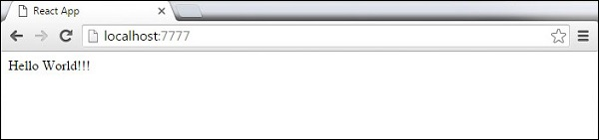

React uses JSX for templating instead of regular JavaScript. It is not necessary to use it, however, following are some pros that come with it.

* It is faster because it performs optimization while compiling code to JavaScript.
* It is also type-safe and most of the errors can be caught during compilation.
* It makes it easier and faster to write templates, if you are familiar with HTML.

## **Using JSX**

JSX looks like a regular HTML in most cases. We already used it in the Environment Setup chapter. Look at the code from **App.jsx** where we are returning **div**.

### **App.jsx**

import React from 'react';

class App extends React.Component {

render() {

return (

<div>

Hello World!!!

</div>

);

}

}

export default App;

Even though it's similar to HTML, there are a couple of things we need to keep in mind when working with JSX.

## **Nested Elements**

If we want to return more elements, we need to wrap it with one container element. Notice how we are using **div** as a wrapper for **h1**, **h2** and **p**elements.

### **App.jsx**

import React from 'react';

class App extends React.Component {

render() {

return (

<div>

<h1>Header</h1>

<h2>Content</h2>

<p>This is the content!!!</p>

</div>

);

}

}

export default App;

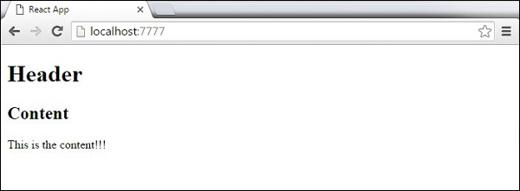

## **Attributes**

We can use our own custom attributes in addition to regular HTML properties and attributes. When we want to add custom attribute, we need to use **data-**prefix. In the following example, we added **data-myattribute** as an attribute of **p** element.

import React from 'react';

class App extends React.Component {

render() {

return (

<div>

<h1>Header</h1>

<h2>Content</h2>

<p data-myattribute = "somevalue">This is the content!!!</p>

</div>

);

}

}

export default App;

## **JavaScript Expressions**

JavaScript expressions can be used inside of JSX. We just need to wrap it with curly brackets **{}**. The following example will render **2**.

import React from 'react';

class App extends React.Component {

render() {

return (

<div>

<h1>{1+1}</h1>

</div>

);

}

}

export default App;

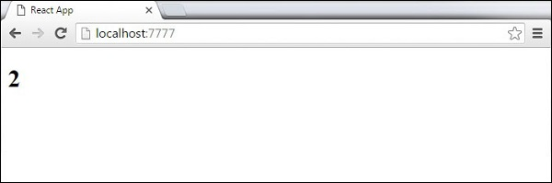

We cannot use **if else** statements inside JSX, instead we can use **conditional (ternary)** expressions. In the following example, variable **i** equals to **1** so the browser will render **true**, If we change it to some other value, it will render **false**.

import React from 'react';

class App extends React.Component {

render() {

var i = 1;

return (

<div>

<h1>{i == 1 ? 'True!' : 'False'}</h1>

</div>

);

}

}

export default App;

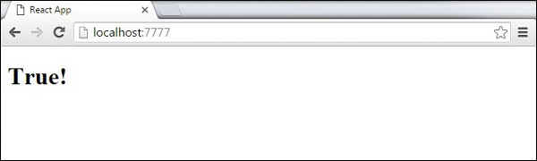

## **Styling**

React recommends using inline styles. When we want to set inline styles, we need to use **camelCase** syntax. React will also automatically append **px** after the number value on specific elements. The following example shows how to add **myStyle** inline to **h1** element.

import React from 'react';

class App extends React.Component {

render() {

var myStyle = {

fontSize: 100,

color: '#FF0000'

}

return (

<div>

<h1 style = {myStyle}>Header</h1>

</div>

);

}

}

export default App;

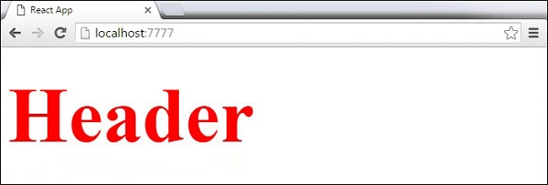

## **Comments**

When writing comments, we need to put curly brackets **{}** when we want to write comment within children section of a tag. It is a good practice to always use **{}** when writing comments, since we want to be consistent when writing the app.

import React from 'react';

class App extends React.Component {

render() {

return (

<div>

<h1>Header</h1>

{//End of the line Comment...}

{/\*Multi line comment...\*/}

</div>

);

}

}

export default App;

## **Naming Convention**

HTML tags always use **lowercase** tag names, while React components start with **Uppercase**.

**Note** − You should use **className** and **htmlFor** as XML attribute names instead of **class** and **for**.

This is explained on React official page as −

Since JSX is JavaScript, identifiers such as **class** and **for** are discouraged as XML attribute names. Instead, React DOM components expect DOM property names such as **className** and **htmlFor**, respectively.

In this chapter, we will learn how to combine components to make the app easier to maintain. This approach allows to update and change your components without affecting the rest of the page.

## **Stateless Example**

Our first component in the following example is **App**. This component is owner of **Header** and **Content**. We are creating **Header** and **Content** separately and just adding it inside JSX tree in our **App** component. Only **App** component needs to be exported.

### **App.jsx**

import React from 'react';

class App extends React.Component {

render() {

return (

<div>

<Header/>

<Content/>

</div>

);

}

}

class Header extends React.Component {

render() {

return (

<div>

<h1>Header</h1>

</div>

);

}

}

class Content extends React.Component {

render() {

return (

<div>

<h2>Content</h2>

<p>The content text!!!</p>

</div>

);

}

}

export default App;

To be able to render this on the page, we need to import it in **main.js** file and call **reactDOM.render()**. We already did this while setting the environment.

### **main.js**

import React from 'react';

import ReactDOM from 'react-dom';

import App from './App.jsx';

ReactDOM.render(<App />, document.getElementById('app'));

The above code will generate the following result.

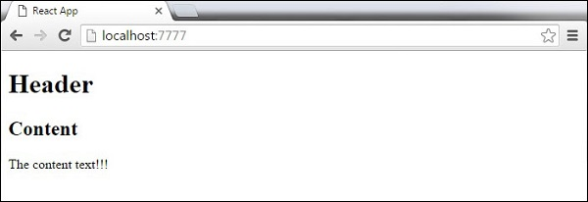

## **Stateful Example**

In this example, we will set the state for owner component (**App**). The **Header** component is just added like in the last example since it doesn't need any state. Instead of content tag, we are creating **table** and **tbody** elements, where we will dynamically insert **TableRow** for every object from the **data**array.

It can be seen that we are using EcmaScript 2015 arrow syntax (**⇒**) which looks much cleaner than the old JavaScript syntax. This will help us create our elements with fewer lines of code. It is especially useful when we need to create a list with a lot of items.

### **App.jsx**

import React from 'react';

class App extends React.Component {

constructor() {

super();

this.state = {

data:

[

{

"id":1,

"name":"Foo",

"age":"20"

},

{

"id":2,

"name":"Bar",

"age":"30"

},

{

"id":3,

"name":"Baz",

"age":"40"

}

]

}

}

render() {

return (

<div>

<Header/>

<table>

<tbody>

{this.state.data.map((person, i) => <TableRow key = {i}

data = {person} />)}

</tbody>

</table>

</div>

);

}

}

class Header extends React.Component {

render() {

return (

<div>

<h1>Header</h1>

</div>

);

}

}

class TableRow extends React.Component {

render() {

return (

<tr>

<td>{this.props.data.id}</td>

<td>{this.props.data.name}</td>

<td>{this.props.data.age}</td>

</tr>

);

}

}

export default App;

### **main.js**

import React from 'react';

import ReactDOM from 'react-dom';

import App from './App.jsx';

ReactDOM.render(<App/>, document.getElementById('app'));

**Note** − Notice that we are using **key = {i} inside map()** function. This will help React to update only the necessary elements instead of re-rendering the entire list when something changes. It is a huge performance boost for larger number of dynamically created elements.

