Hibernate Example
In this tutorial you will see how to persist the java objects using the Hibernate Object/Relational Mapping (ORM) framework. Hibernate automates ORM and considerably reduces the number of lines of code needed to persist the object in the database. This example demonstrates how to automatically generate code from the object/relational mapping file, thus saving the developers time. This helps the developers to focus on the business problem rather than doing repetitive coding work.
Hibernate uses XML document or the properties file to define the object/relational mapping. The object/relational mapping file contains the mapping between the Java object and the corresponding database table. This example illustrates how to create the ORM using the XML document.
First let's setup the environment. I am using
- Eclipse IDE 3.4
- Hibernate Core 3.3
- Hibernate Tools 3.2
- HSQLDB 1.8
You can download the Hibernate Core and Hibernate Tools here. HyperSQL DataBase is a 100% lightweight Java SQL Database Engine. You can download HSQLDB from this site http://hsqldb.org/ .
To install the Hibernate Tools, extract the HibernateTools-3.X.zip file and move all the files inside the features folder into the features folder of the eclipse installation directory and move all the files inside the plugins folder into the plugins folder of the ecilpse installation directory. Restart the eclipse.
First create a new Java project. Add the following lib files on the java build path.
01.antlr-2.7.6
02.commons-collections-3.1
03.dom4j-1.6.1
04.hibernate3
05.hsqldb
06.javassist-3.4.GA
07.jta-1.1
08.slf4j-api-1.5.6
09.slf4j-simple-1.5.6
The hibernate3.jar contains all the core hibernate files. The hsqldb.jar is used, to connect with the HSQL database, if you are using someother database then you need to include that jar file instead of this. The slf4j-api-1.5.6 jar file is used for logging the informations, you can also use other alternatives like log4j, to do that include that jar file instead of slf4j-simple-1.5.6 jar file to your classpath.
Once you have installed the hibernate tools, you will have the option to change to Hibernate prespective. Go to Window -> Open Prespective -> Other, the following dialog box appears, select Hibernate and click the Ok button.
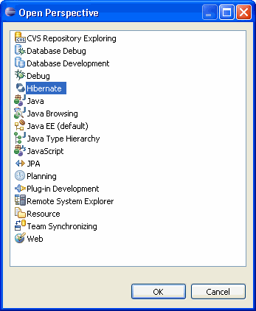
Now let's see how to define the object/relational mapping using the XML document. This document has hbm.xml extension. We will now create the object/relational mapping for the simple class that holds course related details. To do that create a package com.vaannila.course in the src directory. The Hibernate XML mapping file will be created in this directory. To create the mapping file, switch to Hibernate prespective, right click the project folder and select New -> Hibernate XML Mapping File(hbm.xml)
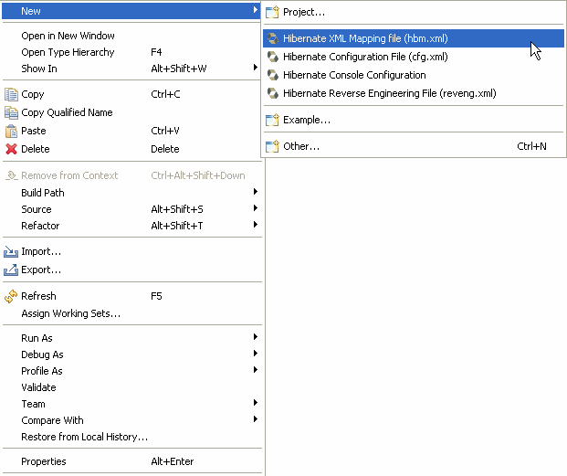
In the pop up window select the course folder, enter the file name as Course.hbm.xml and click Next. In the next window click Finish.
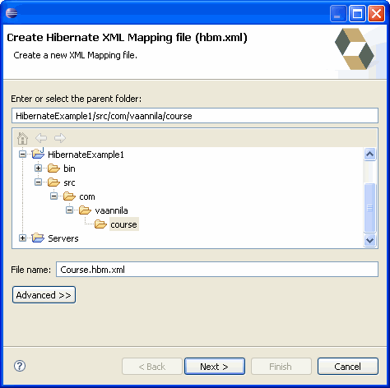
Add the following code to the Course.hbm.xml file.
01.<?xml version="1.0"?>
02.<!DOCTYPE hibernate-mapping PUBLIC
03."-//Hibernate/Hibernate Mapping DTD 3.0//EN"
04."http://hibernate.sourceforge.net/hibernate-mapping-3.0.dtd">
05.<hibernate-mapping>
06.
07. <class name="com.vaannila.course.Course" table="COURSES">
08. <meta attribute="class-description">
09. This class contains the course details.
10. </meta>
11. <id name="courseId" type="long" column="COURSE_ID">
12. <generator class="native"/>
13. </id>
14. <property name="courseName" type="string" column="COURSE_NAME" not-null="true" />
15. </class>
16.
17.</hibernate-mapping>
The hibernate-mapping element is the root element. The class element is used to map the Java class with the database table. The Java class name is specified using the name attribute of the class element and the database table name is specified using the table attribute of the class element. The meta element is used to create the class description. The id element is used to create the primary key. The name attribute of the id element refers to the property in the Course class and the column attribute refers to the column in the COURSES table. The type attribute holds the hibernate mapping type, this mapping types will convert from Java to SQL data type and vice versa. The generator element within the id element is used to automatically generate the primary key values. When the class attribute of the generator element is set to native, hibernate picks either identity, sequence or hilo algorithm depending upon the capabilities of the underlying database. The property element is used to link a property in the Java class to a column in the database table.
The next step is to create the Hibernate configuration file. On startup, Hibernate looks for a file called hibernate.cfg.xml in the root of the classpath. To create the Hibernate Configuration File, right click the project, select New -> Hibernate Configuration File (cfg.xml)

By default the file name will be hibernate.cfg.xml, select the src directory and click Next.
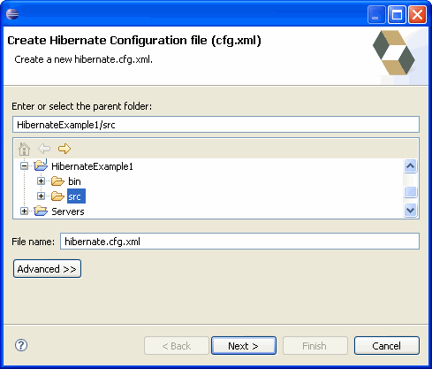
Select the database dialect as HSQL. This property indicates the particular SQL variant that Hibernate generates. Select the "org.hsqldb.jdbcDriver" option for the driver class. Enter the connection url "jdbc:hsqldb:hsql://localhost". Enter the user name as "sa" and click Finish. These properties specifies the necessary configuration for the JDBC connection.
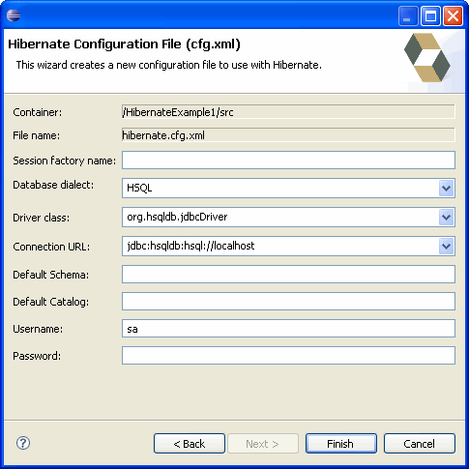
The show_sql option, if set to true will display all the executed SQL queries on the console.
The property hbm2ddl.auto, if set to create, will drop and re-create the database schema on startup.
In the end we add the Course.hbm.xml file to the configuration. The implementation of the hibernate.cfg.xml file is shown below.
01.<?xml version="1.0" encoding="UTF-8"?>
02.<!DOCTYPE hibernate-configuration PUBLIC
03."-//Hibernate/Hibernate Configuration DTD 3.0//EN"
04."http://hibernate.sourceforge.net/ hibernate-configuration-3.0.dtd">
05.<hibernate-configuration>
06. <session-factory>
07. <property name="hibernate.connection.driver_class"> org.hsqldb.jdbcDriver</property>
08. <property name="hibernate.connection.url"> jdbc:hsqldb:hsql://localhost</property>
09. <property name="hibernate.connection.username">sa</property>
10. <property name="connection.password"></property>
11. <property name="connection.pool_size">1</property>
12. <property name="hibernate.dialect"> org.hibernate.dialect.HSQLDialect</property>
13. <property name="show_sql">true</property>
14. <property name="hbm2ddl.auto">create</property>
15. <mapping resource="com/vaannila/course/Course.hbm.xml"/>
16. </session-factory>
17.</hibernate-configuration>
Once the Hibernate configuration file is created we need to create a Hibernate console configuration. To do this right click the project folder, select New -> Hibernate Console Configuration.
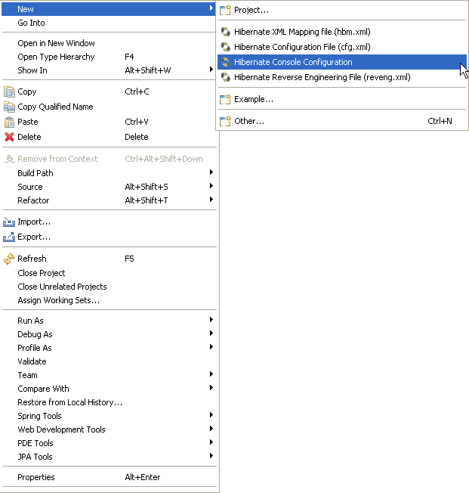
The Hibernate Console configuration wizard appears.
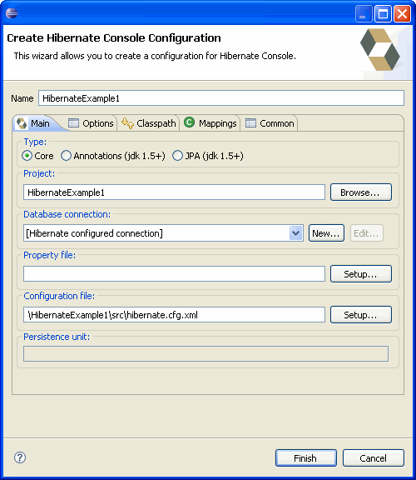
By default the wizard will load the Hibernate configuration file information. Just click the Finish button to create the Hibernate console configuration.
Once the Hibernate console configuration is created, you can generate code by selecting the Hibernate Code Generation Configurations option form the toolbar.
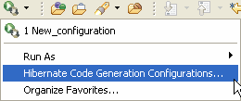
The Hibernate Code Generation wizard will be displayed. Now select the output directory as the src directory.
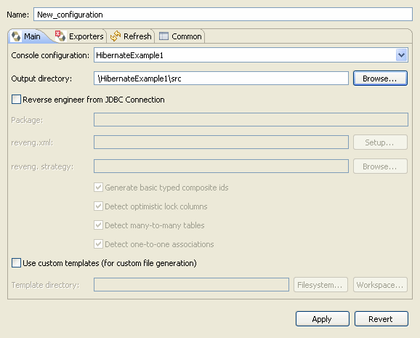
In the Exporters tag select the "Use Java 5 Syntax" option and "Domain Code(.java)" option.
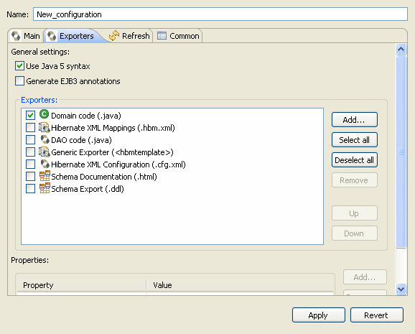
In the Refresh tab select the options as shown below and click the Run button to generate the code.
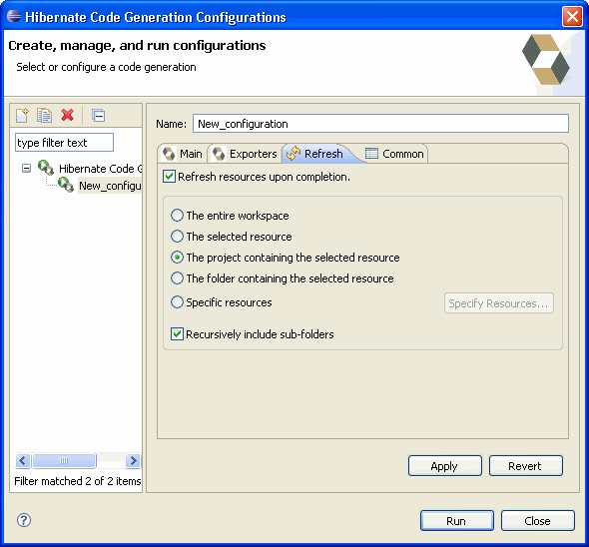
The following Course.java class will be generated from the Course.hbm.xml mapping file.
01.package com.vaannila.course;
02.
03.// Generated May 30, 2009 6:49:31 AM by Hibernate Tools 3.2.4.GA
04.
05./**
06.* This class contains the course details.
07.*
08.*/
09.public class Course implements java.io.Serializable {
10.
11. private long courseId;
12. private String courseName;
13.
14. public Course() {
15. }
16.
17. public Course(String courseName) {
18. this.courseName = courseName;
19. }
20.
21. public long getCourseId() {
22. return this.courseId;
23. }
24.
25. public void setCourseId(long courseId) {
26. this.courseId = courseId;
27. }
28.
29. public String getCourseName() {
30. return this.courseName;
31. }
32.
33. public void setCourseName(String courseName) {
34. this.courseName = courseName;
35. }
36.
37.}
Now create the HibernateUtil class. The HibernateUtil class helps in creating the SessionFactory from the Hibernate configuration file. The SessionFactory is threadsafe, so it is not necessary to obtain one for each thread. Here the static singleton pattern is used to instantiate the SessionFactory. The implementation of the HibernateUtil class is shown below.
01.package com.vaannila.util;
02.
03.import org.hibernate.SessionFactory;
04.import org.hibernate.cfg.Configuration;
05.
06.public class HibernateUtil {
07. private static final SessionFactory sessionFactory;
08. static {
09. try {
10. sessionFactory = new Configuration().configure()
11. .buildSessionFactory();
12. } catch (Throwable ex) {
13. System.err.println("Initial SessionFactory creation failed." + ex);
14. throw new ExceptionInInitializerError(ex);
15. }
16. }
17.
18. public static SessionFactory getSessionFactory() {
19. return sessionFactory;
20. }
21.}
Now we will create a class with the main() method to run the application.
001.package com.vaannila.course;
002.
003.import java.util.List;
004.import java.util.Iterator;
005.
006.import org.hibernate.HibernateException;
007.import org.hibernate.Session;
008.import org.hibernate.Transaction;
009.
010.import com.vaannila.util.HibernateUtil;
011.
012.public class Main {
013.
014. public static void main(String[] args) {
015. Main obj = new Main();
016. Long courseId1 = obj.saveCourse("Physics");
017. Long courseId2 = obj.saveCourse("Chemistry");
018. Long courseId3 = obj.saveCourse("Maths");
019. obj.listCourse();
020. obj.updateCourse(courseId3, "Mathematics");
021. obj.deleteCourse(courseId2);
022. obj.listCourse();
023. }
024.
025. public Long saveCourse(String courseName)
026. {
027. Session session = HibernateUtil.getSessionFactory().openSession();
028. Transaction transaction = null;
029. Long courseId = null;
030. try {
031. transaction = session.beginTransaction();
032. Course course = new Course();
033. course.setCourseName(courseName);
034. courseId = (Long) session.save(course);
035. transaction.commit();
036. } catch (HibernateException e) {
037. transaction.rollback();
038. e.printStackTrace();
039. } finally {
040. session.close();
041. }
042. return courseId;
043. }
044.
045. public void listCourse()
046. {
047. Session session = HibernateUtil.getSessionFactory().openSession();
048. Transaction transaction = null;
049. try {
050. transaction = session.beginTransaction();
051. List courses = session.createQuery("from Course").list();
052. for (Iterator iterator = courses.iterator(); iterator.hasNext();)
053. {
054. Course course = (Course) iterator.next();
055. System.out.println(course.getCourseName());
056. }
057. transaction.commit();
058. } catch (HibernateException e) {
059. transaction.rollback();
060. e.printStackTrace();
061. } finally {
062. session.close();
063. }
064. }
065.
066. public void updateCourse(Long courseId, String courseName)
067. {
068. Session session = HibernateUtil.getSessionFactory().openSession();
069. Transaction transaction = null;
070. try {
071. transaction = session.beginTransaction();
072. Course course = (Course) session.get(Course.class, courseId);
073. course.setCourseName(courseName);
074. transaction.commit();
075. } catch (HibernateException e) {
076. transaction.rollback();
077. e.printStackTrace();
078. } finally {
079. session.close();
080. }
081. }
082.
083. public void deleteCourse(Long courseId)
084. {
085. Session session = HibernateUtil.getSessionFactory().openSession();
086. Transaction transaction = null;
087. try {
088. transaction = session.beginTransaction();
089. Course course = (Course) session.get(Course.class, courseId);
090. session.delete(course);
091. transaction.commit();
092. } catch (HibernateException e) {
093. transaction.rollback();
094. e.printStackTrace();
095. } finally {
096. session.close();
097. }
098. }
099.}
The first call to the openSession() method begins the session. The session.beginTransaction() method is used to start a new transaction. Here we have four different methods to perform the CRUD operations.
The saveCourse() method is used to save a new Course object to the database. In the saveCourse()method a new object of the Course class is created and the courseName value is set, the courseId value is auto generated so the value needn't be set here. The session.save() method is used to persist the value in the database and once the value is saved, the id value (Primary key) is returned. Here the courseId value is of type long so we typecast the returned value to Long. Once the object is saved, the transaction is committed. If any exception occurs then the transaction is rolledback. The transaction ends either through commit or rollback action. Once the transaction ends the session is closed.
The listCourse() method is used to list all the courses. The session.createQuery() method is used to create a query object which helps in retrieving the persistant objects. Here we use Hibernate Query Language (HQL). "from Course" returns a list of all the courses in the COURSES table. Note that in the HQL we only specify the java class names and not the table names. Later, using the for loop we iterate the list of courses and display them on the console.
The updateCourse() method is used to update the course name. It takes the courseId and the new courseName as input parameters. The courseId is used to retrive the actual course object using the session.get() method. The session.get() method takes the class name and the id value as the input parameter and returns the corresponding Object. Here we set the new course name to the Course object and commit the transaction. We need not explicitly call the session.save() method to persist the object. Hibernate will automatically update the database when the state of the persistant object is modified inside a transaction. This feature of Hibernate is called automatic dirty checking.
The deleteCourse() method is used to delete a Course object. This method is similar to the updateCourse() method, here instead of updating the object we call the session.delete() method to delete a persistant object.
The figure below shows the final directory structure of the example.
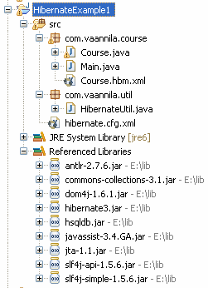
To run the example, first start the HSQLDB server. To start the HSQLDB server, run the command prompt, go to the hsqldb directory and execute the following command.
1.java -cp ./lib/hsqldb.jar org.hsqldb.Server
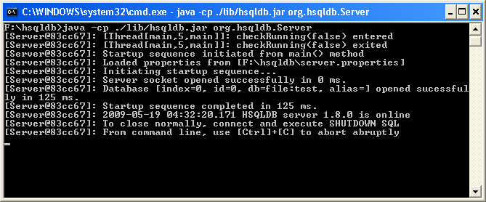
After starting the server, run the Main class. On startup the database schema will be created and the following actions will happen.
01.public static void main(String[] args) {
02. Main obj = new Main();
03. Long courseId1 = obj.saveCourse("Physics");
04. Long courseId2 = obj.saveCourse("Chemistry");
05. Long courseId3 = obj.saveCourse("Maths");
06. obj.listCourse();
07. obj.updateCourse(courseId3, "Mathematics");
08. obj.deleteCourse(courseId2);
09. obj.listCourse();
10.}
Each time on startup the database schema will be droped and recreated, if you want to use the existing one change the value of hbm2ddl.auto option to update.
The SQL statement generated gets displayed on the console. This is set using the show_sql option in the hibernate configuration file.
01.Hibernate: insert into COURSES (COURSE_ID, COURSE_NAME) values (null, ?)
02.Hibernate: call identity()
03.Hibernate: insert into COURSES (COURSE_ID, COURSE_NAME) values (null, ?)
04.Hibernate: call identity()
05.Hibernate: insert into COURSES (COURSE_ID, COURSE_NAME) values (null, ?)
06.Hibernate: call identity()
07.Hibernate: select course0_.COURSE_ID as COURSE1_0_, course0_.COURSE_NAME as COURSE2_0_ from COURSES course0_
08.Physics
09.Chemistry
10.Maths
11.Hibernate: select course0_.COURSE_ID as COURSE1_0_0_, course0_.COURSE_NAME as COURSE2_0_0_ from COURSES course0_ where course0_.COURSE_ID=?
12.Hibernate: update COURSES set COURSE_NAME=? where COURSE_ID=?
13.Hibernate: select course0_.COURSE_ID as COURSE1_0_0_, course0_.COURSE_NAME as COURSE2_0_0_ from COURSES course0_ where course0_.COURSE_ID=?
14.Hibernate: delete from COURSES where COURSE_ID=?
15.Hibernate: select course0_.COURSE_ID as COURSE1_0_, course0_.COURSE_NAME as COURSE2_0_ from COURSES course0_
16.Physics
17.Mathematics
Now let's check whether the database schema is created and the data is inserted into the COURSES table or not. Open a new command prompt, go to the hsqldb installed directory and type the following command.
1.java -cp ./lib/hsqldb.jar org.hsqldb.util.DatabaseManager
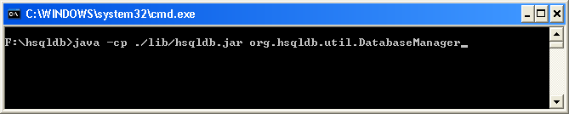
The following dialog box pops up. Select the Type as "HSQL Database Engine Server" and click Ok.
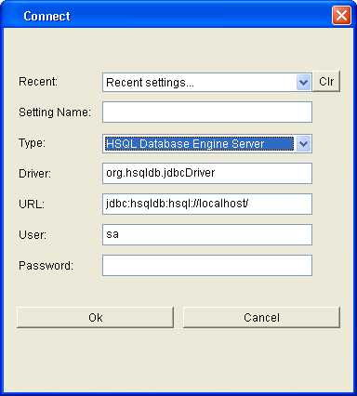
The HSQL Databse Manager window opens. Here you can enter the following SQL statement, and see the data is successfully stored in the COURSES table.
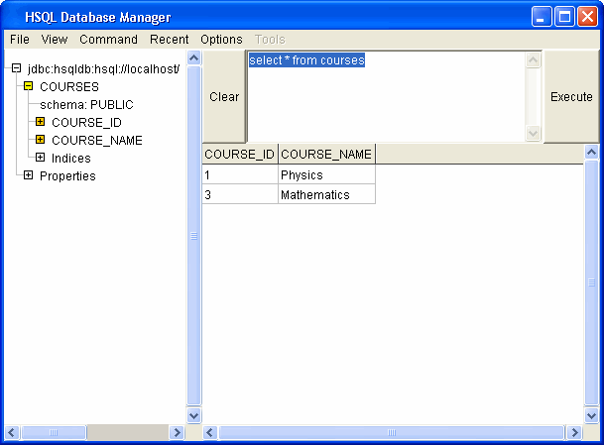
To shutdown the HSQLDB properly enter "shutdown" and click the Execute button. Alternatively you can also shutdown programmatically by closing the SessionFactory, using HibernateUtil.getSessionFactory().close() method.
You can download the source code of this example by clicking the Download link below.
Source :Download

Hibernate Annotations
This example is the same as the first example except that it uses annotations. There we first started by creating the .hbm.xml file, here there is no need to create it instead we will use annotations to do the object relational mapping.
In addition to the already existing jar files you need to add the following jar files to the classpath.
1.hibernate-commons-annotations.jar
2.ejb3-persistence.jar
3.hibernate-annotations.jar
Here we first start by creating the Course class. The Course class is shown below.
01.package com.vaannila.course;
02.
03.import javax.persistence.Column;
04.import javax.persistence.Entity;
05.import javax.persistence.GeneratedValue;
06.import javax.persistence.Id;
07.import javax.persistence.Table;
08.
09.
10.@Entity
11.@Table(name="COURSES")
12.public class Course {
13.
14. private long courseId;
15. private String courseName;
16.
17. public Course() {
18. }
19.
20. public Course(String courseName) {
21. this.courseName = courseName;
22. }
23.
24. @Id
25. @GeneratedValue
26. @Column(name="COURSE_ID")
27. public long getCourseId() {
28. return this.courseId;
29. }
30.
31. public void setCourseId(long courseId) {
32. this.courseId = courseId;
33. }
34.
35. @Column(name="COURSE_NAME", nullable=false)
36. public String getCourseName() {
37. return this.courseName;
38. }
39.
40. public void setCourseName(String courseName) {
41. this.courseName = courseName;
42. }
43.
44.}
As you can see we have used annotations in the code to do the object relational mapping. Hibernate supports EJB 3 persistence annotations. The EJB 3 annotations are contained in the javax.persistence package. If you avoid using Hibernate specific features in your application, then you will have the freedom to deploy your application in any environment that supports EJB 3. Anything imported from javax.persistence package tree is EJB 3 supported and anything imported from org.hibernate package tree is Hibernate specific.
The @Entity annotation is used to mark this class as an Entity bean. So the class should atleast have a package scope no-argument constructor.
The @Table annotation is used to specify the table to persist the data. The name attribute refers to the table name. If @Table annotation is not specified then Hibernate will by default use the class name as the table name.
The @Id annotation is used to specify the identifier property of the entity bean. The placement of the @Id annotation determines the default access strategy that Hibernate will use for the mapping. If the @Id annotation is placed over the field, then filed access will be used. Instead if it placed over the getter method of that field, then property access will be used. Here we use property access.
The @GeneratedValue annotation is used to specify the primary key generation strategy to use. If the strategy is not specified by default AUTO will be used.
The @Column annotation is used to specify the details of the column to which a field or property will be mapped. Here the courseId property is mapped to COURSE_ID column in the COURSES table. If the @Column annotation is not specified by default the property name will be used as the column name.
The next change you need to do here is, instead of adding the .hbm.xml file to the hibernate.cfg.xml file, we add the fully qualified name of the annotated class to the mapping element.
01.<?xml version="1.0" encoding="UTF-8"?>
02.<!DOCTYPE hibernate-configuration PUBLIC
03. "-//Hibernate/Hibernate Configuration DTD 3.0//EN"
04. "http://hibernate.sourceforge.net/hibernate-configuration-3.0.dtd">
05.<hibernate-configuration>
06. <session-factory>
07. <property name="hibernate.connection.driver_class"> org.hsqldb.jdbcDriver</property>
08. <property name="hibernate.connection.url"> jdbc:hsqldb:hsql://localhost</property>
09. <property name="hibernate.connection.username">sa</property>
10. <property name="connection.password"></property>
11. <property name="connection.pool_size">1</property>
12. <property name="hibernate.dialect"> org.hibernate.dialect.HSQLDialect</property>
13. <property name="show_sql">true</property>
14. <property name="hbm2ddl.auto">create</property>
15. <mapping class="com.vaannila.course.Course" />
16. </session-factory>
17.</hibernate-configuration>
The SessionFactory should be configured using the AnnotationConfiguration object instead of the Configuration object used with XML mappings.
01.package com.vaannila.util;
02.
03.import org.hibernate.SessionFactory;
04.import org.hibernate.cfg.AnnotationConfiguration;
05.
06.public class HibernateUtil {
07. private static final SessionFactory sessionFactory;
08. static {
09. try {
10. sessionFactory = new AnnotationConfiguration().configure()
11. .buildSessionFactory();
12. } catch (Throwable ex) {
13. System.err.println("Initial SessionFactory creation failed." + ex);
14. throw new ExceptionInInitializerError(ex);
15. }
16. }
17.
18. public static SessionFactory getSessionFactory() {
19. return sessionFactory;
20. }
21.}
These are the only few changes you need to do to make the example work using annotations. Now the big question is should you use annotations?
If your answer is yes to the following questions then you can use annotations in your project.
- Do you have the flexibility to use Java 5 Environment?
- Do you have the knowledge of which production database you are going to use? If yes, you can use annotations, this brings in strong coupling. Inorder to support multiple databases, it is better to have the mapping information in a seperate xml file rather than using annotations. You can easily have multiple xml files each specific for a particular database rather than having a different sets of source codes.
Instead than keeping the mapping informations in a seperate file, using annotations you can always keep them along with the source code, in this way the soure code and mapping information will always be in sync.
You can download the source code of this example by clicking the Download link below.
Hibernate Mapping Many-to-One
In this example you will learn how to map many-to-one relationship using Hibernate. Consider the following relationship between Student and Address entity.
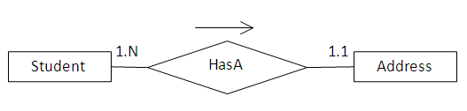
According to the relationship many students can have the same address.
To create this relationship you need to have a STUDENT and ADDRESS table. The relational model is shown below.
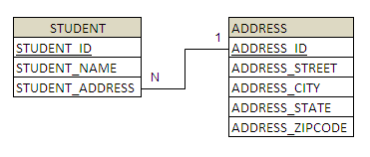
To create the STUDENT and ADDRESS table you need to create the following hibernate mapping files.
Student.hbm.xml is used to create the STUDENT table.
01.<?xml version="1.0"?>
02.<!DOCTYPE hibernate-mapping PUBLIC
03."-//Hibernate/Hibernate Mapping DTD 3.0//EN"
04."http://hibernate.sourceforge.net/hibernate-mapping-3.0.dtd">
05.<hibernate-mapping>
06. <class name="com.vaannila.student.Student" table="STUDENT">
07. <meta attribute="class-description">This class contains student details.</meta>
08. <id name="studentId" type="long" column="STUDENT_ID">
09. <generator class="native" />
10. </id>
11. <property name="studentName" type="string" length="100" not-null="true" column="STUDENT_NAME" />
12. <many-to-one name="studentAddress" class="com.vaannila.student.Address" column="STUDENT_ADDRESS" cascade="all" not-null="true" />
13. </class>
14.</hibernate-mapping>
The many-to-one element is used to create the many-to-one relationship between the Student and Address entities. The cascade option is used to cascade the required operations to the associated entity. If the cascade option is set to all then all the operations will be cascaded. For instance when you save a Student object, the associated Address object will also be saved automatically.
Address.hbm.xml is used to create the ADDRESS table.
01.<?xml version="1.0"?>
02.<!DOCTYPE hibernate-mapping PUBLIC
03."-//Hibernate/Hibernate Mapping DTD 3.0//EN"
04."http://hibernate.sourceforge.net/hibernate-mapping-3.0.dtd">
05.<hibernate-mapping>
06. <class name="com.vaannila.student.Address" table="ADDRESS">
07. <meta attribute="class-description">This class contains the student's address
08. details.</meta>
09. <id name="addressId" type="long" column="ADDRESS_ID">
10. <generator class="native" />
11. </id>
12. <property name="street" column="ADDRESS_STREET" type="string" length="250" />
13. <property name="city" column="ADDRESS_CITY" type="string" length="50" />
14. <property name="state" column="ADDRESS_STATE" type="string" length="50" />
15. <property name="zipcode" column="ADDRESS_ZIPCODE" type="string" length="10" />
16. </class>
17.</hibernate-mapping>
Now create the hibernate configuration file and add all the mapping files.
01.<?xml version="1.0" encoding="UTF-8"?>
02.<!DOCTYPE hibernate-configuration PUBLIC
03. "-//Hibernate/Hibernate Configuration DTD 3.0//EN"
04. "http://hibernate.sourceforge.net/hibernate-configuration-3.0.dtd">
05.<hibernate-configuration>
06. <session-factory>
07. <property name="hibernate.connection.driver_class"> org.hsqldb.jdbcDriver </property>
08. <property name="hibernate.connection.url"> jdbc:hsqldb:hsql://localhost</property>
09. <property name="hibernate.connection.username">sa</property>
10. <property name="connection.password"></property>
11. <property name="connection.pool_size">1</property>
12. <property name="hibernate.dialect"> org.hibernate.dialect.HSQLDialect </property>
13. <property name="show_sql">true</property>
14. <property name="hbm2ddl.auto">create-drop</property>
15. <mapping resource="com/vaannila/student/Student.hbm.xml"/>
16. <mapping resource="com/vaannila/student/Address.hbm.xml"/>
17. </session-factory>
18.</hibernate-configuration>
After creating the configuration file, generate java class files using Hibernate Tools.(To generate code using Hibernate Tools refer this example )
The following classes will be generated.
01.package com.vaannila.student;
02.
03.// Generated Sep 3, 2009 7:20:37 PM by Hibernate Tools 3.2.4.GA
04.
05./**
06. * This class contains student details.
07. */
08.public class Student implements java.io.Serializable {
09.
10. private long studentId;
11. private String studentName;
12. private Address studentAddress;
13.
14. public Student() {
15. }
16.
17. public Student(String studentName, Address studentAddress) {
18. this.studentName = studentName;
19. this.studentAddress = studentAddress;
20. }
21.
22. public long getStudentId() {
23. return this.studentId;
24. }
25.
26. public void setStudentId(long studentId) {
27. this.studentId = studentId;
28. }
29.
30. public String getStudentName() {
31. return this.studentName;
32. }
33.
34. public void setStudentName(String studentName) {
35. this.studentName = studentName;
36. }
37.
38. public Address getStudentAddress() {
39. return this.studentAddress;
40. }
41.
42. public void setStudentAddress(Address studentAddress) {
43. this.studentAddress = studentAddress;
44. }
45.
46.}
01.package com.vaannila.student;
02.
03.// Generated Sep 3, 2009 7:20:37 PM by Hibernate Tools 3.2.4.GA
04.
05./**
06. * This class contains the student's address
07. * details.
08. */
09.public class Address implements java.io.Serializable {
10.
11. private long addressId;
12. private String street;
13. private String city;
14. private String state;
15. private String zipcode;
16.
17. public Address() {
18. }
19.
20. public Address(String street, String city, String state, String zipcode) {
21. this.street = street;
22. this.city = city;
23. this.state = state;
24. this.zipcode = zipcode;
25. }
26.
27. public long getAddressId() {
28. return this.addressId;
29. }
30.
31. public void setAddressId(long addressId) {
32. this.addressId = addressId;
33. }
34.
35. public String getStreet() {
36. return this.street;
37. }
38.
39. public void setStreet(String street) {
40. this.street = street;
41. }
42.
43. public String getCity() {
44. return this.city;
45. }
46.
47. public void setCity(String city) {
48. this.city = city;
49. }
50.
51. public String getState() {
52. return this.state;
53. }
54.
55. public void setState(String state) {
56. this.state = state;
57. }
58.
59. public String getZipcode() {
60. return this.zipcode;
61. }
62.
63. public void setZipcode(String zipcode) {
64. this.zipcode = zipcode;
65. }
66.
67.}
Create the Main class to run the example.
01.package com.vaannila.student;
02.
03.import org.hibernate.HibernateException;
04.import org.hibernate.Session;
05.import org.hibernate.Transaction;
06.
07.import com.vaannila.util.HibernateUtil;
08.
09.public class Main {
10.
11. public static void main(String[] args) {
12. Session session = HibernateUtil.getSessionFactory().openSession();
13. Transaction transaction = null;
14. try {
15. transaction = session.beginTransaction();
16. Address address = new Address("OMR Road", "Chennai", "TN", "600097");
17. //By using cascade=all option the address need not be saved explicitly when the student object is persisted the address will be automatically saved.
18. //session.save(address);
19. Student student1 = new Student("Eswar", address);
20. Student student2 = new Student("Joe", address);
21. session.save(student1);
22. session.save(student2);
23. transaction.commit();
24. } catch (HibernateException e) {
25. transaction.rollback();
26. e.printStackTrace();
27. } finally {
28. session.close();
29. }
30.
31. }
32.
33.}
On executing the Main class you will see the following output.
The Student table has two records.
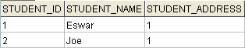
The Address table has one record.
Both the student records points to the same address record, this illustrates the many-to-one mapping.
The folder structure of the example is shown below.
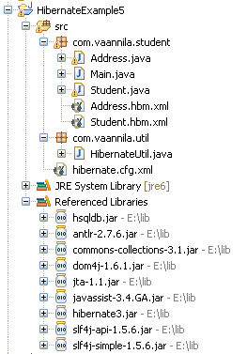
You can download the source code of this example here.
Source :Download

Hibernate Mapping One-to-One
In this example you will learn how to map one-to-one relationship using Hibernate. Consider the following relationship between Student and Address entity.
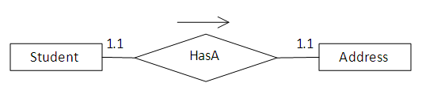
According to the relationship each student should have a unique address.
To create this relationship you need to have a STUDENT and ADDRESS table. The relational model is shown below.
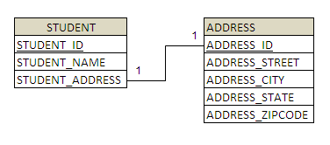
To create the STUDENT and ADDRESS table you need to create the following hibernate mapping files.
Student.hbm.xml is used to create the STUDENT table.
01.<?xml version="1.0"?>
02.<!DOCTYPE hibernate-mapping PUBLIC
03."-//Hibernate/Hibernate Mapping DTD 3.0//EN"
04."http://hibernate.sourceforge.net/hibernate-mapping-3.0.dtd">
05.<hibernate-mapping>
06. <class name="com.vaannila.student.Student" table="STUDENT">
07. <meta attribute="class-description">This class contains student details.</meta>
08. <id name="studentId" type="long" column="STUDENT_ID">
09. <generator class="native" />
10. </id>
11. <property name="studentName" type="string" not-null="true" length="100" column="STUDENT_NAME" />
12. <many-to-one name="studentAddress" class="com.vaannila.student.Address" column="STUDENT_ADDRESS" not-null="true" cascade="all" unique="true" />
13. </class>
14.</hibernate-mapping>
We use the many-to-one element to create the one-to-one relationship between the Student and Address entities. We do this my making the STUDENT_ADDRESS column unique in the STUDENT table.
Address.hbm.xml is used to create the ADDRESS table.
01.<?xml version="1.0"?>
02.<!DOCTYPE hibernate-mapping PUBLIC
03."-//Hibernate/Hibernate Mapping DTD 3.0//EN"
04."http://hibernate.sourceforge.net/hibernate-mapping-3.0.dtd">
05.<hibernate-mapping>
06. <class name="com.vaannila.student.Address" table="ADDRESS">
07. <meta attribute="class-description">This class contains the student's address
08. details.</meta>
09. <id name="addressId" type="long" column="ADDRESS_ID">
10. <generator class="native" />
11. </id>
12. <property name="street" column="ADDRESS_STREET" type="string" length="250" />
13. <property name="city" column="ADDRESS_CITY" type="string" length="50" />
14. <property name="state" column="ADDRESS_STATE" type="string" length="50" />
15. <property name="zipcode" column="ADDRESS_ZIPCODE" type="string" length="10" />
16. </class>
17.</hibernate-mapping>
Now create the hibernate configuration file and add all the mapping files.
01.<?xml version="1.0" encoding="UTF-8"?>
02.<!DOCTYPE hibernate-configuration PUBLIC
03. "-//Hibernate/Hibernate Configuration DTD 3.0//EN"
04. "http://hibernate.sourceforge.net/hibernate-configuration-3.0.dtd">
05.<hibernate-configuration>
06. <session-factory>
07. <property name="hibernate.connection.driver_class"> org.hsqldb.jdbcDriver </property>
08. <property name="hibernate.connection.url"> jdbc:hsqldb:hsql://localhost</property>
09. <property name="hibernate.connection.username">sa</property>
10. <property name="connection.password"></property>
11. <property name="connection.pool_size">1</property>
12. <property name="hibernate.dialect"> org.hibernate.dialect.HSQLDialect </property>
13. <property name="show_sql">true</property>
14. <property name="hbm2ddl.auto">create-drop</property>
15. <mapping resource="com/vaannila/student/Student.hbm.xml"/>
16. <mapping resource="com/vaannila/student/Address.hbm.xml"/>
17. </session-factory>
18.</hibernate-configuration>
After creating the configuration file, generate java class files using Hibernate Tools.(To generate code using Hibernate Tools refer this example )
The following classes will be generated.
01.package com.vaannila.student;
02.
03.// Generated Sep 3, 2009 7:20:37 PM by Hibernate Tools 3.2.4.GA
04.
05./**
06. * This class contains student details.
07. */
08.public class Student implements java.io.Serializable {
09.
10. private long studentId;
11. private String studentName;
12. private Address studentAddress;
13.
14. public Student() {
15. }
16.
17. public Student(String studentName, Address studentAddress) {
18. this.studentName = studentName;
19. this.studentAddress = studentAddress;
20. }
21.
22. public long getStudentId() {
23. return this.studentId;
24. }
25.
26. public void setStudentId(long studentId) {
27. this.studentId = studentId;
28. }
29.
30. public String getStudentName() {
31. return this.studentName;
32. }
33.
34. public void setStudentName(String studentName) {
35. this.studentName = studentName;
36. }
37.
38. public Address getStudentAddress() {
39. return this.studentAddress;
40. }
41.
42. public void setStudentAddress(Address studentAddress) {
43. this.studentAddress = studentAddress;
44. }
45.
46.}
01.package com.vaannila.student;
02.
03.// Generated Sep 3, 2009 7:20:37 PM by Hibernate Tools 3.2.4.GA
04.
05./**
06. * This class contains the student's address
07. * details.
08. */
09.public class Address implements java.io.Serializable {
10.
11. private long addressId;
12. private String street;
13. private String city;
14. private String state;
15. private String zipcode;
16.
17. public Address() {
18. }
19.
20. public Address(String street, String city, String state, String zipcode) {
21. this.street = street;
22. this.city = city;
23. this.state = state;
24. this.zipcode = zipcode;
25. }
26.
27. public long getAddressId() {
28. return this.addressId;
29. }
30.
31. public void setAddressId(long addressId) {
32. this.addressId = addressId;
33. }
34.
35. public String getStreet() {
36. return this.street;
37. }
38.
39. public void setStreet(String street) {
40. this.street = street;
41. }
42.
43. public String getCity() {
44. return this.city;
45. }
46.
47. public void setCity(String city) {
48. this.city = city;
49. }
50.
51. public String getState() {
52. return this.state;
53. }
54.
55. public void setState(String state) {
56. this.state = state;
57. }
58.
59. public String getZipcode() {
60. return this.zipcode;
61. }
62.
63. public void setZipcode(String zipcode) {
64. this.zipcode = zipcode;
65. }
66.
67.}
Create the Main class to run the example.
01.package com.vaannila.student;
02.
03.import org.hibernate.HibernateException;
04.import org.hibernate.Session;
05.import org.hibernate.Transaction;
06.
07.import com.vaannila.util.HibernateUtil;
08.
09.public class Main {
10.
11. public static void main(String[] args) {
12. Session session = HibernateUtil.getSessionFactory().openSession();
13. Transaction transaction = null;
14. try {
15. transaction = session.beginTransaction();
16. Address address1 = new Address("OMR Road", "Chennai", "TN", "600097");
17. Address address2 = new Address("Ring Road", "Banglore", "Karnataka", "560000");
18. Student student1 = new Student("Eswar", address1);
19. Student student2 = new Student("Joe", address2);
20. session.save(student1);
21. session.save(student2);
22. transaction.commit();
23. } catch (HibernateException e) {
24. transaction.rollback();
25. e.printStackTrace();
26. } finally {
27. session.close();
28. }
29.
30. }
31.
32.}
On executing the Main class you will see the following output.
The Student table has two records.
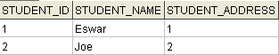
The Address table has two record.
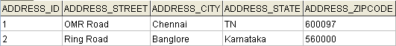
Each student record points to a different address record, this illustrates the one-to-one mapping.
The folder structure of the example is shown below.
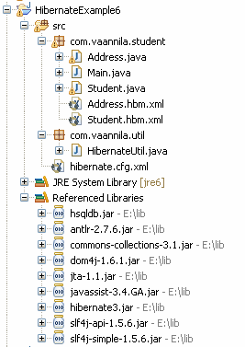
You can download the source code of this example here.

Hibernate Mapping One-to-One
In this example you will learn how to map one-to-one relationship using Hibernate. Consider the following relationship between Student and Address entity.
According to the relationship each student should have a unique address.
To create this relationship you need to have a STUDENT and ADDRESS table. The relational model is shown below.
To create the STUDENT and ADDRESS table you need to create the following hibernate mapping files.
Student.hbm.xml is used to create the STUDENT table.
01.<?xml version="1.0"?>
02.<!DOCTYPE hibernate-mapping PUBLIC
03."-//Hibernate/Hibernate Mapping DTD 3.0//EN"
04."http://hibernate.sourceforge.net/hibernate-mapping-3.0.dtd">
05.<hibernate-mapping>
06. <class name="com.vaannila.student.Student" table="STUDENT">
07. <meta attribute="class-description">This class contains student details.</meta>
08. <id name="studentId" type="long" column="STUDENT_ID">
09. <generator class="native" />
10. </id>
11. <property name="studentName" type="string" not-null="true" length="100" column="STUDENT_NAME" />
12. <many-to-one name="studentAddress" class="com.vaannila.student.Address" column="STUDENT_ADDRESS" not-null="true" cascade="all" unique="true" />
13. </class>
14.</hibernate-mapping>
We use the many-to-one element to create the one-to-one relationship between the Student and Address entities. We do this my making the STUDENT_ADDRESS column unique in the STUDENT table.
Address.hbm.xml is used to create the ADDRESS table.
01.<?xml version="1.0"?>
02.<!DOCTYPE hibernate-mapping PUBLIC
03."-//Hibernate/Hibernate Mapping DTD 3.0//EN"
04."http://hibernate.sourceforge.net/hibernate-mapping-3.0.dtd">
05.<hibernate-mapping>
06. <class name="com.vaannila.student.Address" table="ADDRESS">
07. <meta attribute="class-description">This class contains the student's address
08. details.</meta>
09. <id name="addressId" type="long" column="ADDRESS_ID">
10. <generator class="native" />
11. </id>
12. <property name="street" column="ADDRESS_STREET" type="string" length="250" />
13. <property name="city" column="ADDRESS_CITY" type="string" length="50" />
14. <property name="state" column="ADDRESS_STATE" type="string" length="50" />
15. <property name="zipcode" column="ADDRESS_ZIPCODE" type="string" length="10" />
16. </class>
17.</hibernate-mapping>
Now create the hibernate configuration file and add all the mapping files.
01.<?xml version="1.0" encoding="UTF-8"?>
02.<!DOCTYPE hibernate-configuration PUBLIC
03. "-//Hibernate/Hibernate Configuration DTD 3.0//EN"
04. "http://hibernate.sourceforge.net/hibernate-configuration-3.0.dtd">
05.<hibernate-configuration>
06. <session-factory>
07. <property name="hibernate.connection.driver_class"> org.hsqldb.jdbcDriver </property>
08. <property name="hibernate.connection.url"> jdbc:hsqldb:hsql://localhost</property>
09. <property name="hibernate.connection.username">sa</property>
10. <property name="connection.password"></property>
11. <property name="connection.pool_size">1</property>
12. <property name="hibernate.dialect"> org.hibernate.dialect.HSQLDialect </property>
13. <property name="show_sql">true</property>
14. <property name="hbm2ddl.auto">create-drop</property>
15. <mapping resource="com/vaannila/student/Student.hbm.xml"/>
16. <mapping resource="com/vaannila/student/Address.hbm.xml"/>
17. </session-factory>
18.</hibernate-configuration>
After creating the configuration file, generate java class files using Hibernate Tools.(To generate code using Hibernate Tools refer this example )
The following classes will be generated.
01.package com.vaannila.student;
02.
03.// Generated Sep 3, 2009 7:20:37 PM by Hibernate Tools 3.2.4.GA
04.
05./**
06. * This class contains student details.
07. */
08.public class Student implements java.io.Serializable {
09.
10. private long studentId;
11. private String studentName;
12. private Address studentAddress;
13.
14. public Student() {
15. }
16.
17. public Student(String studentName, Address studentAddress) {
18. this.studentName = studentName;
19. this.studentAddress = studentAddress;
20. }
21.
22. public long getStudentId() {
23. return this.studentId;
24. }
25.
26. public void setStudentId(long studentId) {
27. this.studentId = studentId;
28. }
29.
30. public String getStudentName() {
31. return this.studentName;
32. }
33.
34. public void setStudentName(String studentName) {
35. this.studentName = studentName;
36. }
37.
38. public Address getStudentAddress() {
39. return this.studentAddress;
40. }
41.
42. public void setStudentAddress(Address studentAddress) {
43. this.studentAddress = studentAddress;
44. }
45.
46.}
01.package com.vaannila.student;
02.
03.// Generated Sep 3, 2009 7:20:37 PM by Hibernate Tools 3.2.4.GA
04.
05./**
06. * This class contains the student's address
07. * details.
08. */
09.public class Address implements java.io.Serializable {
10.
11. private long addressId;
12. private String street;
13. private String city;
14. private String state;
15. private String zipcode;
16.
17. public Address() {
18. }
19.
20. public Address(String street, String city, String state, String zipcode) {
21. this.street = street;
22. this.city = city;
23. this.state = state;
24. this.zipcode = zipcode;
25. }
26.
27. public long getAddressId() {
28. return this.addressId;
29. }
30.
31. public void setAddressId(long addressId) {
32. this.addressId = addressId;
33. }
34.
35. public String getStreet() {
36. return this.street;
37. }
38.
39. public void setStreet(String street) {
40. this.street = street;
41. }
42.
43. public String getCity() {
44. return this.city;
45. }
46.
47. public void setCity(String city) {
48. this.city = city;
49. }
50.
51. public String getState() {
52. return this.state;
53. }
54.
55. public void setState(String state) {
56. this.state = state;
57. }
58.
59. public String getZipcode() {
60. return this.zipcode;
61. }
62.
63. public void setZipcode(String zipcode) {
64. this.zipcode = zipcode;
65. }
66.
67.}
Create the Main class to run the example.
01.package com.vaannila.student;
02.
03.import org.hibernate.HibernateException;
04.import org.hibernate.Session;
05.import org.hibernate.Transaction;
06.
07.import com.vaannila.util.HibernateUtil;
08.
09.public class Main {
10.
11. public static void main(String[] args) {
12. Session session = HibernateUtil.getSessionFactory().openSession();
13. Transaction transaction = null;
14. try {
15. transaction = session.beginTransaction();
16. Address address1 = new Address("OMR Road", "Chennai", "TN", "600097");
17. Address address2 = new Address("Ring Road", "Banglore", "Karnataka", "560000");
18. Student student1 = new Student("Eswar", address1);
19. Student student2 = new Student("Joe", address2);
20. session.save(student1);
21. session.save(student2);
22. transaction.commit();
23. } catch (HibernateException e) {
24. transaction.rollback();
25. e.printStackTrace();
26. } finally {
27. session.close();
28. }
29.
30. }
31.
32.}
On executing the Main class you will see the following output.
The Student table has two records.
The Address table has two record.
Each student record points to a different address record, this illustrates the one-to-one mapping.
The folder structure of the example is shown below.
You can download the source code of this example here.
Hibernate Mapping One-to-Many
In this example you will learn how to map one-to-many relationship using Hibernate. Consider the following relationship between Student and Phone entity.
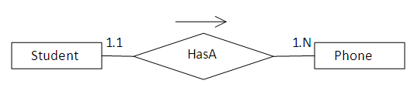
According to the relationship a student can have any number of phone numbers.
To create this relationship you need to have a STUDENT, PHONE and STUDENT_PHONE table. The relational model is shown below.
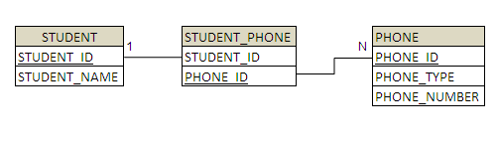
To create the STUDENT and PHONE table you need to create the following hibernate mapping files.
Student.hbm.xml is used to create the STUDENT and STUDENT_PHONE table.
01.<?xml version="1.0"?>
02.<!DOCTYPE hibernate-mapping PUBLIC
03."-//Hibernate/Hibernate Mapping DTD 3.0//EN"
04."http://hibernate.sourceforge.net/hibernate-mapping-3.0.dtd">
05.<hibernate-mapping>
06. <class name="com.vaannila.student.Student" table="STUDENT">
07. <meta attribute="class-description">This class contains student details.</meta>
08. <id name="studentId" type="long" column="STUDENT_ID">
09. <generator class="native" />
10. </id>
11. <property name="studentName" type="string" not-null="true" length="100" column="STUDENT_NAME" />
12. <set name="studentPhoneNumbers" table="STUDENT_PHONE" cascade="all">
13. <key column="STUDENT_ID" />
14. <many-to-many column="PHONE_ID" unique="true" class="com.vaannila.student.Phone" />
15. </set>
16. </class>
17.</hibernate-mapping>
We use many-to-many element to create the one-to-many relationship between the Student and Phone entities. Since a student can have any number of phone numbers we use a collection to hold the values. In this case we use Set. Many-to-many element is usually used to create many-to-many relationship, here we place the unique constraint on the PHONE_ID column, this makes the relationship one-to-many.
Phone.hbm.xml is used to create the PHONE table.
01.<?xml version="1.0"?>
02.<!DOCTYPE hibernate-mapping PUBLIC
03."-//Hibernate/Hibernate Mapping DTD 3.0//EN"
04."http://hibernate.sourceforge.net/hibernate-mapping-3.0.dtd">
05.<hibernate-mapping>
06. <class name="com.vaannila.student.Phone" table="PHONE">
07. <meta attribute="class-description">This class contains student's phone number
08. details.</meta>
09. <id name="phoneId" type="long" column="PHONE_ID">
10. <generator class="native" />
11. </id>
12. <property name="phoneType" type="string" length="10" column="PHONE_TYPE" />
13. <property name="phoneNumber" type="string" length="15" column="PHONE_NUMBER" />
14. </class>
15.</hibernate-mapping>
Now create the hibernate configuration file and add all the mapping files.
01.<?xml version="1.0" encoding="UTF-8"?>
02.<!DOCTYPE hibernate-configuration PUBLIC
03. "-//Hibernate/Hibernate Configuration DTD 3.0//EN"
04. "http://hibernate.sourceforge.net/hibernate-configuration-3.0.dtd">
05.<hibernate-configuration>
06. <session-factory>
07. <property name="hibernate.connection.driver_class">org.hsqldb.jdbcDriver </property>
08. <property name="hibernate.connection.url">jdbc:hsqldb:hsql://localhost </property>
09. <property name="hibernate.connection.username">sa</property>
10. <property name="connection.password"></property>
11. <property name="connection.pool_size">1</property>
12. <property name="hibernate.dialect">org.hibernate.dialect.HSQLDialect </property>
13. <property name="show_sql">true</property>
14. <property name="hbm2ddl.auto">create-drop</property>
15. <mapping resource="com/vaannila/student/Student.hbm.xml"/>
16. <mapping resource="com/vaannila/student/Phone.hbm.xml"/>
17. </session-factory>
18.</hibernate-configuration>
After creating the configuration file, generate java class files using Hibernate Tools.(To generate code using Hibernate Tools refer this example )
The following classes will be generated.
01.package com.vaannila.student;
02.
03.// Generated Sep 3, 2009 8:47:06 PM by Hibernate Tools 3.2.4.GA
04.
05.import java.util.HashSet;
06.import java.util.Set;
07.
08./**
09. * This class contains student details.
10. */
11.public class Student implements java.io.Serializable {
12.
13. private long studentId;
14. private String studentName;
15. private Set<Phone> studentPhoneNumbers = new HashSet<Phone>(0);
16.
17. public Student() {
18. }
19.
20. public Student(String studentName) {
21. this.studentName = studentName;
22. }
23.
24. public Student(String studentName, Set<Phone> studentPhoneNumbers) {
25. this.studentName = studentName;
26. this.studentPhoneNumbers = studentPhoneNumbers;
27. }
28.
29. public long getStudentId() {
30. return this.studentId;
31. }
32.
33. public void setStudentId(long studentId) {
34. this.studentId = studentId;
35. }
36.
37. public String getStudentName() {
38. return this.studentName;
39. }
40.
41. public void setStudentName(String studentName) {
42. this.studentName = studentName;
43. }
44.
45. public Set<Phone> getStudentPhoneNumbers() {
46. return this.studentPhoneNumbers;
47. }
48.
49. public void setStudentPhoneNumbers(Set<Phone> studentPhoneNumbers) {
50. this.studentPhoneNumbers = studentPhoneNumbers;
51. }
52.
53.}
01.package com.vaannila.student;
02.
03.// Generated Sep 3, 2009 8:47:06 PM by Hibernate Tools 3.2.4.GA
04.
05./**
06. * This class contains student's phone number
07. * details.
08. */
09.public class Phone implements java.io.Serializable {
10.
11. private long phoneId;
12. private String phoneType;
13. private String phoneNumber;
14.
15. public Phone() {
16. }
17.
18. public Phone(String phoneType, String phoneNumber) {
19. this.phoneType = phoneType;
20. this.phoneNumber = phoneNumber;
21. }
22.
23. public long getPhoneId() {
24. return this.phoneId;
25. }
26.
27. public void setPhoneId(long phoneId) {
28. this.phoneId = phoneId;
29. }
30.
31. public String getPhoneType() {
32. return this.phoneType;
33. }
34.
35. public void setPhoneType(String phoneType) {
36. this.phoneType = phoneType;
37. }
38.
39. public String getPhoneNumber() {
40. return this.phoneNumber;
41. }
42.
43. public void setPhoneNumber(String phoneNumber) {
44. this.phoneNumber = phoneNumber;
45. }
46.
47.}
Create the Main class to run the example.
01.package com.vaannila.student;
02.
03.import java.util.HashSet;
04.import java.util.Set;
05.
06.import org.hibernate.HibernateException;
07.import org.hibernate.Session;
08.import org.hibernate.Transaction;
09.
10.import com.vaannila.util.HibernateUtil;
11.
12.public class Main {
13.
14. public static void main(String[] args) {
15. Session session = HibernateUtil.getSessionFactory().openSession();
16. Transaction transaction = null;
17. try {
18. transaction = session.beginTransaction();
19.
20. Set<Phone> phoneNumbers = new HashSet<Phone>();
21. phoneNumbers.add(new Phone("house","32354353"));
22. phoneNumbers.add(new Phone("mobile","9889343423"));
23.
24. Student student = new Student("Eswar", phoneNumbers);
25. session.save(student);
26.
27. transaction.commit();
28. } catch (HibernateException e) {
29. transaction.rollback();
30. e.printStackTrace();
31. } finally {
32. session.close();
33. }
34.
35. }
36.
37.}
On executing the Main class you will see the following output.
The STUDENT table has one record.
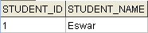
The PHONE table has two records.
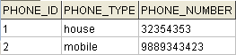
The STUDENT_PHONE table has two records to link the student and phone numbers.
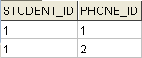
A single student record points to two phone numbers, this illustrates the one-to-many mapping.
The folder structure of the example is shown below.
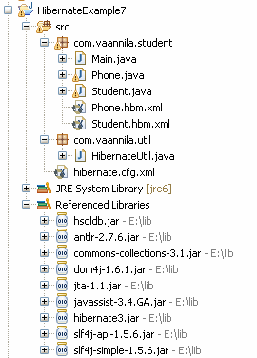
You can download the source code of this example here.
Hibernate Mapping Many-to-Many
In this example you will learn how to map many-to-many relationship using Hibernate. Consider the following relationship between Student and Course entity.
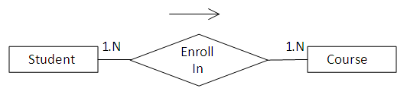
According to the relationship a student can enroll in any number of courses and the course can have any number of students.
To create this relationship you need to have a STUDENT, COURSE and STUDENT_COURSE table. The relational model is shown below.
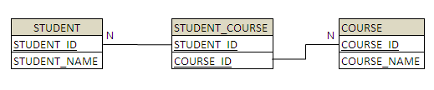
To create the STUDENT and COURSE tables you need to create the following hibernate mapping files.
Student.hbm.xml is used to create the STUDENT and STUDENT_COURSE table.
01.<?xml version="1.0"?>
02.<!DOCTYPE hibernate-mapping PUBLIC
03."-//Hibernate/Hibernate Mapping DTD 3.0//EN"
04."http://hibernate.sourceforge.net/hibernate-mapping-3.0.dtd">
05.<hibernate-mapping>
06. <class name="com.vaannila.student.Student" table="STUDENT">
07. <meta attribute="class-description">This class contains student details.</meta>
08. <id name="studentId" type="long" column="STUDENT_ID">
09. <generator class="native" />
10. </id>
11. <property name="studentName" type="string" length="100" not-null="true" column="STUDENT_NAME" />
12. <set name="courses" table="STUDENT_COURSE" cascade="all">
13. <key column="STUDENT_ID" />
14. <many-to-many column="COURSE_ID" class="com.vaannila.student.Course" />
15. </set>
16. </class>
17.</hibernate-mapping>
We use many-to-many element to create the many-to-many relationship between the Student and Course entities. Since a student can enroll in any number of courses we use a collection to hold the values. In this case we use Set.
Course.hbm.xml is used to create the COURSE table.
01.<?xml version="1.0"?>
02.<!DOCTYPE hibernate-mapping PUBLIC
03. "-//Hibernate/Hibernate Mapping DTD 3.0//EN"
04. "http://hibernate.sourceforge.net/hibernate-mapping-3.0.dtd">
05.<hibernate-mapping>
06.<class name="com.vaannila.student.Course" table="COURSE">
07. <meta attribute="class-description">
08. This class contains course details.
09. </meta>
10. <id name="courseId" type="long" column="COURSE_ID">
11. <generator class="native"/>
12. </id>
13. <property name="courseName" type="string" column="COURSE_NAME"/>
14.</class>
15.</hibernate-mapping>
Now create the hibernate configuration file and add all the mapping files.
01.<?xml version="1.0" encoding="UTF-8"?>
02.<!DOCTYPE hibernate-configuration PUBLIC
03. "-//Hibernate/Hibernate Configuration DTD 3.0//EN"
04. "http://hibernate.sourceforge.net/hibernate-configuration-3.0.dtd">
05.<hibernate-configuration>
06. <session-factory>
07. <property name="hibernate.connection.driver_class"> org.hsqldb.jdbcDriver</property>
08. <property name="hibernate.connection.url"> jdbc:hsqldb:hsql://localhost</property>
09. <property name="hibernate.connection.username">sa</property>
10. <property name="connection.password"></property>
11. <property name="connection.pool_size">1</property>
12. <property name="hibernate.dialect"> org.hibernate.dialect.HSQLDialect</property>
13. <property name="show_sql">true</property>
14. <property name="hbm2ddl.auto">create-drop</property>
15. <mapping resource="com/vaannila/student/Student.hbm.xml"/>
16. <mapping resource="com/vaannila/student/Course.hbm.xml"/>
17. </session-factory>
18.</hibernate-configuration>
After creating the configuration file, generate java class files using Hibernate Tools.(To generate code using Hibernate Tools refer this example )
The following classes will be generated.
01.package com.vaannila.student;
02.
03.// Generated May 30, 2009 6:48:40 AM by Hibernate Tools 3.2.4.GA
04.
05.import java.util.HashSet;
06.import java.util.Set;
07.
08./**
09. * This class contains the student details.
10. */
11.public class Student implements java.io.Serializable {
12.
13. private long studentId;
14. private String studentName;
15. private Set<Course> courses = new HashSet<Course>(0);
16.
17. public Student() {
18. }
19.
20. public Student(String studentName) {
21. this.studentName = studentName;
22. }
23.
24. public Student(String studentName, Set<Course> courses) {
25. this.studentName = studentName;
26. this.courses = courses;
27. }
28.
29. public long getStudentId() {
30. return this.studentId;
31. }
32.
33. public void setStudentId(long studentId) {
34. this.studentId = studentId;
35. }
36.
37. public String getStudentName() {
38. return this.studentName;
39. }
40.
41. public void setStudentName(String studentName) {
42. this.studentName = studentName;
43. }
44.
45. public Set<Course> getCourses() {
46. return this.courses;
47. }
48.
49. public void setCourses(Set<Course> courses) {
50. this.courses = courses;
51. }
52.
53.}
01.package com.vaannila.student;
02.
03.// Generated May 30, 2009 6:48:40 AM by Hibernate Tools 3.2.4.GA
04.
05./**
06. * This class contains the course details.
07. *
08. */
09.public class Course implements java.io.Serializable {
10.
11. private long courseId;
12. private String courseName;
13.
14. public Course() {
15. }
16.
17. public Course(String courseName) {
18. this.courseName = courseName;
19. }
20.
21. public long getCourseId() {
22. return this.courseId;
23. }
24.
25. public void setCourseId(long courseId) {
26. this.courseId = courseId;
27. }
28.
29. public String getCourseName() {
30. return this.courseName;
31. }
32.
33. public void setCourseName(String courseName) {
34. this.courseName = courseName;
35. }
36.
37.}
Create the Main class to run the example.
01.package com.vaannila.student;
02.
03.import java.util.HashSet;
04.import java.util.Set;
05.
06.import org.hibernate.HibernateException;
07.import org.hibernate.Session;
08.import org.hibernate.Transaction;
09.
10.import com.vaannila.util.HibernateUtil;
11.
12.public class Main {
13.
14. public static void main(String[] args) {
15.
16. Session session = HibernateUtil.getSessionFactory().openSession();
17. Transaction transaction = null;
18. try {
19. transaction = session.beginTransaction();
20.
21. Set<Course> courses = new HashSet<Course>();
22. courses.add(new Course("Maths"));
23. courses.add(new Course("Computer Science"));
24.
25. Student student1 = new Student("Eswar", courses);
26. Student student2 = new Student("Joe", courses);
27. session.save(student1);
28. session.save(student2);
29.
30. transaction.commit();
31. } catch (HibernateException e) {
32. transaction.rollback();
33. e.printStackTrace();
34. } finally {
35. session.close();
36. }
37.
38. }
39.}
On executing the Main class you will see the following output.
The STUDENT table has two records.
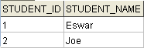
The COURSE table has two records.
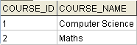
The STUDENT_COURSE table has four records to link the student and courses.
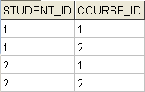
Each student has enrolled in the same two courses, this illustrates the many-to-many mapping.
The folder structure of the example is shown below.
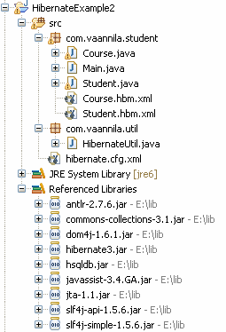
You can download the source code of this example here
Hibernate Mapping Component
In this example you will learn how to map components using Hibernate. Consider the following relationship between Student and Address entity.
According to the relationship each student should have a unique address.
Since the Student and Address entities are strongly related (composition relation), it is better to store them in a single table. The relational model is shown below.
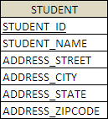
Student.hbm.xml is used to create the STUDENT table.
01.<?xml version="1.0"?>
02.<!DOCTYPE hibernate-mapping PUBLIC
03."-//Hibernate/Hibernate Mapping DTD 3.0//EN"
04."http://hibernate.sourceforge.net/hibernate-mapping-3.0.dtd">
05.<hibernate-mapping>
06. <class name="com.vaannila.student.Student" table="STUDENT">
07. <meta attribute="class-description">This class contains student details.</meta>
08. <id name="studentId" type="long" column="STUDENT_ID">
09. <generator class="native" />
10. </id>
11. <property name="studentName" type="string" not-null="true"
12. column="STUDENT_NAME" />
13. <component name="studentAddress" class="com.vaannila.student.Address">
14. <property name="street" column="ADDRESS_STREET" type="string"
15. length="250" />
16. <property name="city" column="ADDRESS_CITY" type="string"
17. length="50" />
18. <property name="state" column="ADDRESS_STATE" type="string"
19. length="50" />
20. <property name="zipcode" column="ADDRESS_ZIPCODE" type="string"
21. length="10" />
22. </component>
23. </class>
24.</hibernate-mapping>
The component element is used to map all the Address entity fields to the STUDENT table. In Hibernate terms the Address entity is called the component and it cannot have its own primary key, it uses the primary key of the enclosing Student entity.
Now create the hibernate configuration file.
01.<?xml version="1.0" encoding="UTF-8"?>
02.<!DOCTYPE hibernate-configuration PUBLIC
03. "-//Hibernate/Hibernate Configuration DTD 3.0//EN"
04. "http://hibernate.sourceforge.net/hibernate-configuration-3.0.dtd">
05.<hibernate-configuration>
06. <session-factory>
07. <property name="hibernate.connection.driver_class"> org.hsqldb.jdbcDriver</property>
08. <property name="hibernate.connection.url"> jdbc:hsqldb:hsql://localhost</property>
09. <property name="hibernate.connection.username">sa</property>
10. <property name="connection.password"></property>
11. <property name="connection.pool_size">1</property>
12. <property name="hibernate.dialect"> org.hibernate.dialect.HSQLDialect</property>
13. <property name="show_sql">true</property>
14. <property name="hbm2ddl.auto">create-drop</property>
15. <mapping resource="com/vaannila/student/Student.hbm.xml"/>
16. </session-factory>
17.</hibernate-configuration>
After creating the configuration file, generate java class files using Hibernate Tools.(To generate code using Hibernate Tools refer this example )
The following classes will be generated. You will still have a Student and Address class seperately but they will be mapped to only one table.
01.package com.vaannila.student;
02.
03.// Generated Sep 3, 2009 6:57:20 PM by Hibernate Tools 3.2.4.GA
04.
05./**
06. * This class contains student details.
07. */
08.public class Student implements java.io.Serializable {
09.
10. private long studentId;
11. private String studentName;
12. private Address studentAddress;
13.
14. public Student() {
15. }
16.
17. public Student(String studentName) {
18. this.studentName = studentName;
19. }
20.
21. public Student(String studentName, Address studentAddress) {
22. this.studentName = studentName;
23. this.studentAddress = studentAddress;
24. }
25.
26. public long getStudentId() {
27. return this.studentId;
28. }
29.
30. public void setStudentId(long studentId) {
31. this.studentId = studentId;
32. }
33.
34. public String getStudentName() {
35. return this.studentName;
36. }
37.
38. public void setStudentName(String studentName) {
39. this.studentName = studentName;
40. }
41.
42. public Address getStudentAddress() {
43. return this.studentAddress;
44. }
45.
46. public void setStudentAddress(Address studentAddress) {
47. this.studentAddress = studentAddress;
48. }
49.
50.}
01.package com.vaannila.student;
02.
03.// Generated Sep 3, 2009 6:57:20 PM by Hibernate Tools 3.2.4.GA
04.
05./**
06. * This class contains student details.
07. */
08.public class Address implements java.io.Serializable {
09.
10. private String street;
11. private String city;
12. private String state;
13. private String zipcode;
14.
15. public Address() {
16. }
17.
18. public Address(String street, String city, String state, String zipcode) {
19. this.street = street;
20. this.city = city;
21. this.state = state;
22. this.zipcode = zipcode;
23. }
24.
25. public String getStreet() {
26. return this.street;
27. }
28.
29. public void setStreet(String street) {
30. this.street = street;
31. }
32.
33. public String getCity() {
34. return this.city;
35. }
36.
37. public void setCity(String city) {
38. this.city = city;
39. }
40.
41. public String getState() {
42. return this.state;
43. }
44.
45. public void setState(String state) {
46. this.state = state;
47. }
48.
49. public String getZipcode() {
50. return this.zipcode;
51. }
52.
53. public void setZipcode(String zipcode) {
54. this.zipcode = zipcode;
55. }
56.
57.}
Create the Main class to run the example.
01.package com.vaannila.student;
02.
03.import org.hibernate.HibernateException;
04.import org.hibernate.Session;
05.import org.hibernate.Transaction;
06.
07.import com.vaannila.util.HibernateUtil;
08.
09.public class Main {
10.
11. public static void main(String[] args) {
12. Session session = HibernateUtil.getSessionFactory().openSession();
13. Transaction transaction = null;
14. try {
15. transaction = session.beginTransaction();
16. Address address = new Address("OMR Road", "Chennai", "TN", "600097");
17. Student student = new Student("Eswar", address);
18. session.save(student);
19. transaction.commit();
20. } catch (HibernateException e) {
21. transaction.rollback();
22. e.printStackTrace();
23. } finally {
24. session.close();
25. }
26.
27. }
28.
29.}
On executing the Main class you will see the following output.
Each student has one address and the values are stored in the same STUDENT table.
The folder structure of the example is shown below.
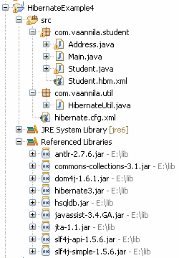
You can download the source code of this example here
Hibernate Mapping Many-to-One using Annotations
In this example you will learn how to map many-to-one relationship using Hibernate Annotations. Consider the following relationship between Student and Address entity.
According to the relationship many students can have the same address.
To create this relationship you need to have a STUDENT and ADDRESS table. The relational model is shown below.
To create the STUDENT and ADDRESS table you need to create the following Java classes with hibernate annotations.
Student class is used to create the STUDENT table.
01.package com.vaannila.student;
02.
03.import javax.persistence.CascadeType;
04.import javax.persistence.Column;
05.import javax.persistence.Entity;
06.import javax.persistence.GeneratedValue;
07.import javax.persistence.Id;
08.import javax.persistence.ManyToOne;
09.import javax.persistence.Table;
10.
11.@Entity
12.@Table(name = "STUDENT")
13.public class Student {
14.
15. private long studentId;
16. private String studentName;
17. private Address studentAddress;
18.
19. public Student() {
20. }
21.
22. public Student(String studentName, Address studentAddress) {
23. this.studentName = studentName;
24. this.studentAddress = studentAddress;
25. }
26.
27. @Id
28. @GeneratedValue
29. @Column(name = "STUDENT_ID")
30. public long getStudentId() {
31. return this.studentId;
32. }
33.
34. public void setStudentId(long studentId) {
35. this.studentId = studentId;
36. }
37.
38. @Column(name = "STUDENT_NAME", nullable = false, length = 100)
39. public String getStudentName() {
40. return this.studentName;
41. }
42.
43. public void setStudentName(String studentName) {
44. this.studentName = studentName;
45. }
46.
47. @ManyToOne(cascade = CascadeType.ALL)
48. public Address getStudentAddress() {
49. return this.studentAddress;
50. }
51.
52. public void setStudentAddress(Address studentAddress) {
53. this.studentAddress = studentAddress;
54. }
55.
56.}
The @ManyToOne annotation is used to create the many-to-one relationship between the Student and Address entities. The cascade option is used to cascade the required operations to the associated entity. If the cascade option is set to CascadeType.ALL then all the operations will be cascaded. For instance when you save a Student object, the associated Address object will also be saved automatically.
Address class is used to create the ADDRESS table.
01.package com.vaannila.student;
02.
03.import javax.persistence.Column;
04.import javax.persistence.Entity;
05.import javax.persistence.GeneratedValue;
06.import javax.persistence.Id;
07.import javax.persistence.Table;
08.
09.@Entity
10.@Table(name = "ADDRESS")
11.public class Address {
12.
13. private long addressId;
14. private String street;
15. private String city;
16. private String state;
17. private String zipcode;
18.
19. public Address() {
20. }
21.
22. public Address(String street, String city, String state, String zipcode) {
23. this.street = street;
24. this.city = city;
25. this.state = state;
26. this.zipcode = zipcode;
27. }
28.
29. @Id
30. @GeneratedValue
31. @Column(name = "ADDRESS_ID")
32. public long getAddressId() {
33. return this.addressId;
34. }
35.
36. public void setAddressId(long addressId) {
37. this.addressId = addressId;
38. }
39.
40. @Column(name = "ADDRESS_STREET", nullable = false, length=250)
41. public String getStreet() {
42. return this.street;
43. }
44.
45. public void setStreet(String street) {
46. this.street = street;
47. }
48.
49. @Column(name = "ADDRESS_CITY", nullable = false, length=50)
50. public String getCity() {
51. return this.city;
52. }
53.
54. public void setCity(String city) {
55. this.city = city;
56. }
57.
58. @Column(name = "ADDRESS_STATE", nullable = false, length=50)
59. public String getState() {
60. return this.state;
61. }
62.
63. public void setState(String state) {
64. this.state = state;
65. }
66.
67. @Column(name = "ADDRESS_ZIPCODE", nullable = false, length=10)
68. public String getZipcode() {
69. return this.zipcode;
70. }
71.
72. public void setZipcode(String zipcode) {
73. this.zipcode = zipcode;
74. }
75.
76.}
Now create the hibernate configuration file with the Student and Address class mapping.
01.<?xml version="1.0" encoding="UTF-8"?>
02.<!DOCTYPE hibernate-configuration PUBLIC
03. "-//Hibernate/Hibernate Configuration DTD 3.0//EN"
04. "http://hibernate.sourceforge.net/hibernate-configuration-3.0.dtd">
05.<hibernate-configuration>
06. <session-factory>
07. <property name="hibernate.connection.driver_class"> org.hsqldb.jdbcDriver</property>
08. <property name="hibernate.connection.url"> jdbc:hsqldb:hsql://localhost</property>
09. <property name="hibernate.connection.username">sa</property>
10. <property name="connection.password"></property>
11. <property name="connection.pool_size">1</property>
12. <property name="hibernate.dialect"> org.hibernate.dialect.HSQLDialect</property>
13. <property name="show_sql">true</property>
14. <property name="hbm2ddl.auto">create</property>
15. <mapping class="com.vaannila.student.Student" />
16. <mapping class="com.vaannila.student.Address" />
17. </session-factory>
18.</hibernate-configuration>
Create the Main class to run the example.
01.package com.vaannila.student;
02.
03.import org.hibernate.HibernateException;
04.import org.hibernate.Session;
05.import org.hibernate.Transaction;
06.
07.import com.vaannila.util.HibernateUtil;
08.
09.public class Main {
10.
11. public static void main(String[] args) {
12. Session session = HibernateUtil.getSessionFactory().openSession();
13. Transaction transaction = null;
14. try {
15. transaction = session.beginTransaction();
16. Address address = new Address("OMR Road", "Chennai", "TN", "600097");
17. //By using cascade=all option the address need not be saved explicitly when the student object is persisted the address will be automatically saved.
18. //session.save(address);
19. Student student1 = new Student("Eswar", address);
20. Student student2 = new Student("Joe", address);
21. session.save(student1);
22. session.save(student2);
23. transaction.commit();
24. } catch (HibernateException e) {
25. transaction.rollback();
26. e.printStackTrace();
27. } finally {
28. session.close();
29. }
30.
31. }
32.
33.}
On executing the Main class you will see the following output.
The Student table has two records.
The Address table has one record.
Both the student records points to the same address record, this illustrates the many-to-one mapping.
The folder structure of the example is shown below.
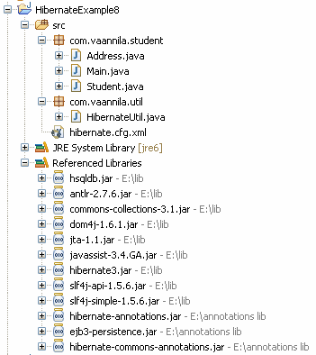
You can download the source code of this example here.
Hibernate Mapping One-to-One using Annotations
In this example you will learn how to map one-to-one relationship using Hibernate Annotations. Consider the following relationship between Student and Address entity.
According to the relationship each student should have a unique address.
To create this relationship you need to have a STUDENT and ADDRESS table. The relational model is shown below.
To create the STUDENT and ADDRESS tables you need to create the following Java classes with hibernate annotations.
Student class is used to create the STUDENT table.
01.package com.vaannila.student;
02.
03.import javax.persistence.CascadeType;
04.import javax.persistence.Column;
05.import javax.persistence.Entity;
06.import javax.persistence.GeneratedValue;
07.import javax.persistence.Id;
08.import javax.persistence.OneToOne;
09.import javax.persistence.Table;
10.
11.@Entity
12.@Table(name = "STUDENT")
13.public class Student {
14.
15. private long studentId;
16. private String studentName;
17. private Address studentAddress;
18.
19. public Student() {
20. }
21.
22. public Student(String studentName, Address studentAddress) {
23. this.studentName = studentName;
24. this.studentAddress = studentAddress;
25. }
26.
27. @Id
28. @GeneratedValue
29. @Column(name = "STUDENT_ID")
30. public long getStudentId() {
31. return this.studentId;
32. }
33.
34. public void setStudentId(long studentId) {
35. this.studentId = studentId;
36. }
37.
38. @Column(name = "STUDENT_NAME", nullable = false, length = 100)
39. public String getStudentName() {
40. return this.studentName;
41. }
42.
43. public void setStudentName(String studentName) {
44. this.studentName = studentName;
45. }
46.
47. @OneToOne(cascade = CascadeType.ALL)
48. public Address getStudentAddress() {
49. return this.studentAddress;
50. }
51.
52. public void setStudentAddress(Address studentAddress) {
53. this.studentAddress = studentAddress;
54. }
55.
56.}
The @OneToOne annotation is used to create the one-to-one relationship between the Student and Address entities.
Address class is used to create the ADDRESS table.
01.package com.vaannila.student;
02.
03.import javax.persistence.Column;
04.import javax.persistence.Entity;
05.import javax.persistence.GeneratedValue;
06.import javax.persistence.Id;
07.import javax.persistence.Table;
08.
09.@Entity
10.@Table(name = "ADDRESS")
11.public class Address {
12.
13. private long addressId;
14. private String street;
15. private String city;
16. private String state;
17. private String zipcode;
18.
19. public Address() {
20. }
21.
22. public Address(String street, String city, String state, String zipcode) {
23. this.street = street;
24. this.city = city;
25. this.state = state;
26. this.zipcode = zipcode;
27. }
28.
29. @Id
30. @GeneratedValue
31. @Column(name = "ADDRESS_ID")
32. public long getAddressId() {
33. return this.addressId;
34. }
35.
36. public void setAddressId(long addressId) {
37. this.addressId = addressId;
38. }
39.
40. @Column(name = "ADDRESS_STREET", nullable = false, length=250)
41. public String getStreet() {
42. return this.street;
43. }
44.
45. public void setStreet(String street) {
46. this.street = street;
47. }
48.
49. @Column(name = "ADDRESS_CITY", nullable = false, length=50)
50. public String getCity() {
51. return this.city;
52. }
53.
54. public void setCity(String city) {
55. this.city = city;
56. }
57.
58. @Column(name = "ADDRESS_STATE", nullable = false, length=50)
59. public String getState() {
60. return this.state;
61. }
62.
63. public void setState(String state) {
64. this.state = state;
65. }
66.
67. @Column(name = "ADDRESS_ZIPCODE", nullable = false, length=10)
68. public String getZipcode() {
69. return this.zipcode;
70. }
71.
72. public void setZipcode(String zipcode) {
73. this.zipcode = zipcode;
74. }
75.
76.}
Now create the hibernate configuration file with the Student and Address class mapping.
01.<?xml version="1.0" encoding="UTF-8"?>
02.<!DOCTYPE hibernate-configuration PUBLIC
03. "-//Hibernate/Hibernate Configuration DTD 3.0//EN"
04. "http://hibernate.sourceforge.net/hibernate-configuration-3.0.dtd">
05.<hibernate-configuration>
06. <session-factory>
07. <property name="hibernate.connection.driver_class"> org.hsqldb.jdbcDriver</property>
08. <property name="hibernate.connection.url"> jdbc:hsqldb:hsql://localhost</property>
09. <property name="hibernate.connection.username">sa</property>
10. <property name="connection.password"></property>
11. <property name="connection.pool_size">1</property>
12. <property name="hibernate.dialect"> org.hibernate.dialect.HSQLDialect</property>
13. <property name="show_sql">true</property>
14. <property name="hbm2ddl.auto">create</property>
15. <mapping class="com.vaannila.student.Student" />
16. <mapping class="com.vaannila.student.Address" />
17. </session-factory>
18.</hibernate-configuration>
Create the Main class to run the example.
01.package com.vaannila.student;
02.
03.import org.hibernate.HibernateException;
04.import org.hibernate.Session;
05.import org.hibernate.Transaction;
06.
07.import com.vaannila.util.HibernateUtil;
08.
09.public class Main {
10.
11. public static void main(String[] args) {
12. Session session = HibernateUtil.getSessionFactory().openSession();
13. Transaction transaction = null;
14. try {
15. transaction = session.beginTransaction();
16. Address address1 = new Address("OMR Road", "Chennai", "TN", "600097");
17. Address address2 = new Address("Ring Road", "Banglore", "Karnataka", "560000");
18. Student student1 = new Student("Eswar", address1);
19. Student student2 = new Student("Joe", address2);
20. session.save(student1);
21. session.save(student2);
22. transaction.commit();
23. } catch (HibernateException e) {
24. transaction.rollback();
25. e.printStackTrace();
26. } finally {
27. session.close();
28. }
29.
30. }
31.
32.}
On executing the Main class you will see the following output.
The Student table has two records.
The Address table has two record.
Each student record points to a different address record, this illustrates the one-to-one mapping.
The folder structure of the example is shown below.
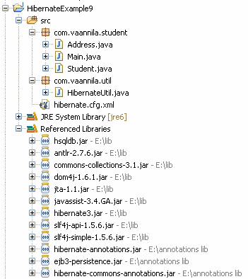
You can download the source code of this example here.
Hibernate Mapping One-to-One using Annotations
In this example you will learn how to map one-to-one relationship using Hibernate Annotations. Consider the following relationship between Student and Address entity.
According to the relationship each student should have a unique address.
To create this relationship you need to have a STUDENT and ADDRESS table. The relational model is shown below.
To create the STUDENT and ADDRESS tables you need to create the following Java classes with hibernate annotations.
Student class is used to create the STUDENT table.
01.package com.vaannila.student;
02.
03.import javax.persistence.CascadeType;
04.import javax.persistence.Column;
05.import javax.persistence.Entity;
06.import javax.persistence.GeneratedValue;
07.import javax.persistence.Id;
08.import javax.persistence.OneToOne;
09.import javax.persistence.Table;
10.
11.@Entity
12.@Table(name = "STUDENT")
13.public class Student {
14.
15. private long studentId;
16. private String studentName;
17. private Address studentAddress;
18.
19. public Student() {
20. }
21.
22. public Student(String studentName, Address studentAddress) {
23. this.studentName = studentName;
24. this.studentAddress = studentAddress;
25. }
26.
27. @Id
28. @GeneratedValue
29. @Column(name = "STUDENT_ID")
30. public long getStudentId() {
31. return this.studentId;
32. }
33.
34. public void setStudentId(long studentId) {
35. this.studentId = studentId;
36. }
37.
38. @Column(name = "STUDENT_NAME", nullable = false, length = 100)
39. public String getStudentName() {
40. return this.studentName;
41. }
42.
43. public void setStudentName(String studentName) {
44. this.studentName = studentName;
45. }
46.
47. @OneToOne(cascade = CascadeType.ALL)
48. public Address getStudentAddress() {
49. return this.studentAddress;
50. }
51.
52. public void setStudentAddress(Address studentAddress) {
53. this.studentAddress = studentAddress;
54. }
55.
56.}
The @OneToOne annotation is used to create the one-to-one relationship between the Student and Address entities.
Address class is used to create the ADDRESS table.
01.package com.vaannila.student;
02.
03.import javax.persistence.Column;
04.import javax.persistence.Entity;
05.import javax.persistence.GeneratedValue;
06.import javax.persistence.Id;
07.import javax.persistence.Table;
08.
09.@Entity
10.@Table(name = "ADDRESS")
11.public class Address {
12.
13. private long addressId;
14. private String street;
15. private String city;
16. private String state;
17. private String zipcode;
18.
19. public Address() {
20. }
21.
22. public Address(String street, String city, String state, String zipcode) {
23. this.street = street;
24. this.city = city;
25. this.state = state;
26. this.zipcode = zipcode;
27. }
28.
29. @Id
30. @GeneratedValue
31. @Column(name = "ADDRESS_ID")
32. public long getAddressId() {
33. return this.addressId;
34. }
35.
36. public void setAddressId(long addressId) {
37. this.addressId = addressId;
38. }
39.
40. @Column(name = "ADDRESS_STREET", nullable = false, length=250)
41. public String getStreet() {
42. return this.street;
43. }
44.
45. public void setStreet(String street) {
46. this.street = street;
47. }
48.
49. @Column(name = "ADDRESS_CITY", nullable = false, length=50)
50. public String getCity() {
51. return this.city;
52. }
53.
54. public void setCity(String city) {
55. this.city = city;
56. }
57.
58. @Column(name = "ADDRESS_STATE", nullable = false, length=50)
59. public String getState() {
60. return this.state;
61. }
62.
63. public void setState(String state) {
64. this.state = state;
65. }
66.
67. @Column(name = "ADDRESS_ZIPCODE", nullable = false, length=10)
68. public String getZipcode() {
69. return this.zipcode;
70. }
71.
72. public void setZipcode(String zipcode) {
73. this.zipcode = zipcode;
74. }
75.
76.}
Now create the hibernate configuration file with the Student and Address class mapping.
01.<?xml version="1.0" encoding="UTF-8"?>
02.<!DOCTYPE hibernate-configuration PUBLIC
03. "-//Hibernate/Hibernate Configuration DTD 3.0//EN"
04. "http://hibernate.sourceforge.net/hibernate-configuration-3.0.dtd">
05.<hibernate-configuration>
06. <session-factory>
07. <property name="hibernate.connection.driver_class"> org.hsqldb.jdbcDriver</property>
08. <property name="hibernate.connection.url"> jdbc:hsqldb:hsql://localhost</property>
09. <property name="hibernate.connection.username">sa</property>
10. <property name="connection.password"></property>
11. <property name="connection.pool_size">1</property>
12. <property name="hibernate.dialect"> org.hibernate.dialect.HSQLDialect</property>
13. <property name="show_sql">true</property>
14. <property name="hbm2ddl.auto">create</property>
15. <mapping class="com.vaannila.student.Student" />
16. <mapping class="com.vaannila.student.Address" />
17. </session-factory>
18.</hibernate-configuration>
Create the Main class to run the example.
01.package com.vaannila.student;
02.
03.import org.hibernate.HibernateException;
04.import org.hibernate.Session;
05.import org.hibernate.Transaction;
06.
07.import com.vaannila.util.HibernateUtil;
08.
09.public class Main {
10.
11. public static void main(String[] args) {
12. Session session = HibernateUtil.getSessionFactory().openSession();
13. Transaction transaction = null;
14. try {
15. transaction = session.beginTransaction();
16. Address address1 = new Address("OMR Road", "Chennai", "TN", "600097");
17. Address address2 = new Address("Ring Road", "Banglore", "Karnataka", "560000");
18. Student student1 = new Student("Eswar", address1);
19. Student student2 = new Student("Joe", address2);
20. session.save(student1);
21. session.save(student2);
22. transaction.commit();
23. } catch (HibernateException e) {
24. transaction.rollback();
25. e.printStackTrace();
26. } finally {
27. session.close();
28. }
29.
30. }
31.
32.}
On executing the Main class you will see the following output.
The Student table has two records.
The Address table has two record.
Each student record points to a different address record, this illustrates the one-to-one mapping.
The folder structure of the example is shown below.
You can download the source code of this example here.
Hibernate Mapping One-to-Many using Annotations
In this example you will learn how to map one-to-many relationship using Hibernate Annotations. Consider the following relationship between Student and Phone entity.
According to the relationship a student can have any number of phone numbers.
To create this relationship you need to have a STUDENT, PHONE and STUDENT_PHONE table. The relational model is shown below.
To create the STUDENT and PHONE table you need to create the following Java Class files.
Student class is used to create the STUDENT and STUDENT_PHONE table.
01.package com.vaannila.student;
02.
03.import java.util.HashSet;
04.import java.util.Set;
05.
06.import javax.persistence.CascadeType;
07.import javax.persistence.Column;
08.import javax.persistence.Entity;
09.import javax.persistence.GeneratedValue;
10.import javax.persistence.Id;
11.import javax.persistence.JoinColumn;
12.import javax.persistence.JoinTable;
13.import javax.persistence.OneToMany;
14.import javax.persistence.Table;
15.
16.@Entity
17.@Table(name = "STUDENT")
18.public class Student {
19.
20. private long studentId;
21. private String studentName;
22. private Set<Phone> studentPhoneNumbers = new HashSet<Phone>(0);
23.
24. public Student() {
25. }
26.
27. public Student(String studentName, Set<Phone> studentPhoneNumbers) {
28. this.studentName = studentName;
29. this.studentPhoneNumbers = studentPhoneNumbers;
30. }
31.
32. @Id
33. @GeneratedValue
34. @Column(name = "STUDENT_ID")
35. public long getStudentId() {
36. return this.studentId;
37. }
38.
39. public void setStudentId(long studentId) {
40. this.studentId = studentId;
41. }
42.
43. @Column(name = "STUDENT_NAME", nullable = false, length = 100)
44. public String getStudentName() {
45. return this.studentName;
46. }
47.
48. public void setStudentName(String studentName) {
49. this.studentName = studentName;
50. }
51.
52. @OneToMany(cascade = CascadeType.ALL)
53. @JoinTable(name = "STUDENT_PHONE", joinColumns = { @JoinColumn(name = "STUDENT_ID") }, inverseJoinColumns = { @JoinColumn(name = "PHONE_ID") })
54. public Set<Phone> getStudentPhoneNumbers() {
55. return this.studentPhoneNumbers;
56. }
57.
58. public void setStudentPhoneNumbers(Set<Phone> studentPhoneNumbers) {
59. this.studentPhoneNumbers = studentPhoneNumbers;
60. }
61.
62.}
The @OneToMany annotation is used to create the one-to-many relationship between the Student and Phone entities. The @JoinTable annotation is used to create the STUDENT_PHONE link table and @JoinColumn annotation is used to refer the linking columns in both the tables.
Phone class is used to create the PHONE table.
01.package com.vaannila.student;
02.
03.import javax.persistence.Column;
04.import javax.persistence.Entity;
05.import javax.persistence.GeneratedValue;
06.import javax.persistence.Id;
07.import javax.persistence.Table;
08.
09.@Entity
10.@Table(name = "PHONE")
11.public class Phone {
12.
13. private long phoneId;
14. private String phoneType;
15. private String phoneNumber;
16.
17. public Phone() {
18. }
19.
20. public Phone(String phoneType, String phoneNumber) {
21. this.phoneType = phoneType;
22. this.phoneNumber = phoneNumber;
23. }
24.
25. @Id
26. @GeneratedValue
27. @Column(name = "PHONE_ID")
28. public long getPhoneId() {
29. return this.phoneId;
30. }
31.
32. public void setPhoneId(long phoneId) {
33. this.phoneId = phoneId;
34. }
35.
36. @Column(name = "PHONE_TYPE", nullable = false, length=10)
37. public String getPhoneType() {
38. return this.phoneType;
39. }
40.
41. public void setPhoneType(String phoneType) {
42. this.phoneType = phoneType;
43. }
44.
45. @Column(name = "PHONE_NUMBER", nullable = false, length=15)
46. public String getPhoneNumber() {
47. return this.phoneNumber;
48. }
49.
50. public void setPhoneNumber(String phoneNumber) {
51. this.phoneNumber = phoneNumber;
52. }
53.
54.}
Now create the hibernate configuration file with the Student and Phone class mapping.
01.<?xml version="1.0" encoding="UTF-8"?>
02.<!DOCTYPE hibernate-configuration PUBLIC
03. "-//Hibernate/Hibernate Configuration DTD 3.0//EN"
04. "http://hibernate.sourceforge.net/hibernate-configuration-3.0.dtd">
05.<hibernate-configuration>
06. <session-factory>
07. <property name="hibernate.connection.driver_class"> org.hsqldb.jdbcDriver</property>
08. <property name="hibernate.connection.url"> jdbc:hsqldb:hsql://localhost</property>
09. <property name="hibernate.connection.username">sa</property>
10. <property name="connection.password"></property>
11. <property name="connection.pool_size">1</property>
12. <property name="hibernate.dialect"> org.hibernate.dialect.HSQLDialect</property>
13. <property name="show_sql">true</property>
14. <property name="hbm2ddl.auto">create-drop</property>
15. <mapping class="com.vaannila.student.Student" />
16. <mapping class="com.vaannila.student.Phone" />
17. </session-factory>
18.</hibernate-configuration>
Create the Main class to run the example.
01.package com.vaannila.student;
02.
03.import java.util.HashSet;
04.import java.util.Set;
05.
06.import org.hibernate.HibernateException;
07.import org.hibernate.Session;
08.import org.hibernate.Transaction;
09.
10.import com.vaannila.util.HibernateUtil;
11.
12.public class Main {
13.
14. public static void main(String[] args) {
15. Session session = HibernateUtil.getSessionFactory().openSession();
16. Transaction transaction = null;
17. try {
18. transaction = session.beginTransaction();
19.
20. Set<Phone> phoneNumbers = new HashSet<Phone>();
21. phoneNumbers.add(new Phone("house","32354353"));
22. phoneNumbers.add(new Phone("mobile","9889343423"));
23.
24. Student student = new Student("Eswar", phoneNumbers);
25. session.save(student);
26.
27. transaction.commit();
28. } catch (HibernateException e) {
29. transaction.rollback();
30. e.printStackTrace();
31. } finally {
32. session.close();
33. }
34.
35. }
36.
37.}
On executing the Main class you will see the following output.
The STUDENT table has one record.
The PHONE table has two records.
The STUDENT_PHONE table has two records to link the student and phone numbers.
A single student record points to two phone numbers, this illustrates the one-to-many mapping.
The folder structure of the example is shown below.
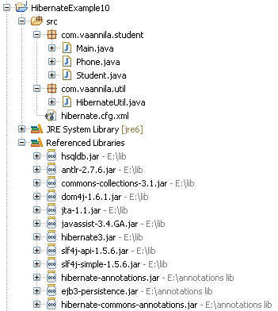
You can download the source code of this example here
Hibernate Mapping Many-to-Many using Annotations
In this example you will learn how to map many-to-many relationship using Hibernate Annotations. Consider the following relationship between Student and Course entity.
According to the relationship a student can enroll in any number of courses and the course can have any number of students.
To create this relationship you need to have a STUDENT, COURSE and STUDENT_COURSE table. The relational model is shown below.
To create the STUDENT, COURSE and STUDENT_COURSE table you need to create the following Java Class files.
Student class is used to create the STUDENT and STUDENT_COURSE table.
01.package com.vaannila.student;
02.
03.import java.util.HashSet;
04.import java.util.Set;
05.
06.import javax.persistence.CascadeType;
07.import javax.persistence.Column;
08.import javax.persistence.Entity;
09.import javax.persistence.GeneratedValue;
10.import javax.persistence.Id;
11.import javax.persistence.JoinColumn;
12.import javax.persistence.JoinTable;
13.import javax.persistence.ManyToMany;
14.import javax.persistence.Table;
15.
16.@Entity
17.@Table(name = "STUDENT")
18.public class Student {
19.
20. private long studentId;
21. private String studentName;
22. private Set<Course> courses = new HashSet<Course>(0);
23.
24. public Student() {
25. }
26.
27. public Student(String studentName) {
28. this.studentName = studentName;
29. }
30.
31. public Student(String studentName, Set<Course> courses) {
32. this.studentName = studentName;
33. this.courses = courses;
34. }
35.
36. @Id
37. @GeneratedValue
38. @Column(name = "STUDENT_ID")
39. public long getStudentId() {
40. return this.studentId;
41. }
42.
43. public void setStudentId(long studentId) {
44. this.studentId = studentId;
45. }
46.
47. @Column(name = "STUDENT_NAME", nullable = false, length = 100)
48. public String getStudentName() {
49. return this.studentName;
50. }
51.
52. public void setStudentName(String studentName) {
53. this.studentName = studentName;
54. }
55.
56. @ManyToMany(cascade = CascadeType.ALL)
57. @JoinTable(name = "STUDENT_COURSE", joinColumns = { @JoinColumn(name = "STUDENT_ID") }, inverseJoinColumns = { @JoinColumn(name = "COURSE_ID") })
58. public Set<Course> getCourses() {
59. return this.courses;
60. }
61.
62. public void setCourses(Set<Course> courses) {
63. this.courses = courses;
64. }
65.
66.}
The @ManyToMany annotation is used to create the many-to-many relationship between the Student and Course entities. The @JoinTable annotation is used to create the STUDENT_COURSE link table and @JoinColumn annotation is used to refer the linking columns in both the tables.
Course class is used to create the COURSE table.
01.package com.vaannila.student;
02.
03.import javax.persistence.Column;
04.import javax.persistence.Entity;
05.import javax.persistence.GeneratedValue;
06.import javax.persistence.Id;
07.import javax.persistence.Table;
08.
09.@Entity
10.@Table(name="COURSE")
11.public class Course {
12.
13. private long courseId;
14. private String courseName;
15.
16. public Course() {
17. }
18.
19. public Course(String courseName) {
20. this.courseName = courseName;
21. }
22.
23. @Id
24. @GeneratedValue
25. @Column(name="COURSE_ID")
26. public long getCourseId() {
27. return this.courseId;
28. }
29.
30. public void setCourseId(long courseId) {
31. this.courseId = courseId;
32. }
33.
34. @Column(name="COURSE_NAME", nullable=false)
35. public String getCourseName() {
36. return this.courseName;
37. }
38.
39. public void setCourseName(String courseName) {
40. this.courseName = courseName;
41. }
42.
43.}
Now create the hibernate configuration file with the Student and Course class mapping.
01.<?xml version="1.0" encoding="UTF-8"?>
02.<!DOCTYPE hibernate-configuration PUBLIC
03. "-//Hibernate/Hibernate Configuration DTD 3.0//EN"
04. "http://hibernate.sourceforge.net/hibernate-configuration-3.0.dtd">
05.<hibernate-configuration>
06. <session-factory>
07. <property name="hibernate.connection.driver_class"> org.hsqldb.jdbcDriver</property>
08. <property name="hibernate.connection.url"> jdbc:hsqldb:hsql://localhost</property>
09. <property name="hibernate.connection.username">sa</property>
10. <property name="connection.password"></property>
11. <property name="connection.pool_size">1</property>
12. <property name="hibernate.dialect"> org.hibernate.dialect.HSQLDialect</property>
13. <property name="show_sql">true</property>
14. <property name="hbm2ddl.auto">create-drop</property>
15. <mapping class="com.vaannila.student.Student" />
16. <mapping class="com.vaannila.student.Course" />
17. </session-factory>
18.</hibernate-configuration>
Create the Main class to run the example.
01.package com.vaannila.student;
02.
03.import java.util.HashSet;
04.import java.util.Set;
05.
06.import org.hibernate.HibernateException;
07.import org.hibernate.Session;
08.import org.hibernate.Transaction;
09.
10.import com.vaannila.util.HibernateUtil;
11.
12.public class Main {
13.
14. public static void main(String[] args) {
15.
16. Session session = HibernateUtil.getSessionFactory().openSession();
17. Transaction transaction = null;
18. try {
19. transaction = session.beginTransaction();
20.
21. Set<Course> courses = new HashSet<Course>();
22. courses.add(new Course("Maths"));
23. courses.add(new Course("Computer Science"));
24.
25. Student student1 = new Student("Eswar", courses);
26. Student student2 = new Student("Joe", courses);
27. session.save(student1);
28. session.save(student2);
29.
30. transaction.commit();
31. } catch (HibernateException e) {
32. transaction.rollback();
33. e.printStackTrace();
34. } finally {
35. session.close();
36. }
37.
38. }
39.}
On executing the Main class you will see the following output.
The STUDENT table has two records.
The COURSE table has two records.
The STUDENT_COURSE table has four records to link the student and courses.
Each student has enrolled in the same two courses, this illustrates the many-to-many mapping.
The folder structure of the example is shown below.
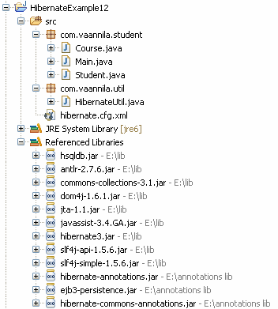
You can download the source code of this example here.
Hibernate Mapping Many-to-Many using Annotations
In this example you will learn how to map many-to-many relationship using Hibernate Annotations. Consider the following relationship between Student and Course entity.
According to the relationship a student can enroll in any number of courses and the course can have any number of students.
To create this relationship you need to have a STUDENT, COURSE and STUDENT_COURSE table. The relational model is shown below.
To create the STUDENT, COURSE and STUDENT_COURSE table you need to create the following Java Class files.
Student class is used to create the STUDENT and STUDENT_COURSE table.
01.package com.vaannila.student;
02.
03.import java.util.HashSet;
04.import java.util.Set;
05.
06.import javax.persistence.CascadeType;
07.import javax.persistence.Column;
08.import javax.persistence.Entity;
09.import javax.persistence.GeneratedValue;
10.import javax.persistence.Id;
11.import javax.persistence.JoinColumn;
12.import javax.persistence.JoinTable;
13.import javax.persistence.ManyToMany;
14.import javax.persistence.Table;
15.
16.@Entity
17.@Table(name = "STUDENT")
18.public class Student {
19.
20. private long studentId;
21. private String studentName;
22. private Set<Course> courses = new HashSet<Course>(0);
23.
24. public Student() {
25. }
26.
27. public Student(String studentName) {
28. this.studentName = studentName;
29. }
30.
31. public Student(String studentName, Set<Course> courses) {
32. this.studentName = studentName;
33. this.courses = courses;
34. }
35.
36. @Id
37. @GeneratedValue
38. @Column(name = "STUDENT_ID")
39. public long getStudentId() {
40. return this.studentId;
41. }
42.
43. public void setStudentId(long studentId) {
44. this.studentId = studentId;
45. }
46.
47. @Column(name = "STUDENT_NAME", nullable = false, length = 100)
48. public String getStudentName() {
49. return this.studentName;
50. }
51.
52. public void setStudentName(String studentName) {
53. this.studentName = studentName;
54. }
55.
56. @ManyToMany(cascade = CascadeType.ALL)
57. @JoinTable(name = "STUDENT_COURSE", joinColumns = { @JoinColumn(name = "STUDENT_ID") }, inverseJoinColumns = { @JoinColumn(name = "COURSE_ID") })
58. public Set<Course> getCourses() {
59. return this.courses;
60. }
61.
62. public void setCourses(Set<Course> courses) {
63. this.courses = courses;
64. }
65.
66.}
The @ManyToMany annotation is used to create the many-to-many relationship between the Student and Course entities. The @JoinTable annotation is used to create the STUDENT_COURSE link table and @JoinColumn annotation is used to refer the linking columns in both the tables.
Course class is used to create the COURSE table.
01.package com.vaannila.student;
02.
03.import javax.persistence.Column;
04.import javax.persistence.Entity;
05.import javax.persistence.GeneratedValue;
06.import javax.persistence.Id;
07.import javax.persistence.Table;
08.
09.@Entity
10.@Table(name="COURSE")
11.public class Course {
12.
13. private long courseId;
14. private String courseName;
15.
16. public Course() {
17. }
18.
19. public Course(String courseName) {
20. this.courseName = courseName;
21. }
22.
23. @Id
24. @GeneratedValue
25. @Column(name="COURSE_ID")
26. public long getCourseId() {
27. return this.courseId;
28. }
29.
30. public void setCourseId(long courseId) {
31. this.courseId = courseId;
32. }
33.
34. @Column(name="COURSE_NAME", nullable=false)
35. public String getCourseName() {
36. return this.courseName;
37. }
38.
39. public void setCourseName(String courseName) {
40. this.courseName = courseName;
41. }
42.
43.}
Now create the hibernate configuration file with the Student and Course class mapping.
01.<?xml version="1.0" encoding="UTF-8"?>
02.<!DOCTYPE hibernate-configuration PUBLIC
03. "-//Hibernate/Hibernate Configuration DTD 3.0//EN"
04. "http://hibernate.sourceforge.net/hibernate-configuration-3.0.dtd">
05.<hibernate-configuration>
06. <session-factory>
07. <property name="hibernate.connection.driver_class"> org.hsqldb.jdbcDriver</property>
08. <property name="hibernate.connection.url"> jdbc:hsqldb:hsql://localhost</property>
09. <property name="hibernate.connection.username">sa</property>
10. <property name="connection.password"></property>
11. <property name="connection.pool_size">1</property>
12. <property name="hibernate.dialect"> org.hibernate.dialect.HSQLDialect</property>
13. <property name="show_sql">true</property>
14. <property name="hbm2ddl.auto">create-drop</property>
15. <mapping class="com.vaannila.student.Student" />
16. <mapping class="com.vaannila.student.Course" />
17. </session-factory>
18.</hibernate-configuration>
Create the Main class to run the example.
01.package com.vaannila.student;
02.
03.import java.util.HashSet;
04.import java.util.Set;
05.
06.import org.hibernate.HibernateException;
07.import org.hibernate.Session;
08.import org.hibernate.Transaction;
09.
10.import com.vaannila.util.HibernateUtil;
11.
12.public class Main {
13.
14. public static void main(String[] args) {
15.
16. Session session = HibernateUtil.getSessionFactory().openSession();
17. Transaction transaction = null;
18. try {
19. transaction = session.beginTransaction();
20.
21. Set<Course> courses = new HashSet<Course>();
22. courses.add(new Course("Maths"));
23. courses.add(new Course("Computer Science"));
24.
25. Student student1 = new Student("Eswar", courses);
26. Student student2 = new Student("Joe", courses);
27. session.save(student1);
28. session.save(student2);
29.
30. transaction.commit();
31. } catch (HibernateException e) {
32. transaction.rollback();
33. e.printStackTrace();
34. } finally {
35. session.close();
36. }
37.
38. }
39.}
On executing the Main class you will see the following output.
The STUDENT table has two records.
The COURSE table has two records.
The STUDENT_COURSE table has four records to link the student and courses.
Each student has enrolled in the same two courses, this illustrates the many-to-many mapping.
The folder structure of the example is shown below.
You can download the source code of this example here.
Hibernate Mapping Component using Annotations
In this example you will learn how to map components using Hibernate Annotations. Consider the following relationship between Student and Address entity.
According to the relationship each student should have a unique address.
Since the Student and Address entities are strongly related (composition relation), it is better to store them in a single table. The relational model is shown below.
Student class is used to create the STUDENT table.
01.package com.vaannila.student;
02.
03.import javax.persistence.Column;
04.import javax.persistence.Embedded;
05.import javax.persistence.Entity;
06.import javax.persistence.GeneratedValue;
07.import javax.persistence.Id;
08.import javax.persistence.Table;
09.
10.@Entity
11.@Table(name = "STUDENT")
12.public class Student {
13.
14. private long studentId;
15. private String studentName;
16. private Address studentAddress;
17.
18. public Student() {
19. }
20.
21. public Student(String studentName, Address studentAddress) {
22. this.studentName = studentName;
23. this.studentAddress = studentAddress;
24. }
25.
26. @Id
27. @GeneratedValue
28. @Column(name = "STUDENT_ID")
29. public long getStudentId() {
30. return this.studentId;
31. }
32.
33. public void setStudentId(long studentId) {
34. this.studentId = studentId;
35. }
36.
37. @Column(name = "STUDENT_NAME", nullable = false, length = 100)
38. public String getStudentName() {
39. return this.studentName;
40. }
41.
42. public void setStudentName(String studentName) {
43. this.studentName = studentName;
44. }
45.
46. @Embedded
47. public Address getStudentAddress() {
48. return this.studentAddress;
49. }
50.
51. public void setStudentAddress(Address studentAddress) {
52. this.studentAddress = studentAddress;
53. }
54.
55.}
The @Embedded annotation is used to specify the Address entity should be stored in the STUDENT table as a component.
@Embeddable annotation is used to specify the Address class will be used as a component. The Address class cannot have a primary key of its own, it uses the enclosing class primary key.
01.package com.vaannila.student;
02.
03.import javax.persistence.Column;
04.import javax.persistence.Embeddable;
05.
06.@Embeddable
07.public class Address {
08.
09. private String street;
10. private String city;
11. private String state;
12. private String zipcode;
13.
14. public Address() {
15. }
16.
17. public Address(String street, String city, String state, String zipcode) {
18. this.street = street;
19. this.city = city;
20. this.state = state;
21. this.zipcode = zipcode;
22. }
23.
24. @Column(name = "ADDRESS_STREET", nullable = false, length=250)
25. public String getStreet() {
26. return this.street;
27. }
28.
29. public void setStreet(String street) {
30. this.street = street;
31. }
32.
33. @Column(name = "ADDRESS_CITY", nullable = false, length=50)
34. public String getCity() {
35. return this.city;
36. }
37.
38. public void setCity(String city) {
39. this.city = city;
40. }
41.
42. @Column(name = "ADDRESS_STATE", nullable = false, length=50)
43. public String getState() {
44. return this.state;
45. }
46.
47. public void setState(String state) {
48. this.state = state;
49. }
50.
51. @Column(name = "ADDRESS_ZIPCODE", nullable = false, length=10)
52. public String getZipcode() {
53. return this.zipcode;
54. }
55.
56. public void setZipcode(String zipcode) {
57. this.zipcode = zipcode;
58. }
59.
60.}
Now create the hibernate configuration file and add the Student and Address classes.
01.<?xml version="1.0" encoding="UTF-8"?>
02.<!DOCTYPE hibernate-configuration PUBLIC
03. "-//Hibernate/Hibernate Configuration DTD 3.0//EN"
04. "http://hibernate.sourceforge.net/hibernate-configuration-3.0.dtd">
05.<hibernate-configuration>
06. <session-factory>
07. <property name="hibernate.connection.driver_class"> org.hsqldb.jdbcDriver</property>
08. <property name="hibernate.connection.url"> jdbc:hsqldb:hsql://localhost</property>
09. <property name="hibernate.connection.username">sa</property>
10. <property name="connection.password"></property>
11. <property name="connection.pool_size">1</property>
12. <property name="hibernate.dialect"> org.hibernate.dialect.HSQLDialect</property>
13. <property name="show_sql">true</property>
14. <property name="hbm2ddl.auto">create-drop</property>
15. <mapping class="com.vaannila.student.Student" />
16. <mapping class="com.vaannila.student.Address" />
17. </session-factory>
18.</hibernate-configuration>
Create the Main class to run the example.
01.package com.vaannila.student;
02.
03.import org.hibernate.HibernateException;
04.import org.hibernate.Session;
05.import org.hibernate.Transaction;
06.
07.import com.vaannila.util.HibernateUtil;
08.
09.public class Main {
10.
11. public static void main(String[] args) {
12. Session session = HibernateUtil.getSessionFactory().openSession();
13. Transaction transaction = null;
14. try {
15. transaction = session.beginTransaction();
16. Address address = new Address("OMR Road", "Chennai", "TN", "600097");
17. Student student = new Student("Eswar", address);
18. session.save(student);
19. transaction.commit();
20. } catch (HibernateException e) {
21. transaction.rollback();
22. e.printStackTrace();
23. } finally {
24. session.close();
25. }
26.
27. }
28.
29.}
On executing the Main class you will see the following output.
Each student has one address and the values are stored in the same STUDENT table.
The folder structure of the example is shown below.
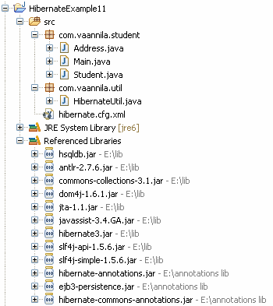
You can download the source code of this example here.

