User experience, or UX, is a term used to describe the overall experience a user has when interacting with a product or service in a given context.

Depending on how the product or service is designed, the experience can range from delightful to downright frustrating!

**UX is all about the user’s interaction or experience with a product or service**

**User experience design, or UXD, considers each and every element that shapes the user experience.**

**Design thinking:**

* Empathize: research your users' needs.
* Define: state your users' needs and problems.
* Ideate: challenge assumptions and create ideas.
* Prototype: start to create solutions.
* Test: try your solutions out.

**What is Design Thinking?**

Design thinking is a non-linear, iterative process that teams use to understand users, challenge assumptions, redefine problems and create innovative solutions to prototype and test. Involving five phases—Empathize, Define, Ideate, Prototype and Test—it is most useful to tackle problems that are ill-defined or unknown.

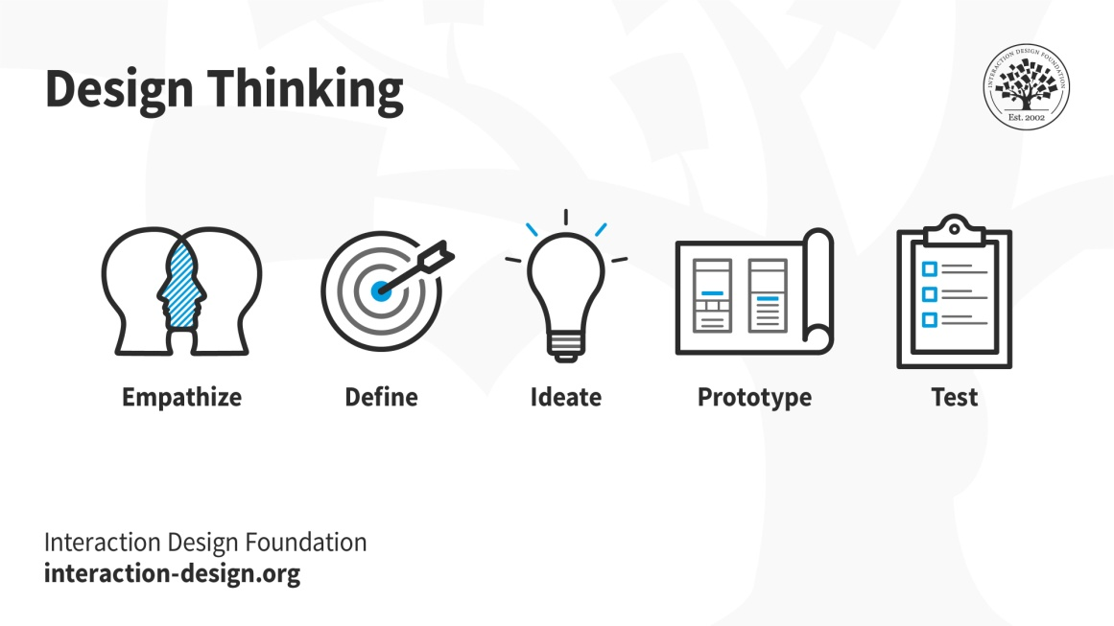

*© Interaction Design Foundation, CC BY-SA 3.0*

*In his 2009 TED talk, Design Thinking pioneer Tim Brown discusses Design Thinking’s value in solving extremely complex challenges.*

**Why Is Design Thinking so Important?**

In [user experience (UX) design](https://www.interaction-design.org/literature/topics/ux-design), it’s crucial to develop and refine skills to understand and address rapid changes in users’ environments and behaviors. The world has become increasingly interconnected and complex since cognitive scientist and Nobel Prize laureate Herbert A. Simon first mentioned design thinking in his 1969 book,*The Sciences of the Artificial*, and then contributed many ideas to its principles. Professionals from a variety of fields, including architecture and engineering, subsequently advanced this highly creative process to address human needs in the modern age. Twenty-first-century organizations from a wide range of industries find design thinking a valuable means to problem-solve for the users of their products and services. **Design teams use design thinking to tackle ill-defined/unknown problems (aka**[**wicked problems**](https://www.interaction-design.org/literature/topics/wicked-problems)**) because they can reframe these in *human-centric* ways and focus on what’s most important for users**. Of all [design processes](https://www.interaction-design.org/literature/topics/design-processes), design thinking is almost certainly the best for “thinking outside the box”. With it, teams can do better [UX research](https://www.interaction-design.org/literature/topics/ux-research), [prototyping](https://www.interaction-design.org/literature/topics/prototyping) and [usability testing](https://www.interaction-design.org/literature/topics/usability-testing) to uncover new ways to meet users’ needs.

Design thinking’s value as a world-improving, driving force in business (global heavyweights such as Google, Apple and Airbnb have wielded it to notable effect) matches its status as a popular subject at leading international universities. **With design thinking,** **teams have the freedom to generate ground-breaking solutions**

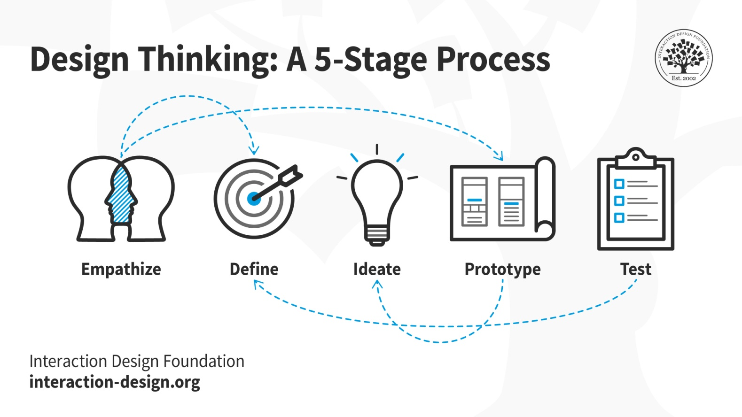

Design thinking is an iterative and non-linear process that contains five phases: 1. Empathize, 2. Define, 3. Ideate, 4. Prototype and 5. Test.

1. **Stage 1:**[**Empathize**](https://www.interaction-design.org/literature/topics/empathize)**—*Research Your Users' Needs***

Here, you should gain an empathetic understanding of the problem you’re trying to solve, typically through user research. Empathy is crucial to a human-centered design process such as design thinking because it allows you to set aside your own assumptions about the world and gain real insight into users and their needs.

1. **Stage 2: Define—*State Your Users' Needs and Problems***

It’s time to accumulate the information gathered during the Empathize stage. You then analyze your observations and synthesize them to define the core problems you and your team have identified. These definitions are called [problem statements](https://www.interaction-design.org/literature/topics/problem-statements). You can create [personas](https://www.interaction-design.org/literature/topics/user-personas) to help keep your efforts human-centered before proceeding to [ideation](https://www.interaction-design.org/literature/topics/ideation).

1. **Stage 3: Ideate—*Challenge Assumptions and Create Ideas***

Now, you’re ready to generate ideas. The solid background of knowledge from the first two phases means you can start to “think outside the box”, look for alternative ways to view the problem and identify innovative solutions to the problem statement you’ve created. [Brainstorming](https://www.interaction-design.org/literature/topics/brainstorming) is particularly useful here..

1. **Stage 4: Prototype—*Start to Create Solutions***

This is an experimental phase. The aim is to identify the best possible solution for each problem found. Your team should produce some inexpensive, scaled-down versions of the product (or specific features found within the product) to investigate the ideas you’ve generated. This could involve simply [paper prototyping](https://www.interaction-design.org/literature/topics/paper-prototyping).

1. **Stage 5: Test—*Try Your Solutions Out***

Evaluators rigorously test the prototypes. Although this is the final phase, design thinking is iterative: **Teams often use the results to *redefine*one or more further problems**. So, you can return to previous stages to make further iterations, alterations and refinements – to find or rule out alternative solutions.

Overall, you should understand that **these stages are different *modes* which contribute to the entire design project, rather than sequential steps**. Your goal throughout is to gain the deepest understanding of the users and what their ideal solution/product would be.