Jenkins Tutorial

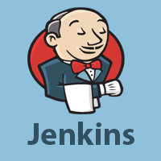

Jenkins Tutorial is designed for both beginners and professionals. Our Tutorial provides all the basic and vanced concepts of Jenkins, such as Jenkins installation, Jenkins Configuration, Jenkins Pipeline, etc.

Jenkins is an open source automation tool written in Java programming language that allows continuous integration.

Jenkins builds and tests our software projects, which continuously making it easier for developers to integrate changes to the project, and making it easier for users to obtain a fresh build.

What is Jenkins?

Jenkins is an open source automation tool written in Java programming language that allows continuous integration.

Jenkins **builds** and **tests** our software projects which continuously making it easier for developers to integrate changes to the project, and making it easier for users to obtain a fresh build.

It also allows us to continuously **deliver** our software by integrating with a large number of testing and deployment technologies.

Jenkins offers a straightforward way to set up a continuous integration or continuous delivery environment for almost any combination of languages and source code repositories using pipelines, as well as automating other routine development tasks.

With the help of Jenkins, organizations can speed up the software development process through automation. Jenkins ds development life-cycle processes of all kinds, including build, document, test, package, stage, deploy static analysis and much more.

Jenkins achieves CI (Continuous Integration) with the help of plugins. Plugins is used to allow the integration of various DevOps stages. If you want to integrate a particular tool, you have to install the plugins for that tool. For example: Maven 2 Project, Git, HTML Publisher, Amazon EC2, etc.

**For example:** If any organization is developing a project, then **Jenkins** will continuously test your project builds and show you the errors in early stages of your development.

Possible steps executed by Jenkins are for example:

* Perform a software build using a build system like Gr le or Maven Apache
* Execute a shell script
* Archive a build result
* Running software tests

**Work Flow:**

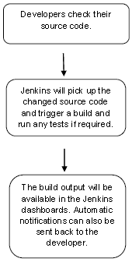

History of Jenkins

Kohsuke Kawaguchi, who is a Java developer, working at SUN Microsystems, was tired of building the code and fixing errors repetitively. In 2004, he created an automation server called **Hudson** that automates build and test task.

In 2011, Oracle who owned Sun Microsystems h a dispute with Hudson open source community, so they forked Hudson and renamed it as **Jenkins**.

Both Hudson and Jenkins continued to operate independently. But in short span of time, Jenkins acquired a lot of contributors and projects while Hudson remained with only 32 projects. Then with time, Jenkins became more popular, and Hudson is not maintained anymore.

What is Continuous Integration?

Continuous Integration *(CI)* is a development practice in which the developers are needs to commit changes to the source code in a shared repository at regular intervals. Every commit m e in the repository is then built. This allows the development teams to detect the problems early.

Continuous integration requires the developers to have regular builds. The general practice is that whenever a code commit occurs, a build should be triggered.

Continuous Integration with Jenkins

Let's consider a scenario where the complete source code of the application was built and then deployed on test server for testing. It sounds like a perfect way to *develop software*, but this process has many problems.

* Developer teams have to wait till the complete software is developed for the test results.
* There is a high prospect that the test results might show multiple bugs. It was tough for developers to locate those bugs because they have to check the entire source code of the application.
* It slows the software delivery process.
* Continuous feedback pertaining to things like architectural or coding issues, build failures, test status and file release uplo s was missing due to which the quality of software can go down.
* The whole process was manual which increases the threat of frequent failure.

It is obvious from the above stated problems that not only the software delivery process became slow but the quality of software also went down. This le s to customer dissatisfaction.

So to overcome such problem there was a need for a system to exist where developers can continuously trigger a build and test for every change m e in the source code.

This is what Continuous Integration (CI) is all about. Jenkins is the most mature Continuous Integration tool available so let us see how Continuous Integration with Jenkins overcame the above shortcomings.

Let's see a generic flow diagram of Continuous Integration with Jenkins:

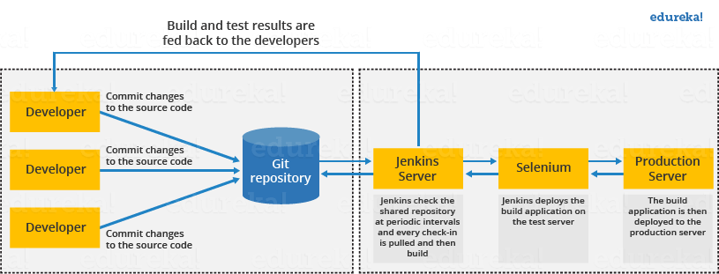

**Let's see how Jenkins works**. The above diagram is representing the following functions:

* First of all, a developer commits the code to the source code repository. Meanwhile, the Jenkins checks the repository at regular intervals for changes.
* Soon after a commit occurs, the Jenkins server finds the changes that have occurred in the source code repository. Jenkins will draw those changes and will start preparing a new build.
* If the build fails, then the concerned team will be notified.
* If built is successful, then Jenkins server deploys the built in the test server.
* After testing, Jenkins server generates a feedback and then notifies the developers about the build and test results.
* It will continue to verify the source code repository for changes m e in the source code and the whole process keeps on repeating.

vantages and Dis vantages of using Jenkins

**vantages of Jenkins**

* It is an open source tool.
* It is free of cost.
* It does not require ditional installations or components. Means it is easy to install.
* Easily configurable.
* It supports 1000 or more plugins to ease your work. If a plugin does not exist, you can write the script for it and share with community.
* It is built in java and hence it is portable.
* It is platform independent. It is available for all platforms and different operating systems. Like OS X, Windows or Linux.
* Easy support, since it open source and widely used.
* Jenkins also supports cloud based architecture so that we can deploy Jenkins in cloud based platforms.

**Dis vantages of Jenkins**

* Its interface is out dated and not user friendly compared to current user interface trends.
* Not easy to maintain it because it runs on a server and requires some skills as server ministrator to monitor its activity.
* CI regularly breaks due to some small setting changes. CI will be paused and therefore requires some developer's team attention.

Jenkins Architecture

Jenkins follows Master-Slave architecture to manage distributed builds. In this architecture, slave and master communicate through TCP/IP protocol.

Jenkins architecture has two components:

* Jenkins Master/Server
* Jenkins Slave/Node/Build Server

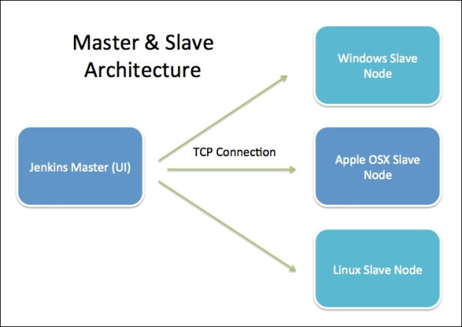

Jenkins Master

The main server of Jenkins is the Jenkins Master. It is a web dashboard which is nothing but powered from a war file. By default it runs on 8080 port. With the help of Dashboard, we can configure the jobs/projects but the build takes place in Nodes/Slave. By default one node (slave) is configured and running in Jenkins server. We can d more nodes using IP dress, user name and password using the ssh, jnlp or webstart methods.

The server's job or master's job is to handle:

* Scheduling build jobs.
* Dispatching builds to the nodes/slaves for the actual execution.
* Monitor the nodes/slaves (possibly taking them online and offline as required).
* Recording and presenting the build results.
* A Master/Server instance of Jenkins can also execute build jobs directly.

Jenkins Slave

Jenkins slave is used to execute the build jobs dispatched by the master. We can configure a project to always run on a particular slave machine, or particular type of slave machine, or simple let the Jenkins to pick the next available slave/node.

As we know Jenkins is developed using Java is platform independent thus Jenkins Master/Servers and Slave/nodes can be configured in any servers including Linux, Windows, and Mac.

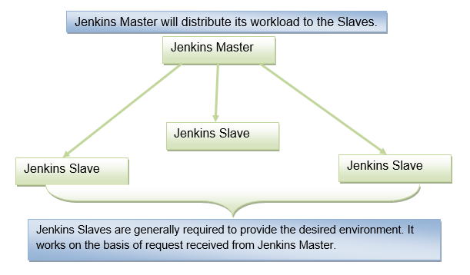

Jenkins Pipeline

In Jenkins, a pipeline is a collection of events or jobs which are interlinked with one another in a sequence.

It is a combination of plugins that support the integration and implementation of **continuous delivery pipelines** using Jenkins.

In other words, a Jenkins Pipeline is a collection of jobs or events that brings the software from version control into the hands of the end users by using automation tools. It is used to incorporate continuous delivery in our software development workflow.

A pipeline has an extensible automation server for creating simple or even complex delivery pipelines "as code", via DSL (Domain-specific language).

What is Continuous Delivery Pipeline?

In a Jenkins Pipeline, every job has some sort of dependency on at least one or more jobs or events.

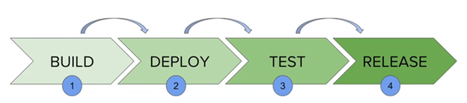

The above diagram represents a continuous delivery pipeline in Jenkins. It contains a collection of states such as build, deploy, test and release. These jobs or events are interlinked with each other. Every state has its jobs, which work in a sequence called a continuous delivery pipeline.

A continuous delivery pipeline is an automated expression to show your process for getting software for version control. Thus, every change made in your software goes through a number of complex processes on its manner to being released. It also involves developing the software in a repeatable and reliable manner, and progression of the built software through multiple stages of testing and deployment.

JenkinsFile

Jenkins Pipeline can be defined by a text file called JenkinsFile. You can implement pipeline as code using JenkinsFile, and this can be defined by using a DSL (Domain Specific Language). With the help of JenkinsFile, you can write the steps required for running a Jenkins Pipeline.

The benefits of using JenkinsFile are:

* You can make pipelines automatically for all branches and can execute pull requests with just one JenkinsFile.
* You can review your code on the pipeline.
* You can review your Jenkins pipeline.
* This is the singular source for your pipeline and can be customized by multiple users.

JenkinsFile can be defined by using either Web UI or with a JenkinsFile.

Pipeline syntax

Two types of syntax are used for defining your JenkinsFile.

* Declarative
* Scripted

**Declarative:**

Declarative pipeline syntax offers a simple way to create pipelines. It consists of a predefined hierarchy to create Jenkins pipelines. It provides you the ability to control all aspects of a pipeline execution in a simple, straightforward manner.

**Scripted:**

Scripted Jenkins pipeline syntax runs on the Jenkins master with the help of a lightweight executor. It uses very few resources to convert the pipeline into atomic commands.

Both scripted and declarative syntax are different from each other and are defined totally differently.

Why Use Jenkins Pipeline?

Jenkins is a continuous integration server which has the ability to support the automation of software development processes. You can create several automation jobs with the help of use cases, and run them as a Jenkins pipeline.

Here are the reasons why you should use Jenkins pipeline:

* Jenkins pipeline is implemented as a code which allows several users to edit and execute the pipeline process.
* Pipelines are robust. So if your server undergoes an unpredicted restart, the pipeline will be automatically resumed.
* You can pause the pipeline process and make it wait to continue until there is an input from the user.
* Jenkins Pipelines support big projects. You can run many jobs, and even use pipelines in a loop.

Jenkins Pipeline Concepts

**Pipeline:** This is the user-defined block, which contains all the processes such as build, test, deploy, etc. it is a group of all the stages in a JenkinsFile. All the stages and steps are defined in this block. It is used in declarative pipeline syntax.

1. pipeline{
2. }

**Node:** The node is a machine on which Jenkins runs is called a node. A node block is used in scripted pipeline syntax.

1. node{
2. }

**Stage:** This block contains a series of steps in a pipeline. i.e., build, test, and deploy processes all come together in a stage. Generally, a stage block visualizes the Jenkins pipeline process.

Let's see an example for multiple stages, where each stage performs a specific task:

1. pipeline {
2. agent any
3. stages {
4. stage ('Build') {
5. ...
6. }
7. stage ('Test') {
8. ...
9. }
10. stage ('QA') {
11. ...
12. }
13. stage ('Deploy') {
14. ...
15. }
16. stage ('Monitor') {
17. ...
18. }
19. }
20. }

**Step:** A step is a single task that executes a specific process at a defined time. A pipeline involves a series of steps defined within a stage block.

pipeline {

    agent any

    stages {

            stage ('Build') {

               steps {

                       echo 'Running build phase...'

              }

           }

    }

}

Jenkins - Setup Build Jobs

Let's create and run a job in Jenkins for simple **HelloWorld** in Java.

**Step 1:** Go to the Jenkins dashboard and click on the New Item.

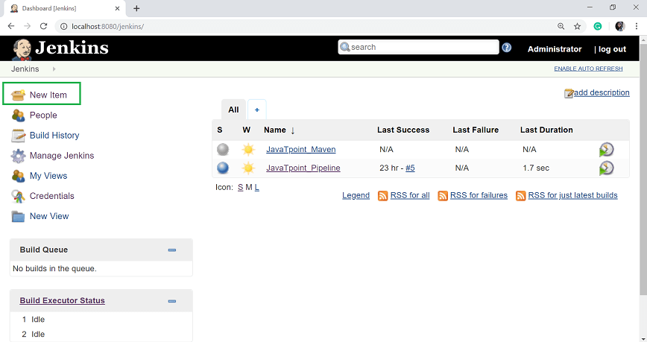

**Step 2:** In the next page, enter the item name, and select the 'Freestyle project' option. And click OK. Here, my item name is HelloWorld.

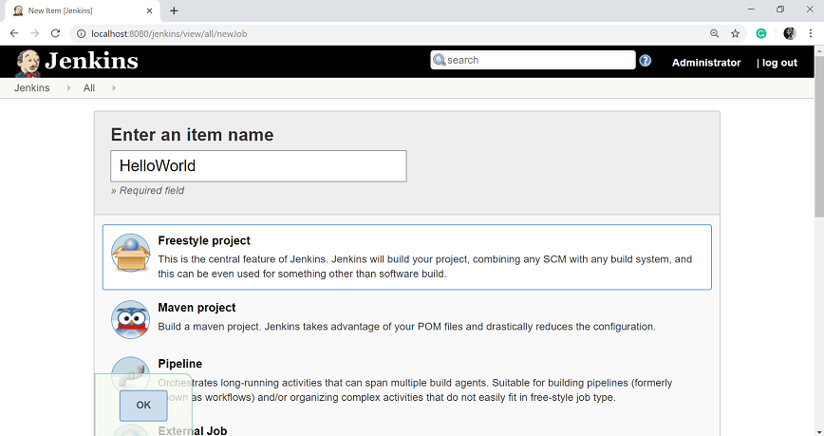

**Step 3:** When you enter the OK, you will get a configuration page. Enter the details of the project in the Description section.

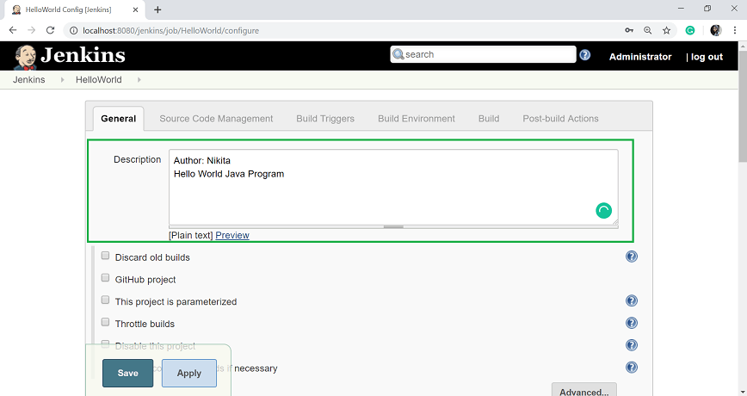

**Step 4:** On the Source Code Management section, select the **Git** option, and specify the Repository URL.

To do that you should have proper github setup on your system. To do the github setup:

* First, you have to create a project in java. Here, I created a simple **HelloWorld** program and saved it to one folder i.e. C:\GitRepo. Compile the HelloWorld.java file.

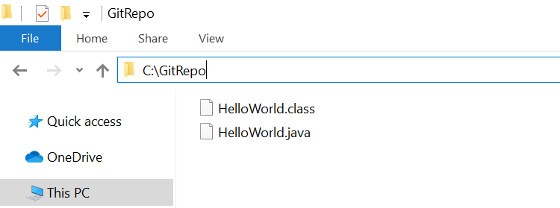

* Now create a project in your GitHub account and give the Repository name. Here my repository name is HelloWorld.

AD

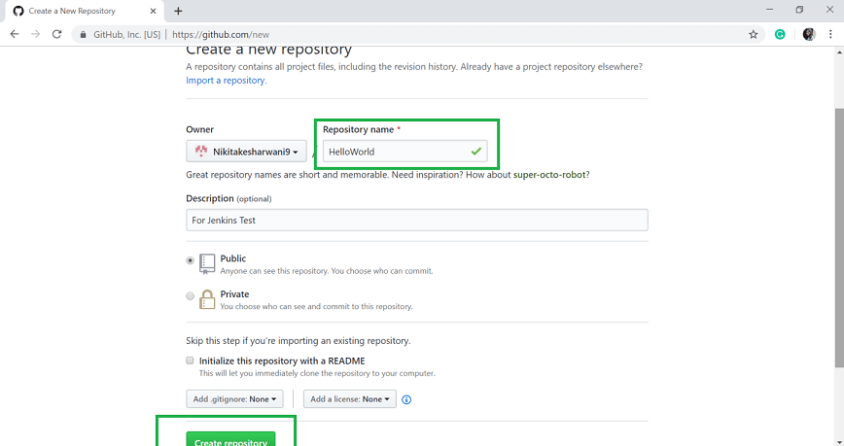

* Click on **Create repository**.

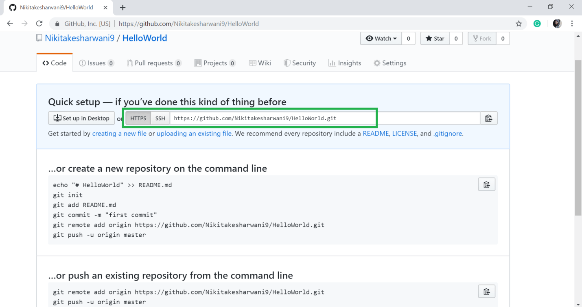

* Your repository is created. Copy the repository URL. My repository URL is: [https://github.com/Nikitakesharwani9/HelloWorld.git](https://github.com/Nikitakesharwani9/HelloWorld)
* Open the command prompt in your Windows and go to the path where your java file is created.
* Then run the following command.

1. git init
2. git status
3. git add .
4. git status

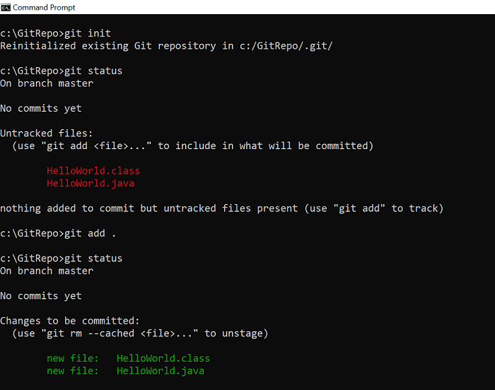

* Configure your GitHub account in your system.

1. git config --global user.email "your@email"
2. git config --global user.name "username"

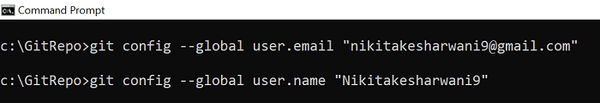

* Commit it and add the repository URL.

1. git commit -m "added HelloWorld program"
2. git remote add origin https://github.com/Nikitakesharwani9/HelloWorld.git
3. git push -u origin master

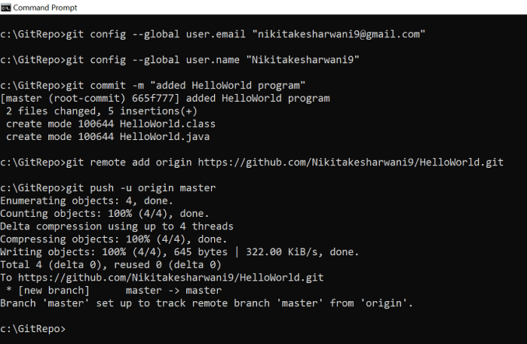

* Now, when you refresh your GitHub account, the helloWorld file will be added in your repository.

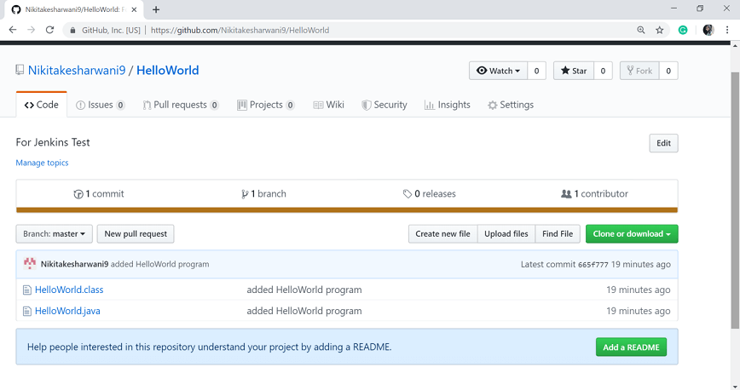

**Step 5:** Add the Repository URL in the **Source Code Management** section.

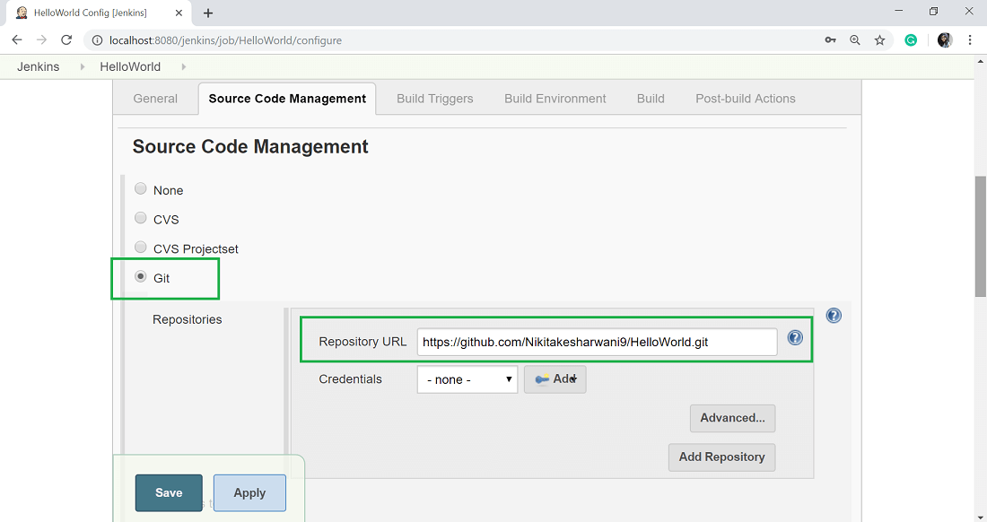

You can also use a local repository. And if your GitHub repository is private, Jenkins will first validate your login credentials with GitHub and only then access the source code from your GitHub repository.

**Step 6:** Now, it is time to build the code. Click on "**Add build step**" and select the "**Execute Windows batch command**".

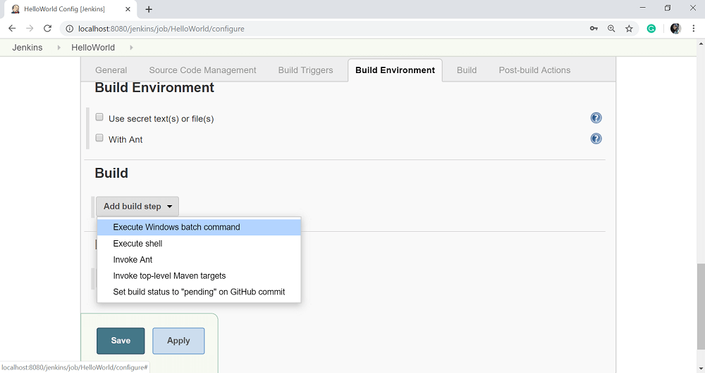

**Step 7:** Enter the following command to compile the java code.

1. javac HelloWorld.java
2. java HelloWorld

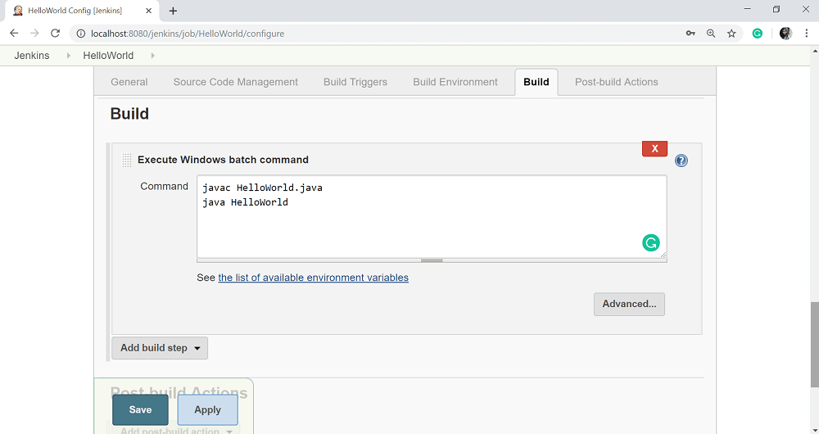

**Step 8:** Click Apply and then Save button.

**Step 9:** Once you saved the configuration, then now can click on **Build Now** option.

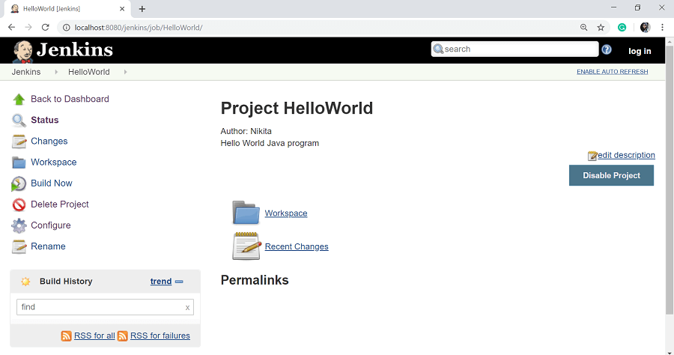

**Step 10:** After clicking on **Build Now**, you can see the status of the build on the Build History section.

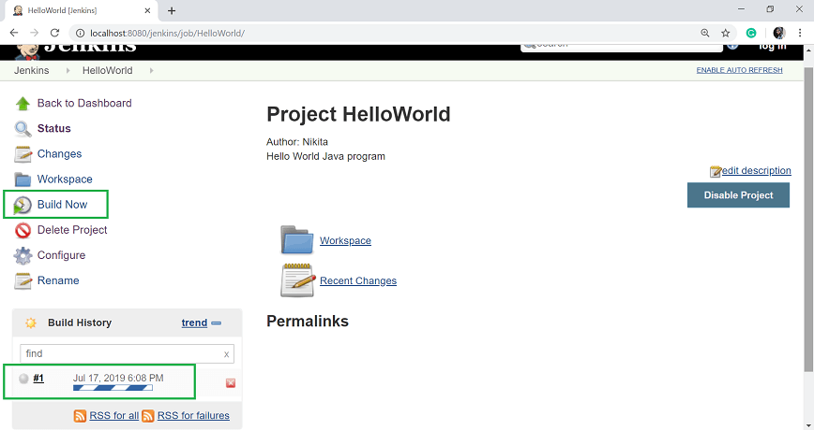

Once the build is completed, a status of the build will show if the build was successful or not. If the build is failed then it will show in red color. Blue symbol is for success.

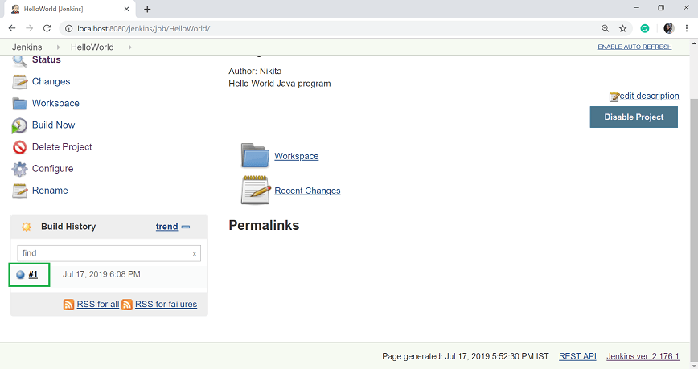

Click on the build number **#1** in the **Build History section** to see the details of the build.

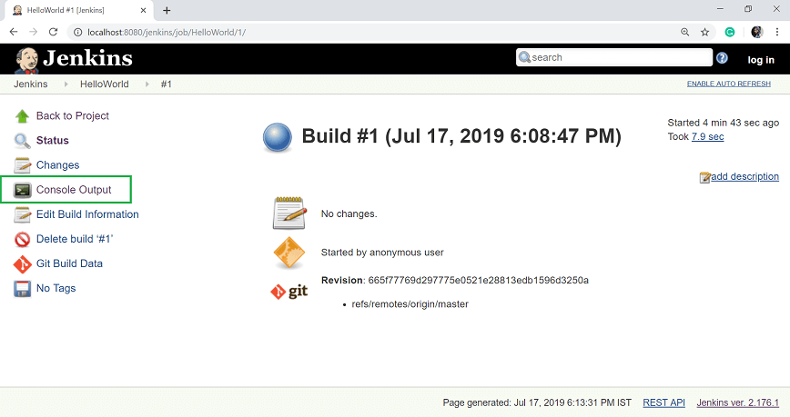

**Step 11:** Click on **Console Output** from the left side of the screen to see the status of the build you run. It should show the success message.

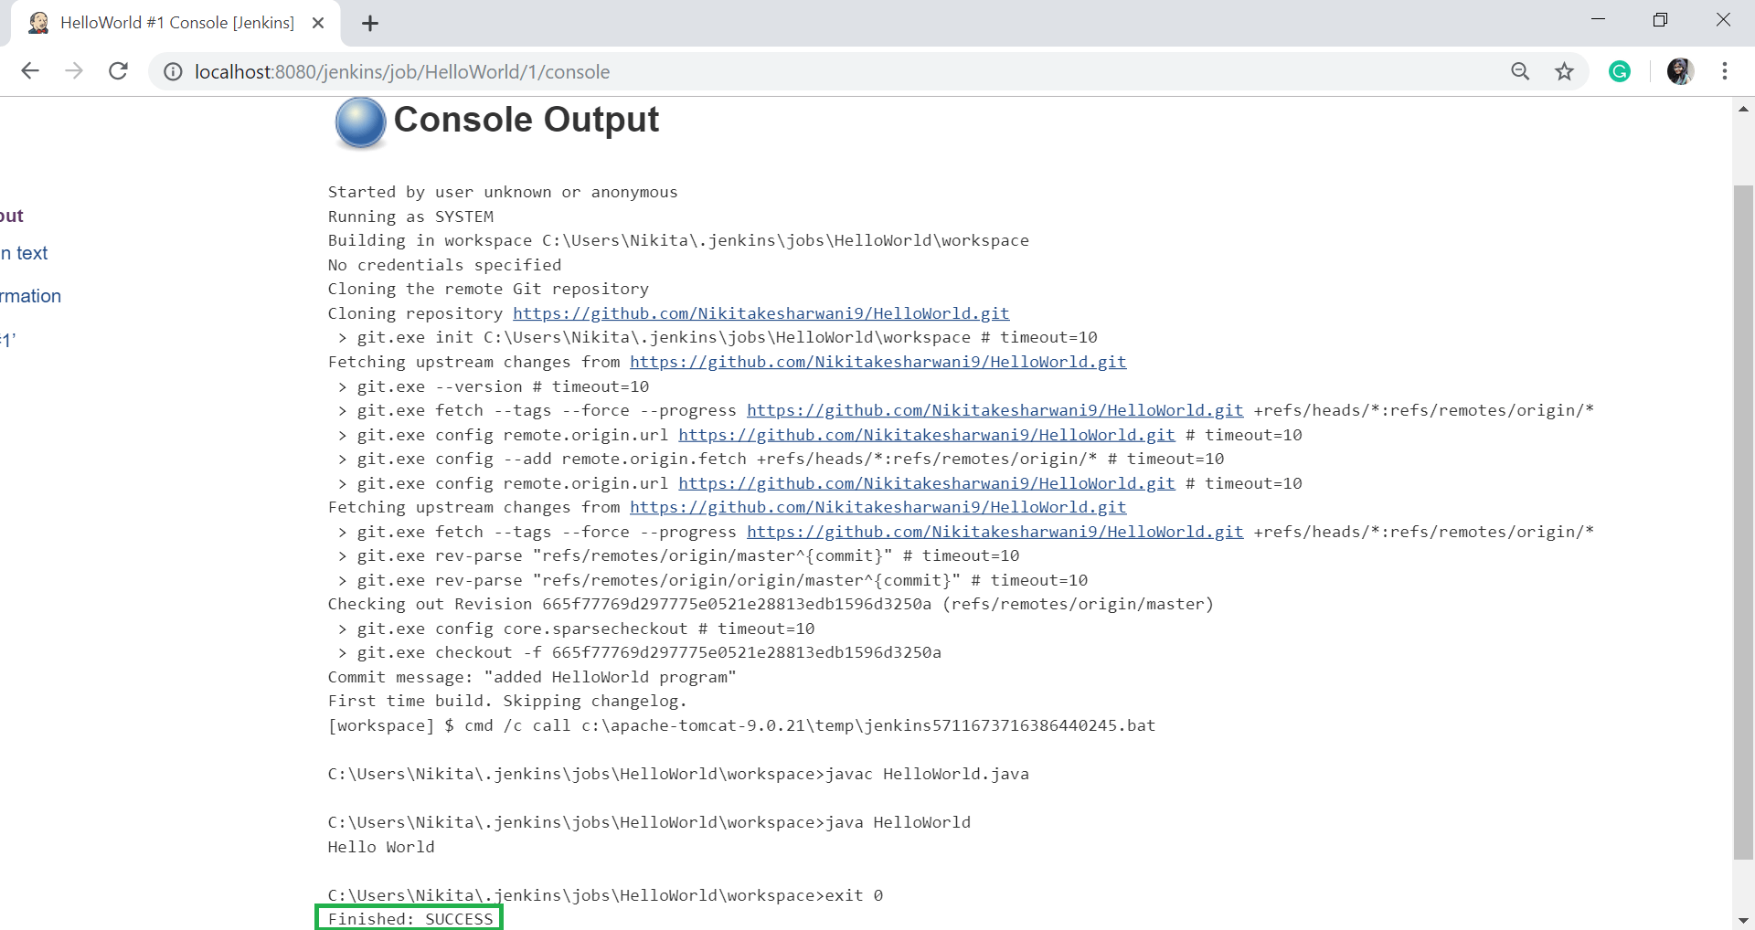

pipeline {  
 agent any  
 stages {  
 stage('Checkout') {  
 steps {  
 git 'https://github.com/org/repo.git'  
 }  
 }  
 stage('Build') {  
 steps {  
 // compile code  
 // save build artifacts to S3 bucket  
 }  
 }  
 stage('Test') {  
 steps {  
 // download artifacts from S3  
 // load test data into Postgres DB  
 // run integration tests  
 // continue only if all tests pass  
 }  
 }  
 stage('Deploy') {  
 steps {  
 // download artifacts from S3  
 // deploy to Kubernetes cluster  
 }  
 }  
 }  
}