University of Bridgeport

SPRING 2016

COMPUTER SCIENCE

Course CPSC- 350-11 – Advance Database Design



Assignment: Project -1 (phase 3)

**Title: AIR RESERVATION SYSTEM**

Professor Name: Jeongkyu Lee

*Submitted* *by:* *ARUNA VEERAMREDDY-1004293*

When: On Campus

**AIR RESERVATION SYSTEM**

**Team Information**

**Number**: Group 17

**Name**: ARUNA VEERAMREDDY

ANUSHA KARATI.

**NOTE:**

There are four files are attached with this submission. Their details are below:

dbDROP.sql

* Drop statements reside in this file. These are used to drop tables and functions from Database schema.

dbDDL.sql

* Contains tables and function creation statements.

dbDML.sql

* Contains Data insertion statements for all tables.

dbSQL.sql

* Contains some useful and fully tested queries. That includes details of flight, employee name allotted to flight, etc. Also contains joins, update and delete statements.

Moreover, we have tested all above statements in UB lab.

In this paper, We have attached screenshot of our few database queries.

**Database Objects:**

* This below function “GETEMPLOYEENAME” returns the EMPLOYEE name for specific FLIGHT NO.

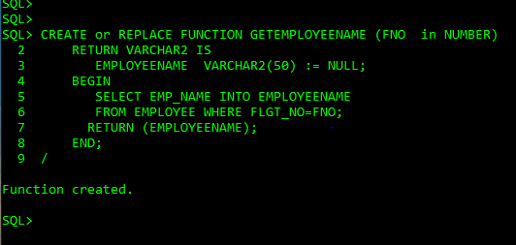

* This below function “GETCUSTOMERNAME” returns the customer name for specific ACC_NO

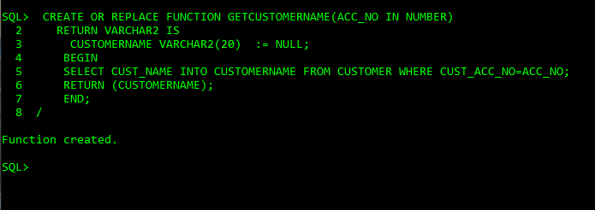

* This below function “GETDEPARPORT” returns the DEPATURE AIRPORT CODE for specific FLIGHT NUMBER.

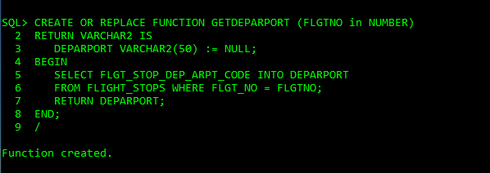

* This below function “GETDAY” returns the DAY OF THE JOURNEY for specific FLIGHT NUMBER.

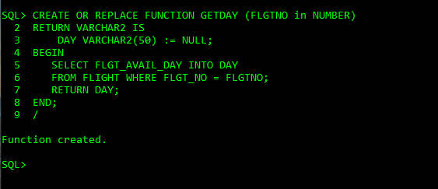

* This below function “GETFARE” returns the FARE for specific FLIGHT NUMBER.

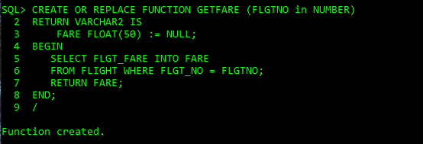

* This below function “GETFLIGHTLEG” returns the FLIGHT LEG(CONNECTING FLIGHT )for specific SEAT NUMBER.

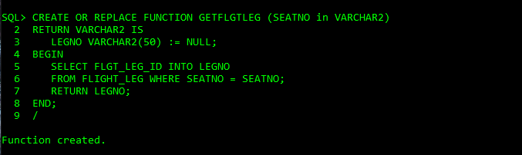

* **SQL Query**: Get the CUSTOMER DETAILS from “SEAT_RESERVATION ” table using the above database objects.

SELECT RESV_NO "RESERVATION NO",

GETCUSTOMERNAME(5) "CUSTOMER NAME",

SEAT_NO "SEAT NO",

GETDEPARPORT(122) "AIRPORT",

DATE_OF_TRAVEL "DATE",

GETDAY(122) "DAY" FROM SEAT_RESERVATION;

* **OUTPUT:**

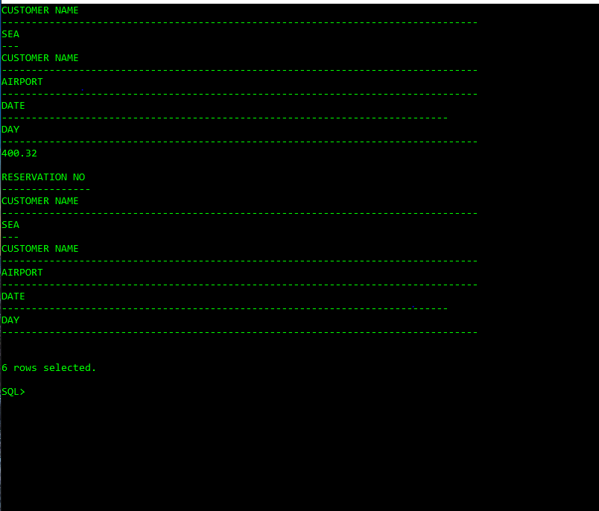

* **SQL Query:** Get the FARE AND EMPLOYEE NAME of the flight

SELECT FLGT_NO "FLIGHT NO",

FLGT_STOP_ID "STOP_ID",

GETFARE(122) "FARE",

FLGT_STOP_SHD_DEP_TIME "TIME",

GETEMPLOYEENAME(122) "EMPLOYEE"

FROM FLIGHT_STOPS;

* **OUTPUT:**

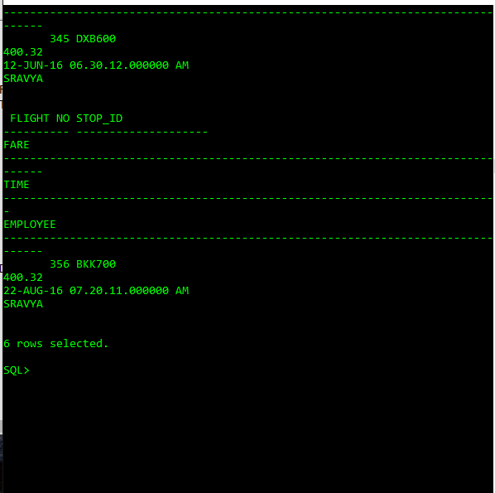

******************CROSS JOIN*****************

select C.CUST_NAME,S.SEAT_NO FROM CUSTOMER C,SEAT_RESERVATION S;

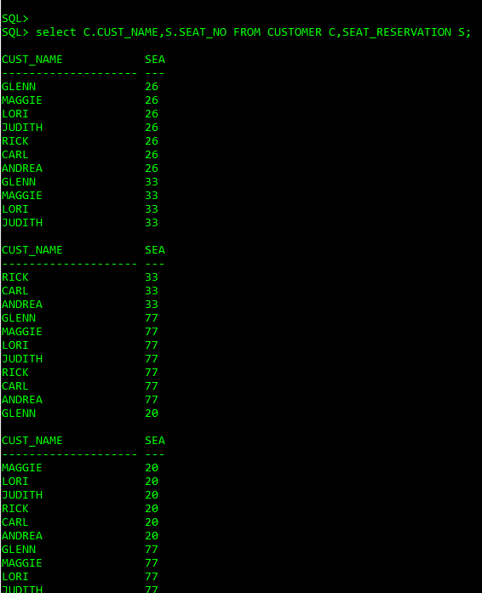

**SQL Query:**

**********NATURAL JOIN*******

SELECT * FROM CUSTOMER C JOIN SEAT_RESERVATION S ON (C.CUST_ACC_NO = S.CUST_ACC_NO);

**OUTPUT:**

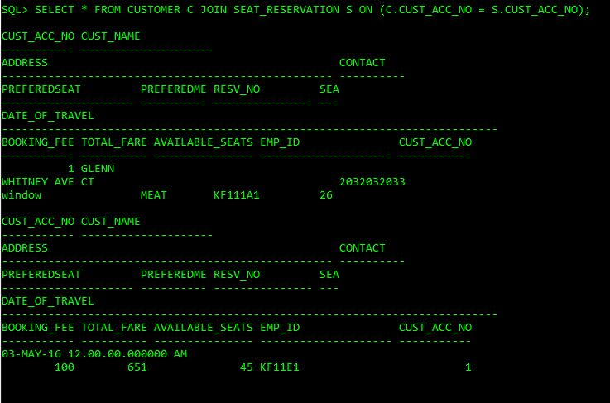

**SQL Query:**

NON-EQUI JOIN OPERATION

SELECT E.EMP_NAME,E.EMP_ALLOTED_FOR,S.RESV_NO FROM EMPLOYEE E JOIN SEAT_RESERVATION S ON(E.EMP_ID=S.EMP_ID);

**OUTPUT:**

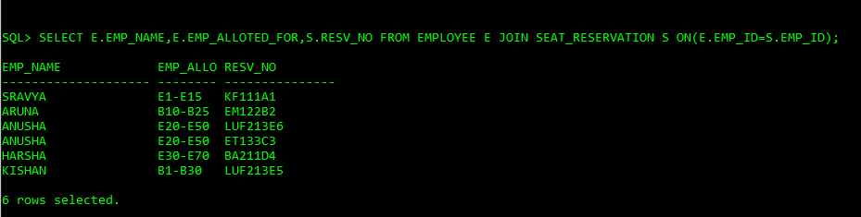

**SQL Query:**

SELECT A.ARPORT_NAME,F.FLGT_STOP_DEP_ARPT_CODE FROM AIRPORT A JOIN FLIGHT_STOP F ON (A.ARPORT_CODE = F.FLGT_STOP_DEP_ARPT_CODE);

**OUTPUT:**

