Advanced Microprocessors & peripherals

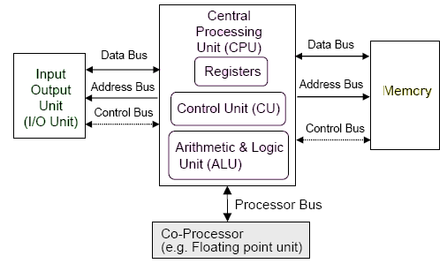

Pin Diagram of 8086/8088

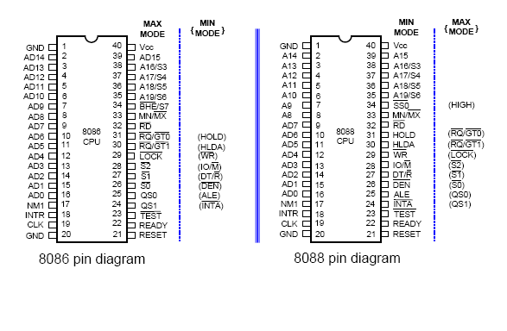

Architecture of 8086

The architecture of Intel’s first 16-bit processor, 8086 microprocessor is as follows. The 8086 has two independent functional units aimed to work in parallel : the BIU (Bus Interface Unit) and the EU (Execution Unit). Dividing the work between these 2 units speeds up processing.
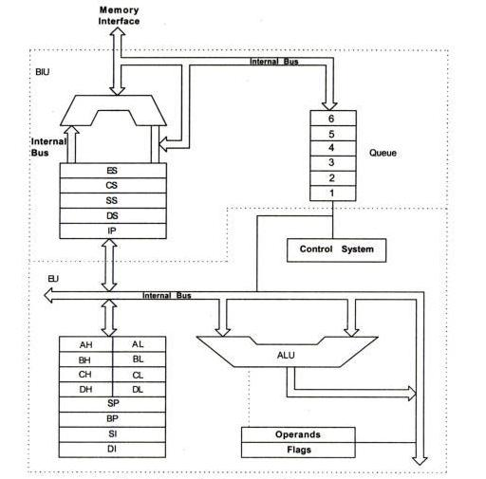
Execution Unit : The EU of 8086 tells the BIU where to fetch the instructions or data from, decodes instruction and fetches instruction. It contains an instruction decoder, control circuitry, ALU and a 16 bit flag register. It removes the instruction from the instruction queue.
Control Circuitry: The Circuitry directs the internal operations of the micro processor. The decoder translates instructions fetched from memory into a series of actions which the EU carries out. The EU has a 16 bit ALU which can add, subtract, AND, OR, XOR, increment, decrement, compliment or shift binary numbers. It generates all the control signals within the CPU. It initializes the registers on power up, generates the signal to fetch instructions for the ALU. The control unit may be implemented completely by the hardware (hard-wired controller eg: using a state counter and a programmable logic array) or a mixture of software instructions (microcode stored in the CPU) and hardware (micro-programmed control). The Intel 8086 family Motorola 68000 family, both use micro-programmed controllers.
Flag Registers: Flag is a flip-flop that indicates some condition produced by the execution of an instruction or controls certain operations of the EU. The 16 bit flag register contained 9 active flags. 6 out of 9 (CF, PF,AF,ZF,SF) are known as conditional flags and the other 3 (TF,IF,DF) are known as control flags.
15 11 10 8 6 4 2 0
Bit Definition of 8086 flag register.
The carry flag will be set to 1 if the addition of two 16-bit binary numbers produces a carry out of the MSB position. If no carryout of MSB is produced by the addition, then the carry flag will be zero. The EU, thus effectively runs up a flag to tell you that a carry was produced. Certain 8086 instructions check these flags to determine which of 2 alternative actions should be done in executing the instructions.
The control flags which control certain operations of the processor are TF, IF and DF. The conditional flags are set or reset by the EU on the basis of the result of some arithmetic or logic operations. The control flags are deliberately set or reset with specific instructions put in the program itself. TF or Trap flag is used for single stepping through the program. Interrupt flag is used to allow or prohibit the interruption of a program. Direction Flag is used with string operations.
General Purpose Registers(Multi-purpose Registers): EU has 8 general purpose registers, consist in four general purpose(multipurpose) registers labeled AX, BX, CX and DX, two stack pointers (SP and BP), and two index registers (SI and DI). These registers can be used individually or together for temporary storage of 8 or 16 bit data. The AX register is also called the accumulator.
Accumulator register consists of two 8-bit registers AL and AH, which can be combined together and used as a 16-bit register AX. AL in this case contains the low-order byte of the word, and AH contains the high-order byte. Accumulator can be used for I/O operations and string manipulation.
Base register consists of two 8-bit registers BL and BH, which can be combined together and used as a 16-bit register BX. BL in this case contains the low-order byte of the word, and BH contains the high-order byte. BX register usually contains a data pointer used for based, based indexed or register indirect addressing.
Count register consists of two 8-bit registers CL and CH, which can be combined together and used as a 16-bit register CX. When combined, CL register contains the low-order byte of the word, and CH contains the high-order byte. Count register can be used as a counter in string manipulation and shift/rotate instructions.
Data register consists of two 8-bit registers DL and DH, which can be combined together and used as a 16-bit register DX. When combined, DL register contains the low-order byte of the word, and DH contains the high-order byte. Data register can be used as a port number in I/O operations. In integer 32-bit multiply and divide instruction the DX register contains high-order word of the initial or resulting number.
The advantage of using internal registers for the temporary storage of data is that, since the data is already in the EU, it can be accessed much more quickly than it could be accessed in external memory.
Bus Interface Unit: BIU sends out addresses, fetches instruction from the memory, reads data from ports & memory and writes data to ports and memory. In general BIU handles all transfers of data and addresses on the buses for the execution unit. This unit is made of four segment registers (DS, CS, SS and ES), a program counter (IP - Instruction Pointer), and a 6-byte queue to store the pre-fetched instructions.
The queue: While the EU is decoding an instruction or executing an instruction which does not require use of the buses, the BIU fetches upto 6 instruction bytes from the memory unit. BIU stores these pre-fetched bytes in a FIFO register set called queue. When the EU is ready for its next instruction, it simply reads the instruction bytes for the instruction from the queue in the BIU. This is much faster then sending out an address to the system memory & waiting for memory to send back the next instruction byte or bytes. The queue is dumped and then reloaded starting from a new address, this pre-fetch and queue scheme greatly speeds up processing. Fetching the next instruction while the current instruction executes is called pipelining. So the instruction fetch and execution are pipelined parallel processing.
Segment Registers: The 8086 BIU sends out 20 bit addresses so it can address any of the 2 20 or 1048576 bytes of memory. At any given time 8086 works with only four 64 KB segments within this 1MB range. The 4 segment registers in the BIU are used to hold the upper 16 bits of the starting address of 4 memory segments that the 8086 is working with at a particular time.
- code segment(CS) register: Holds the upper 16-bits of the starting address for the segment from which the BIU is currently fetching instruction code bytes. BIU always inserts ‘0’ for the lowest 4 bits of the 20 bit starting address for a segment. The part of a segment starting address stored in a segment register is often called the segment base.
- Stack segment (SS) register: The stack is a section of memory set aside to store addresses and data while a sub program executes. The SS register is used to hold the upper 16-bits of the starting address for the program stack.
- Extra Segment (ES) and Data Segment (DS) registers: These are used to hold the upper 16 bits of the starting address of 2 memory segments that are used for data.
Instruction Pointer (IP): The IP register holds the 16-bit address or offset of the next code byte within this code segment. The value in IP is offset from( added to) the segment base address in CS to produce the required 20-bit physical address sent out by BIU. So, the CS points to the base or start of the current code segment. IP contains the distance or offset from this base address to the next instruction byte to be fetched.
Eg:
CS 4589 IP 1324
Physical Address : 46BB4H OR 4589:1324
Stack Segment and Stack Pointer Registers: The upper 16-bits of the starting address for stack segment are kept in the stack segment register. The stack pointer register (SP) in the EU holds the 16 bit offset from the start of the segment to the memory location where a word was most recently stored on the stack (that position is termed as top of the stack). The physical address of the stack is represented as SS:SP
Pointer & Index Registers in the EU: The 16-bit registers BP, SI and DI can be used for temporary storage of data just as the general purpose registers. Their main purpose is to hold the 16-bit offset of the data word in one of the segments. The 16-bit default segment & offset registers are as follows:
Segment Offset Special Purpose
CS IP Instruction Address
SS SP or BP Stack Address
DS BX,DI,SI Data Address
ES DI (for string instructions) String Destination Address

