Module 1
Internal architecture of a typical 8-bit Microprocessor (Intel 8085), Signals,
Registers, Machine cycles
Module 2 Instruction set
Instruction set of 8085, Addressing modes-Register, Direct, Immediate, Indirect
and Implicit addressing, examples
Instruction types – Arithmetic, Logic, Data transfer, Branch, Stack, I/O and
Machine control Instructions, examples (Assembly language programming not
intended)

8085 Microprocessor

Introduction
A Microprocessing unit (MPU) is similar to CPU, defined as a device or group of devices that can communicate with peripherals, provide timing signals, direct the data flow, and perform computing tasks as specified by the instructions in memory.
8085 microprocessor is am 8-bit general-purpose microprocessor capable of addressing 64K (2¹⁶) of memory. The device has forty pins, requires +5V single power supply, and can operate with a 3Mhz single- phase clock.

Signals
All the signals in 8085 can be classified into six groups.
- Address bus
- Data bus
- Control and Status signals
- Externally initialized signals
- Serial I/O ports

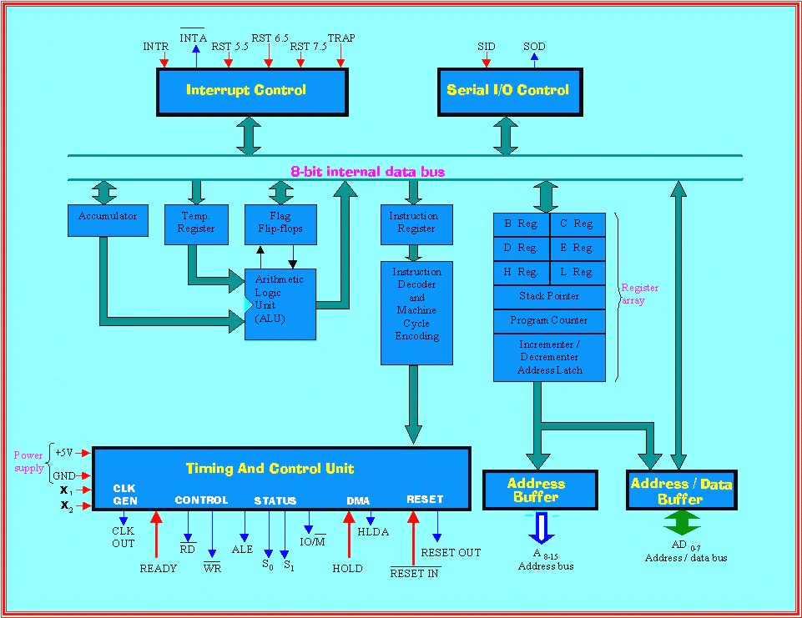

INTEL 8085 CPU BLOCK DIAGRAM

Internal architecture of a typical 8-bit Microprocessor (Intel 8085)
Microprocessor is a programmable logic device, designed with registers, flip-flops, and timing elements. The microprocessor has asset of instructions, designed internally, to manipulate data and to communicate with peripherals. The process of manipulation and communication is determined by the logic design of microprocessor, called the architecture. The microprocessor can be programmed to perform functions on given data by selecting necessary instructions from its set. These instructions are given to the microprocessor by writing them into its memory.
The internal architecture of 8085 includes ALU (Arithmetic & logic unit) , timing and control unit, Instruction register and decoder , Register array , Interrupt control, and serial I/O control.
The ALU
The arithmetic/ Logic unit performs the computing functions: it includes the accumulator, the temporary register, the arithmetic and logic circuits and five flags. The temporary registers are used to hold data during an arithmetic/logic operation. The results are stored in the accumulator and the flags are set or rest according to the result of the operation.

FLAGS
The ALU includes five flip-flops that are set or reset according to data conditions in the accumulator and other registers. These flags have critical importance in the decision making process of the microprocessor. 8085 has five flags to indicate five different types of data conditions.

SF | ZF |  | AC |  | P |  | CF

SF- Sign Flag: This flag is used with signed numbers. After the execution of an arithmetic or logic operation, if bit D7 of the result is set, the sign flag is set. In a given byte, if D7 is 1, the number will be viewed as negative and if it is 0, the number is considered as positive. i.e. in signed numbers the D7 bit is reserved for sign and the remaining seven bits are used to indicate the magnitude.
ZF- Zero Flag: The zero flag is set if the result is zero, and reset if the result is not zero.
AC- Auxiliary Carry Flag: In arithmetic operation, when a carry is generated by digit D3 and passed on to digit D4, AC is set. This flag is used internally for BCD operation and is not available for the programmer.
PF-Parity Flag: After an arithmetic or logic operation, if the result contain even number of 1s, the flag is set. And if it contains odd number of 1s the flag is reset.
Eg: 0000 1001 has even parity since it has even number of ones.
CF-Carry Flag: If an arithmetic operation results in a carry, the carry flag is set; otherwise it is reset.
Timing and Control Unit
This unit synchronizes all the microprocessor operations with the clock and generates the control signals necessary for communication between the microprocessor and peripherals. The RD and WR are the synchronization signals indicating the availability of data on the data bus.
The instruction register and Decoder
The instruction register and decoder are part of ALU. When an instruction is fetched from memory, it is loaded in the instruction register. The decoder decodes the instruction and establishes the sequence of events to follow. The instruction register is not programmable and cannot be accessed through any instruction.
Register Array
The 8085 has six general purpose registers B, C, D, E, H and L to perform its different operations like to store 8-bit data during program execution. They can b combined as register pairs BC, DE & HL to perform 16-bit operations. These registers are programmable, meaning that a programmer can use them to load or transfer data from register one register to another register.
Two additional registers called Wand Z are included in the register array. These registers are used to hold 8 –bit data during the execution of some instructions. these registers are used internally, and are not available to the programmer.

- Accumulator
Accumulator is an 8-bit register that is part of arithmetic and logic unit. This register is used to store 8-bit data and in performing arithmetic and logical operations. The result of an operation is stored in the accumulator. It is also identified as register A.
Program Counter
This is 16-bit register that deals sequence the execution of instructions. This register is a memory pointer. i.e. it points to the memory locations. The memory locations are 16-bits and the register is designed as 16-bit.
Stack pointer
The stack pointer is also a 16-bit register used as a memory pointer. It points to a memory location in read/write memory, called stack. The beginning of the stack is defined by loading a 16-bit address in the stack pointer register.
Addressing modes
The various formats of specifying the operands are called addressing modes. In instruction, the operands can be a register, an input port or an 8-bit number.The 8085 instruction set has the following addressing modes:
a) Implied
The addressing mode of certain instructions is implied by the instruction’s function. i.e the operands are implied within the instructions itself. For example, the STC (set carry flag) instruction deals only with the carry flag, the DAA (decimal adjust accumulator) instruction deals with the accumulator.

b) Register
Quite a large set of instructions are in register addressing mode. With these instructions, operands are specified by one of the registers A through E, H or L as well as the operation code. And mostly, the accumulator is implied as a second operand.
For example, the instruction ADD C interpreted as ‘Add the contents of C register to the Accumulator contents and store it into the accumulator itself’ & CMP E may be interpreted as 'compare the contents of the E register with the contents of the accumulator. Most of the instructions that use register addressing deal with 8-bit values. However, a few of these instructions deal with 16-bit register pairs. For example, the PCHL instruction exchanges the contents of the program counter with the contents of the H and L registers.
c) Immediate
Instructions that use immediate addressing have data assembled as a part of the instruction itself.
For example, the instruction ADI 08H can be interpreted as ‘To add immediate value 8H to the accumulator’ & CPI 'C' may be interpreted as ‘compare the contents of the accumulator with the letter C. When this instruction is executed, the processor fetches the first instruction byte and determines that it must fetch one more byte. The processor fetches the next byte into one of its internal registers and then performs the compare operation.The names of the immediate instructions indicate that they use immediate data. Thus, the name of an add instruction is ADD; the name of an add immediate instruction is ADI.
All but two of the immediate instructions use the accumulator as an implied operand. The MVI (move immediate) instruction can move its immediate data to any of the working registers including the accumulator or to memory. Thus, the instruction MVI D, OFFH moves the hexadecimal value FF to the D register.
The LXI instruction (load register pair immediate) is even more unusual in that its immediate data is a 16-bit value. This instruction is commonly used to load addresses into a register pair. As mentioned previously, your program must initialize the stack pointer; LXI is the instruction most commonly used for this purpose. For example, the instruction LXI SP, 3OFFH loads the stack pointer with the hexadecimal value 30FF.
d) Direct
Jump instructions include a 16-bit address as part of the instruction. For example, the instruction JMP 1000H causes a jump to the hexadecimal address 1000 by replacing the current contents of the program counter with the new value 1000H.
Instructions that include a direct address require three bytes of storage: one for the instruction code, and two for the 16-bit address.
e) Register Indirect
Register indirect instructions reference memory via a register pair. Thus, the instruction MOV M,C moves the contents of the C register into the memory address stored in the H and L register pair. The instruction LDAX B loads the accumulator with the byte of data specified by the address in the B and C register pair. i.e address of data is indirectly specified in register pair.
Combined addressing modes
Some instructions use a combination of addressing modes. CALL instructions, for example, combines direct addressing and register indirect addressing. The direct address in a CALL instruction specifies the address of the desired subroutine; the register indirect address is the stack pointer. The CALL instruction pushes the current contents of the program counter into the memory location specified by the stack pointer.

Address Bus:

The 8085 bus has 16 signal lines or pins that are used as address bus; however, these lines are split into 2 segments: A₁₅–A₁₈ and AD₇–AD₀. The 8 signal lines, A₁₅–A₈, are unidirectional and used for the most significant bits (high order address) of a 16-bit address. The AD₇–AD₀ are used for actual purpose.

Multiplexed address / Data bus:

The signal lines AD₇ – AD₀ are bidirectional; they serve a dual purpose. They are used as the low order address bus as well as data bus. In executing an instruction, during the earlier part of the cycle, these lines are used as the low order address bus. During the later part of the cycle, these lines are used as the data bus. The low order address bus can be separated from these signals using a latch.

Microprocessor Pinout and Signals:

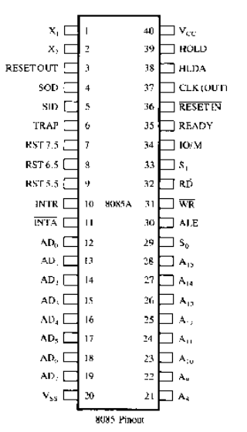

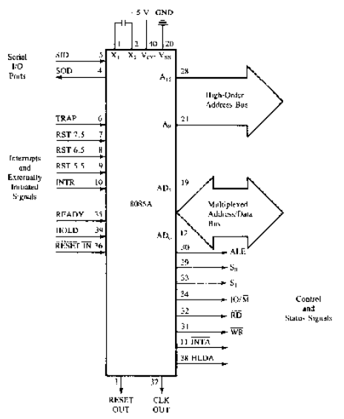

Control and Status signals:

8085 include 2 control signals and their status signals to identify nature of operation, and one special signal (ALE) to indicate the beginning of the operation.

ALE:
This is a positive going pulse generated every time the 8085 begins an operation (machine cycle). It indicates that the bits on AD₇ – AD₀ are address bits are address bits. This signal is primarily use to latch the low order address from the multiplexed bus and generate a separate set of 8 address lines A₇ – A₀.
__
WR:
This is a write control signal. It indicates that the data on the data bus are to be written into a selected memory or I/O location.
__
RD:
This is a read control signal. It indicates that a selected I/O or memory device is to be read and data are available on data bus.
__
IO/ M:
This is a status signal use to differentiate between I/O and memory operations. High indicates an I/O operation and low indicates a memory operation. This signal is combined with RD and WR to generate I/O and memory control signals- S₁ and S_{0.} These status signals identify various operations:

Machine Status Control Signals
Cycle IO/M S₁ S0___________________________________________

Opcode Fetch 0 1 1 RD = 0
Memory Read 0 1 0 RD = 0
Memory Write 0 0 1 WR = 0
I/O Read 1 1 0 RD = 0
I/O Write 1 0 1 WR = 0
Interrupt Acknw 1 1 1 INTA = 0
Halt z 0 0
Hold z x x RD, WR = z and INTA = 1
Reset z x x

Power Supply and Clock frequency:

Vcc = +5V power supply
Vss = Ground reference
X1, X2: A crystal (RC, LC n/w) is connected at these 2 pins. The frequency is internally divided by 2.
CLK:

Externally initiated Signals and Interrupts:

8085 has 5 interrupt signals that can interrupt the execution of the program.

- INTR (Input) Interrupt Request – MP can be interrupted from the normal execution of instructions and asked to execute some other instructions called Service routine. The MP resumes its operation after completing the service routine.
- INTA (out) – used to acknowledge an interrupt.
- RST 7.5
6.5 Restart are interrupts which transfer control to a specific
5.5 memory location. HP than INTR
- TRAP – Non-maskable, highest priority.
- HOLD – Indicates that a peripheral (DMA) is requesting the use of the address and the data bus.
- HLDA – Acknowledge the hold request.
- Ready – Used to delay the MP read or write cycles until a slow responding peripheral is ready to send or accept data. When this signal goes low, the MP waits for an integral number of clock cycles until it goes high.
That is, it enters into a wait state when the pin is low. Synchronize slower peripherals with the microprocessor.
- Reset – when the Reset pin is activated by an external key, all internal operations are suspended and the PC is cleared. Program execution again begins at zero (0000_{H})
- RESET IN – The PC is set to zero; buses are terstated; and the MPU is reset.
- RESET OUT – Indicates that the MPU is being reset. Also used to reset other devices.

Serial I/O Ports:

8085 has 2 signals to implement the serial transmission – SID (Serial Input Data) and SOD (Serial Output Data). Data bits are sent over a single line, one bit at a time.

MP is a programmable digital electronic component that incorporates the functions of a CPU on a single semi conducting integrated circuit.

MP Architecture:

MP has a set of instructions designed internally to manipulate data and to communicate with peripherals. The process of logic designing for data manipulation and communication is called MP architecture.

Address bus: Group of 16 lines used to send memory address/ device address generated by the processor to identify a memory/ peripheral device. It is unidirectional.

Data bus: Group of bidirectional lines used to transfer data between the MPU and peripherals.
Control bus: Single lines that carry synchronization signals. They provide timing signals for operation. They identify the device type with which MPU intends for communication.

8085 Programmable registers:

Accumulator Flag register B C D E H L Stack Pointer Program Counter

Data Bus Address Bus
(Bidirectional) (Unidirectional)

8085 functional block diagram.
8084 MP pinout and signals.

Multiprocessor Communication and Bus Timings:

Communication: Reading from and writing to memory between the MP and memory and the timing of these signals in relation to the system clock.
The first step is reading from memory or fetching an instruction.
E.g. MOV C, A – 4F_{H} (0100 1111)

Let us discuss the steps and timing of data flow when this instruction which is stored in 2005_{H} is being fetched. To fetch the byte, the MP needs to identify the memory location 2005H and enable the data flow from memory. This is called Fetch Cycle.

<Figure>

Timing diagrams shows 5 different groups of signals in relation to the system clock. The address bus and data bus are shown as 2 parallel lines. Crossover indicates that new information is placed on the bus, and a dashed line indicates a high impedance state.

<Figure>

Steps to fetch a byte from memory:

- MP places 16-bit memory address from the PC on the address bus.
At T₁, the high-order memory address 20_{H} is placed on the address line A₁₅-A₈ and low-order 05_{H} at AD₇-AD₀ lines and ALE signal goes high. M/IO status goes low, indicating a memory related operation.
- The control unit sends the control signal RD to enable the memory chip during clock period T₂ and is active during 2 clock periods.
- The byte (4F_{H}) from memory location is placed on the data bus AD₇-AD₆ and transferred to MP. RD goes high and cause bus to go into high impedance.
- The byte is placed in the instruction decoder of the MP and the task is carried out according to the instruction.

8085 Machine Cycles and Bus timings:

To execute an operation MOV C, A -4F_{H}
- One byte instruction.
- Requires one external operation- fetching a machine code from memory location 2005H
- The entire operation – fetching, decoding and executing require 4 clock periods.
There are 3 terms to examine the timing of various 8085 operations.

Instruction cycle:
The time required to complete the execution of an instruction. 8085 instruction cycle consist of 1 to 6 operations.

Machine Cycle:
Time required completing one operation of accessing memory, I/O or acknowledging an external request. It may contain 3 to 8 T-states.
T-State: One subdivision of the operation performed in one clock period and it is equal to one clock period.

Basically MP external functions can be divided into:
- Memory read
- Memory Write
- I/O Read
- I/O Write
- Opcode fetch
- Request acknowledge

Now we can focus on 3 operations Memory Read, Memory Write, and Opcode fetch and can examine the signals on various buses in relations to system clock.

Opcode fetch machine cycle:

The first operation in any instruction is Opcode fetch. The MP need to fetch this machine code from the memory register where it is stored before the microprocessor can begin to execute the instruction.
To differentiate an Opcode from a data byte or an address, this machine cycle is identified as the Opcode fetch cycle by the status signals (IO/M = 0, S₁=1, S₀=1). S₁ and S₀ being high indicate that it is an Opcode fetch cycle.
This Opcode fetch is called M₁ cycle and has 4 T-states. The first T₁-T₃ states are used to fetch the code and T₄ to decode and execute the Opcode.

Memory Read and machine cycle:

We can consider a 2-byte instruction.
E.g. MVI A, 32_{H}
Load a byte 32_{H} in the accumulator.
2000_{H} 0011 1110 ->3E_{H}
2001_{H} 0011 0010 ->32_{H}

Here this instruction has 2 machine codes stored in memory locations 2000_{H} and 2001_{H}. 3E_{H} represent the opcode to load a data byte in the accumulator and the second byte represents the data byte to be loaded in the accumulator. This instruction requires at least 2 machine cycles – one to fetch the opcode, the second one to load the data byte (memory read) –requires 7 T-states for these 2 machine cycles.
The fifth cycle is completed in state T₃. During T₄, 8085 decodes the opcode and finds that second byte needs to be read. After the T₃ state, the contents of the bus A₁₅-A₈ are unknown and the data bus AD₇–AD₀ goes into high impedance.

