1. Differentiate between synchronous and asynchronous data transfer. Site examples.
Serial communication occurs in either synchronous or asynchronous format. In the synchronous format, a receiver and transmitter are synchronized; a block of characters is transmitted along with the synchronization information. This format is generally used for high speed transmission.

The asynchronous format is character oriented. Each character carries the information of start and stop bits. The asynchronous format is generally used in low speed transmission lines

2. Explain the function of 8279 in four steps.
There are four major sections of 8279: keyboard, scan, display and MOPU interface.

- Keyboard is scanned and entries are debounced, and stored in internal FIFO
- Key code generation
- The key code generated is send to display section whichhas eight output lines. This section has RAM which can be used to read/ write information for display purposes
- Display refreshing

3. What is a control register? Explain the purpose of it.
Control register is a logical register, which helps to configure the different ports of the peripheral device. For example consider the control register of 8255. All the ports A, B and C can be configured in simple I/O mode or handshake mode by writing the appropriate control word into it. The contents of control register is called the control word, specify an I/O function for each port. This register can be accessed to write a control word when A0 and A1 are at logic 1. This register is not accessible for a read operation.

4. What are micro controllers?
A microcontroller is a computer-on-a-chip optimised to control devices. It is a type of microprocessor emphasizing self-sufficiency and cost-effectiveness, in contrast to a general-purpose microprocessor, the kind used in a PC. A typical microcontroller contains all the memory and I/O interfaces needed, whereas a general purpose microprocessor requires additional chips to provide these necessary functions.

5. What is the difference between near, short and far jumps implemented in 8086?
Near Jumps: The near jump is similar to the short jump except the distance is farther. A near jump passes control to an instruction in the current code segment located within ±32K bytes from the near jump instruction. The near jump is a 3-byte instruction that contains an opcode followed by a signed 16-bit displacement. The signed displacement adds to the instruction pointer (IP) to generate the jump address. Because the signed displacement is in the range of ±32K, a near jump can jump to any memory location within the current real mode code segment.
Short Jumps: Short jumps are called relative jumps because they can be moved anywhere in current code segment without a change. This is because a jump address is not stored with the opcode. Instead of a jump address, a distance, or displacement, follows the opcode. The short jump displacement is a distance represented by a 1-byte signed number whose value ranges between +127 and -128.
Far Jumps: The far jump obtains a new segment and offset address to accomplish the jump. Bytes 2 and 3 of this 5-byte instruction contain the new offset address and bytes 4 and 5 contain the new segment address, with the Low Byte followed by the High Byte in both cases.
6. What are the different types of program memory addressing modes?
- Direct Program Memory addressing modes (JMP instructions- intersegment jump)
- Relative Program Memory Addressing modes (JMP instructions-intrasegment jumps)
- Indirect program memory accessing modes (CALL instructions)

7. Explain the memory management in an 80286 processor.
80286 works in two operating modes like real address mode and protected virtual address mode. In the real address mode the 80286 just acts a fast 8086. In PVAM, 80286 works with all of its memory management and protection capabilities. In PVAM 80286 is able to address 16MB of physical memory whereas virtual memory available is 1 GB. This complete virtual memory is mapped to the physical memory. Another important aspect is the data protection or unauthorized access prevention. These concepts came from the segmented memory and also setting access privilege in the descriptor tables

Selectors: used to address a 64 kB memory segment in protected model; a segment register that holds the current descriptor number; 16 bits in length , 2 bits for requested privilege level ,1 bit for table indicator (local or global) ,13 bits for index (8,192 possible descriptors)

8. What are string related instructions for 8086?
- REP
- MOVSB/MOVSW
- CMPS
- SCAS
- LODS
- STOS

9. Explain the paging mechanism of 80386
Paging mechanism : - pages of fixed size.
Page descriptor, Global Descriptor Table.
Idea that Page directory + page table base entry + offset is the effective address. (With figure.) PCD bit is in CR3(bit 4). The PCD bit along with PWT bit is used to control the operation of the PCD and PWT pins of the microprocessor. If PCD is set (1), the PCD pin becomes a logic one during bus cycles that are not pages. This allows the external hardware to control the level 2 cache memory.

10. Compare RISC and CISC processors.
CISC-Complex Instruction Set Computers
Disadvantages of CISCs
  - complexity in the addressing modes
  - Slower speed ( due to less pipelinin)
  - Separate coprocessors- the overall floating point speed performace is not much
  - Total no of registers is only 8
RISC Reduced Instruction set computers consists of a simple set of instruction set with less complex addressing modes and obviously and associated simple instruction decoder. The power of a RISC architecture lies in the massive pipelining

11. Draw the block diagram of 8255 and explain the functional blocks

Data Bus Buffer
This three-state bi-directional 8-bit buffer is used to interface the 8255 to the system data bus. Data is transmitted or received by the buffer upon execution of input or output instructions by the CPU. Control words and status informa-tion are also transferred through the data bus buffer.
Read/Write and Control Logic
The function of this block is to manage all of the internal and external transfers of both Data and Control or Status words. It accepts inputs from the CPU Address and Control busses and in turn, issues commands to both of the Control Groups.
(CS) Chip Select. A "low" on this input pin enables the communcation between the 8255 and the CPU.
(RD) Read. A "low" on this input pin enables 8255 to send the data or status information to the CPU on the data bus. In essence, it allows the CPU to "read from" the 8255.
(WR) Write. A "low" on this input pin enables the CPU to write data or control words into the 8255.
(A0 and A1) Port Select 0 and Port Select 1. These input signals, in conjunction with the RD and WR inputs, control the selection of one of the three ports or the control word register. They are normally connected to the least significant bits of the address bus (A0 and A1).
(RESET) Reset. A "high" on this input initializes the control register to 9Bh and all ports (A, B, C) are set to the input mode.

A1 | A0 | SELECTION
0 | 0 | PORT A
0 | 1 | PORT B
1 | 0 | PORT C
1 | 1 | CONTROL
Group A and Group B Controls
The functional configuration of each port is programmed by the systems software. In essence, the CPU "outputs" a control word to the 8255. The control word contains information such as "mode", "bit set", "bit reset", etc., that initializes the functional configuration of the 8255. Each of the Control blocks (Group A and Group B) accepts "commands" from the Read/Write Control logic, receives "control words" from the internal data bus and issues the proper commands to its associated ports.
Ports A, B, and C
The 8255 contains three 8-bit ports (A, B, and C). All can be configured to a wide variety of functional characteristics by the system software but each has its own special features or "personality" to further enhance the power and flexibility of the 8255.
Port A One 8-bit data output latch/buffer and one 8-bit data input latch. Both "pull-up" and "pull-down" bus-hold devices are present on Port A.
Port B One 8-bit data input/output latch/buffer and one 8-bit data input buffer.
Port C One 8-bit data output latch/buffer and one 8-bit data input buffer (no latch for input). This port can be divided into two 4-bit ports under the mode control. Each 4-bit port contains a 4-bit latch and it can be used for the control signal output and status signal inputs in conjunction with ports A and B.

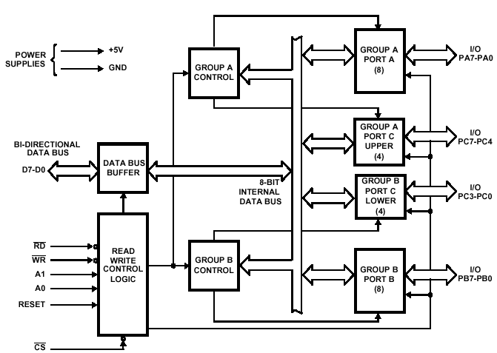
12. With a neat block diagram explain the architecture of USART 8251A
The programmable communications interface (USART) core provides data formatting and control to a serial communication channel.The core has select, read/write, interrupt and bus interface logic features that allow data transfers over an 8-bit bi-directional parallel data bus system. With proper formatting and error checking, the core can transmit and receive serial data, supporting both synchronous and asynchronous operation
The 8251Acomes up in any mode and must be initialized. It has only onecommand port, but the command word has an internal reset bit. The data sheet recommends writing 0 to the command port three times and then an internal reset (40H). Then the mode word can be sent. After the mode word has been sent, command words can be sent to 0FFF2H. Commands can be written at any time. A reset command in needed to change the mode. The initial command enables the receiver and transmitter.
Once programmed, the 8251Aoperates as follows. TxRDY is high if the 8251A is ready transmit. TxRDY is reset when the CPU writes a character to the 8251A.The 8251A adds start, stop, and parity bits.The character is put into a shift register and shifted out one bit at a time. Data is shifted out on the TxD pin. Data is shifted out on the falling edge of the transmitter clock TxC’.The bit rate is 1, 1/16, or 1/64 that of the transmitter clock. TxRDY goes high after character has been shifted out. When not transmitting, TxD is high unless a Break is sent.
Serial data comes into the 8251A on the RxD pin.After receiving the entire character, RxRDY is asserted.RxRDY is reset when the CPU reads the data. The validity of the start bit is checked by strobing this bit in its nominal center (16x or 64x mode only).Bits are sampled on the rising edge of RxC. Errors (Shown in bits 3, 4, and 5 of the status word.)
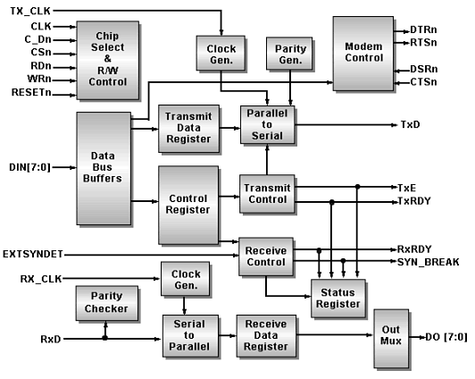
13. Explain how a keyboard and a seven segment LED can be interfaced to 8085

A pushbutton keyboard is connected to port A and a seven segment Led is connected to port B of 8255. Port A should be configured as an input port and port B as an output port

- Analyse the address decoding circuits and find the address of port A, port B and control register
- Write the appopriate control word to the control register to configure the ports as required.
- Check if a key is pressed- write the software program to do it
- Debounce the key- hardware soln- use of cross coupled NAND gate and software soln is to write a delay loop
- Identify the key pressed- write the ALP to store the identified key in the accumulator
- Encode the key – converts the binary hardware reading of the key 0pressed into appropriate binary format according to the number of the key
- Obtain the seven segment LED code using table look-up technique and display it

Circuit diagram needed.

14. Explain the interfacing of ADC with 8085
ADC converts analog signal to digital signal. The most commonly used is successive approximation type ADC. (explain SAR etc)

ADC can be interfaced to 8085 microprocessor system through tri-state buffer or port devices such as 8255. ADC0801 is a single channel 8 bit conversion type ADC. It has two analog inputs Vin(+) and vin(-). When the analog signal is single ended positive, then Vin(+) is used and Vin(-) is grounded. ADC requires an external clock. Typically the clock frequency is 640 kHz. The chip select signal is obtained form the address decoder of the 8085 system. The conversion is initiated when both chip select and write signal is low. The write control signal is used to reset the SAR of ADC to give SOC. The end of conversion by asserting interrupt signal low and this signal can be inverted to interrupt the 8085 microprocessor. The processor reads the digital data.

Give diagram also
15. With a block diagram, explain the architecture of 8086

The 8086 introduced the reign of the Intel 80x86 microprocessor family. Despite its design based on the previous 8-bit processors (e.g. the 8080 and the 8085), the 8086 is not entirely compatible with its predecessors. The 8086, the first widely used 16-bit microprocessor has been used to power the first IBM PCs.

The 8086 has a microprogrammed sequencer, but has also many wired functionalities such as to optimise the size of the microcode. The vertical microinstructions are 21-bit wide. The microprogram ROM contains 504 microinstructions. The 8086 has two functional units aimed to work in parallel : the BIU (Bus Interface Unit) and the EU (Execution Unit)
Execution Unit
The arithmetic and logic unit may be loaded from three temporary registers (TMPA, TMPB, TMPC) and execute operations on bytes or 16-bit words. The result of an operation may be stored into one the temporary registers, or into any one of the 16-bit registers connected to the internal data bus. These registers consist in four general registers called AX, BX, CX and DX, two stack pointers (SP and BP), and two index registers (SI and DI).
Bus Interface Unit
The bus interface unit is intended to co,pute the addresses. This unit is made of two temporary registers used by indirect addressing, four segment registers (DS, CS, SS and ES), a program counter (IP - Instruction Pointer), and a 6-byte stack to store the pre-fetched opcodes and data.

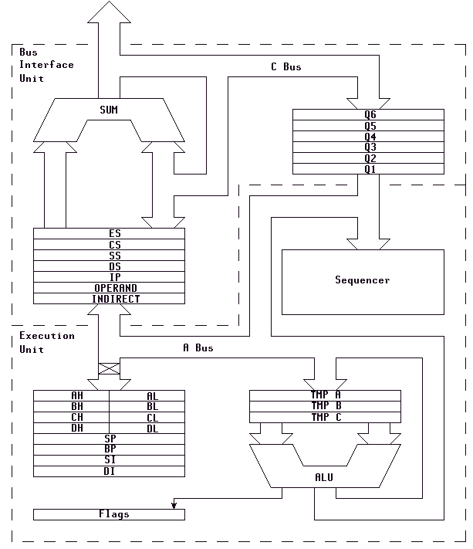

16. Explain the various addressing modes used in 8086. Give examples

The Displacement Only Addressing Mode
The most common addressing mode, is the displacement-only (or direct) addressing mode. The displacement-only addressing mode consists of a 16 bit constant that specifies the address of the target location. The instruction mov al,ds:[8088h] loads the al register with a copy of the byte at memory location 8088h. Likewise, the instruction mov ds:[1234h],dl stores the value in the dl register to memory location 1234h:
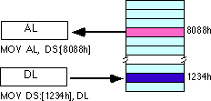
The displacement-only addressing mode is perfect for accessing simple variables.
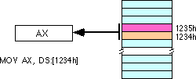
By default, all displacement-only values provide offsets into the data segment. If we want to provide an offset into a different segment, we must use a segment override prefix before the address. For example, to access location 1234h in the extra segment (es) we would use an instruction of the form mov ax,es:[1234h]. Likewise, to access this location in the code segment we would use the instruction mov ax, cs:[1234h]. The ds: prefix in the previous examples is not a segment override. The CPU uses the data segment register by default. These specific examples require ds: because of MASM's syntactical limitations.

The Register Indirect Addressing Modes
In 80x86, memory can be accessed indirectly through a register using the register indirect addressing modes. There are four forms of this addressing mode on the 8086, best demonstrated by the following instructions:
mov al, [bx]
mov al, [bp]
mov al, [si]
mov al, [di]
As with the x86 [bx] addressing mode, these four addressing modes reference the byte at the offset found in the bx, bp, si, or di register, respectively. The [bx], [si], and [di] modes use the ds segment by default. The [bp] addressing mode uses the stack segment (ss) by default.
Intel refers to [bx] and [bp] as base addressing modes and bx and bp as base registers (in fact, bp stands for base pointer). Intel refers to the [si] and [di] addressing modes as indexed addressing modes (si stands for source index, di stands for destination index). However, these addressing modes are functionally equivalent. This text will call these forms register indirect modes to be consistent.
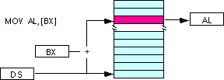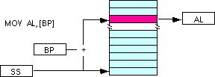
Note: the [si] and [di] addressing modes work exactly the same way, just substitute si and di for bx above.

Indexed Addressing Modes
The indexed addressing modes use the following syntax:
mov al, disp[bx]
mov al, disp[bp]
mov al, disp[si]
mov al, disp[di]
If bx contains 1000h, then the instruction mov cl,20h[bx] will load cl from memory location ds:1020h. Likewise, if bp contains 2020h, mov dh,1000h[bp] will load dh from location
ss:3020.
The offsets generated by these addressing modes are the sum of the constant and the specified register. The addressing modes involving bx, si, and di all use the data segment, the disp[bp] addressing mode uses the stack segment by default. As with the register indirect addressing modes, we can use the segment override prefixes to specify a different segment:
mov al, ss:disp[bx]
mov al, es:disp[bp]
mov al, cs:disp[si]
mov al, ss:disp[di]
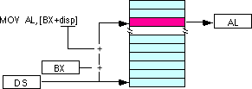

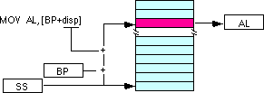
We may substitute si or di in the figure above to obtain the [si+disp] and [di+disp] addressing modes.
Based Indexed Addressing Modes
The based indexed addressing modes are simply combinations of the register indirect addressing modes. These addressing modes form the offset by adding together a base register (bx or bp) and an index register (si or di). The allowable forms for these addressing modes are
mov al, [bx][si]
mov al, [bx][di]
mov al, [bp][si]
mov al, [bp][di]
Suppose that bx contains 1000h and si contains 880h. Then the instruction
mov al,[bx][si]
would load al from location DS:1880h. Likewise, if bp contains 1598h and di contains 1004, mov ax,[bp+di] will load the 16 bits in ax from locations SS:259C and SS:259D.
The addressing modes that do not involve bp use the data segment by default. Those that have bp as an operand use the stack segment by default.
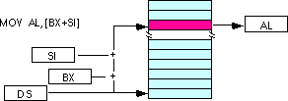
By substituting di in the figure above, we can obtain the [bx+di] addressing mode.
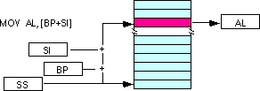
We substitute di in the figure above for the [bp+di] addressing mode.

Based Indexed Plus Displacement Addressing Mode
These addressing modes are a slight modification of the base/indexed addressing modes with the addition of an eight bit or sixteen bit constant. The following are some examples of these addressing modes:
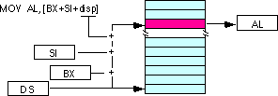
mov al, disp[bx][si]
mov al, disp[bx+di]
mov al, [bp+si+disp]
mov al, [bp][di][disp]
di may be substituted in the figure above to produce the [bx+di+disp] addressing mode.
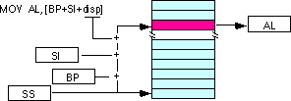
Suppose bp contains 1000h, bx contains 2000h, si contains 120h, and di contains 5. Then mov al,10h[bx+si] loads al from address DS:2130; mov ch,125h[bp+di] loads ch from location SS:112A; and mov bx,cs:2[bx][di] loads bx from location CS:2007.
17. What are the various data transfer instructions associated with 8086.

- Load Effective Address LEA
Loads the register specified by the destination operand with the effective address of the source operand. If the source operand is a symbol, then LEA reg,symbol is equivalent to MOV reg, OFFSET symbol. This instruction is thus only meaningful if the operand is specified using a based or indexed addessing mode.
LEA reg, mem
- Load string data LODS
  - LODSB
Loads AL with the byte pointed to by DS:SI, and updates SI depending on the direction flag. If DF is set SI is decremented, otherwise SI is decremented.
  - LODSW
Loads AX with the 16-bit word pointed to by DS:SI, and updates SI depending on the direction flag. If DF is set SI is added 2, otherwise SI is subtracted 2.
- MOV
Copies the value in the source operand to the destination operand.
- MOVS Move String Data
  - MOVSB
Copies a byte string from one area of memory to another. The source string must be pointed to by DS:SI, and the destination address must be pointed to by ES:DI. For each element copied, DI and SI are updated depending on the direction flag : if DF is cleared they are incremented, if DF is set they are decremented. This instruction is usually used with a repetition prefix like REP.

  - MOVSW
Copies a 16-bit word string from one area of memory to another. The source string must be pointed to by DS:SI, and the destination address must be pointed to by ES:DI. For each element copied, DI and SI are updated depending on the direction flag : if DF is cleared they are incremented by 2, if DF is set they are decremented by 2.
- XCHG
Exchanges the values of the source and the destination operands

18. Write an ALP to find the largest of ten numbers

ASSUME CS:CODE, DS:DATA
DATA SEGMENT ;Data segment starts
LIST DB 10H, 23H ,05H…. ;List of bytes
COUNT EQU O9H ; Number of bytes in the list
LARGEST DB 01H DUP(?) ;One byte is reserved for largest No:
DATA ENDS ;Data Segment ends

CODE SEGMENT ;Code segment starts
START: MOV AX,DATA ;Intitialise data segment
MOV DS, AX
MOV SI, OFFSET LIST
MOV CL, COUNT ;Number of bytes in CL
MOV AL, [SI] ;Take the first number in AL
AGAIN: CMP AL,[SI+1] ; and compare it with next number
JNL NEXT
MOV AL,[SI+1]
NEXT: INC SI ;Increment pointer to byte list
DEC CL ;Decrement counter
JNZ AGAIN ;If all numbers are compared point to result
MOV SI, OFFSET LARGEST;destination and store it
MOV [SI], AL
CODE ENDS

19. What are global and local descriptors? Explain the descriptor structure for 80386.
The segment descriptor provides the processor with the data it needs to map a logical address into a linear address. Descriptors are created by compilers, linkers, loaders, or the operating system, not by applications programmers. There are two general descriptor formats. All types of segment descriptors take one of these formats. Segment-descriptor fields are:
BASE: Defines the location of the segment within the 4 gigabyte linear address space. The processor concatenates the three fragments of the base address to form a single 32-bit value.
LIMIT: Defines the size of the segment. When the processor concatenates the two parts of the limit field, a 20-bit value results. The processor interprets the limit field in one of two ways, depending on the setting of the granularity bit:
- In units of one byte, to define a limit of up to 1 megabyte.
- In units of 4 Kilobytes, to define a limit of up to 4 gigabytes. The limit is shifted left by 12 bits when loaded, and low-order one-bits are inserted.
Granularity bit: Specifies the units with which the LIMIT field is interpreted. When thebit is clear, the limit is interpreted in units of one byte; when set, the limit is interpreted in units of 4 Kilobytes.
TYPE: Distinguishes between various kinds of descriptors.
DPL (Descriptor Privilege Level): Used by the protection mechanism
Segment-Present bit: If this bit is zero, the descriptor is not valid for use in address transformation; the processor will signal an exception when a selector for the descriptor is loaded into a segment register. The figure shows the format of a descriptor when the present-bit is zero. The operating system is free to use the locations marked AVAILABLE. Operating systems that implement segment-based virtual memory clear the present bit in either of these cases:
- When the linear space spanned by the segment is not mapped by the paging mechanism.
- When the segment is not present in memory.
Accessed bit: The processor sets this bit when the segment is accessed; i.e., a selector for the descriptor is loaded into a segment register or used by a selector test instruction. Operating systems that implement virtual memory at the segment level may, by periodically testing and clearing this bit, monitor frequency of segment usage.
Segment descriptors are stored in either of two kinds of descriptor table:
- The global descriptor table (GDT)
- A local descriptor table (LDT)
A descriptor table is simply a memory array of 8-byte entries that contain descriptors, A descriptor table is variable in length and may contain up to 8192 (2^(13)) descriptors.

20. Explain the architecture of Pentium processor. Discuss Code and data cache.

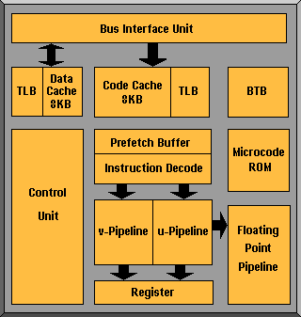
The majority of Pentiums (75MHz and above) operate on 3.3v with 5v I/O protection. The Pentium has a dual pipelined superscalar design, allowing it to execute more instructions per clock cycle. There are still five stages (Prefetch, Instruction Decode, Address Generate, Execute and Write Back) in the execution of integer instructions, like that of the 486, but the Pentium has two parallel integer pipelines, enabling it to read, interpret, execute and despatch two operations simultaneously. These only handle integer calculations - a separate Floating Point Unit handles "real" numbers.
The Pentium also uses two 8KB, two-way set, associative buffers one for instructions and another for data. They are known as code and data cache.This is twice the amount of its predecessor, the 486. These caches contribute to increased performance because they act as a temporary storage place for data instructions obtained from the slower main memory.
A Branch Target Buffer (BTB) provides dynamic branch prediction. The BTB enhances instruction execution by "remembering" which way an instruction branched and applying the same branch the next time the instruction is used. When the BTB makes a correct prediction, performance is improved. An 80-point Floating Point Unit provides the arithmetic engine to handle "real" numbers.

- Explain the display modes of 8279
Display section has eight output lines divided into two groups A0-A3 and B0-B3. The output lines are connected to the anodes through driver transistor in case of common cathode 7 segment LED. The display can be blanked by BD line. The display section consist of 16X 8 display RAM which can also be organsied into dual 16X4. the CPU have to load the display codes in this RAM. Once the data is loaded, 8270 takes care of display and refreshing

- Give the control word format of 8255
8255 can operate in two modes Input/Output mode and Bit set/Reset Mode. To make the operation possible in either of these modes, we write control words to control register
If bit 7 of the control word is a logical 1 then the 8255 will be configured in I/O mode
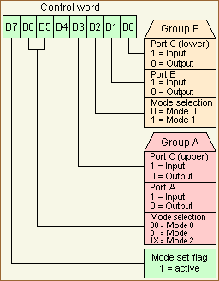
If bit 7 of the control word is a logical 0 then each bit of the port C can be set or reset.
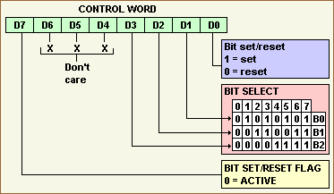

- Explain the features of a microcontroller

A microcontroller is a computer-on-a-chip optimised to control devices. It is a type of microprocessor emphasizing self-sufficiency and cost-effectiveness, in contrast to a general-purpose microprocessor, the kind used in a PC. A typical microcontroller contains all the memory and I/O interfaces needed, whereas a general purpose microprocessor requires additional chips to provide these necessary functions.

- How a key debounce can be checked? Explain

When a key is pressed it bounces for a short time. If a key code is generated immediately after sensing a key actuation, then the processor will generate the same keycode a number of times. A key typically bounces for 10 to 20 ms. Hence the processor has to wait for the key bounces to settle before reading the keycode.
To avoid this, the software approach is to write a delay loop and the hardware approach is to use cross-coupled NAND gate.

- How the physical address can be generated from effective address
The complete physical address which is 20 bits long is generated using segment and offset registers, each 16 bit long.. For generating a physical address from contents of these two registers, the content of a segment register also called as segment address is shifted left bit-wise four times and to this result, content of an offset register also called as offset address is added to produce a 20 bit physical address.
Give examples also

- What is a stack register? How it can be initialized?
The stack can be described as a set of memory locations in the R/W memory. The beginning of the stack is defined in the program by using the instruction LXI, SP 16 bit that loads a 16-bit memory address in the stack pointer register of the microprocessor. The stack is initialized at the highest available memory location. The size of the stack is limited only by the available memory. Data bytes in the register pair of the mp can be stored on the stack in reverse order by using PUSH and data can be transferred form the stack to respective registers by using POP

- What are the logical instructions available for 8086? Explain

AND- Performs a bitwise logical AND on the source and destination operands and stores the result in the destination operand
NOT- Toggles each bit of the operand.
OR-Performs a bitwise logical OR on the source and destination operands and stores the result to the destination operand.
XOR-Performs a bitwise exclusive OR on the source and the destination operands, and stores the result in the destination operand.

- Give the functions of the following intimations
  - POPF- Pops the value on the top of the stack into the flags register.

  - LEA- load Effective Address Loads the register specified by the destination operand with the effective address of the source operand. If the source operand is a symbol, then LEA reg,symbol is equivalent to MOV reg, OFFSET symbol. This instruction is thus only meaningful if the operand is specified using a based or indexed addressing mode.
c) SCASW- Scans a string of 16-bit words to find a value specified in AX. The string to be scanned is considered the destination and must be pointed to by ES:DI. For each string element, the destination element is subtracted from the accumulator value and the flags are updated to reflect the result (although the result is not stored). DI is adjusted depending on the value of the direction flag. It is incremented by 2 if the flag is cleared or decremented by 2 if it is set.
d) LOOP- Loops repeatedly to a specified label. LOOP decrements CX (without changing any flags) and if the result is not 0, transfers execution to the address specified by the operand. If CX is 0 after being decremented, execution continues at the next instruction. The operand must specify a short label (between -128 and +127 bytes from the instruction following the LOOP instruction).

- How a processor can function in virtual mode? Explain

In a programmer’s view, there exists a large memory space which is not actually present in the system memory. Although the processor may have only 16MB of physical memory, large application programs, requiring more memory can be executed using the available memory by dividing it into smaller segments. Thus to the user there exists a very large logical memory space which is not actually available. As the name suggests, virtual memory does not exist physically in a system. It is however possible to map a large virtual memory space onto the real physical memory.

- Give the features of RISC processor
- RISC is Reduced Instruction Set Computers
- Simple set of instructions
- Less complex addressing modes
- Simple instruction decoder
- Massive pipelining
- On-chip co-processors
- More speed compared to CISCs

- Discuss the organization and architecture of 8255 with block diagram
Data Bus Buffer
This three-state bi-directional 8-bit buffer is used to interface the 8255 to the system data bus. Data is transmitted or received by the buffer upon execution of input or output instructions by the CPU. Control words and status informa-tion are also transferred through the data bus buffer.
Read/Write and Control Logic
The function of this block is to manage all of the internal and external transfers of both Data and Control or Status words. It accepts inputs from the CPU Address and Control busses and in turn, issues commands to both of the Control Groups.
(CS) Chip Select. A "low" on this input pin enables the communcation between the 8255 and the CPU.
(RD) Read. A "low" on this input pin enables 8255 to send the data or status information to the CPU on the data bus. In essence, it allows the CPU to "read from" the 8255.
(WR) Write. A "low" on this input pin enables the CPU to write data or control words into the 8255.
(A0 and A1) Port Select 0 and Port Select 1. These input signals, in conjunction with the RD and WR inputs, control the selection of one of the three ports or the control word register. They are normally connected to the least significant bits of the address bus (A0 and A1).
(RESET) Reset. A "high" on this input initializes the control register to 9Bh and all ports (A, B, C) are set to the input mode.

A1 | A0 | SELECTION
0 | 0 | PORT A
0 | 1 | PORT B
1 | 0 | PORT C
1 | 1 | CONTROL
Group A and Group B Controls
The functional configuration of each port is programmed by the systems software. In essence, the CPU "outputs" a control word to the 8255. The control word contains information such as "mode", "bit set", "bit reset", etc., that initializes the functional configuration of the 8255. Each of the Control blocks (Group A and Group B) accepts "commands" from the Read/Write Control logic, receives "control words" from the internal data bus and issues the proper commands to its associated ports.
Ports A, B, and C
The 8255 contains three 8-bit ports (A, B, and C). All can be configured to a wide variety of functional characteristics by the system software but each has its own special features or "personality" to further enhance the power and flexibility of the 8255.
Port A One 8-bit data output latch/buffer and one 8-bit data input latch. Both "pull-up" and "pull-down" bus-hold devices are present on Port A.
Port B One 8-bit data input/output latch/buffer and one 8-bit data input buffer.
Port C One 8-bit data output latch/buffer and one 8-bit data input buffer (no latch for input). This port can be divided into two 4-bit ports under the mode control. Each 4-bit port contains a 4-bit latch and it can be used for the control signal output and status signal inputs in conjunction with ports A and B.

- a) Give the internal architecture of 8279 and explain the functions of each block

The functional block diagram of 8279 has four major sections
    - Keyboard
    - Scan
    - Display
    - CPU Interface
Keyboard section consists of eight return lines RL0-RL7, that can be used to form the columns of a keyboard matrix. It has two additional inputs shift and control/strobe. The keys are automatically debounce. It also has a 8X8 FIFO RAM. It can store 8 keycodes. The status of the shift and control key are also stored along with keycode. 8279 generates an interrupt signal when there is an entry on FIFO.
Display section has eight output lines divided into two groups A0-A3 and B0-B3. The output lines are connected to the anodes through driver transistor in case of common cathode 7 segment LED. The display can be blanked by BD line. The display section consist of 16X 8 display RAM which can also be organsied into dual 16X4. the CPU have to load the display codes in this RAM. Once the data is loaded, 8270 takes care of display and refreshing
Scan section has a scan counter and four scan lines, SL0-SL3. The scan lines are used to form the rows of a matrix keyboard and the digit drivers of a multiplexed display.
CPU interface takes care of data transfer between 8279 and the processor. This section has eight bi-directional data lines DB0-DB7 for data transfer.

b) Explain the necessity of display RAM in 8279
Display section has eight output lines divided into two groups A0-A3 and B0-B3. The output lines are connected to the anodes through driver transistor in case of common cathode 7 segment LED. The display can be blanked by BD line. The display section consist of 16X 8 display RAM which can also be organsied into dual 16X4. the CPU have to load the display codes in this RAM. Once the data is loaded, 8270 takes care of display and refreshing

- a) Give the procedure for interfacing a matrix keyboard with 8085
(matrix keyboard interfacing is not mentioned in the syllabus)

A matrix keyboard is where there are more than eight keys. A keyboard with 16 keys can be arranged in a 4 x 4 matrix. It requires eight lines from the microprocessor to make all the connections. When a key is pressed, it shorts one row and column. The interfacing of a matrix keyboard requires two ports: one output port and one input port. Rows are connected to the output port and the columns are connected to the input port.

- Ground all the rows by sending logic 0 through the output port
- Check the columns by reading the input port. If no key is pressed, all columns remain high. Continue the above two steps until the reading indicates a change
- When one of the keys is pressed, the corresponding column goes low; identify and encode the key
(Description in Gaonkar 575-580)

b) Explain the features of a DAC
- DAC requires three elements – resistor network with appropriate weighting, switches and a reference source
- The output can be a current signal or converted into a voltage signal using an operational amplifier
- The time required for conversion, called settling time, is dependent on the response time of the switches and the output amplifier.

- a) Give the detailed procedure for interfacing a seven segment display with 8085 using 8255

A pushbutton keyboard is connected to port A and a seven segment Led is connected to port B of 8255. Port A should be configured as an input port and port B as an output port

- Analyse the address decoding circuits and find the address of port A, port B and control register
- Write the appopriate control word to the control register to configure the ports as required.
- Check if a key is pressed- write the software program to do it
- Debounce the key- hardware soln- use of cross coupled NAND gate and software soln is to write a delay loop
- Identify the key pressed- write the ALP to store the identified key in the accumulator
- Encode the key – converts the binary hardware reading of the key 0pressed into appropriate binary format according to the number of the key
- Obtain the seven segment LED code using table look-up technique and display it

Circuit diagram needed.

b) Explain the procedure for interfacing an ADC with 8085 using status check method

ADC converts analog signal to digital signal. The most commonly used is successive approximation type ADC. (explain SAR etc)

ADC can be interfaced to 8085 microprocessor system through tri-state buffer or port devices such as 8255. ADC0801 is a single channel 8 bit conversion type ADC. It has two analog inputs Vin(+) and vin(-). When the analog signal is single ended positive, then Vin(+) is used and Vin(-) is grounded. ADC requires an external clock. Typically the clock frequency is 640 kHz. The chip select signal is obtained form the address decoder of the 8085 system. The conversion is initiated when both chip select and write signal is low. The write control signal is used to reset the SAR of ADC to give SOC. The end of conversion by asserting interrupt signal low and this signal can be inverted to interrupt the 8085 microprocessor. The processor reads the digital data.

Give diagram also

- a) Give the internal architecture of 8086
The 8086 introduced the reign of the Intel 80x86 microprocessor family. Despite its design based on the previous 8-bit processors (e.g. the 8080 and the 8085), the 8086 is not entirely compatible with its predecessors. The 8086, the first widely used 16-bit microprocessor has been used to power the first IBM PCs.
The 8086 has a microprogrammed sequencer, but has also many wired functionalities such as to optimise the size of the microcode. The vertical microinstructions are 21-bit wide. The microprogram ROM contains 504 microinstructions. The 8086 has two functional units aimed to work in parallel : the BIU (Bus Interface Unit) and the EU (Execution Unit)
Execution Unit
The arithmetic and logic unit may be loaded from three temporary registers (TMPA, TMPB, TMPC) and execute operations on bytes or 16-bit words. The result of an operation may be stored into one the temporary registers, or into any one of the 16-bit registers connected to the internal data bus. These registers consist in four general registers called AX, BX, CX and DX, two stack pointers (SP and BP), and two index registers (SI and DI).
Bus Interface Unit
The bus interface unit is intended to compute the addresses. This unit is made of two temporary registers used by indirect addressing; four segment registers (DS, CS, SS and ES), a program counter (IP - Instruction Pointer), and a 6-byte stack to store the pre-fetched opcodes and data.

b) What is the necessity of instruction queue?

Instruction queue is 6 bytes long, FIFI structure. The instructions form the queue are taken for decoding sequentially. Once a byte is decoded, the queue is rearranged by pushing it out and the queue status is checked for the possibility of the next opcode fetch cycle. While the opcode is fetched bus interface unit, the execution unit executes the previously decoded instruction concurrently. The microprocessor does not perform the next fetch instruction till at least two bytes of the instruction queue are emptied.By prefetching the instruction there is a considerable speeding up in instruction execution in 8086. This scheme is known as instruction pipelining.

- With the help of examples explain the various addressing modes of 8086

The Displacement Only Addressing Mode
The most common addressing mode, is the displacement-only (or direct) addressing mode. The displacement-only addressing mode consists of a 16 bit constant that specifies the address of the target location. The instruction mov al,ds:[8088h] loads the al register with a copy of the byte at memory location 8088h. Likewise, the instruction mov ds:[1234h],dl stores the value in the dl register to memory location 1234h:
The displacement-only addressing mode is perfect for accessing simple variables.
By default, all displacement-only values provide offsets into the data segment. If we want to provide an offset into a different segment, we must use a segment override prefix before the address. For example, to access location 1234h in the extra segment (es) we would use an instruction of the form mov ax,es:[1234h]. Likewise, to access this location in the code segment we would use the instruction mov ax, cs:[1234h]. The ds: prefix in the previous examples is not a segment override. The CPU uses the data segment register by default. These specific examples require ds: because of MASM's syntactical limitations.

The Register Indirect Addressing Modes
In 80x86, memory can be accessed indirectly through a register using the register indirect addressing modes. There are four forms of this addressing mode on the 8086, best demonstrated by the following instructions:
mov al, [bx]
mov al, [bp]
mov al, [si]
mov al, [di]
As with the x86 [bx] addressing mode, these four addressing modes reference the byte at the offset found in the bx, bp, si, or di register, respectively. The [bx], [si], and [di] modes use the ds segment by default. The [bp] addressing mode uses the stack segment (ss) by default.
Intel refers to [bx] and [bp] as base addressing modes and bx and bp as base registers (in fact, bp stands for base pointer). Intel refers to the [si] and [di] addressing modes as indexed addressing modes (si stands for source index, di stands for destination index). However, these addressing modes are functionally equivalent. This text will call these forms register indirect modes to be consistent.
Note: the [si] and [di] addressing modes work exactly the same way, just substitute si and di for bx above.

Indexed Addressing Modes
The indexed addressing modes use the following syntax:
mov al, disp[bx]
mov al, disp[bp]
mov al, disp[si]
mov al, disp[di]
If bx contains 1000h, then the instruction mov cl,20h[bx] will load cl from memory location ds:1020h. Likewise, if bp contains 2020h, mov dh,1000h[bp] will load dh from location
ss:3020.
The offsets generated by these addressing modes are the sum of the constant and the specified register. The addressing modes involving bx, si, and di all use the data segment, the disp[bp] addressing mode uses the stack segment by default. As with the register indirect addressing modes, we can use the segment override prefixes to specify a different segment:
mov al, ss:disp[bx]
mov al, es:disp[bp]
mov al, cs:disp[si]
mov al, ss:disp[di]

We may substitute si or di in the figure above to obtain the [si+disp] and [di+disp] addressing modes.
Based Indexed Addressing Modes
The based indexed addressing modes are simply combinations of the register indirect addressing modes. These addressing modes form the offset by adding together a base register (bx or bp) and an index register (si or di). The allowable forms for these addressing modes are
mov al, [bx][si]
mov al, [bx][di]
mov al, [bp][si]
mov al, [bp][di]
Suppose that bx contains 1000h and si contains 880h. Then the instruction
mov al,[bx][si]
would load al from location DS:1880h. Likewise, if bp contains 1598h and di contains 1004, mov ax,[bp+di] will load the 16 bits in ax from locations SS:259C and SS:259D.
The addressing modes that do not involve bp use the data segment by default. Those that have bp as an operand use the stack segment by default.
By substituting di in the figure above, we can obtain the [bx+di] addressing mode.
We substitute di in the figure above for the [bp+di] addressing mode.

Based Indexed Plus Displacement Addressing Mode
These addressing modes are a slight modification of the base/indexed addressing modes with the addition of an eight bit or sixteen bit constant. The following are some examples of these addressing modes:
mov al, disp[bx][si]
mov al, disp[bx+di]
mov al, [bp+si+disp]
mov al, [bp][di][disp]
di may be substituted in the figure above to produce the [bx+di+disp] addressing mode.
Suppose bp contains 1000h, bx contains 2000h, si contains 120h, and di contains 5. Then mov al,10h[bx+si] loads al from address DS:2130; mov ch,125h[bp+di] loads ch from location SS:112A; and mov bx,cs:2[bx][di] loads bx from location CS:2007.

- a) Write an ALP for checking the even and odd numbers from a group of numbers for 8086 store this even numbers and odd numbers in to separate memory location

ASSUME CS: CODE, DS:DATA
DATA SEGMENT
LIST DW 2357H, 0A579H, 0C322H,….
COUNT EQU 010H
DATA ENDS
CODE SEGMENT
START: XOR BX,BX
XOR DX, DX
MOV AX, DATA
MOV DS, AX
MOV CL, COUNT
MOV SI, OFFSET LIST
AGAIN: MOV AX,[SI]
ROR AX, 01
JC ODD
INC BX
JMP NEXT
ODD: INC DX
NEXT: ADD SI,02
DEC CL
JNZ AGAIN
CODE ENDS
END START

b) What is an assembler directive?
The assembler directives are the instructions to the assembler regarding the program being assembled. The assembler directives will give information like start and end of a program; values of variable used in the program; storage locations for input and output data. The assembler directives are not translated into machine code.
Eg: START, ENDS, EQU, DB , DW

- a) Give the additional features of 80286
- 16-bit processor with 24 bit addressing 16 Mb of physical memory.
- Two modes
  - Real mode - Fast 8086
    - 1 Mb address limit
    - Powers up in Real mode
  - Protected mode - Protected Virtual Address Mode (PVAM)
    - OS or app must switch into PVAM
    - Address 16 Mb physical memory
    - Each task can address up to 1 GB of virtual memory.
    - 16384 (segments) * 64 (k) * 1024 (bytes) = 1 GB
  - processor must be RESET to switch from PVAM back to real mode
- 8086 register set plus extras
- Execution Unit (EU)
  - CS, DS, ES, SS
  - 16-bit ALU
- BUS Interface Unit (BIU) Adds:
  - Address Unit (AU) - computes the physical address
  - Instruction Unit (IU) - another prefetch queue
- Flag registers (two extra entries)
  - Bit 12-13: I/O privilege level (IOPL)
  - Bit 14: Nested Task (NT) Set = IRET to perform task switch
- Machine Status Word (MSW) switch to PVAM and 286 functions

b) What are the string instructions of 8086

CMPS- Compare String Data
CMPSB- Compare String Byte
CMPSW- Compare String Word
LODS- Load String Data
LODSB- Load String Byte
LODSW- Load String Word
MOVS- Move String Data
MOVSB- Move String Byte
MOVSW- Move String Word
REP- Repeat String
REPE - Repeat String while Equal
REPNE- Repeat String while Not Equal
REPNZ- Repeat String while Not Equal
REPZ- Repeat String while Zero
SCAS- Scan String Data
SCASB- Scan String Byte
SCASW- Scan String Word
STOS- Store String Data
STOSB- Store String Byte
STOSW- Store String Word

- a) Explain the functional units of 80386
  - Central Processing Unit
Execution Unit
Instruction Unit
  - Memory Management Unit
Segmentation Unit
Paging Unit
  - Bus Interface unit

The execution unit has eight general-purpose registers and eight special purpose registers, which are either used for handling data or calculating offset addresses. The instruction unit decodes the opcode bytes received form the 16 byte instruction code queue and arranges them in a 3 instruction decoded instruction queue. The barrel shifter increases the speed of all shift and rotate operations. The MMU consists of a segmentation unit and a paging unit. The segmentation unit allows segments of size 4GB at maximum. The paging unit organizes the physical memory in terms of pages of 4KB size each. The paging unit works under the control of the segmentation unit i.e., each segment is further divided into pages. The paging unit converts linear addresses into physical addresses.

The bus control unit has a prioritiser to resolve the priority of the various bus requests. This controls the access of the bus. The address driver drives the bus enable and address signals. The pipeline and dynamic bus-sizing units handle the related control signals. The data buffers interface the internal data bus with the system bus.

b) Give the additional features of Pentium processor
The majority of Pentiums (75MHz and above) operate on 3.3v with 5v I/O protection. The Pentium has a dual pipelined superscalar design, allowing it to execute more instructions per clock cycle. There are still five stages (Prefetch, Instruction Decode, Address Generate, Execute and Write Back) in the execution of integer instructions, like that of the 486, but the Pentium has two parallel integer pipelines, enabling it to read, interpret, execute and despatch two operations simultaneously. These only handle integer calculations - a separate Floating Point Unit handles "real" numbers.
The Pentium also uses two 8KB, two-way set, associative buffers one for instructions and another for data. They are known as code and data cache.This is twice the amount of its predecessor, the 486. These caches contribute to increased performance because they act as a temporary storage place for data instructions obtained from the slower main memory.
A Branch Target Buffer (BTB) provides dynamic branch prediction. The BTB enhances instruction execution by "remembering" which way an instruction branched and applying the same branch the next time the instruction is used. When the BTB makes a correct prediction, performance is improved. An 80-point Floating Point Unit provides the arithmetic engine to handle "real" numbers.

- How does the 386 processor can be operated in protected mode? Give the features of protected mode

In protected mode 80386 can address 4 GB of physical memory and 64 TB of virtual memory.
In real mode, addresses are generated by adding an address offset to the value of a segment register shifted left four bits. As the segment register and address offset are 16 bits long this results in a 20-bit address. This is the origin of the one megabyte (2^20) limit in real mode. There are 4 segment registers on processors before the Intel 80386. The 80386 introduced two more segment registers. Which segment register is used depends on the instruction, on the addressing mode and of an optional instruction prefix which selects the segment register explicitly.
In protected mode, the segment registers contain an index into a table of segment descriptors. Each segment descriptor contains the start address of the segment, to which the offset is added to generate the address. In addition, the segment descriptor contains memory protection information. This includes an offset limit and bits for write and read permission. This allows the processor to prevent memory accesses to certain data. The operating system can use this to protect different processes' memory from each other, hence the name "protected mode".
While the standard register set belongs to the CPU, the segment registers lie "at the boundary" between the CPU and MMU. Each time a new value is loaded into a segment register while in protected mode, the corresponding descriptor is loaded into a descriptor cache in the (Segment-)MMU. On processors before the Pentium this takes longer than just loading the segment register in real mode. Addresses generated by the CPU (which are segment offsets) are passed to the MMU to be checked against the limit in the segment descriptor and are there added to the segment base address in the descriptor to form a linear address. On a 80386 or later, the linear address is further processed by the paged MMU before the result (the physical address) appears on the chip's address pins.

