Lecture # 1

1) Synopsis: Organization and Architecture- Functional Units of a Computer

2) Target: At the completion of this lecture you should be able to answer questions like

- What is the difference between computer organization and architecture?
- What is computer design?
- What is a computer?
- What are the functional units of a computer?

3) Introduction

As this is our first lecture we will discuss the basic concepts in the first module. Among those, first we will outline the difference between Computer Organization and Computer Architecture. Then we will have a review of the basic functional/operational units in the computer. We will have a detailed study of the working of all the functional units in coordination in the next lecture.

4) Revision / Prerequisites
As this is your first lecture, which just covers basics , pre-requisites are not necessary.

5.1) Computer Organization and Architecture

When we start learning about computer hardware, there are three different ways, depending upon the interest. It is customary to distinguish between computer organization, computer design and computer architecture. So what are they?

Computer organization is concerned with the way the hardware components operate and the way they are connected together to form the computer system.

Computer design is concerned with the determination of what hardware should be used and how the parts should be connected.

Computer architecture is concerned with the structure and behavior of the computer as seen by the user. It includes the instruction formats, instruction set and techniques for addressing memory. The architectural design of a computer system is concerned with the specifications of the various functional modules and structuring them together into a computer system.

5.2) Definition of a computer

A computer is a machine able to accept data, store it, process it and produce information. A contemporary computer is a fast electronic calculating machine that accepts digitized input information, processes it according to a list of internally stored instruction and produces the resulting output information. All these tasks are carried out by various functional units of a computer. It consisted of an interconnected system of processors, memories and input /output devices

5.3) Functional units of a computer

A computer in its simplest form consists of five functionally independent main components: input, output, memory, arithmetic and logic unit, and control unit. The following figure illustrates this.

Memory
Input Unit
Output Unit
ALU
Control

The operations performed by a computer using the functional components can be summarized as follows:
- It accepts information (program and data) through input unit and transfers it to the memory
- Information stored in the memory is fetched, under program control, into an arithmetic and logic unit for processing
- Processed information leaves the computer through an output unit
- The control unit controls all activities taking place inside a computer.
2.1 Input Unit

A computer must receive both data and program statements to function properly and be able to solve problems. The method of feeding data and programs to a computer is accomplished by an input device. Computer input devices read data from a source, such as magnetic disks, and translate that data into electronic impulses for transfer into the CPU. Some typical input devices are a keyboard, a mouse, or a scanner.

2.2 Central Processing Unit

The brain of a computer system is the central processing unit (CPU). The CPU processes data transferred to it from one of the various input devices. It then transfers either an intermediate or final result of the CPU to one or more output devices. A central control section and work areas are required to perform calculations or manipulate data. The CPU is the computing center of the system. It consists of a control unit and an arithmetic-logic unit. Each section within the CPU serves a specific function and has a particular relationship with the other sections within the CPU.

2.2.1 Control Unit

The control section directs the flow of traffic (operations) and data. It also maintains order within the computer. The control section selects one program statement at a time from the program storage area, interprets the statement, and sends the appropriate electronic impulses to the arithmetic-logic and storage sections so they can carry out the instructions. The control section does not perform actual processing operations on the data. The control section instructs the input device on when to start and stop transferring data to the input storage area. It also tells the output device when to start and stop receiving data from the output storage area.

2.2.2 Arithmetic and Logic Unit (ALU)

The arithmetic-logic section performs arithmetic operations, such as addition, subtraction, multiplication, and division. Through internal logic capability, it tests various conditions encountered during processing and takes action based on the result.

2.3 Memory Unit

The memory unit is sometimes called primary storage or main storage because this section functions similar to our own human memory. The storage section serves different purposes; some relate to retention (holding) of data during processing. First, data is transferred from an input device to the memory unit where it remains until the computer is ready to process it. Second, a "scratch pad" memory within the storage section holds both the data being processed and the intermediate results of the arithmetic-logic operations. Third, the storage section retains the processing. From there the processing results can be transferred to an output device. The fourth purpose is to store program statements transferred from an input device to process the data.

2.4 Output Unit

As program statements and data are received by the CPU from an input device, the results of the processed data are sent from the CPU to an output device. These results are transferred from the output storage area onto an output medium, such as a floppy disk, hard drive, video display, printer, and so on.

So to summarize t is the CPU that executes stored programs and does all of the processing and manipulating of data. The input and output (I/O) devices simply aid the computer by sending and receiving data and programs.

Central Processing Unit (CPU)

Control Unit

Arithmetic Logic unit
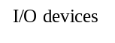

Main memory
Disk
Printer
Registers

Bus

6.0) Summary
We have seen the basic difference between computer organsiation and architecture. Also we had a review of the basic functional units of a computer. We will go for a detailed study of functional units in the next lecture.

Lecture # 2

1) Synopsis: Functional Units of a Computer-CPU-Memory Connection, Review of basic operational concepts like CPU Registers.

2) Target: At the completion of this lecture you should be able to answer questions like

- Outline the functions of all the functional units of a computer.
- What is Instruction Register?
- What is the purpose of Program Counter?
- What is MAR and MDR?
- Outline the different steps in fetching and executing an instruction.

3) Introduction

Here we will have a detailed study of the basic functional/operational units in the computer.

4) Revision / Prerequisites
You should know the basic functional units of a computer which we reviewed in our first lecture.

5.1) Basic Operational Concepts

What is a program? A program is nothing but a sequence of instructions that instruct the computer to perform some specified operation on given data. Programs reside in the main memory of the computer. In-order to perform the specified operations, the instructions is to be brought from memory into the processor.
The processor contains arithmetic and logic unit as the main processing unit, the control unit to control and coordinate all activities in the system. It also contains a number of registers used for temporary storage of data, such as the Instruction Register (IR), the Program Counter(PC), the general-purpose registers, the Memory Address Register(MAR) and Memory Data Register(MDR).

The following figure describes the connections between the CPU and the main memory.

Main memory

CPU

MAR
MDR
Control unit

PC
R₀

GP Regs

R_{n-1}
Rn

Arithmetic logic unit

IR

Let us see the picture in detail.

Instruction Register: contains the instruction that is being executed. Its output is available to the control circuits, that generate the timing signals for control of the actual processing circuits needed to execute the instruction.
Program Counter: is a register that contains the memory address of the instruction currently being executed. During the execution of the current instruction, the content of program counter is updated to correspond to the address of the next instruction.
Memory Address Register: holds the address of the memory location to or from which data is to be transferred.
Memory Data Register: contains the data to be written into or read-out of the addressed memory location.
General- purpose Registers: are used for holding data, intermediate results of operations. They are also known as scratch-pad registers.

5.2) Instruction fetch and execution-Instruction Cycle

Let us consider some typical operating steps involving instruction fetch and execution:
- Program gets into the memory through an input device

Instruction Fetch
- Execution of a program starts by setting the PC to point to the first instruction of the program.
- The contents of PC are transferred to the MAR and a Read control signal is sent to the memory
- The addressed word (here it is the first instruction of the program) is read out of memory and loaded into the MDR
- The contents of MDR are transferred to the IR for instruction decoding

Instruction Execution
- The operation field of the instruction in IR is examined to determine the type of operation to be performed by the ALU
- The specified operation is performed by obtaining the operand(s) from the memory locations or from GP registers.
- Fetching the operands from the memory requires sending the memory location address to the MAR and initiating a Read cycle.
- The operand is read from the memory into the MDR and then from MDR to the ALU.
- The ALU performs the desired operation on one or more operands fetched in this manner and sends the result either to memory location or to a GP register.
- The result is sent to MDR and the address of the location where the result is to be stored is sent to MAR and Write cycle is initiated.
Thus, the execute cycle ends for the current instruction and the PC is incremented to point to the next instruction for a new fetch cycle.

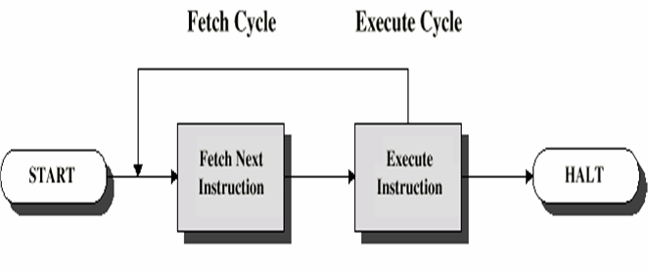
5.3) State Diagram of Instruction Cycle

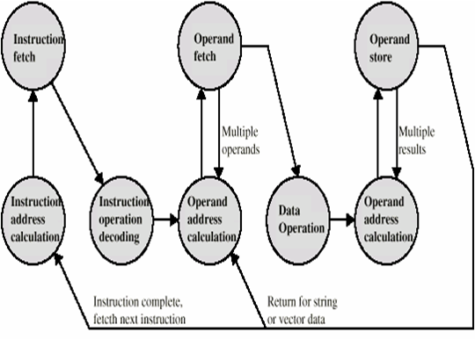

6.0) Summary
We have seen the detailed operational concepts involving CPU registers. The detailed study of a single instruction fetching and execution is also done in this lecture of ours.

7.0) Exercise questions

1. List the steps needed to execute the machine instruction ADD LOCA,R0 in terms of transfers between the functional units of the computer. Assume that the instruction itself is stored in the memory at location INSTR and this address is initially there in PC.

2. Repeat the above problem for the instruction ADD R1,R2,R3.

3. Suppose that the following instructions are found at the given locations in memory:
20 LDA 60
21 ADD 61
60 1011
61 3009
- Show the contents of the IR, the PC, the MAR, the MDR, and A at the conclusion
of instruction 20.
b. Show the contents of each register as each step of the fetch-execute cycle performed for instruction 21.

Lecture # 3

1) Synopsis: Instruction formats

2) Target: At the completion of this lecture you should be able to answer questions like

- Explain the address organization in the main memory.
- What is an instruction set?
- What are the different classifications of instructions?
- Give examples of arithmetic instructions.
- What are miscellaneous instructions?

3) Introduction

Here we will have a study of the memory addresses and basic operations related to main memory.

4) Revision / Prerequisites

5.1) Main Memory Addresses and Operations

The main memory consists of a large number of storage cells, each of which can store a binary digit 0 or 1. This 1-bit representation of information is too small to be handled by a computer. So, a group of n bits are used while storing or retrieving. Each group of n bits is referred to as its word length. The word length can be 8 bits, 16 bits, 32, 64 or 128 bits depending on the size of the computer. The main memory organization is shown in figure

Main memory address

Address
contents

0

1

i bn-1……..b0

m-1

Word 0

Word 1

Word i

Word m-1
n bits

Each location in the main memory is given a distinct name or address. With this address it is possible to store or retrieve information from the memory location. The contents of memory locations can represent either instructions or operands. The operands can be numbers or characters. Fetch (or Read) and Store (or Write) are the basic operations used for moving the operands and results between main memory and the CPU. The Fetch operation transfers the contents of a specific memory location to the CPU. But, the word in the main memory remains unchanged. The Store operation transfers a word of information from the CPU to a specific main memory location destroying the original contents of that location.

5.2) Machine Operations and Instruction Formats

An instruction is nothing but an explicit command to processor to do some specified task. A group of instructions that a specific processor can execute is called its instruction set. The number of instructions in an instruction set depends on the architecture and the intended use of processors.

5.3) Classification of Instructions

Data transfer instructions
Some examples of data transfer instructions include load, store, move, input, and output.
These instructions are used for transferring the data from one location to another. The location can be a memory location, registers in the CPU or I/O sub system.

Arithmetic and logic instructions
Some examples of arithmetic instructions include add, subtract, multiply, divide, increment, decrement. These instructions are used for performing arithmetic operations on data. Some examples of logic instructions include AND, OR, NOT, shift right, shift left. These instructions are used for performing logic operations on data.

Branch instructions
Some examples of branch instructions include branch if zero, branch if equal, branch if not equal, unconditional branch. These instructions are used for program sequencing and control.

Miscellaneous instructions
Some examples include No operation, Push, Pop, Wait, Halt, Enable interrupt, Disable interrupt.

6.0) Summary
We have seen the operation of main memory. Also we have seen the classification of different types of instruction. Of course we will have a deeper study of the different instruction formats.

7.0) Exercise Questions

- One large modern computer has a 64-bit memory address register. How much memory can this computer address?

Lecture # 4

1) Synopsis: Instruction formats

2) Target: At the completion of this lecture you should be able to answer questions like

- What is an Instruction format?
- Explain the method of calculating the number of memory access in different types of instruction formats.

3) Introduction

Here we will have a study of all the different types of instruction formats.

4) Revision / Prerequisites
You should be aware of what does an instruction mean and also of the different types of instructions in prevail.

5.1) Instruction format

Instruction format specifies the information like the operations to be performed, location of the operands, place to store the result, location or address of the next instruction to be executed.

The different types of instruction formats are
Three -address instruction format
Two - address instruction format
One - address instruction format
Zero -address instruction format

5.2) Three Address Instruction Format

This instruction format consists of three addresses along with an operation field. The three addresses include the address of the first operand, address of the second operand, address to store the result. The address of the next instruction is held in a CPU register called program counter (PC).
The figure shows the three-address machine operation and instruction format
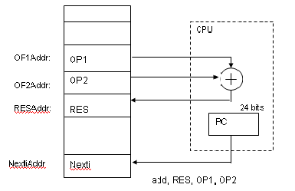
Instruction format:

Consider a machine with 24-bit memory addresses and 128 instructions,

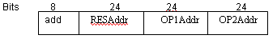
Using this machine,
- The number of bytes required to encode an instruction is 10 bytes. i.e. each address requires 24 bits = 3 bytes. Since there are 3 addresses and one operation code field , 3 * 3 + 1 = 10 bytes
- The number of memory access required is 7 words i.e. 4 words for instruction fetch + 2 words for operand fetch + 1 word for result to be placed back in memory.

5.3) Two Address Instruction Format
This instruction format consists of two addresses along with an operation field. The two addresses include the address of the first operand, address of the second operand, the result is stored in one of the operand address . The address of the next instruction is held in a CPU register called program counter (PC).

The figure 2.4 shows the two-address machine operation and instruction format

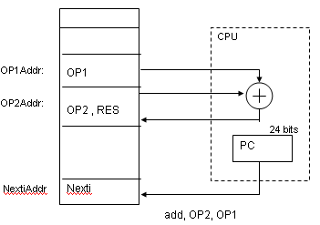

Instruction format:
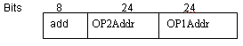
Using this machine,
- The number of bytes required to encode an instruction is 7 bytes. i.e. each address requires 24 bits = 3 bytes. Since there are 2 addresses and one operation code field, 2 * 3 + 1 = 7 bytes
- The number of memory access required is 6 words i.e. 3 words for instruction fetch + 2 words for operand fetch + 1 word for result to be placed back in memory.

5.4) One Address Instruction Format

This instruction format consists of one address along with an operation field. The address is that of the first operand. The second operand, and the result are stored in a CPU register called accumulator . The address of the next instruction is held in a CPU register called program counter (PC). Because a machine has only one accumulator, it need not be explicitly mentioned in the instruction.
The figure shows the one-address machine operation and instruction format
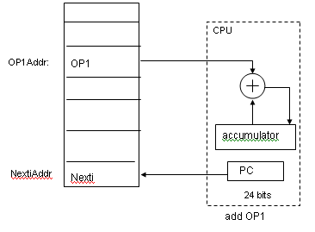
Instruction Format
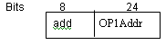

This machine requires extra 2 instructions to load and store the accumulator contents
Using this machine,
- The number of bytes required to encode an instruction is 4 bytes. i.e. each address requires 24 bits = 3 bytes. Since there only 1 address and one operation code field , 1 * 3 + 1 = 4 bytes
- The number of memory access required is 3 words i.e. 2 words for instruction fetch + 1 words for operand fetch

5.5) Zero Address Instruction Format
A stack is included in the CPU for performing arithmetic and logic instructions with no addresses. The operands are pushed onto the stack from memory and ALU operations are implicitly performed on the top elements of the stack. . The address of the next instruction is held in a CPU register called program counter (PC).

Instruction format:

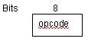
Eg. add
Top of stack = top of stack + second top of stack
Using this machine,
- The number of bytes required to encode an instruction is 1 byte. Since there is only 1 operation code field

6.0) Summary
We have seen the different instruction formats and we have also learned the technique to calculate the number of bytes needed to encode an instruction in different instruction formats.

7.0) Exercise questions
1. Suppose a computer has a 24-bit instruction format with the following fields:
op: 8 bits ra: 4 bits rb: 4 bits rc: 4 bits rd: 4 bits
where the ra, rb, and rc specify the input registers and rd specifies the destination
register.
a. If there is a single register file, how many registers should there be in that
register file?
b. How many read-register select lines should the register file have? How
many write-register select lines? How many data output lines?

Lecture # 5

1) Synopsis: Addressing modes

2) Target: At the completion of this lecture you should be able to answer questions like

- What is an addressing mode?
- What are the common addressing modes?
- Give examples for different addressing modes.

3) Introduction

Here we will have a detailed study of all the addressing modes

4) Revision / Prerequisites

5.1) Addressing methods

The methods used to provide an access path to operands in memory and CPU registers is addressing mode. The address generated by the CPU in-order to access the operand in the memory is termed as an effective address.

Following are the different addressing modes.

5.2) Direct Addressing Mode
The address of the operand is explicitly given as a part of the instruction.
Example: ADD 100
This instruction causes the CPU to add the contents of memory location 100 to the contents of the accumulator. i.e. ACC ← [ACC ]+ [100]
Suppose, accumulator contains 10, memory location 100 contains 150 then the result of executing this instruction is 10 + 150 = 160 stored in the accumulator.

5.3) Indirect Addressing Mode
The instruction contains address of address of operand.
Example : ADD @ 100 ; @ indicates indirect addressing
This instruction causes the CPU to add the contents of contents of memory location 100 to the contents of the accumulator. i.e. ACC ← [ACC] + [ [100] ]
Suppose, accumulator contains 10, memory location 100 contains 150, this value 150 is treated as an address that contains operand 10. Then the result of executing this instruction is 20 stored in the accumulator. i.e. (10 + [ [100] ] = 10 + [150] = 10 + 10 = 20 )

5.4) Immediate Addressing Mode
In this mode, the actual data is a part of the instruction.
Example : ADD # 100 ; # indicates immediate mode
This instruction causes the CPU to add the data 100 to the contents of the accumulator. i.e. ACC ← [ACC] + 100
Suppose, accumulator contains 10, then the result of executing this instruction is 110 stored in the accumulator. (i.e. 10 + 100 = 110 )

5.5) Register Direct Addressing Mode
This is same as direct addressing except that the address is that of a register instead of a memory location.
Example : ADD R1
This instruction causes the CPU to add the contents of the accumulator to the contents of the register R1 i.e. ACC ← [ACC] + [ R1 ]
Suppose, accumulator contains 10, register R1 contains 50 then the result of executing this instruction is 60 stored in the accumulator.

5.6) Register Indirect Addressing Mode
This is same as indirect addressing except that the address is that of a register instead of a memory location.
Example : ADD @ R1
This instruction causes the CPU to add the contents of the accumulator to the contents of contents of the register R1 i.e. ACC ← [ACC] + [ [ R1 ] ]

5.7) Index Addressing Mode
The effective address of the operand is generated by adding an index value to the address given in the instruction. The index value is held a register called index register.
Example : Load 4[R2]

5.8) Relative Addressing Mode
The effective address of the operand is obtained by adding the contents of the program counter with the constant value specified with the instruction.
Example : Loadrel 4[PC]

6.0) Summary
We have seen the different addressing modes and also examples related to it.

7.0) Exercise questions
1. Identify the operand-addressing mode used in each of these instructions.

  - AND DX,AX
  - JMP JMPTAB[BX]
  - ADD DX,15
  - CMP WORD PTR [BX+DI],10
  - MOV IVAL[DI+4],CX

2. Determine the fetch-execute cycle for a LOAD instruction in a machine that uses relative addressing.

Lecture # 6

1) Synopsis: Interrupt, Operating system, Interconnection Structures, Layered view of a computer system.

2) Target: At the completion of this lecture you should be able to answer questions like
- What is an interrupt?
- What happens when an interrupt is incurred?
- What is system software
- What is an operating system?
- Explain the commonly used interconnection structures.

3) Introduction
In this lecture we will have an overview of how an interrupt works, what constitute an operating system. Also we will see the different interconnection structures of a computing system.
4) Revision / Prerequisites

5.1) Interrupt
An interrupt is an event that alters the sequence in which the processor executes instructions. An interrupt might be planned (specifically requested by the currently running program) or unplanned (caused by an event that might or might not be related to the currently running program). Following are the common interrupts.
- I/O interrupts
These occur when the channel subsystem signals a change of status, such as an I/O operation completing, an error occurring, or an I/O device such as a printer has become ready for work.
- External interrupts
These can indicate any of several events, such as a time interval expiring, the operator pressing the interrupt key on the console, or the processor receiving a signal from another processor.
- Restart interrupts
These occur when the operator selects the restart function at the console or when a restart SIGP (signal processor) instruction is received from another processor.
- Program interrupts
These are caused by program errors (for example, the program attempts to perform an invalid operation), page faults (the program references a page that is not in central storage), or requests to monitor an event.
- Machine check interrupts
These are caused by machine malfunctions.
When an interrupt occurs, the hardware saves pertinent information about the program that was interrupted and, if possible, disables the processor for further interrupts of the same type. The hardware then routes control to the appropriate interrupt handler routine. The program status word or PSW is a key resource in this process
Interrupt Cycle
• Added to instruction cycle
• Processor checks for interrupt
—Indicated by an interrupt signal
• If no interrupt, fetch next instruction
• If interrupt pending:
—Suspend execution of current program
—Save context
—Set PC to start address of interrupt handler routine
—Process interrupt
—Restore context and continue interrupted program
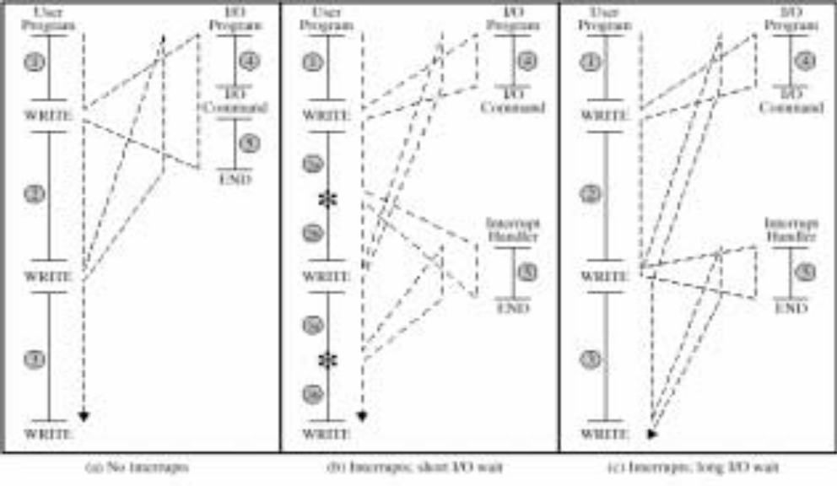
Transfer of Control via Interrupts

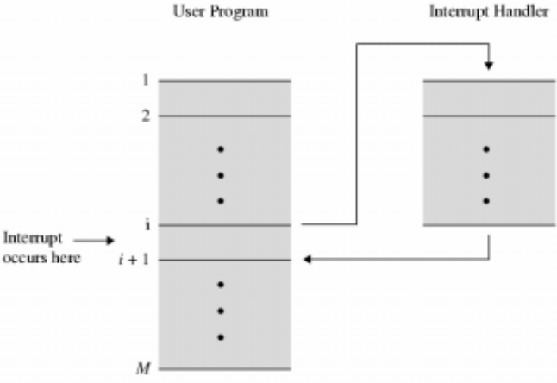

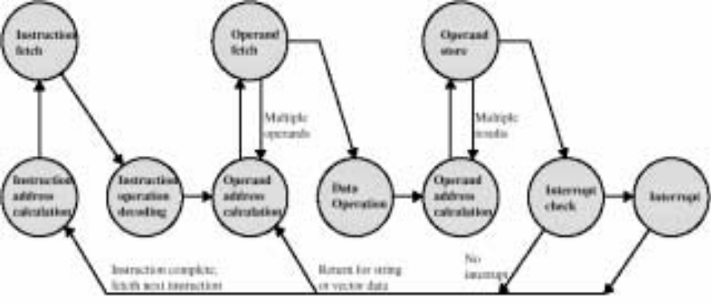
5.2) Operating System
In simplest terms, an operating system is a collection of programs that manage a computer system's internal workings--its memory, processors, devices, and file system.

Operating systems are designed to make the best use of the computer's various resources, and ensure that the maximum amount of work is processed as efficiently as possible. Although an operating system cannot increase the speed of a computer, it can maximize its use, thereby making the computer seem faster by allowing it to do more work in a given period of time.

A computer's architecture consists of the functions the computer system provides. The architecture is distinct from the physical design, and, in fact, different machine designs might conform to the same computer architecture. In a sense, the architecture is the computer as seen by the user, such as a system programmer. For example, part of the architecture is the set of machine instructions that the computer can recognize and execute. In the mainframe environment, the system software and hardware comprise a highly advanced computer architecture, the result of decades of technological innovation.

Interconnection Structures
A Computer consist of a set of components or modules of three different types .(CPU, Memory and I/O) that communicate with each other. I.e. A computer is a network of basic modules and hence there must be paths for connecting the modules together.
The connection of paths connecting the various modules is called a interconnection structure. The design of the structure will depend on the exchanges that must be made between modules.

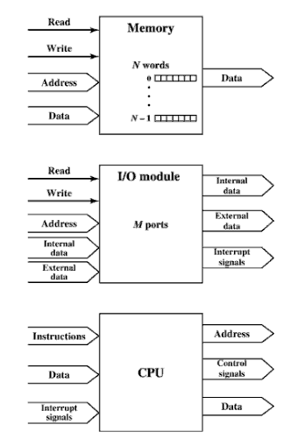
Computer Modules.
The above figure suggests the types of exchanges that are needed by indicating the major forms of input and output for each module type .
Memory :- A memory module will consist of N words of equal length . Each is assigned a unique numerical address (0 ,1, ….. N-1). A word of data can be read from or written in to the memory. The nature of the operation is indicated by Read and Write control signals. The location for the operation is specified by an address.

I/O module:- From an internal point of view , I/O is functionally similar to memory. There are 2 operations ,read and write . Also an I/O module may control more than one external device. Each of these interface to external device is called as a port and each is given unique address(eg: 0 , 1, …… M-1). .Also there are external data paths for the input and output of data with a an external device . Finally , an I/O module may be able to send interrupt signals to the CPU.
CPU:- The CPU reads in instructions and data , writes out data after processing , and uses control signals to control the overall operation of the system. It also receives interrupt signals.
The interconnection structure must support the following types of transfers.
- Memory to CPU: The CPU needs an instruction or a unit of data from memory.
- CPU to memory : The CPU writes a unit of data to memory.
- I/O to CPU : The CPU reads data from an I/O device via an I/O module
- CPU to I/O : The CPU sends data to an I/O device.
- I/O to or from memory : - For these two cases, I/O module is allowed to exchange data directly with memory , without going through the CPU ,using Direct Memory Access.(DMA).

Layered View Of a Computer System. And Operating system
Refer pages 222 to 224 (Ch. 7 Operating system support) - Computer Organization and architecture - William stallings -4 th Edition)

6.0) Summary
We have seen what an interrupt is, the basic concepts in operating system. Also we have seen the interconnection structures.

