RAJAGIRI SCHOOL OF ENGINEERING
AND TECHNOLOGY
Rajagiri Valley, Kochi -39



R402 -COMPUTER ORGANISATION
MODULE I

Prepared by
Preetha K G

INDEX
Topics Page Number

Introduction
1.1 Computer Organization & Architecture ……………………… 3
  - Functional Units of a Computer……………………………….. 4
    - Input Unit……………………………………………….. 4
    - Arithmetic & Logic Unit( A L U)………………………. 4
    - Control Unit……………………………………………… 4
    - Memory unit……………………………………………… 5
    - Output Unit……………………………………………… 8
1.3 Review of Basic Operational Concepts of a Computer………….8
1.4 Interrupts…………………………………………………………. 12
1.5 Instructions & Instruction Formats……………………………. 12
1.6 Memory Organization…………………………………………… 16
1.7 Addressing Modes………………………………………………… 19
1.7.1 Immediate…………………………………………………. 20
1.7.2 Register……………………………………………………. 20
1.7.3 Direct (Absolute)………………………………………….. 21
1.7.4 Indirect…………………………………………………….. 22
1.7.5 Index (Displacement) ………………………………………. 22
1.7.6 Base with index……………………………………………… 23
1.7.7 Base with index and offset…………………………………. 23
1.7.8 Relative………………………………………………………. 23
1.7.9 Auto increment…………………………………………….. 24
1.7.10 Auto decrement…………………………………………… 24
1.8 Bus Structures……………………………………………………. 24
1.9 Execution of a Complete Instruction…………………………….. 26
1.8 Interconnection Networks…………………………………………39
1.9 Layered view of Computer System…………………………….. 44

Introduction to Computer Organization
A computer is a fast electronic calculating machine able to accept data, store it, process it according to the instruction stored in the internal storage and produce the output information. All these tasks are carried out by various functional units of a computer. The list of instruction is called programs and the internal storage is called memory.
Many types of computers exist depends upon their size, cost and computing power.
- Personal computer (PC): This is found in homes, schools etc. It is desktop computers have processing and storage units, visual display, input, output units.
- Work Stations: This has more computational power than PC.
- Enterprise Systems (Mainframes) & Supercomputers: These are very powerful computers. This has much more computational power and storage capacity than the workstations can provide. Supercomputers are used for the large scale numerical calculations required in areas like weather forecasting, aircraft design & simulation.
Software: Set of program to do a particular task is called software.
Mainly software are of two types: System software and application software.
a) System software is the software that contain in memory and is responsible for the coordination of all activities in a computing system.
Example: Operating system, compiler, interpreter etc.
b) Application software is the software developed by the programmer for their use.
Example: MS word, Flash etc.
Hardware: Consists of electronic circuits, displays, storage media, and communication facilities.
1.1 Computer Organization & Architecture
Computer organization is concerned with the way the hardware components operate and the way they are connected together works as a system. It describes the function and design of various units of computer.
Computer design is concerned with the determination of what hardware should be used and how the parts should be connected.
Computer architecture is concerned with the structure and behavior of the computer as seen by the user. It includes the instruction formats, instruction set and techniques for addressing memory. The architectural design of a computer system is concerned with the specifications of the various functional modules and structuring them together into a computer system.
  - Functional Units of a Computer
A computer in its simplest form consists of five functionally independent main components: input, output, memory, arithmetic and logic unit, and control unit as shown in the following figure. These units are interconnected by electrical cables to permit communication between them.
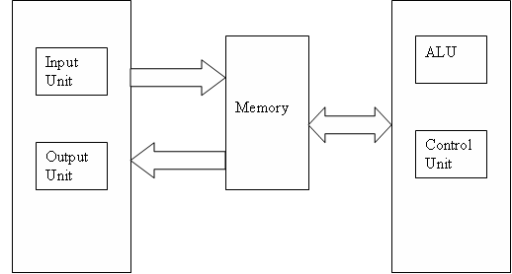
    - Input Unit
A computer must receive both data and program statements to function properly and be able to solve problems. Computer accepts the information through input devices. Computer input devices read data from a source, such as magnetic disks, and translate that data into electronic impulses for transfer into the CPU. Some typical input devices are a keyboard, a mouse, or a scanner.
    - Arithmetic & Logic Unit
The arithmetic-logic section performs arithmetic operations, such as addition, subtraction, multiplication, and division. Through internal logic capability, it tests various conditions encountered during processing and takes action based on the result.
    - Control Unit
The control section directs the flow of traffic (operations) and data. It also maintains order within the computer. The control section selects one program statement at a time from the program storage area, interprets the statement, and sends the appropriate electronic impulses to the arithmetic-logic and storage sections so they can carry out the instructions. The control section does not perform actual processing operations on the data. The control section instructs the input device on when to start and stop transferring data to the input storage area. It also tells the output device when to start and stop receiving data from the output storage area.
ALU &Control Unit together called Central Processing Unit ( CPU). CPU is the brain of a computer system. The CPU processes data transferred to it from one of the various input devices. It then transfers either an intermediate or final result of the CPU to one or more output devices. A central control section and work areas are required to perform calculations or manipulate data. The CPU is the computing center of the system. It consists of a control unit and an arithmetic-logic unit. Each section within the CPU serves a specific function and has a particular relationship with the other sections within the CPU.
    - Memory unit
The memory unit is sometimes called primary storage or main storage because this section functions similar to our own human memory. The storage section serves different purposes; some relate to retention (holding) of data during processing. First, data is transferred from an input device to the memory unit where it remains until the computer is ready to process it. Second, a "scratch pad" memory within the storage section holds both the data being processed and the intermediate results of the arithmetic-logic operations. Third, the storage section retains the processing. From there the processing results can be transferred to an output device. The fourth purpose is to store program statements transferred from an input device to process the data.

Memory is referred to by size, such as 16K, 32K, 64K, and so on. Semiconductor memory consists of hundreds of thousands of tiny electronic circuits etched on a silicon chip. Each of these electronic circuits is called a bit cell and can be in either an OFF or ON state to represent a 0 or 1 bit. This state depends on whether or not current is flowing in that cell. Another name used for semiconductor memory chips is integrated circuits (ICs). Developments in technology have led to large-scale integration (LSI) that allows more and more circuits to be squeezed onto the same silicon chip. Some of the advantages of semiconductor storage are fast internal processing speeds, high reliability, low power consumption, high density (many circuits), and low cost. However, there is a drawback to this type of storage. It may be volatile, which means it requires a constant power source. When the power for the system fails and we have no backup power supply, all of the stored data is lost.
Memory can be either primary memory or Secondary memory.
Primary memory
Two classifications of primary storage are read-only memory (ROM) and random-access memory (RAM).
READ-ONLY MEMORY (ROM)
In computers, it is useful to have instructions that are used often, permanently stored inside the computer. ROM enables us to do this without loosing the programs and data when the computer is powered down. Only the computer manufacturer can provide these programs in ROM; once done, we cannot change it. Consequently, we cannot put any of our own data or programs in ROM. Many complex functions, such as translators for high-level languages, and operating systems are placed in ROM memory. Since these instructions are hardwired, they can be performed quickly and accurately.
Programmable ROM (PROM): This is a type of ROM that can be programmed using special equipment; it can be written to, but only once. This is useful for companies that make their own ROMs from software they write, because when they change their code they can create new PROMs without requiring expensive equipment. This is similar to the way a CD-ROM recorder works by letting you "burn" programs onto blanks once and then letting you read from them many times. In fact, programming a PROM is also called burning, just like burning a CD-R, and it is comparable in terms of its flexibility.
Erasable Programmable ROM (EPROM): An EPROM is a ROM that can be erased and reprogrammed. A little glass window is installed in the top of the ROM package, through which you can actually see the chip that holds the memory. Ultraviolet light of a specific frequency can be shined through this window for a specified period of time, which will erase the EPROM and allow it to be reprogrammed again.
Electrically Erasable Programmable ROM (EEPROM): The next level of erasability is the EEPROM, which can be erased under software control. This is the most flexible type of ROM, and is now commonly used for holding BIOS programs.

RANDOM-ACCESS MEMORY (RAM)
RAM is another type of memory found inside computers. It may be compared to a chalkboard on which we can scribble down notes, read them, and erase them when finished. In the computer, RAM is the working memory. Data can be read (retrieved) or written (stored) in RAM by providing the computer with an address location where the data is stored or where you want it to be stored. When the data is no longer required, we may simply write over it. Thus you can use the storage location again for something else.

Different Types of RAM
The RAM family includes two important memory devices static RAM (SRAM) and dynamic RAM (DRAM). The primary difference between them is the lifetime of the data they store. SRAM retains its contents as long as electrical power is applied to the chip. If the power is turned off or lost temporarily, its contents will be lost forever. DRAM, on the other hand, has an extremely short data lifetime-typically about four milliseconds. This is true even when power is applied constantly.
A simple piece of hardware called a DRAM controller can be used to make DRAM behave more like SRAM. The job of the DRAM controller is to periodically refresh the data stored in the DRAM. By refreshing the data before it expires, the contents of memory can be kept alive for as long as they are needed. So DRAM is as useful as SRAM after all.
SRAM devices offer extremely fast access times (approximately four times faster than DRAM) but are much more expensive to produce. Generally, SRAM is used only where access speed is extremely important. A lower cost-per-byte makes DRAM attractive whenever large amounts of RAM are required.
Secondary Memory
Secondary storage, or auxiliary storage, is memory external to the main body of the computer (CPU) where programs and data can be stored for future use. When the computer is ready to use these programs, the data is read into primary storage. Secondary storage media extends the storage capabilities of the computer system. Secondary storage is required for two reasons. First, the working memory of the CPU is limited in size and cannot always hold the amount of data required. Second, data and programs in secondary programs do not disappear when the power is turned off. Secondary storage is nonvolatile memory. This information is lost only when we erase it. Magnetic disks are the most common type of secondary storage. They may be either floppy disks or hard disks (hard drives).
    - Output Unit
As program statements and data are received by the CPU from an input device, the results of the processed data are sent from the CPU to an output device. These results are transferred from the output storage area onto an output medium, such as a floppy disk, hard drive, video display, printer, and so on.
The operations performed by a computer using the functional components can be summarized as follows:
- It accepts information (program and data) through input unit and transfers it to the memory
- Information stored in the memory is fetched, under program control, into an arithmetic and logic unit for processing
- Processed information leaves the computer through an output unit
- The control unit controls all activities taking place inside a computer.
  - Review of Basic Operational Concepts of a Computer
A program is nothing but a sequence of instructions that instruct the computer to perform some specified operation on given data. Programs reside in the main memory of the computer. In-order to perform the specified operations, the instructions is to be brought from memory into the processor.
The following figure describes the connections between the CPU and the main memory.
The processor contains arithmetic and logic unit as the main processing unit, the control unit to control and coordinate all activities in the system. It also contains a number of registers used for temporary storage of data, such as the Instruction Register (IR), the Program Counter(PC), the general-purpose registers, the Memory Address Register(MAR) and Memory Data Register(MDR).
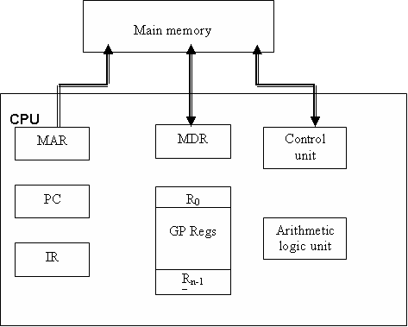
Registers are high-speed storage area within the CPU. All data must be represented in a register before it can be processed. For example, if two numbers are to be multiplied, both numbers must be in registers, and the result is also placed in a register. The number of registers that a CPU has and the size of each (number of bits) help determine the power and speed of a CPU. For example a 32-bit CPU is one in which each register is 32 bits wide. Therefore, each CPU instruction can manipulate 32 bits of data. Usually, the movement of data in and out of registers is completely transparent to users, and even to programmers. Only assembly language programs can manipulate registers. In high-level languages, the compiler is responsible for translating high-level operations into low-level operations that access registers.
In a computer, a register is one of a small set of data holding places that are part of a computer processor. A register may hold a computer instruction, a storage address, or any kind of data (such as a bit sequence or individual characters). Some instructions specify registers as part of the instruction. For example, an instruction may specify that the contents of two defined registers be added together and then placed in a specified register. A register must be large enough to hold an instruction - for example, in a 32-bit instruction computer; a register must be 32 bits in length. In some computer designs, there are smaller registers - for example, half-registers - for shorter instructions. Depending on the processor design and language rules, registers may be numbered or have arbitrary names.
Instruction Register: contains the instruction that is being executed. Its output is available to the control circuits, that generate the timing signals for control of the actual processing circuits needed to execute the instruction.
Program Counter: is a register that contains the memory address of the instruction currently being executed. During the execution of the current instruction, the content of program counter is updated to correspond to the address of the next instruction.
Memory Address Register: holds the address of the memory location to or from which data is to be transferred.
Memory Data Register: contains the data to be written into or read-out of the addressed memory location.
General- purpose Registers: are used for holding data, intermediate results of operations. They are also known as scratch-pad registers.
Let us consider some typical operating steps involving instruction fetch and execution:
- Program gets into the memory through an input device
Instruction Fetch
- Execution of a program starts by setting the PC to point to the first instruction of the program.
- The contents of PC are transferred to the MAR and a Read control signal is sent to the memory
- The addressed word (here it is the first instruction of the program) is read out of memory and loaded into the MDR
- The contents of MDR are transferred to the IR for instruction decoding
Instruction Execution
- The operation field of the instruction in IR is examined to determine the type of operation to be performed by the ALU
- The specified operation is performed by obtaining the operand(s) from the memory locations or from GP registers.

- Fetching the operands from the memory requires sending the memory location address to the MAR and initiating a Read cycle.
- The operand is read from the memory into the MDR and then from MDR to the ALU.
- The ALU performs the desired operation on one or more operands fetched in this manner and sends the result either to memory location or to a GP register.
- If the result is to be stored in memory then sent to MDR and the address of the location where the result is to be stored is sent to MAR and Write cycle is initiated.
Thus, the execute cycle ends for the current instruction and the PC is incremented to point to the next instruction for a new fetch cycle.
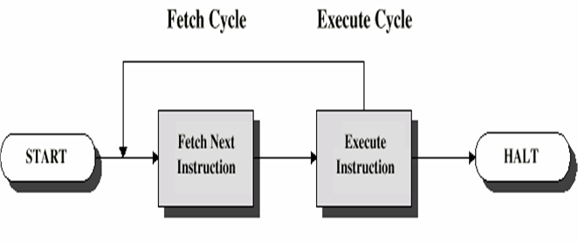
Instruction cycle:
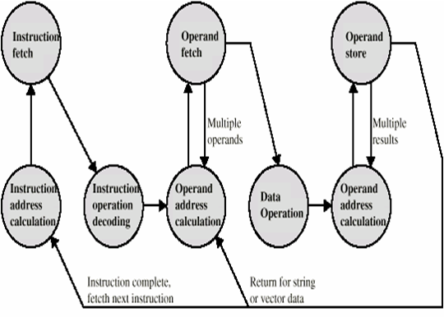
1.4 Interrupts
An interrupt is an event that alters the sequence in which the processor executes instructions. An interrupt might be planned (specifically requested by the currently running program) or unplanned (caused by an event that might or might not be related to the currently running program). Following are the common interrupts.
a) I/O interrupts
These occur when the channel subsystem signals a change of status, such as an I/O operation completing, an error occurring, or an I/O device such as a printer has become ready for work.
b) External interrupts
These can indicate any of several events, such as a time interval expiring, the operator pressing the interrupt key on the console, or the processor receiving a signal from another processor.
c) Restart interrupts
These occur when the operator selects the restart function at the console or when a restart signal processor instruction is received from another processor.
d) Program interrupts
These are caused by program errors (for example, the program attempts to perform an invalid operation or requests to monitor an event.
e) Machine check interrupts
These are caused by machine malfunctions.
When an interrupt occurs, the hardware saves information about the program that was interrupted and, if possible, disables the processor for further interrupts of the same type. The hardware then routes control to the appropriate interrupt service routine (ISR). After the interrupt is serviced, the processor resumes functioning from the interrupted point, and all the information saved was retrieved.
1.5 Instructions & Instruction Formats
An instruction is nothing but an explicit command to processor to do some specified task. A group of instructions that a specific processor can execute is called its instruction set. The number of instructions in an instruction set depends on the architecture and the intended use of processors.

Classification of Instructions
a) Data transfer instructions
Some examples of data transfer instructions include load, store, move, input, and output.
These instructions are used for transferring the data from one location to another. The location can be a memory location, registers in the CPU or I/O sub system.
b) Arithmetic and logic instructions
Some examples of arithmetic instructions include add, subtract, multiply, divide, increment, decrement. These instructions are used for performing arithmetic operations on data. Some examples of logic instructions include AND, OR, NOT, shift right, shift left. These instructions are used for performing logic operations on data.
c) Branch instructions
Some examples of branch instructions include branch if zero, branch if equal, branch if not equal, unconditional branch. These instructions are used for program sequencing and control.
d) Miscellaneous instructions
Some examples include No operation, Push, Pop, Wait, Halt, Enable interrupt, Disable interrupt.
Instruction format specifies the information like the operations to be performed, location of the operands, place to store the result, location or address of the next instruction to be executed.
The different types of instruction formats are
- Three -address instruction format
- Two - address instruction format
- One - address instruction format
- Zero -address instruction format
1. Three Address Instruction Format
This instruction format consists of three addresses along with an operation field. The three addresses include the address of the first operand, address of the second operand, address to store the result.
Example: Add A,B,C
C← [A]+[B]
Content of memory location A and B are fetched from memory and is transferred to the processor and compute the sum. The result is sent back to memory at location C.
The figure shows the three-address machine operation and instruction format
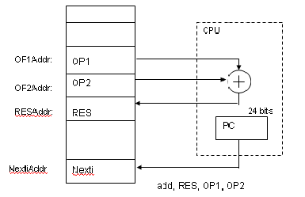

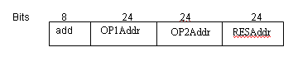
Using this format,
- The number of bytes required to encode an instruction is 10 bytes. i.e. each address requires 24 bits = 3 bytes. Since there are 3 addresses and one operation code field , 3 * 3 + 1 = 10 bytes
- The number of memory access required is 7 words i.e. 4 words for instruction fetch + 2 words for operand fetch + 1 word for result to be placed back in memory.
2. Two Address Instruction Format
This instruction format consists of two addresses along with an operation field. The two addresses include the address of the first operand, address of the second operand; the result is stored in one of the operand address.
Example: Add A, B
B← [A]+[B]
The content of memory location A and B are added and the result is stored back in to memory location B.
The following figure shows the two-address machine operation and instruction format
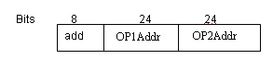
Using this format
- The number of bytes required to encode an instruction is 7 bytes. i.e. each address requires 24 bits = 3 bytes. Since there are 2 addresses and one operation code field, 2 * 3 + 1 = 7 bytes
- The number of memory access required is 6 words i.e. 3 words for instruction fetch + 2 words for operand fetch + 1 word for result to be placed back in memory.
3. One Address Instruction Format
This instruction format consists of one address along with an operation field. The address is that of the first operand. The second operand and the result are stored in a CPU register called accumulator. A machine has only one accumulator; it need not be explicitly mentioned in the instruction.
Example: Add A
Add the content of memory location A to the accumulator and place the sum back to accumulator.
The figure shows the one-address machine operation and instruction format
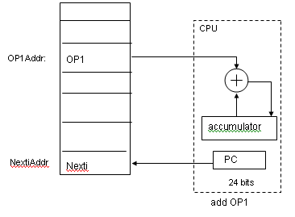
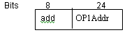
This machine requires extra 2 instructions to load and store the accumulator contents
Using this machine,
- The number of bytes required to encode an instruction is 4 bytes. i.e. each address requires 24 bits = 3 bytes. Since there only 1 address and one operation code field , 1 * 3 + 1 = 4 bytes
- The number of memory access required is 3 words i.e. 2 words for instruction fetch + 1 words for operand fetch
4. Zero Address Instruction Format
A stack is included in the CPU for performing arithmetic and logic instructions with no addresses. The operands are pushed onto the stack from memory and ALU operations are implicitly performed on the top elements of the stack.
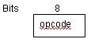
Example: Add
Top of stack = top of stack + second top of stack
Using this machine,
- The number of bytes required to encode an instruction is 1 byte. Since there is only 1 operation code field
1.6 Memory Organization
The main memory consists of a large number of storage cells, each of which can store a binary digit 0 or 1. This 1-bit representation of information is too small to be handled by a computer. So, a group of n bits are used while storing or retrieving. Each group of n bits is referred to as its word length. The word length can be 8 bits, 16 bits, 32, 64 or 128 bits depending on the size of the computer. The main memory organization is shown in the following figure.

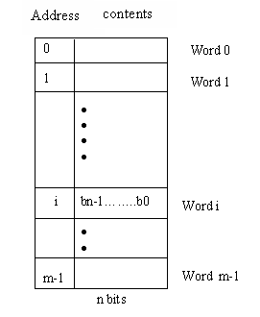
Each location in the main memory is given a distinct name or address. With this address it is possible to store or retrieve information from the memory location. The contents of memory locations can represent either instructions or operands. The operands can be numbers or characters. Fetch (or Read) and Store (or Write) are the basic operations used for moving the operands and results between main memory and the CPU. The Fetch operation transfers the contents of a specific memory location to the CPU. But, the word in the main memory remains unchanged. The Store operation transfers a word of information from the CPU to a specific main memory location destroying the original contents of that location.
In terms of memory-processor organization three main groups of architectures can be distinguished. These are
- shared memory architectures,
- distributed memory architectures, and
- distributed shared memory architectures

Shared Memory Architectures
The main property of shared memory architectures is, that all processors in the system have access to the same memory; there is only one global address space. Typically, the main memory consists of several memory modules (whose number is not necessarily equal to the number of processors in the computer).
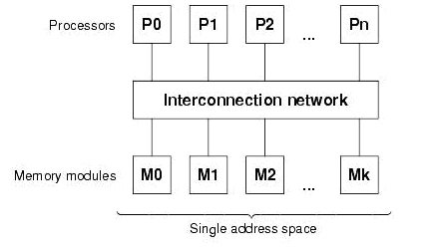

The processors are connected to the memory modules via some kind of interconnection network. This type of parallel computer is also called UMA, which stands for uniform memory access, since all processors access every memory module in the same way concerning latency and bandwidth.
A big advantage of shared memory computers is that programming a shared memory computer is very convenient due to the fact that all data are accessible by all processors, such that there is no need to copy data. However, it is very difficult to obtain high levels of parallelism with shared memory machines; most systems do not have more than 64 processors.

Distributed Memory Architectures
In case of a distributed memory computer, each processor has its own, private memory. There is no common address space, i.e. the processors can access only their own memories. Communication between the processors is done by exchanging messages over the interconnection network.
The figure shows the organization of the processors and memory modules in a distributed memory computer. In contrary to shared memory architecture a distributed memory machine scales very well, since all processors have their own local memory which means that there are no memory access conflicts. Using this architecture, massively parallel processors (MPP) can be built, with up to several hundred or even thousands of processors.
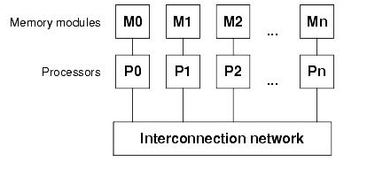

Distributed Shared Memory Architectures
To combine the advantages of the architectures described above, ease of programming on the one hand, and high scalability on the other hand, a third kind of architecture has been established: distributed shared memory machines. Here, each processor has its own local memory, but, contrary to the distributed memory architecture, all memory modules form one common address space, i.e. each memory cell has a system-wide unique address. In order to avoid the disadvantage of shared memory computers, namely the low scalability, each processor uses a cache, which keeps the number of memory access conflicts low.
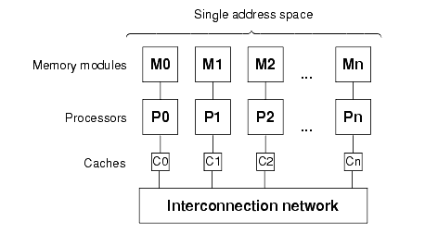
1.7 Addressing Modes
The address generated by the CPU in-order to access the operand in the memory is termed as an effective address. The methods used to provide an access path to operands in memory and CPU registers is addressing mode.
Addressing modes are an aspect of the instruction set architecture in most central processing unit (CPU) designs. The various addressing modes that are defined in a given instruction set architecture define how machine language instructions in that architecture identify the operand (or operands) of each instruction. An addressing mode specifies how to calculate the effective memory address of an operand by using information held in registers and/or constants contained within a machine instruction or elsewhere. Following are the general addressing modes.
- Immediate
- Register
- Direct(Absolute)
- Indirect
- Index (Displacement)
- Base with index
- Base with index and offset
- Relative
- Auto increment
- Auto decrement
1.7.1 Immediate Addressing Mode
In this the operand is explicitly given in the instruction.
Example: Move #200, R0
- Move the value 200 to register R0
- 200 is operand
The value is prefixed by the # symbol.
Features:
- No memory reference to fetch data
- Fast
- Limited range
1.7.2 Register Addressing Mode
Here the operand is held in register. The name of the register is given in the instruction.
Example: Move R1, R2
- Move the contents of register R1 to register R2
- The names of registers R1 and R2 are given in the instruction.
Features:
- Very small address field needed
- Shorter instructions
- Faster instruction fetch
- No memory access
- Very fast execution
- Very limited address space
Register Address R
Opcode
Instruction
Registers
Operand
1.7.3 Direct Addressing Mode (Absolute addressing mode)
The operand is in a memory location, the address of this location is given explicitly in the instruction. Here the effective address (EA) = address field
Example: Move LOC, R1
- Move the contents of cell LOC to register R1
- Look in memory at address LOC for operand
Features:
- Single memory reference to access data
- No additional calculations to work out effective address
- Limited address space
Address A
Opcode
Instruction
Memory
Operand

1.7.4 Indirect Addressing Mode
Here the memory cell pointed to by address field contains the address of (pointer to) the operand. The effective address,
EA = Contents of register or memory location whose address in the instruction.
Example: ADD (A)
- Add contents of cell pointed to by contents of A to accumulator
Address A
Opcode
Instruction
Memory
Operand
Pointer to operand

1.7.5 Index Addressing Mode
The effective address of the operand is generated by adding a constant value to the content of the register. The register can be general purpose or special purpose register.
EA = A + (R)
Address field hold two values
A = base value
R = register that holds displacement
or vice versa

Example: Add 20 [R₁] , R₂
So operand will be at location 1020 since the value of R₁ is 1000.
Features:
Good for accessing arrays and lists.
Register R
Opcode
Instruction
Memory
Operand
Pointer to Operand
Registers
Address A
+

1.7.6 Base with index
EA= [R_{i}]+ [R_{j}]
Example: Add (R₁,R₂),R₃
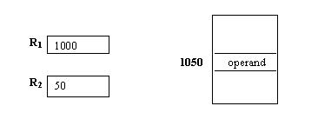
1.7.7 Base with index and offset
EA= [R_{i}]+ [R_{j}] +X
Example: Add 20(R₁,R₂),R₃
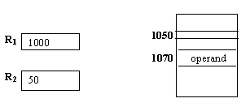
1.7.8 Relative Addressing Mode
It is a version of displacement addressing where the register R is always Program Counter, PC
EA = A + (PC) i.e. get operand from A cells from current location pointed to by PC.
It is commonly used to specify the target address in branch instruction.
1.7.9 Auto increment mode
Effective address is the content of the register in the instruction. After accessing the operand the content of this register is automatically incremented to point the next item in the list.
EA= [R_{i}]
Increment R_{i}
1.7.10 Auto decrement mode
The content of the register in the instruction is automatically decremented and then used as the effective address of the operand.
Decrement R_{i}
EA= [R_{i}]
1.8 Bus Structures
Computer consists of a set of modules like processor, memory and I/O that communicate each other. The collection of paths connecting the various modules is called the interconnection structures. A Bus is a collection of wires or distinct lines meant to carry data, address and control information.
Examples are given below.
- Data Bus: It is used for transmission of data. The number of data lines corresponds to the number of bits in a word.
- Address Bus: It carries the address of the main memory location from where the data can be accessed.
- Control Bus: It is used to indicate the direction of data transfer and to coordinate the timing of events during the transfer.
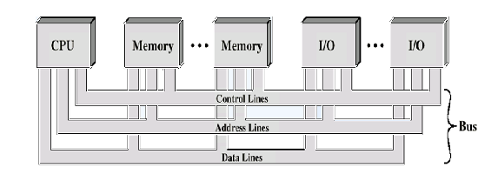
i) Single- Bus Structure
All units are connected to a single bus as shown in figure follwing. The bus can be used for only one transfer at a time since only two units can actively use the bus at any given instant of time. When multiple requests arise for the use of bus, then Bus control lines are used for managing it. The primary advantage of this structure is its low cost and flexibility for attaching peripherals. But the drawback is its low operating speed. This type of structure is mainly found in small computers such as minicomputers and microcomputers.
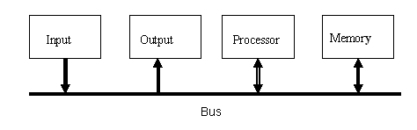
Advantages
- Low Cost
- Flexibility for attaching peripherals
Disadvantages
- Only one transfer at a time
- Only two devices can actively use the bus at a time
- Low operating speed
ii) Two-Bus Structure
The bus is said to perform two distinct functions by connecting the I/O units with memory and processor unit with memory. The processor interacts with the memory through a memory bus and handles input/output functions over I/O bus. The I/O transfers are always under the direct control of the processor, which initiates transfer and monitors their progress until completion. The main advantage of this structure is good operating speed but on account of more cost.
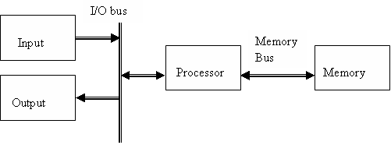
An Alternative Two-Bus Structure
Here the position of memory and processor is interchanged. I/O transfers are directly made to or from the memory. So special purpose processor called peripheral processor is used for providing the necessary controls over the actual data transfer.

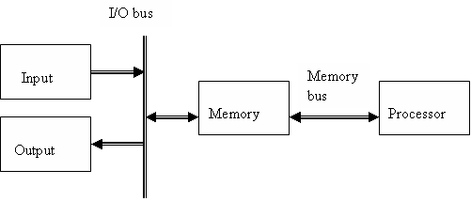

1.9 Execution of a Complete Instruction
To execute a program, the processor fetches one instruction at a time and performs the operation specified. Instructions are fetched from successive memory locations until a branch or a jump instruction is encountered. The processor keeps track of the address of the memory location containing the next instruction to be fetched using Program Counter (PC).
To execute an instruction, the following steps has to perform
- Fetch the contents of the memory location pointed to by the PC. The contents of this location are loaded into the IR (fetch phase).
IR ← [[PC]]
- Assuming that the memory is byte addressable, increment the contents of the PC by 4 (fetch phase).
PC ← [PC] + 4
- Carry out the actions specified by the instruction in the IR (execution phase).
Internal organization of the Processor
There are various registers and other elements in the processor like AKU, general purpose registers, special purpose registers etc. These are interconnected in variety of ways.

1. Single bus organization
ALU and other registers are interconnected via a Single common bus. Single bus organization of the data path inside a processor is given in the following figure.
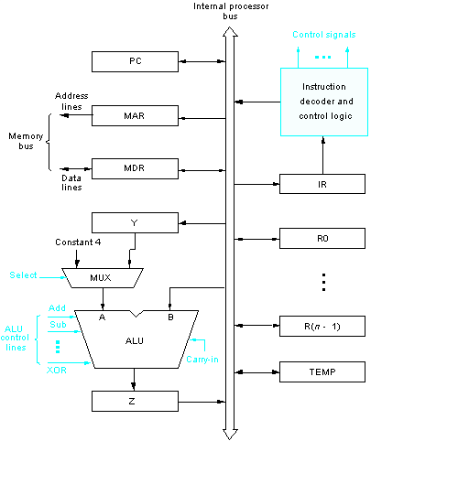
The data and the address lines of external memory connected to the central processor bus via MDR and MAR. Register MDR has two inputs and two outputs. Data may be loaded into MDR either from memory bus or from the internal processor bus. The data MDR may be placed on either bus.
The input of MAR is connected to internal bus and output is connected to external bus. The control lines of the memory bus are connected to the instruction decoder.
R₀ to R_{n-1} are n general purpose registers. The number and use of these registers are different from one processor to another.
Y,Z, Temp are temporary registers and these are never explicitly referenced by any instruction.
Multiplexer (MUX) selects either the output of Y register or a constant value to provide an input A to the ALU. Constant is used to increment the content of PC.
The instruction decoder and control logic unit is responsible for implementing the actions specified by the instruction loaded in the Instruction Register (IR). The decoder generates the control signals needed to select registers involved and direct the transfer of data.
All operations and data transfer are controlled by the processor clock. Registers, ALU and interconnecting bus are collectively known as data Path.
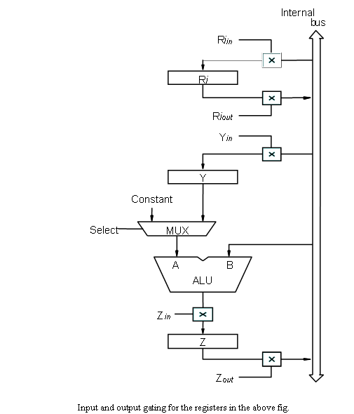

.
The instructions can be executed by performing one or more of the following operations in some specified sequence.
- Transfer a word of data from one processor register to another or to the ALU.
- Perform an arithmetic or logic operation and store the result in a processor register.
- Fetch the contents of a given memory location and load them into a processor register.
- Store the data from a processor register to a given memory location.
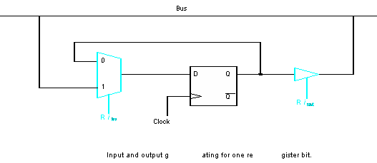

    - Register Transfer

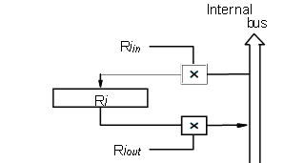
For each register two control signals are used to place the contents of that register on bus and load the data from bus to register.
Input and output of Ri is connected to bus via two signals Ri in and Ri out.
When Ri is set to 1 the data on bus are loaded to register ri. Rout is set 1 then the contents of Ri is placed on bus. When Ri out=0 bus can be used to transfer data from other registers.
b) Performing an arithmetic logic operation

- The ALU is a combinational circuit that has no internal storage.
- ALU gets the two operands from MUX and bus. The result is temporarily stored in register Z.
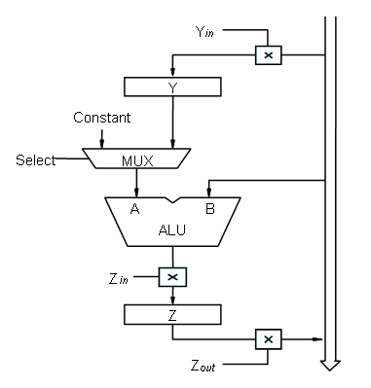
Example: ADD R₁, R₂ R₃
- R1out, Yin
- R2out, SelectY, Add, Zin
- Zout, R3in
c) Fetching a word from memory
- Address into MAR; issue Read operation; data into MDR.
- The response time of each memory access varies (cache miss, memory-mapped I/O).
- To accommodate this, the processor waits until it receives an indication that the requested operation has been completed (Memory-Function-Completed, MFC).

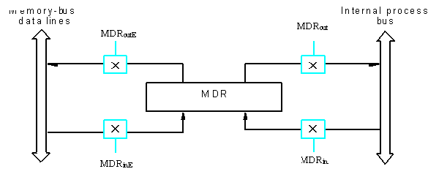

This has four control signals MDR_{in},MDR_{out}, control the connection to the internal bus . MDR_{outE} and MDR_{inE} control the conncetion to external bus.
Example: Move (R1), R2
The action needed to execute this instruction as follows.
- MAR ← [R1]
- Start a Read operation on the memory bus
- Wait for the MFC response from the memory
- Load MDR from the memory bus
- R2 ← [MDR]
The control signals for the above example are given below.
- R1out, MARin, Read
- MDRinE, WMFC
MDRout, R2in
d) Storing a word in memory
The desired address is loaded into MAR and the data loaded into MDR and write control signal is activated.
Example: Move R₂, (R₁)
- R_{1out}, MAR_{in}
- R2_{out}, MDR_{in}, Write
- MDr_{outE},WMFC

Example: 1. Write the control sequence of the instruction ADD (R3), R1
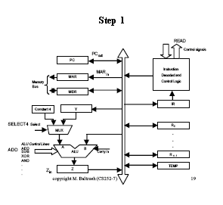
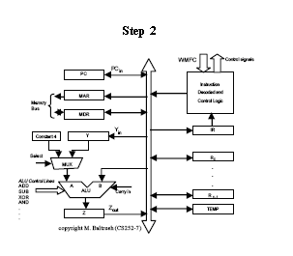
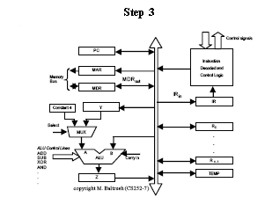

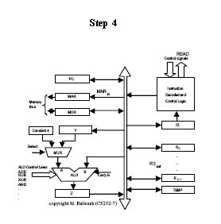
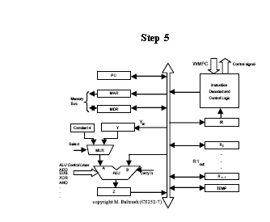
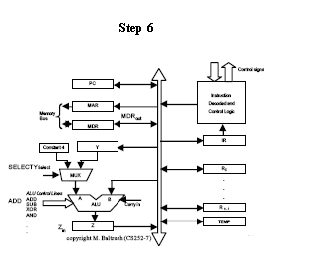
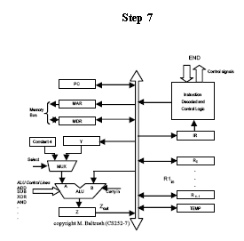
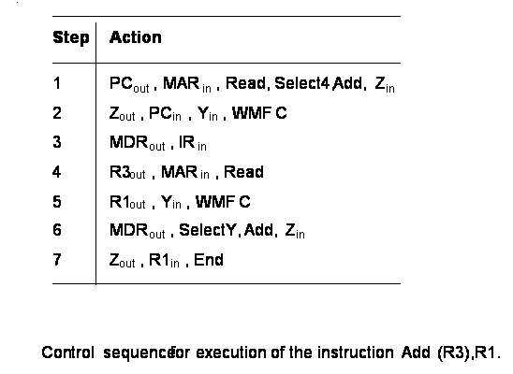
EXECUTION OF BRANCH INSTRUCTION

- A branch instruction replaces the contents of PC with the branch target address, which is usually obtained by adding an offset X given in the branch instruction and updated the value of PC accordingly.
- The offset X is usually the difference between the branch target address and the address immediately following the branch instruction.

a) Unconditional Branch

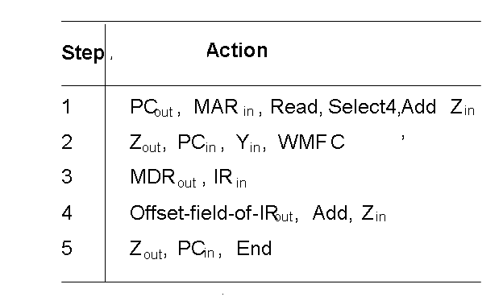
b) Conditional branch
In this we need to check the condition code before loading new value to PC.
Example: If (branch<0)
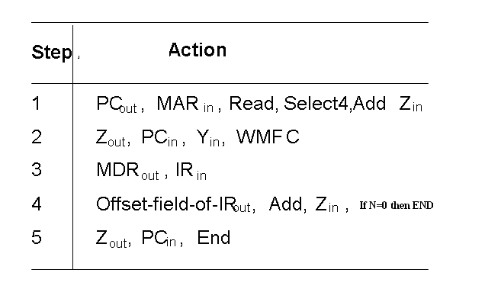
If N=0 processor returns to step1 else step 5 is performed and load new value to PC.

Multiple Bus organization

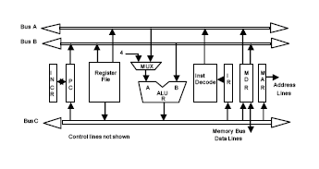
To reduce the number of steps needed, most processors provide multiple internal paths for data transfers. The above figure depicts the three bus organization used to connect the registers and the ALU of the processor. All general purpose registers are combined into a single block called the register file. The register file has three ports. There are two output ports allowing the contents of two different registers to be accessed simultaneously and have their contents placed on buses A and B. The third port allows the data on bus C to be loaded into third register at the same clock cycle. Buses A and B are used to transfer the source operand to the A and B inputs of the ALU. The result is transferred to the destination over bus C. We will use the ALU control signals R=B or R=A.
The incrementer unit is used to increment the value of PC. The source for the constant 4 at the ALU input multiplexer is used to increment other addresses such as LoadMultiple, StoreMultiple instructions.
Example: ADD R4, R5, R6
Control sequence of this operation is given below
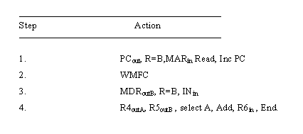
1.10 Interconnection Networks
Basically, there are two kinds of interconnection networks: static and dynamic. In case of a static interconnection network, all connections are fixed, i.e. the processors are wired directly, whereas in the latter case there are switches in between. The decision whether to use a static or dynamic interconnection network depends on the kind of problem that should be solved with the computer. Generally, static topologies are suitable for problems whose communication patterns can be predicted reasonably well, whereas dynamic topologies (switching networks), though more expensive, are suitable for a wider class of problems.
Various Interconnection networks are given below
a) BUS Network: Bus network is a network architecture in which a set of clients are connected via a shared communications line, called a bus. Bus networks are the simplest way to connect multiple clients, but often have problems when two clients want to communicate at the same time on the same bus.

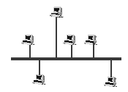

Advantages
- Easy to implement and extend
- Well suited for temporary networks (quick setup)
- Typically the cheapest topology to implement
- Failure of one station does not affect others

Disadvantages
- Difficult to administer/troubleshoot
- Limited cable length and number of stations
- A cable break can disable the entire network
- Maintenance costs may be higher in the long run
- Performance degrades as additional computers are added
- Low security (all computers on the bus can see all data transmissions on the bus)
- One virus in the network will affect all of them (but not as badly as a star or ring network)
b) Star network: Star network is one of the most common computer network topologies. In its simplest form, star network consists of one central, or hub computer which acts as a router to transmit messages.
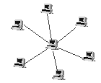

Advantages
- Easy to implement and extend, even in large networks
- Well suited for temporary networks (quick setup)
- The failure of a non-central node will not have major effects on the functionality of the network.

Disadvantages
- Limited cable length and number of stations
- Maintenance costs may be higher in the long run
- Failure of the central node can disable the entire network.
- One virus in the network will affect them all
c) Ring network: Ring network is a topology of computer networks where each user is connected to two other users, so as to create a ring. The most popular example is a token ring network.
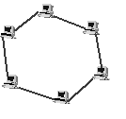

Advantages
- All stations have equal access
- Each node on the ring acts as a repeater, allowing ring networks to span greater distances than other physical topologies.
- When using a coaxial cable to create a ring network the service becomes much faster.

Disadvantages
- Often the most expensive topology
d) Mesh network: The simplest - and cheapest - way to connect the nodes of a parallel computer is to use a one-dimensional mesh. Each node has two connections, boundary nodes have one.
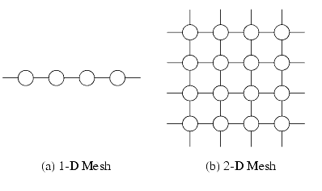

e) Tree Network

Tree network is a topology of computer networks where each user is connected to other users and to form a tree structure.

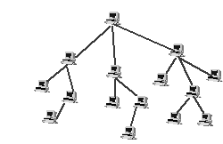

f) Hypercube: The hypercube topology is one of the most popular and used in many large scale systems. A k-dimensional hypercube has 2^{k} nodes, each with k connections. In the figure a four-dimensional hypercube is displayed.
An important property of hypercube is the relationship between node-number and which nodes are connected together. The rule is that any two nodes in the hypercube, whose binary representations differ in exactly one bit, are connected together. For example in a four-dimensional hypercube, node 0 (0000) is connected to node 1 (0001), node 2 (0010), node 4 (0100) and node 8 (1000). This numbering scheme is called Gray code scheme.
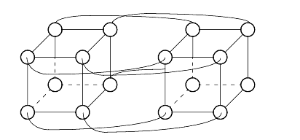

g) Cross bar Networks
The other extreme in terms of complexity is the crossbar network. With a crossbar full connectivity is given, i.e. all processors can communicate with each other simultaneously without reduction of bandwidth. The connection of n processors with m memory modules (as in a shared memory system) is shown. Certainly crossbars can also be used to connect processors with each other. In that case the memory modules are connected directly to the processors (which results in a distributed memory system), and the lines that were connected to the memory modules Mi are now connected to the processors Pi.
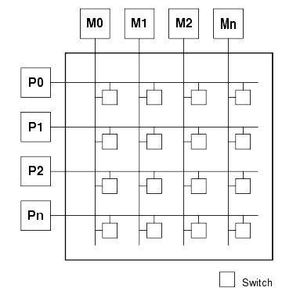
To connect n processors to n memory modules n² switches are needed. Consequently, crossbar networks can not be scaled to any arbitrary size. Today's commercially available crossbars can connect up to 256 units.

h) Multi-Stage Networks
Multi-stage networks are based on the so called shuffle-exchange switching element, which is basically a 2 x 2 crossbar. Multiple layers of these elements are connected and form the network.
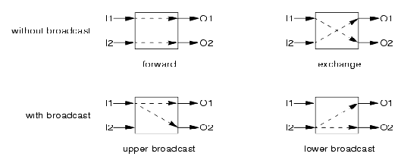

1.9 Layered View of Computer System
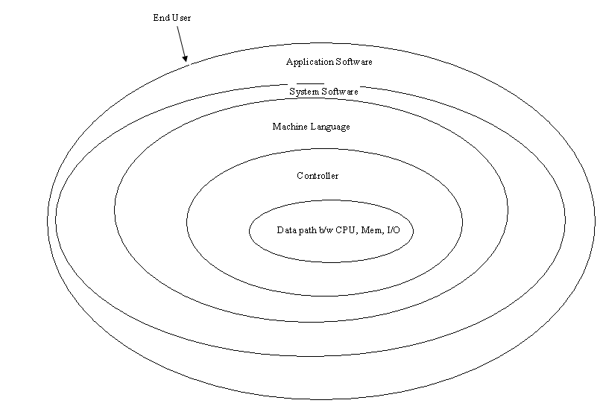

Computer System can be viewed as a collection of different layers as shown in the above figure. At the innermost layer lies the data path connecting various components of I/O device, CPU and memory. Controller unit controls the data transfer between the various modules of I/O, memory and CPU. These two layers are called the Hardware.
As per the machine instructions controller generates control signals for data transfer. The software which operates earlier three layers is machine language, system software (Operating System, compiler etc.) and application software (DBMS, sorting package etc). User interacts with the system from outside with the help of high level language.

