RAJAGIRI SCHOOL OF ENGINEERING
AND TECHNOLOGY
Rajagiri Valley, Kochi -39



R402 -COMPUTER ORGANISATION
MODULE II

Prepared by
Preetha K G

INDEX
Topics Page Number

2.1 Introduction to CPU arithmetic ……………………………. 3
2.1.1 Representation of Signed Number…………………….. 3
2.1.2 Signed Number Arithmetic…………………………….. 6
2.2 Serial & Parallel Adder……………………………………… 8
2.3 Carry Look Ahead Adder…………………………………… 13
2.4 BCD Adder…………………………………………………… 14
2.5 Multiplication………………………………………………… 18
2.5.1 Array Multiplier……………………………………….. 19
2.5.2 Sequential Binary Multiplier………………………….. 20
2.5.3 Booths Algorithm……………………………………… 22
2.5.4 Fast Multiplication………………………………………. 25
2.5.4.1 Bit Pair Recording…………………………….. 25
2.5.4.2 Carry Save Adder……………………………… 26
2.6 Division…………………………………………………………. 28
2.6.1 Unsigned Division………………………………………… 28
2.6.1.1 Restoring Division………………………………. 28
2.6.1.2 Non restoring Division………………………….. 30
2.6.2 Signed Division……………………………………………. 31
2.7 Arithmetic operations on floating Point Numbers ……………….. 32
2.8 ALU design………………………………………………………….. 39

2.1 Introduction to CPU arithmetic
2.1.1 Representation of Signed Number
If we want to represent a negative number in binary format, one way of doing this is use a sign bit. A sign bit is usually used with a binary number of a fixed number of bits and is always the bit furthest to the left of the binary number.
1. Sign-Magnitude Representation
The most significant bit of the number to indicate the sign. Use the same representation as positive number, but with 1 for the sign bit.
Eg.
Using 8 bits

5 0 0000101
- 5 1 0000101

Problems with this method
Addition and Subtraction operations on these numbers are hard .
2. Complement Representation
- There are two kinds of complements for each number system. The r’s and (r-1)’s complement

Eg.
decimal 10’s and 9’s complement
binary 2’s and 1’s complement
hex 16’s and 15’s complement
- (r-1)’s complement and r’s complement are used to represent negative numbers. Most computer architectures use the two’s complement to represent negative numbers.

- The r’s complement is obtained from the r-1 complement and adding a one.
a) r-1’s Complement
- Subtract each digit of the number from r-1 (the radix of the system - 1)
Eg: 952₁₀
9 9 9
9 5 2 -

0 4 7 (9’s complement )
- To represent a negative number using the one’s complement, write out the value (absolute value) of the number. then subtract each digit from r-1
Eg:
5 0000 0101

to represent -5

1 1 1 1 1 1 1 1
0 0 0 0 0 1 0 1 -
1 1 1 1 1 0 1 0 (this is -5 in one’s complement)
- Notice that the sign bit is correct (it became 1) which indicates a negative number.
Problems of using r-1’s complement
- zero has two representations
+0 0000 0000
-0 1111 1111
but +0 and -0 are equal (so the machine has to know this)
- Addition is harder
b) r’s Complement
Step1- get the (r-1)’s complement
Step 2- add 1 to the result
Eg: 935₁₀
9 9 9
9 3 5 -
0 6 4 (r-1)’s complement
0 6 4
1 +
0 6 5
- When using the r’s complement we add normally, and ignore any carry from the MSD (most significant digit)
- If the result is negative, it will be in r’s complement form
Eg:
395 - 210
210 is 789 + 1 = 790 in 10's complement form
395
790+
185
Features of 2’s complement representation
- The left-most bit is still a sign bit
1 for negative
0 for positive
- One way to write 0
+0 0000 0000
-0 0000 0000
- With n bits we can represent -2^{n-1} to ( 2^{n-1} - 1)
- Subtraction is done by taking 2’s complement and adding
- 2’s complement of 2’s complement is the original number
- The 2’s complement of a binary number is the same as the 16’s complement of corresponding Hex.
b₃b₂b₁b₀ | Sign & Magnitude | 1’s Complement | 2’s Complement
0111 | +7 | +7 | +7
0110 | +6 | +6 | +6
0101 | +5 | +5 | +5
0100 | +4 | +4 | +4
0011 | +3 | +3 | +3
0010 | +2 | +2 | +2
0001 | +1 | +1 | +1
0000 | +0 | +0 | +0
1000 | -0 | -7 | -8
1001 | -1 | -6 | -7
1010 | -2 | -5 | -6
1011 | -3 | -4 | -5
1100 | -4 | -3 | -4
1101 | -5 | -2 | -3
1110 | -6 | -1 | -2
1111 | -7 | -0 | -1
2.1.2 Signed Number Arithmetic
a) 1's Complement Addition
Add two numbers and if carry occurs then the carry is added to the result.
b) 1's Complement Subtraction
- Take the 1’s complement of the subtrahend
- Add to the minuend
- If carry occurs then add carry to the result.
Example 1: consider 35 - 22 both represented as 7-bit numbers with a sign bit.
+35 in binary is: 00100011
+22 in binary is: 00010110
-22 in binary is: 10010110
-22 in 1's complement is: 11101001
The sum to be calculated is therefore the sum of the binary for +35 and the 1's complement for -22:
00100011
+ 11101001
100001100
This addition produces a 9th bit. In 1's complement addition, if this occurs, the extra bit is carried to the LSB column and added. Hence:
00001100
+ 1
00001101
The final answer has a 0 for its sign bit. This tells us two things:
- the answer is positive
- the answer is represented in binary notation
The answer is the positive binary number 0001101=13₁₀.
Example 2: 22 - 35, again both represented as 7-bit numbers with a sign bit.
+22 in binary is: 00010110
+35 in binary is: 00100011
-35 in binary is: 10100011
-35 in 1's complement is: 11011100

The sum to be calculated is below
00010110
+ 11011100
11110010
This time the addition does not produce a 9th bit, but the sign bit is 1. In this case it again tells us two things:
- the answer is negative
- the answer is represented in 1's complement notation
So to get the final answer we need to turn our answer into binary. If the 1's complement notation is 11110010 then the binary representation is 10001101 (note - the sign bit doesn't change, it's still a negative number!). This is the binary for -13.
c) 2's Complement Addition
Two's complement addition follows the same rules as binary addition.
Add the numbers and if carry occurs discard the carry.
Example
5 + (-3) = 2 0000 0101 = +5
+ 1111 1101 = -3
--------------------------------------------------------------------------------

0000 0010 = +2
d) 2's Complement Subtraction
- Take the 2’s complement of the subtrahend
- Add to the minuend
- If carry occurs then discard the carry.
Example:
7 - 12 = (-5) 0000 0111 = +7
+ 1111 0100 = -12
--------------------------------------------------------------------------------

1111 1011 = -5

Overflow
A situation occurs because the magnitude of the results of arithmetic operations has become too large for the fixed word length of the computer to represent them properly. (If the result is out of the range then overflow occurs.)
Eg:
using 4- bit (signed numbers)
7₁₀ - 3₁₀ 0007
9997+
0004
-7₁₀ + 3₁₀ 9993
0003+
9996

7₁₀ + 3₁₀ 0007
0003+
0010
Example:

7 ÷ 3 = 2 remainder 1 0000 0111 = +7 0000 0100 = +4
+ 1111 1101 = -3 0000 0100 = -3
--------------------------------------------------------------------------------
+ 1111 1101 = +4 0000 0001 = +1 (remainder)

- Overflow occurs when adding two numbers have same sign.
- If X and Y are two numbers having the same sign then an overflow occurs when the sum is having different sign
2.2 Serial & Parallel Adder
Adders are the basic building blocks of all the arithmetic circuits, adders add two binary numbers and give out sum and carry as output. Basically we have two types of adders. Half adder and Full adder.

Half Adder

Adding two single-bit binary values, A,B produces a Sum bit and a carry out Carry bit. This operation is called half addition and the circuit to realize it is called a half adder.

Truth Table:
A | B | Sum | Carry
0 | 0 | 0 | 0
0 | 1 | 1 | 0
1 | 0 | 1 | 0
1 | 1 | 0 | 1

Symbol

A SUM
HA

B Carry

Sum = A'B + AB' =A ⊕ B,

Carry = AB
There are four possibilities, these are as follows.
- When A = 0 and B = 0.
Sum = A  B = 0  0 = 0
Carry = A.B = 0.0 = 0.
- When A = 0 and B = 1.
Sum = A  B = 0  1 = 1
Carry = A.B = 0.1 = 0.
- When A = 1 and B = 0.
Sum = A  B = 1  0 = 1
Carry = A.B = 1.0 = 0.
- When A = 1 and B = 1.
Sum = A  B = 1  1 = 1
Carry = A.B = 1.1 = 1.
These results are summarized in the truth table as shown above. The addition of two numbers by using the binary rule and above circuit is the same therefore the above circuit is called as half adder.

Logic Circuit

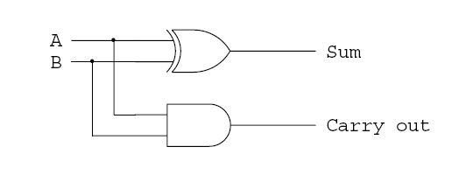
Full Adder
Full adder takes three bit input. Adding two single-bit binary values, X, Y with a carry input bit C-in produces a sum bit S and a carry out C-out bit.
Truth Table

Sum =A BC
A | B | C | Sum | Carry
0 | 0 | 0 | 0 | 0
0 | 0 | 1 | 1 | 0
0 | 1 | 0 | 1 | 0
0 | 1 | 1 | 0 | 1
1 | 0 | 0 | 1 | 0
1 | 0 | 1 | 0 | 1
1 | 1 | 0 | 0 | 1
1 | 1 | 1 | 1 | 1

Carry = (A B)C+A.B

Symbol

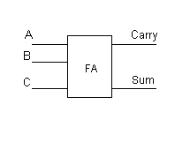

Logic Circuit

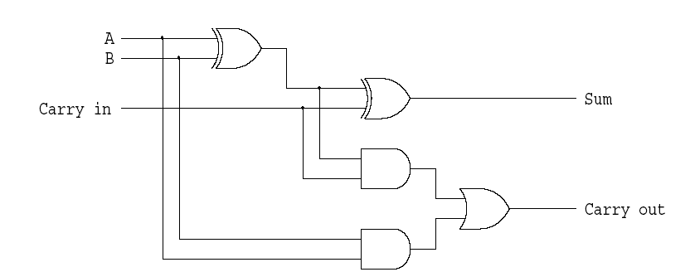

Full adder using 2 half adders

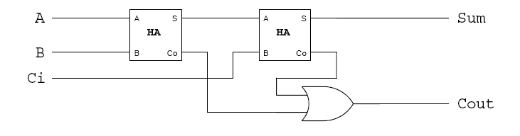

Parallel Adder

An n-bit adder used to add two n-bit binary numbers can build by connecting in series n full adders. Each full adder represents a bit position j (from 0 to n-1).

Each carry out C-out from a full adder at position j is connected to the carry in C-in of the full adder at the higher position j+1.

In the expression of the sum Cj must be generated by the full adder at the lower position j-1. The propagation delay in each full adder to produce the carry is equal to two gate delays = 2 D Since the generation of the sum requires the propagation of the carry from the lowest position to the highest position , the total propagation delay of the adder is approximately:
Total Propagation delay = 2 nD

4-bit Carry Ripple Adder

Adds two 4-bit numbers: A = A_{0,} A_{1,} A_{2,} A₃ , B = B_{0,} B_{1,} B_{2,} B₃. Producing the sum S = S3 S2 S1 S0 and C-out = C4 from the most significant.
A₃ A₂ A₁ A₀
B₃ B₂ B₁ B₀
₋₋₋₋₋₋₋₋₋₋₋₋₋₋₋₋₋₋₋₋₋₋₋₋
S₃ S₂ S₁ S₀
The first column requires only a half adder. For any column above the first there may be a carry from preceding column. Therefore we must use a full adder for each column above the first.

Total Propagation delay = 2 nD = 8D or 8 gate delays
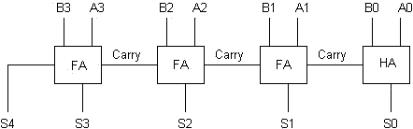

A complete Circuit is given below
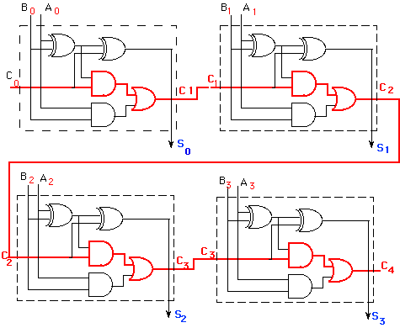
2.3 Carry Look Ahead Adder
The delay generated by an N-bit adder is proportional to the length N of the two numbers Aand B that are added because the carry signals have to propagate from one full-adder to the next. For large values of N, the delay becomes unacceptably large so that a special solution needs to be adopted to accelerate the calculation of the carry bits. This solution involves a look-ahead carry generator which is a block that simultaneously calculates all the carry bits involved. Once these bits are available to the rest of the circuit, each individual three-bit addition (A_{i}+B_{i}+C_{i}) is implemented by a simple 3-input XOR gate. The design of the look-ahead carry generator involves two Boolean functions named Generate and the Propagate.
For each pair of input bits these functions are defined as:
G_{i} = A_{i}.B_{i}
Pi = (A_{i}  B_{i})
The carry bit carry-out_{i} generated when adding two bits Xi and Yi is '1' if the corresponding function Gi is '1' or if the carry_outi-1='1' and the function Pi = '1' simultaneously. In the first case, the carry bit is activated by the local conditions (the values of Xi and Yi). In the second, the carry bit is received from the less significant elementary addition and is propagated further to the more significant elementary addition. Therefore, the carry-out bit corresponding to a pair of bits Xi and Yi is calculated according to the equation:
C_{OUT} = C_{i+1} = A_{i}.B_{i} + (A_{i} + B_{i}).C_{i.}
For a four-bit adder the carry-outs are calculated as follows
C₁ = g₀ + p₀.C₀
C₂ = g₁ + p₁.C₁ = g₁ + p1.g₀ + p₁.p₀.C₀
C₃ = g₂ + p₂.g₁ + p₂.p₁.g₀ + p₂.p₁.p₀.C₀
C₄ = g₃ + p₃.g₂ + p₃.p₂.g₁ + p_{3.}p₂.p₁.g₀ + p₃p₂.p₁.p₀.C₀
So in general C_{i+1}=
The set of equations above are implemented by the circuit below and a complete adder with a look-ahead carry generator is next. Sum output of this adder is as follows
S₀ = A₀.B₀.Cout₀
S₁ = A₁.B₁.Cout₁
S₀ = A₂.B₂.Cout₂
S₀ = A₃.B₃.Cout₃

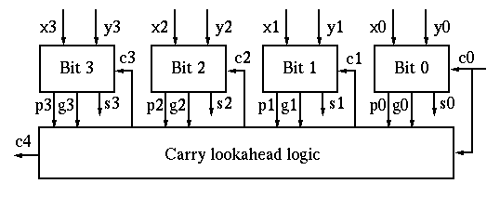
2.4 BCD Adder
In the BCD representation system each digit is encoded into its binary equivalent with four (4) bits.

Decimal | BCD
0 | 0000
1 | 0001
2 | 0010
3 | 0011
4 | 0100
5 | 0101
6 | 0110
7 | 0111
8 | 1000
9 | 1001

For example, let's consider the addition of the two BCD digits 5 and 3:

Now consider the sum of 5 and 8:

The sum is 1101₂ = 13, but this result should be correctly represented as 0001 0011 in BCD notation. Fortunately, there is a simple way to find the correct result. We add 6 (0110₂) to the digit sum if it exceeds 9. Let's examine the following cases:
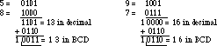

In both cases, by adding six we obtain the correct answer in BCD.
BCD Adder Design
When we add two BCD numbers we can get sum ranges from 0-19. Consider a 4 bit binary adder the adder output named K (carry output) P₃P₂P₁P₀ . if this out put is lass than or equal to 9 then that is a valid BCD number. If it is greater than 9 there should be some corrective action taken. This circuit is given below. And the out put of the corrective network named as CoutZ₃Z₂Z₁Z₀

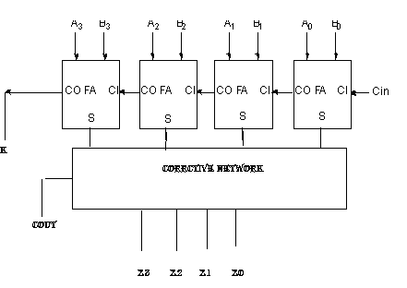
If KP₃P₂P₁P₀=CoutZ₃Z₂Z₁Z₀ there is no corrective procedure is needed. On the other hand when two decimal is added and the adder produce the output KP₃P₂P₁P₀= 01010, 01011,……10011which corresponds to decimal sums of 10 through 19, corrective action must be taken to get appropriate values for CoutZ₃Z₂Z₁Z₀.
Design of correction network

Decimal | Binary Sum |  |  |  |  | Required BCD sum
Decimal | K | P₃ | P₂ | P₁ | P₀ | C_{out} | Z₃ | Z₂ | Z₁ | Z₀
0 | 0 | 0 | 0 | 0 | 0 | 0 | 0 | 0 | 0 | 0
1 | 0 | 0 | 0 | 0 | 1 | 0 | 0 | 0 | 0 | 1
2 | 0 | 0 | 0 | 1 | 0 | 0 | 0 | 0 | 1 | 0
3 | 0 | 0 | 0 | 1 | 1 | 0 | 0 | 0 | 1 | 1
4 | 0 | 0 | 1 | 0 | 0 | 0 | 0 | 1 | 0 | 0
5 | 0 | 0 | 1 | 0 | 1 | 0 | 0 | 1 | 0 | 1
6 | 0 | 0 | 1 | 1 | 0 | 0 | 0 | 1 | 1 | 0
7 | 0 | 0 | 1 | 1 | 1 | 0 | 0 | 1 | 1 | 1
8 | 0 | 1 | 0 | 0 | 0 | 0 | 1 | 0 | 0 | 0
9 | 0 | 1 | 0 | 0 | 1 | 0 | 1 | 0 | 0 | 1
10 | 0 | 1 | 0 | 1 | 0 | 1 | 0 | 0 | 0 | 0
11 | 0 | 1 | 0 | 1 | 1 | 1 | 0 | 0 | 0 | 1
12 | 0 | 1 | 1 | 0 | 0 | 1 | 0 | 0 | 1 | 0
13 | 0 | 1 | 1 | 0 | 1 | 1 | 0 | 0 | 1 | 1
14 | 0 | 1 | 1 | 1 | 0 | 1 | 0 | 1 | 0 | 0
15 | 0 | 1 | 1 | 1 | 1 | 1 | 0 | 1 | 0 | 1
16 | 1 | 0 | 0 | 0 | 0 | 1 | 0 | 1 | 1 | 0
17 | 1 | 0 | 0 | 0 | 1 | 1 | 0 | 1 | 1 | 1
18 | 1 | 0 | 0 | 1 | 0 | 1 | 1 | 0 | 0 | 0
19 | 1 | 0 | 0 | 1 | 1 | 1 | 1 | 0 | 0 | 1
Consider the situation KP₃P₂P₁P₀= 10000,10001,10010,10011. In each case K=1, and
C_{out} is Also 1. In these cases there should be some corrective procedure is needed. In order to obtain a correct BCD number, add 6 to the sum obtained by the 4-bit adder.
Consider another situation sum is ranges from 10 to 15. In these cases also the sum is not a valid BCD number. So add 6. These situations are P₃ P₂ ‘ P₁ P₀’+ P₃ P₂ ‘P₁ P₀ + P₃ P₂ P₁’ P₀ ‘+P₃ P₂ P₁’ P₀+ P₃ P₂ P₁ P₀’ + P₃ P₂ P₁ P₀ Simplify this expression u will get P₃ P₂+ P₃ P₁
So add 6= K+ P₃ P₂+ P₃ P₁
The corrective network is given below.
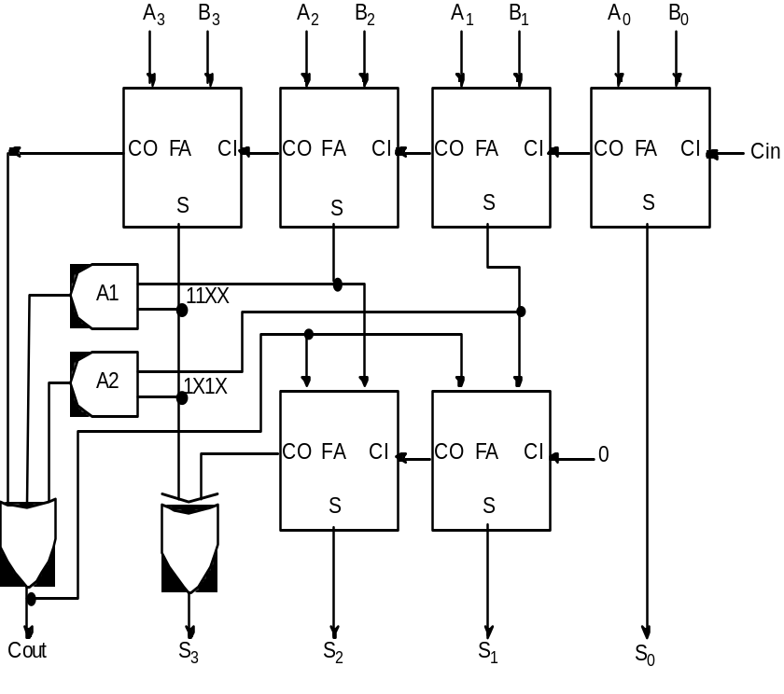

The AND gates labeled A1 and A2 detect the conditions under which the first-level sum matches the patterns 11XX₂ and 1X1X₂. These are exactly the cases in which this sum exceeds 9. When carry-out is asserted, the XOR gate and the adders in the second row effectively add 0110₂ to the first row's sum.
There is one further case to consider. The correction factor should also be applied whenever the first-row sum exceeds 15.
Thus the sum exceeds 9 if either the first-row carry-out is asserted, or the sum matches the pattern 11XX₂, or the sum matches the pattern 1X1X₂. These are precisely the inputs to the OR gate that computes the BCD carry-out.

2.5 Multiplication

Rules of Binary Multiplication
- 0 x 0 = 0
- 0 x 1 = 0
- 1 x 0 = 0
- 1 x 1 = 1, and no carry or borrow bits
For example,
00101001 × 00000110 = 11110110
0 0 1 0 1 0 0 1 = 41(base 10)
× 0 0 0 0 0 1 1 0 = 6(base 10)
=0 0 1 1 1 1 0 1 1 0 = 246(base 10)
A number of methods exist to perform integer multiplication.
- Repeated addition: add the multiplicand to itself “multiplier” times.
- Shift and add -- traditional “pen and paper” way of multiplying (extended to binary format)
- High speed (special purpose) hardware multipliers
1. Repeated addition
  - Least sophisticated method
  - Just use adder over and over again
  - If the multiplier is n bits, can have as many as
  - 2n iterations of addition -- O(2n)
  - Not used in an ALU
2. Shift and add
- Manual multiplication
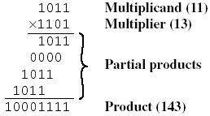

In the binary system, multiplication of the multiplicand by 1 bit is easy. If the multiplier bit is 1, the multiplicand is entered in the appropriate position to be added in the partial product. If the multiplier is zero then zeros are entered.
2.5.1 Array Multiplier
Binary multiplication of positive operands can be implemented in a combinational two dimensional array.
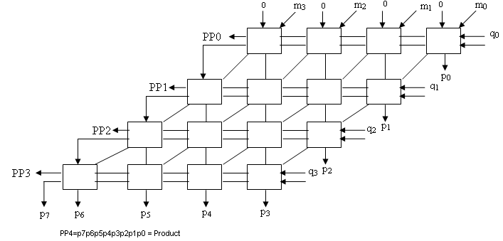
Each cell in the figure is a combination of AND gate and a Full Adder. A typical cell is given in the following figure.
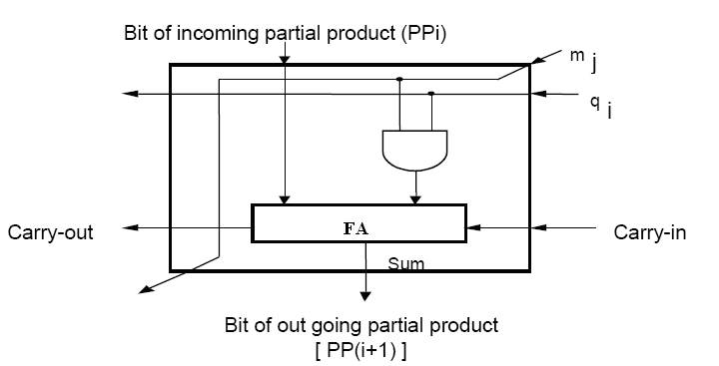

The AND gate in each cell determines whether a multiplicand bit mj is added to the incoming partial product bit, based on the value of the multiplier bit qj. Each raw i adds the multiplicand to the incoming partial product ppi to generate pp(i+1) if qi=1. If qi=0 ppi is passed downward unchanged.
2.5.2 Sequential Binary Multiplier
The simplest way to perform multiplication is to use the adder circuitry in the ALU for a number of sequential steps.
Hardware arrangement for sequential multiplier is given below.
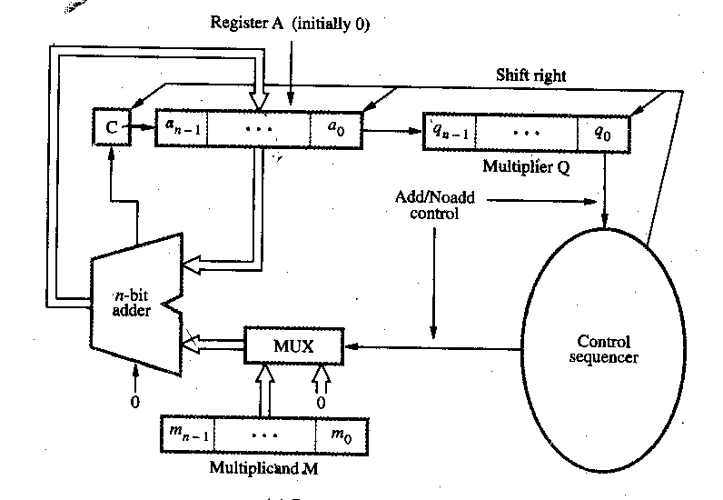
The circuit has a register Q to hold the multiplier, a register M to hold the multiplicand, a register A and a flip flop C which is initially cleared to 0. It also consists of an n-bit adder and a control sequencer. One of the inputs to the adder is the contents of register A and the other input is either the contents of register M or a 0. The bit q₀ determines whether an add or a no add operation should take place. If the bit q₀ is a 1 the multiplexer selects the contents of register M as one of the inputs to the n-bit adder, the control sequencer issues an add signal, the addition is performed and the result is stored back in register A. The contents of C, A and Q is shifted one bit position right. If the bit q₀ is a 0 no addition is performed, but shifting takes place. This should be repeated n times for multiplying two n bit numbers. The final product will be in registers A and Q after n cycles.

Flow Chart
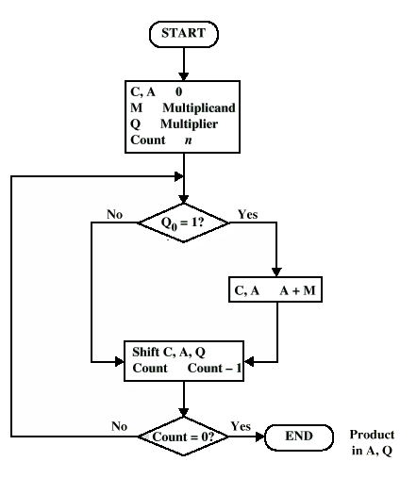

Example:
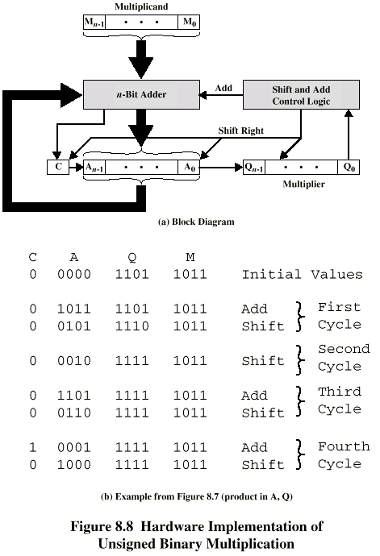

2.5.3 Signed Multiplication-Booth’s Algorithm
If two operands are unsigned numbers multiplication is easy. But any of the number is negative normal multiplication will not work. Example of signed number multiplication is given below.
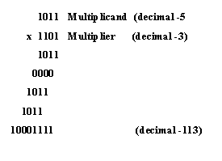
The possible solutions are
Solution 1
- Convert to positive if required
- Multiply as above
- If signs of both operands were different, take the 2’s complement of the result.
Solution 2
- Booth’s algorithm
Booth algorithm uses the following principle
2^{n}+2^{n-1}+……………2^{n-k}= 2^{n+1}-2^{n-k}
So the product can be generated one addition and one subtraction of the multiplicand. This scheme extends to any number of blocks of 1s in the multiplier.
Eg:, M*(01111010)=M*(+1 0 0 0 -1 +1 -1 0)
In general the Booth scheme, when moving from 0 to 1 then -1 is selected and moving from 1 to 0 then +1 is selected as the multiplier scanning from left to right. This algorithm clearly extends to any number of blocks of 1s in a multiplier, including the situation in which a single 1 is considered as a block. If the first bit is 1 then consider the previous bit is 0.

Advantages of Booths algorithm
- Treats positive and negative numbers uniformly.
- String of 1’s and 0’s can be skipped with shift operation for faster execution.

Booth recording table
Multiplier |  | Multiplicand
Bit i | Bit i-1 | Multiplicand Selected
1 | 0  1  0  1 | 0*M  +1*M  -1*M  0*M

Example:
Let the multiplicand A=110011 and multiplier B=101100.
Multiplier recoded using Booth’s algorithm is –1 +1 0 –1 0 0
1 1 0 0 1 1
-1 +1 0 -1 0 0

0 0 0 0 0 0 1 1 0 1 0 0
1 1 1 1 0 0 1 1 0
0 0 0 0 0 1 1 0 1
0 0 0 1 0 0 0 0 0 1 0 0

Flow Chart
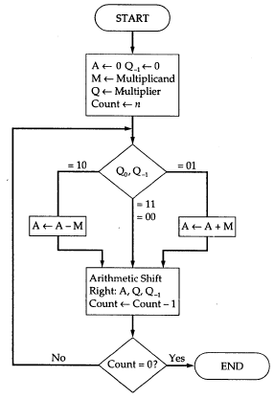
The Multiplicand is placed in M register and multiplier is loaded into register Q. Registers A and Q₋₁ is cleared initially. A bit of multiplier is examined together with the bit in Q₋₁. If these bits are same (0-0,1-1) then all bits of A,Q,Q₋₁ are shifted right 1 bit. If two bits are differ then the multiplicand is added to or subtracted from A depending on 0-1 or 1-0 then right shift occurs. In either case the right shift A_{n-1} to A_{n-2} occurs and A_{n-1} maintains the same bit for maintaining the sign. This is called Arithmetic shift.

Example:
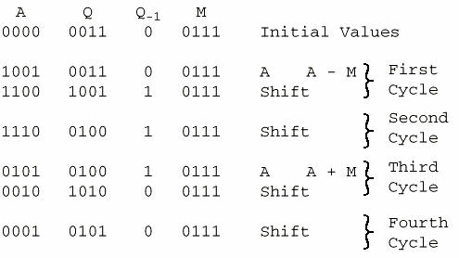
2.5.4 Fast Multiplication
There are mainly two techniques used for speeding up the multiplication process. The first technique reduces the maximum number of summands are added. The second technique reduces the time needed to add all summands.
2.5.4.1 BIT –Pair recoding of multipliers
In this technique halves the maximum number of summands. It is directly derived from the Booth’s algorithm. Group the Booth recoded multiplier bit in pairs starting from the right. Table of multiplicand selection decisions is given below.
Multiplier Bit pair |  | Multiplier bit on the  right | Multiplicand selected at i
i+1 | i | i-1 | Multiplicand selected at i
0 | 0 | 0 | 0*M
0 | 0 | 1 | +1*M
0 | 1 | 0 | +1*M
0 | 1 | 1 | +2*M
1 | 0 | 0 | -2*M
1 | 0 | 1 | -1*M
1 | 1 | 0 | -1*M
1 | 1 | 1 | 0*M

Example:

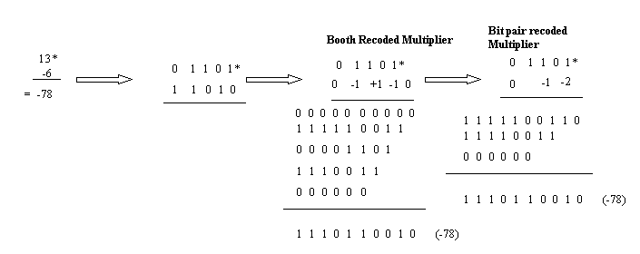
2.5.4.2 Carry save addition of Summands
There are many cases where it is desired to add more than two numbers together. The straightforward way of adding together m numbers (all n bits wide) is to add the first two, then add that sum to the next, and so on. This requires a total of m − 1 additions.

Using carry save addition, the delay can be reduced further still. The idea is to take 3 numbers that we want to add together, x + y + z, and convert it into 2 numbers c + s such that x + y + z = c + s.
To add three numbers by hand, we typically align the three operands, and then proceed column by column in the same fashion that we perform addition with two numbers. The three digits in a row are added, and any overflow goes into the next column. Observe that when there is some non-zero carry, we are really adding four digits (the digits of x,y and z, plus the carry).

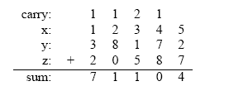
The carry save approach breaks this process down into two steps. The first is to compute the sum ignoring any carries:
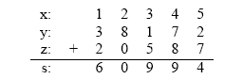

Each si is equal to the sum of xi + yi + zi modulo 10. Now, separately, we can compute the carry on a column by column basis:

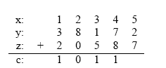
In this case, each ci is the sum of the bits from the previous column divided by 10 (ignoring any remainder). Another way to look at it is that any carry over from one column gets put into the next column. Now, we can add together c and s, and we’ll verify that it indeed is equal to
x + y + z.
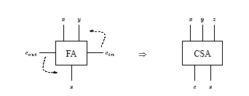
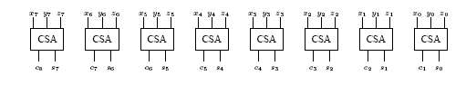
One CSA block is used for each bit. This circuit adds three n = 8 bit numbers together into two new numbers.
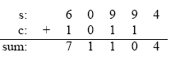
The important point is that c and s can be computed independently, and furthermore, each ci (and si) can be computed independently from all of the other c’s (and s’s).

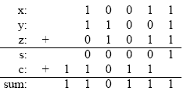
A carry save adder simply is a full adder with the cin input renamed to z, the z output (the original “answer” output) renamed to s, and the cout output renamed to c.
2.6 Division
2.6.1 Unsigned Division
Consider the following example of unsigned number division.
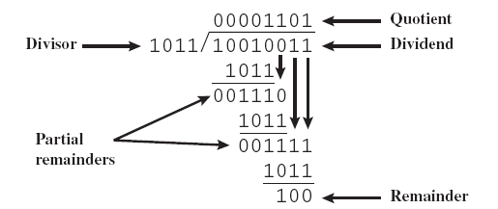

2.6.1.1 Restoring Division
Register A is initially loaded with 0 and it consists of n+1 bits, where n is the number of bits in the dividend. Dividend is loaded in register Q and Register M is loaded with the divisor. After division is complete n bit quotient is in register Q and remainder is in register A. extra bit on A and M accommodates the sign bit during subtractions.
Algorithm:
Do the following n times
    - Shift A & Q left one bit
    - Subtract M from A and place the result back to A.
    - If the sign of A is 1 then set q₀ to 0 and add M back to A, otherwise set q₀ to 1.
Flow Chart
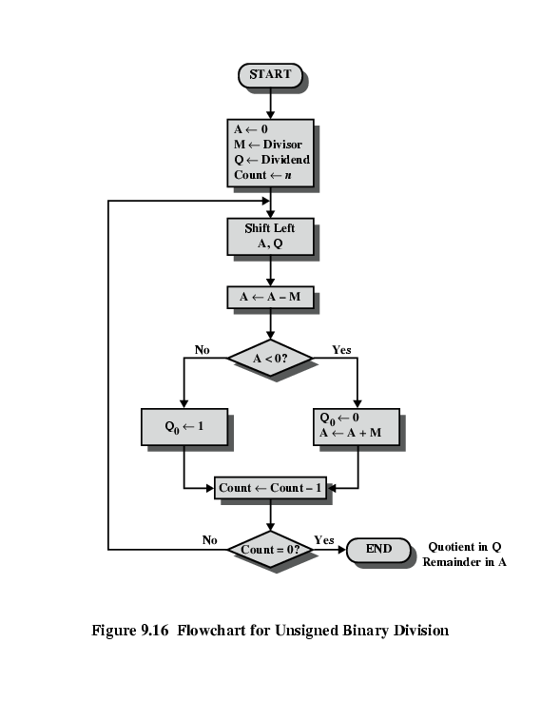
Example:1000/11
A= 000000, M=00011, Q=1000
A | Q | M=00011
00000 | 1000 | Initial value
00001 | 000- | Shift
11110 | 0000 | Subtract/set q₀
00001 |  | Restore
00010 | 000- | Shift
11111 | 0000 | Subtract/set q₀
00010 |  | Restore
00100 | 000- | Shift
00001 | 0001 | Subtract/set q₀
00010 | 001- | Shift
11111 | 0010 | Subtract/set q₀
00010 |  | Restore

Quotient=0010 in Register Q, Remainder=0010 in Register A
Hardware implementation of non restoring division is given in the following figure.
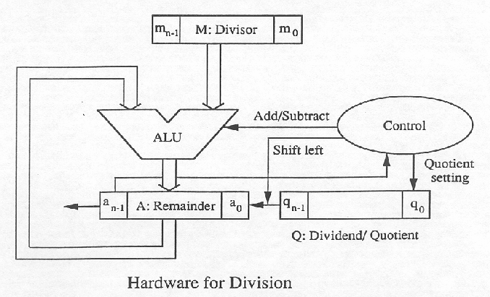

2.6.1.2 Non restoring Division
In this restoring can be avoided.
Algorithm:
Step 1: Do the following n times
a) If the sign of A is 0 , then shift A &Q left one bit and subtract M from A, otherwise shift A &Q left one bit and add M to A
b) If the sign of A is 0 then set q₀ to 1, otherwise set q₀ to 0.
Step2: If the sign of A is 1 then add M to A.
Step 2 is needed to leave the proper positive remainder in A at the end of n cycles of step 1.
Example: Example: 1000/11
A= 000000, M=00011, Q=1000
A | Q | M=00011
00000 | 1000 | Initial value
00001 | 000- | Shift
11110 | 0000 | Subtract/set q₀
11100 | 000- | Shift
11111 | 0000 | Add/set q₀
11110 | 000- | Shift
00001 | 0001 | Add/set q₀
00010 | 001- | Shift
11111 | 0010 | Subtract/set q₀

Quotient=0010 in Register Q
Remainder=11111 in Register A is negative, so restore the remainder by perform A+M=11111+00011=0010
Hardware circuit non restoring and restoring division is same.
2.6.2 Signed Division
Algorithm:
Step 1: Load divisor into M register and dividend into Q register.
Step 2: Shift A, Q left 1 bit position.
Step 3: If M and A have
  - same signs, perform A ← A - M
  - otherwise, A ← A + M
Step 4: Preceding operation is successful if sign of A is same before and after operation.
  - If operation is successful or A=0, then Q0←1.
  - If operation is unsuccessful and A≠0, then Q0←0 and restore previous value of A.
Step 5:. Repeat steps 2 through 4 as many times as there are bit positions in Q.
Step 6: Remainder is in A.
  - If sign of divisor and dividend are same, quotient is in Q.
  - Otherwise, correct quotient is twos complement of Q.

Example: 7/(-3)

A | Q | M=1101
0000 | 0111 | Initial value
0000 | 111- | Shift
1101 | 1110 | Add/set q₀
0000 |  | Restore A
0001 | 110- | Shift
1110 | 1100 | Add/set q₀
0001 |  | Restore A
0011 | 100- | Shift
0000 | 1001 | Add/set q₀
0001 | 001- | Shift
1110 | 0010 | Add/set q₀
0001 |  | Restore A

Quotient=0010 in Register Q
Remainder is in register A=0001
Quotient=0010 in Register Q but the sign of divisor and dividend are different so the actual quotient is 2’s complement of (Q) = 1110
2.7 Arithmetic operations on floating Point Numbers
Floating point numbers based on the scientific notation and is capable of representing very large and very small numbers without increase the number of bits and also used to represent the numbers has both fractional and integer part (real numbers). For example, 123.456 could be represented as 1.23456 × 10². In hexadecimal, the number 123.abc might be represented as 1.23abc × 16². General form is M*2E
IEEE standard for floating point representation
IEEE Standard 754 floating point is the most common representation today for real numbers on computers.
IEEE floating point numbers have three basic components: the sign, the exponent, and the mantissa.
- Mantissa is also known as the significant is the magnitude of the number.
- Exponent is the number of places the decimal point (binary point) is to be moved.
- Sign bit denotes the sign of the number. 0 denotes a positive number and 1 denotes a negative number.
IN IEEE standard there are three forms to represent the floating point numbers.
- Single precision
- Double precision
- Extended precision
Instead of signed exponent E, the value E is represented as a biased exponent E’. Bias is chosen to be large enough to convert to every integer in the range to a positive number.
For single precision, the exponent field is 8 bits, and has a bias of 127.
So the range of the number that can be represented is 0<=E’<=255 and -126<=E<=127.
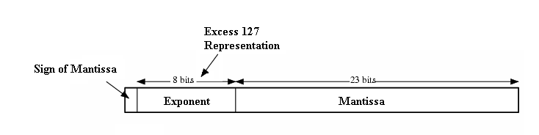
For double precision, the exponent field is 11 bits, and has a bias of 1023.
So the range of the number that can be represented is 1<=E’<=2046 and -1022<=E<=1023.
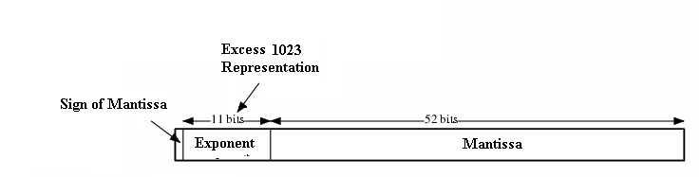
 | Sign | Exponent | Fraction | Bias
Single Precision | 1 [31] | 8 [30-23] | 23 [22-00] | 127
Double Precision | 1 [63] | 11 [62-52] | 52 [51-00] | 1023
When the decimal point is placed to the right of the first significant digit, the number is said to be normalized.
In normalized form the number representation is (-1)^{S} (1+M) 2^{E’-127}
As computation proceed, a number that does not fall in the representable range of normal numbers might be generated. In single precision form if exponent
<-126 then underflow occurs and exponent >127 then overflow occurs.
Special Cases:
        - E’=0 and M=0→ Value 0 is represented
        - E’=0 and M!=0→ Denormal number is represented (number smaller than smallest normal number=0.M*2⁻¹²⁶)
        - E’=255 and M=0 → Value α is represented
        - E’=255 and M!=0→ Not a Number (Invalid Operation)
Arithmetic operations on floating Point Numbers
- Add/Subtract Rule
  - Choose the number with the smallest exponent and shift its mantissa right n times where n is the difference between the exponents.
  - Set the exponent of the result as that of the larger exponent.
  - Perform addition or subtraction on the mantissa and determine the sign of the result.
  - Normalize the resulting value if necessary.
Example: Consider 2.9400 * 10 ² +
4.3100 * 10 ⁴

4.3100 * 10 ⁴ +
.0294 * 10 ⁴

4.3394 * 10 ⁴

Flow Chart
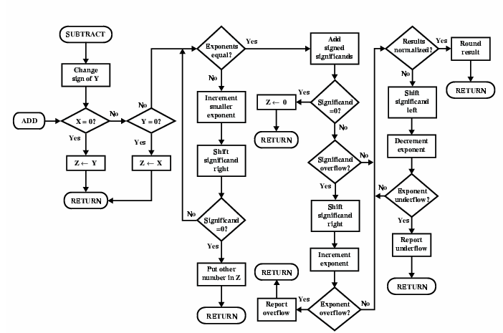
- Multiply Rule
  - If any exponent is zero then result=0.
  - Else add the exponents and subtract 127.
  - Multiply the mantissas and determine the sign of the result.
  - Normalize & round the resulting value if necessary.
Example:
0.3 * 10 ² *
0.2* 10 ³

(0.3*0.2) * 10²⁺³ =0.06*10⁵

Flow Chart
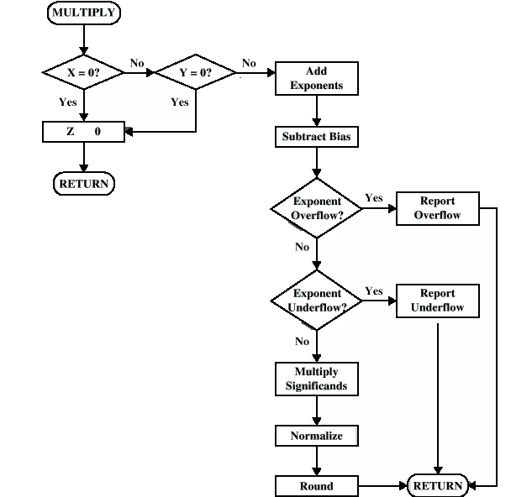
- Divide Rule
  - Check for zero if divisor is 0 then divide error Else dividend is 0 then result is 0.
  - Else subtract the exponents and add 127.
  - Divide the mantissas and determine the sign of the result.
  - Normalize and round the resulting value if necessary.

Example: 0.3 * 10 ² *
0.2* 10 ³

(0.3*0.2) * 10²⁻³ =1.5*10⁻¹

Flow Chart
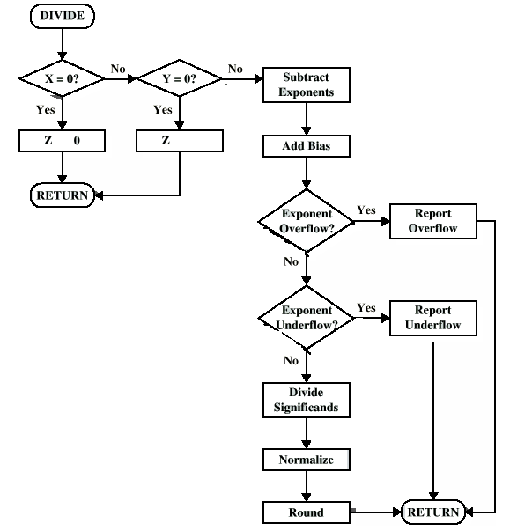

The hardware circuit for Floating point addition-subtraction unit is given below.

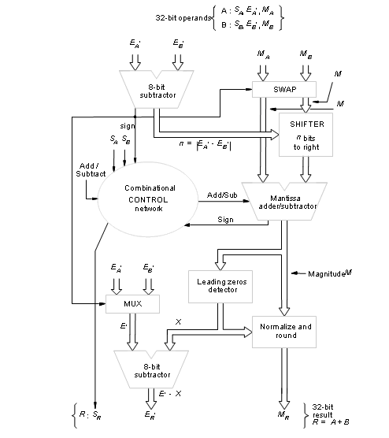

In step 1, compare the exponent to determine how far to shift the smaller exponent. Shift count value n= EA’-EB’ is determined by the subtractor unit. The value n is sent to the shifter unit. The sign of the difference determine which mantissa to be shifted. The sign sent to the Swap circuit. If the sign is 0 then EA’> EB” and mantissa MA and MB are sent straight through the swap network. MB sent to the shifter unit and shift n times right. MA sent directly to the adder/sub unit. If the sign is 1 then EA’< EB’ and mantissa swapped and sent to the shifter.
In step 2, the exponent of the result E’ is determined as EA’ if EA’>=EB’ or EB’ if EA’<EB’ based on the difference resulting from comparing exponent in step 1.
In step 3, the control logic determines whether the mantissas are to be added or subtracted. This is decided by the sign of the operands and the operation that is to be performed on the operands. The control logic also determines the sign of the result S_{R}.
In step 4, normalize the result. The number of leading zeros in M determines the number of bit shift X to be applied to M. The normalized value is rounded to generate the 23 bit mantissa M_{R}. The value X is subtracted from E’ to generate the correct exponent E_{R}’.
2.8 ALU design
ALU is a multi operation combinational circuit. It can perform a set of arithmetic and logic operations using K select lines. Using K select lines it can perform 2^{k} operations.
Consider the block diagram of 4 bit ALU.
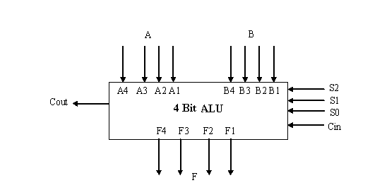
A ns B are the inputs. S2= mode select ( select the arithmetic or logic operation)
S1 S0 specifies the operation to be performed. S0 S1 and Cin combine to generate 8 operations.

Design of ALU has 3 stages.
- Design the arithmetic section independent of the logic section
- Determine the logic operations obtained from the arithmetic circuit in step 1, assuming that the input carries to all stages are 0.
- Modify the arithmetic circuit to obtain the required logic operations
1) Design of Arithmetic circuit
The basic component in the ALU is a Parallel adder.
Consider the above figure we obtain the following 8 functions.
S1 | S0 | Cin | Output | OPERATION
0 | 0 | 0 | A | Transfer A
0 | 0 | 1 | A + 1 | Increment A by 1
0 | 1 | 0 | A + B | Add A and B
0 | 1 | 1 | A + B + 1 | Increment the sum of A and B by 1
1 | 0 | 0 | A + B' | A plus one's complement of B
1 | 0 | 1 | A - B | Subtract B from A (i.e. B' + A + 1)
1 | 1 | 0 | A' + B | B plus one's complement of A
1 | 1 | 1 | B - A | B minus A (or A' + B + 1)

Logic diagram of Arithmetic circuit
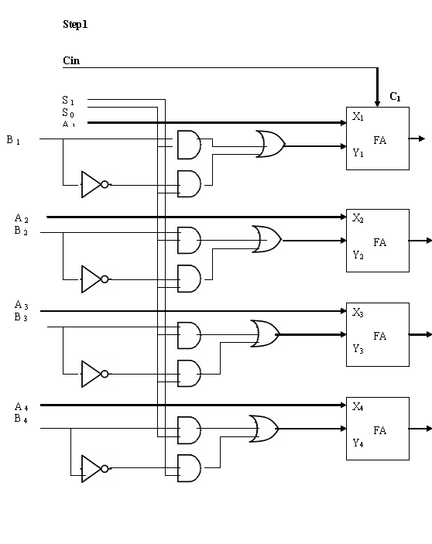
2) Design of Logic circuit
Using the same 2 select lines we can perform 4 logic operations. The Function table of logic operations is given below.
S1 | S0 | FUNCTION | OPERATION (bit wise)
0 | 0 | A_{i}B_{i} | AND
0 | 1 | A_{i} + B_{i} | OR
1 | 0 | A_{i}⊕ B_{i} | XOR
1 | 1 | Ai’ | NOT
Design the circuit according to the function table.
3) The logic circuit can be combined with arithmetic circuit to produce the ALU.
Selection variables S0 S1 are common to both sections. Third selection variable S2 is used to differentiate the arithmetic or logic operations.
