INDEX

2.1 NUMBER REPRESENTATION
2.2 MULTIPLICATION
2.2.1 BOOTHS ALGORITHM
2.2.2 ARRAY MULTIPLIER
2.2.3 SEQUENTIAL BINARY MULTIPLIER
2.3 DIVISION USING SEQUENTIAL BINARY CIRCUIT
2.3.1 RESTORING DIVISION
2.3.2 NON RESTORING DIVISION

2.4 FLOATING POINT ARITHMETIC

2.1 NUMBER REPRESENTATION
An n-bit vector B is represented in binary number system as b_{n-1}b_{n-2}……..b₁b₀.
A signed number can be represented in any of the following systems
- Sign and Magnitude form
- 1’s Complement form
- 2’s Complement form

b₃b₂b₁b₀ | Sign & Magnitude | 1’s Complement | 2’s Complement
0111 | +7 | +7 | +7
0110 | +6 | +6 | +6
0101 | +5 | +5 | +5
0100 | +4 | +4 | +4
0011 | +3 | +3 | +3
0010 | +2 | +2 | +2
0001 | +1 | +1 | +1
0000 | +0 | +0 | +0
1000 | -0 | -7 | -8
1001 | -1 | -6 | -7
1010 | -2 | -5 | -6
1011 | -3 | -4 | -5
1100 | -4 | -3 | -4
1101 | -5 | -2 | -3
1110 | -6 | -1 | -2
1111 | -7 | -0 | -1

In sign and magnitude form negative numbers are represented by changing the MSB to 1. In 1’s complement form negative numbers are represented by complementing each bit of the corresponding positive number. This is same as subtracting that number from 2^{n}-1. In 2’s complement form negative numbers are represented by adding one to the 1’s complement of the positive number. (Same as subtracting the number from 2^{n}).
2.2 MULTIPLICATION
- A number of methods exist to perform integer multiplication.
- Repeated addition: add the multiplicand to itself “multiplier” times.
- Shift and add -- traditional “pen and paper” way of multiplying (extended to binary format)
- High speed (special purpose) hardware multipliers
Repeated addition
  - Least sophisticated method
  - Just use adder over and over again
  - If the multiplier is n bits, can have as many as
  - 2n iterations of addition -- O(2n) !!!!
  - Not used in an ALU
Shift and add – Computer’s version of the pen and paper approach:
1011 (11)
x 1101 (13)
===========
1011
00000 Partial products
101100
1011000
===========
10001111 (143)
The computer version accumulates the partial products into a running (partial) sum as the algorithm progresses. Each partial product generation results in an add and shift operation.

2.2.1 BOOTHS ALGORITHM
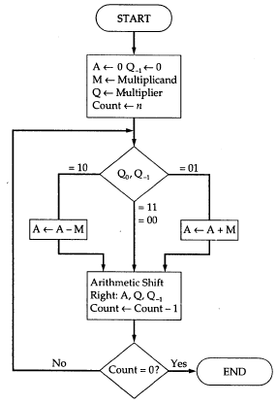
Figure Booths Algorithm for multiplication
Advantages of Booths algorithm
- Treats positive and negative numbers uniformly.
- String of 1’s and 0’s can be skipped with shift operation for faster execution.
  - Let the multiplicand A=110011 and multiplier B=101100.
Multiplier recoded using Booth’s algorithm is –1 +1 0 –1 0 0
1 1 0 0 1 1
-1 +1 0 -1 0 0

0 0 0 0 0 0 1 1 0 1 0 0
1 1 1 1 0 0 1 1 0
0 0 0 0 0 1 1 0 1
0 0 0 1 0 0 0 0 0 1 0 0

2.2.2 ARRAY MULTIPLIER
Binary multiplication of positive numbers can be implemented using a combinational circuit consisting of two dimensional logic arrays.

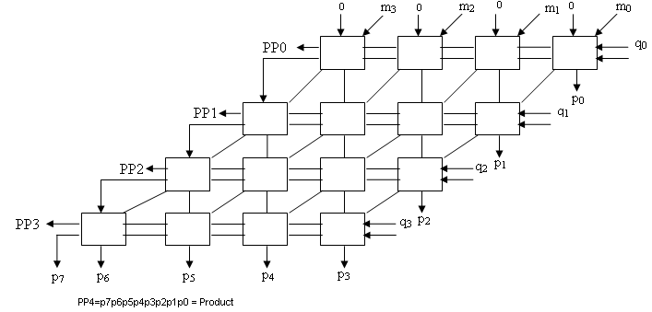

2.2.3 SEQUENTIAL BINARY MULTIPLIER
The circuit has a register Q to hold the multiplier, a register M to hold the multiplicand, a register A and a flip flop C which is initially cleared to 0. It also consists of an n-bit adder and a control sequencer. One of the inputs to the adder is the contents of register A and the other input is either the contents of register M or a 0. The bit q₀ determines whether an add or a no add operation should take place. If the bit q₀ is a 1 the multiplexer selects the contents of register M as one of the inputs to the n-bit adder, the control sequencer issues an add signal, the addition is performed and the result is stored back in register A. The contents of C, A and Q is shifted one bit position right. If the bit q₀ is a 0 no addition is performed, but shifting takes place. This should be repeated n times for multiplying two n bit numbers. The final product will be in registers A and Q after n cycles.

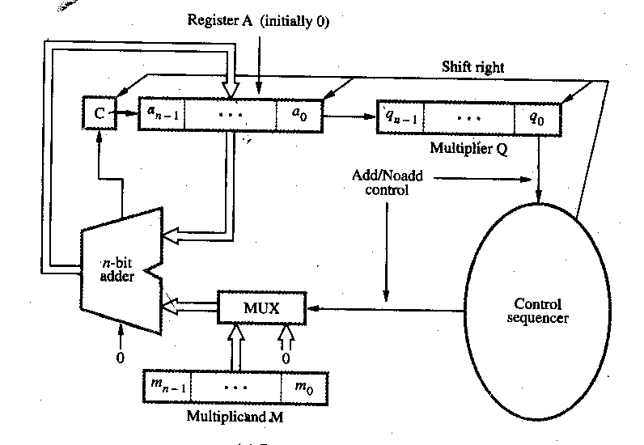

M = 10101
C A Q
0 00000 00101
0 10101 00101 Add I cycle
0 01010 10010 Shift
0 01010 10010 No Add II cycle
0 00101 01001 Shift
0 11010 01001 Add III cycle
0 01101 00100 Shift
0 01101 00100 No Add IV cycle
0 00110 10010 Shift
0 00110 10010 No Add V cycle
0 00011 01001 Shift

2.3 DIVISION USING SEQUENTIAL BINARY CIRCUIT
Register A is initially loaded with 0 and it consists of n+1 bits, where n is the number of bits in the dividend. Dividend is loaded in register Q and Register M is loaded with the divisor.
2.3.1 Restoring Algorithm
Do the following n times
Shift A and Q left one bit position. Subtract M from A and place the answer back in A. If the sign of A is 1, set q₀ to 0 and add M back to A (i.e. restore A). Otherwise set q₀ to 1.

2.3.2 Non-Restoring Algorithm
Step 1: Do the following n times:
If the sign of A is 0, shift A and Q left one bit position and subtract M from A; otherwise shift A and Q left one bit position and add M to A. If the sign of A is 0, set q₀ to 1; otherwise set q₀ to 0.
Step 2: If the sign of A is 1, add M to A
Let
A=0000000
Q=100110 (Dividend)
M=0000101(Divisor)

A Q
0000000 100110
0000001 00110_ Shift left
1111011 Subtract
1111100 001100

1111000 01100_ Shift left
0000101 Add
1111101 011000

1111010 11000_ Shift left
0000101 Add
1111111 110000

1111111 10000_ Shift left
0000101 Add
0000100 100001

0001001 00001_ Shift left
1111011 Subtract
0000100 000011

0001000 00011_ Shift left
1111011 Subtract
0000011 000111
Finally quotient will be in register Q and remainder will be in register A.
Quotient is 0000011 and Remainder is 000111.

2.4 FLOATING POINT ARITHMETIC
In IEEE single precision format a floating point number is represented using 32 bits. The MSB represents the sign, 1 if negative and 0 if positive. The next eight bits represents the exponent of the scale factor. The exponent is stored in the excess 127 format. The value stored is an unsigned integer E’ = E + 127. The last 23 bits represent the mantissa. The number is stored in this format in the normalized form. So the MSB of the mantissa will always be 1 and this bit is not explicitly represented. The 23 bits stored in the mantissa field represent the fractional part of the mantissa.
For e.g. 1.001010…0 * 2⁻⁸⁷ is represented as
0 | 00101000 | 001010………………….0
- For excess-127 format, 0 ≤ E’ ≤ 255. However, 0 and 255 are used to represent special value. So actually 1 ≤ E’ ≤ 254. That means -126 ≤ E ≤ 127.
- Single precision uses 32-bit. The value range is from 2-126 to 2+127.
- Double precision used 64-bit. The value range is from 2-1022 to 2+1023.

Note the following aspects
- If a number is not normalized, it can always be put in normalized form by shifting the fraction and adjusting the exponent.

- As computations proceed, a number that does not fall in the represent able range of normal numbers might be generated.

- It requires an exponent less than -126 (underflow) or greater than +127 (overflow). Both are exceptions that need to be considered.

Add/Subtract Rule
- Choose the number with the smallest exponent and shift its mantissa right n times where n is the difference between the exponents.
- Set the exponent of the result as that of the larger exponent.
- Perform addition or subtraction on the mantissa and determine the sign of the result.
- Normalize the resulting value is necessary.

Multiply Rule
- Add the exponents and subtract 127.
- Multiply the mantissas and determine the sign of the result.
- Normalize the resulting value is necessary.
Divide Rule
- Subtract the exponents and add 127.
- Divide the mantissas and determine the sign of the result.
- Normalize the resulting value is necessary.

E
X
Magnitude
M
M
M
subtractor
8-bit
sign
subtractor
8-bit
MUX
Mantissa
SHIFTER
SWAP
detector
Normalize and
round
Leading zeros
to right
adder/subtractor
Subtract
Add /
Sign
Add/Sub
n
bits
S
A
S
B
E
A
′
E
B
′
M
A
M
B
n
E
A
′
E
B
′
-
=
E
A
′
E
B
′
S
R
E
′
X
-
E
R
′
M
R
R
:
32-bit
result
R
A
B
+
=
32-bit operands
A :
S
A
E
A
′
M
A
,
,
B :
S
B
E
B
′
M
B
,
,
Combinational
CONTROL
network
′

