RAJAGIRI SCHOOL OF ENGINEERING
AND TECHNOLOGY
Rajagiri Valley, Kochi -39



T404 -COMPUTER SYSTEM ARCHITECTURE
MODULE III

Prepared by
Gopika S

INDEX

- NUMBER REPRESENTATION
- MULTIPLICATION
- DIVISION USING SEQUENTIAL BINARY CIRCUIT

EXECUTION OF AN INSTRUCTION

- EXECUTION OF BRANCH INSTRUCTION

- HARDWIRED CONTROL

- MICROPROGRAMMED CONTROL

1 NUMBER REPRESENTATION
An n-bit vector B is represented in binary number system as b_{n-1}b_{n-2}……..b₁b₀.
A signed number can be represented in any of the following systems
- Sign and Magnitude form
- 1’s Complement form
- 2’s Complement form

b₃b₂b₁b₀ | Sign & Magnitude | 1’s Complement | 2’s Complement
0111 | +7 | +7 | +7
0110 | +6 | +6 | +6
0101 | +5 | +5 | +5
0100 | +4 | +4 | +4
0011 | +3 | +3 | +3
0010 | +2 | +2 | +2
0001 | +1 | +1 | +1
0000 | +0 | +0 | +0
1000 | -0 | -7 | -8
1001 | -1 | -6 | -7
1010 | -2 | -5 | -6
1011 | -3 | -4 | -5
1100 | -4 | -3 | -4
1101 | -5 | -2 | -3
1110 | -6 | -1 | -2
1111 | -7 | -0 | -1

In sign and magnitude form negative numbers are represented by changing the MSB to 1. In 1’s complement form negative numbers are represented by complementing each bit of the corresponding positive number. This is same as subtracting that number from 2^{n}-1. In 2’s complement form negative numbers are represented by adding one to the 1’s complement of the positive number. (Same as subtracting the number from 2^{n}).

For the algorithm of Addition and Subtraction, Refer pages 333 – 340 in the text Computer System Architecture by Morris Mano ( Third Edition )

2 MULTIPLICATION
- A number of methods exist to perform integer multiplication.
- Repeated addition: add the multiplicand to itself “multiplier” times.
- Shift and add -- traditional “pen and paper” way of multiplying (extended to binary format)
- High speed (special purpose) hardware multipliers
Repeated addition
  - Least sophisticated method
  - Just use adder over and over again
  - If the multiplier is n bits, can have as many as
  - 2n iterations of addition -- O(2n) !!!!
  - Not used in an ALU
Shift and add – Computer’s version of the pen and paper approach:
1011 (11)
x 1101 (13)
===========
1011
00000 Partial products
101100
1011000
===========
10001111 (143)
The computer version accumulates the partial products into a running (partial) sum as the algorithm progresses. Each partial product generation results in an add and shift operation.

2.1 BOOTHS ALGORITHM
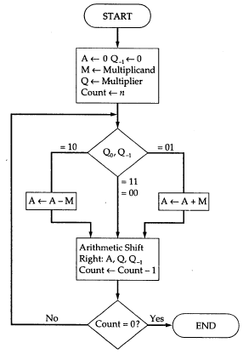
Figure Booths Algorithm for multiplication
Advantages of Booths algorithm
- Treats positive and negative numbers uniformly.
- String of 1’s and 0’s can be skipped with shift operation for faster execution.
  - Let the multiplicand A=110011 and multiplier B=101100.
Multiplier recoded using Booth’s algorithm is –1 +1 0 –1 0 0
1 1 0 0 1 1
-1 +1 0 -1 0 0

0 0 0 0 0 0 1 1 0 1 0 0
1 1 1 1 0 0 1 1 0
0 0 0 0 0 1 1 0 1
0 0 0 1 0 0 0 0 0 1 0 0

2.2 ARRAY MULTIPLIER
Binary multiplication of positive numbers can be implemented using a combinational circuit consisting of two dimensional logic arrays.

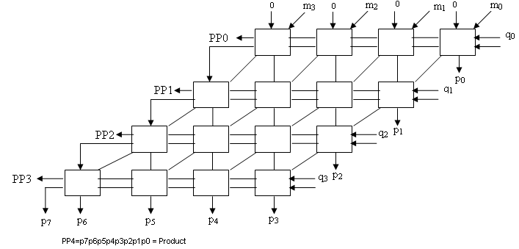
Please refer page 346 of the text Computer System Architecture by Morris Mano ( Third Edition ) for the fig of Array multiplier and notes

2.3 SEQUENTIAL BINARY MULTIPLIER
The circuit has a register Q to hold the multiplier, a register M to hold the multiplicand, a register A and a flip flop C which is initially cleared to 0. It also consists of an n-bit adder and a control sequencer. One of the inputs to the adder is the contents of register A and the other input is either the contents of register M or a 0. The bit q₀ determines whether an add or a no add operation should take place. If the bit q₀ is a 1 the multiplexer selects the contents of register M as one of the inputs to the n-bit adder, the control sequencer issues an add signal, the addition is performed and the result is stored back in register A. The contents of C, A and Q is shifted one bit position right. If the bit q₀ is a 0 no addition is performed, but shifting takes place. This should be repeated n times for multiplying two n bit numbers. The final product will be in registers A and Q after n cycles.

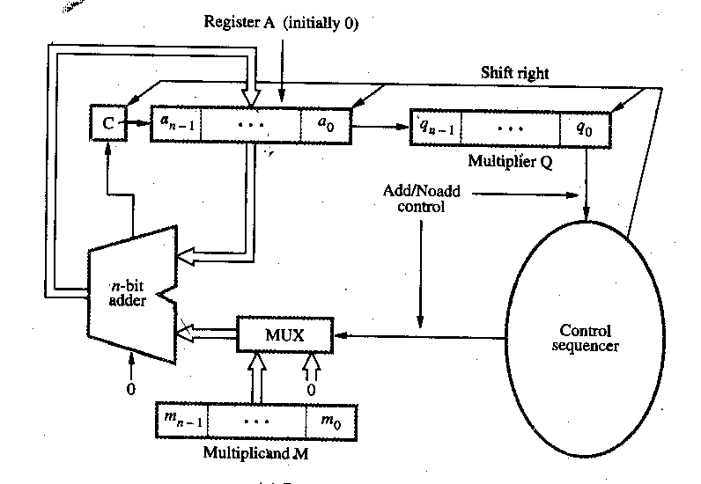

M = 10101
C A Q
0 00000 00101
0 10101 00101 Add I cycle
0 01010 10010 Shift
0 01010 10010 No Add II cycle
0 00101 01001 Shift
0 11010 01001 Add III cycle
0 01101 00100 Shift
0 01101 00100 No Add IV cycle
0 00110 10010 Shift
0 00110 10010 No Add V cycle
0 00011 01001 Shift

3 DIVISION USING SEQUENTIAL BINARY CIRCUIT
Please refer page 346 of the text Computer System Architecture by Morris Mano ( Third Edition ) for the fig of Array multiplier and notes
Register A is initially loaded with 0 and it consists of n+1 bits, where n is the number of bits in the dividend. Dividend is loaded in register Q and Register M is loaded with the divisor.
3.1 Restoring Algorithm
Do the following n times
Shift A and Q left one bit position. Subtract M from A and place the answer back in A. If the sign of A is 1, set q₀ to 0 and add M back to A (i.e. restore A). Otherwise set q₀ to 1.

3.2 Non-Restoring Algorithm
Step 1: Do the following n times:
If the sign of A is 0, shift A and Q left one bit position and subtract M from A; otherwise shift A and Q left one bit position and add M to A. If the sign of A is 0, set q₀ to 1; otherwise set q₀ to 0.
Step 2: If the sign of A is 1, add M to A
Let
A=0000000
Q=100110 (Dividend)
M=0000101(Divisor)

A Q
0000000 100110
0000001 00110_ Shift left
1111011 Subtract
1111100 001100

1111000 01100_ Shift left
0000101 Add
1111101 011000

1111010 11000_ Shift left
0000101 Add
1111111 110000

1111111 10000_ Shift left
0000101 Add
0000100 100001

0001001 00001_ Shift left
1111011 Subtract
0000100 000011

0001000 00011_ Shift left
1111011 Subtract
0000011 000111
Finally quotient will be in register Q and remainder will be in register A.
Quotient is 0000011 and Remainder is 000111.

5. EXECUTION OF A COMPLETE INSTRUCTION
The processor fetches one instruction at a time and performs the operation specified.
Instructions are fetched from successive memory locations until a branch or a jump instruction is encountered. The processor keeps track of the address of the memory location containing the next instruction to be fetched using Program Counter (PC).
For executing an instruction, the following steps are done
- Fetch the contents of the memory location pointed to by the PC. The contents of this location are loaded into the IR (fetch phase).
IR ← [[PC]]
- Assuming that the memory is byte addressable, increment the contents of the PC by 4 (fetch phase).
PC ← [PC] + 4
- Carry out the actions specified by the instruction in the IR (execution phase).

5.1 Processor Organization
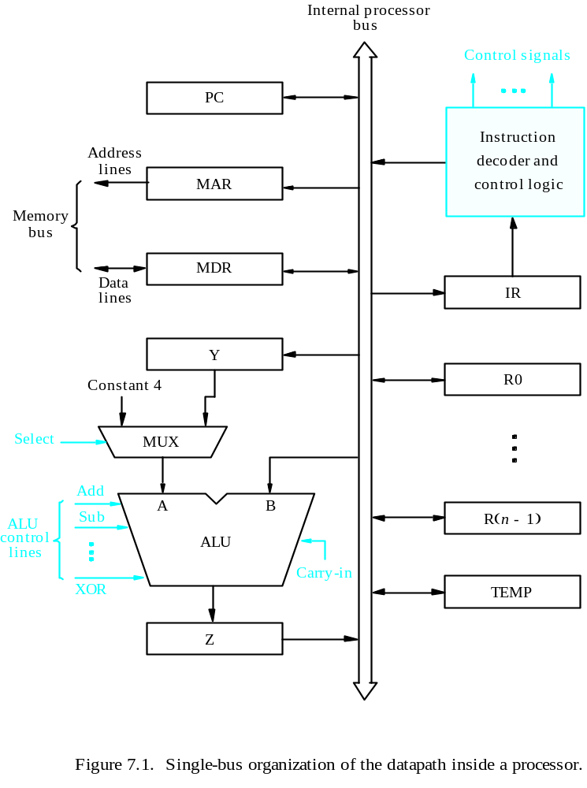
B
A
Z
ALU
Y
in
Y
Z
in
Z
out
R
i
in
R
i
R
i
out
b
us
Internal processor
Constant 4
MUX
Input and output gating for the registers in the above fig.
Select

All operations and data transfer are controlled by the processor clock
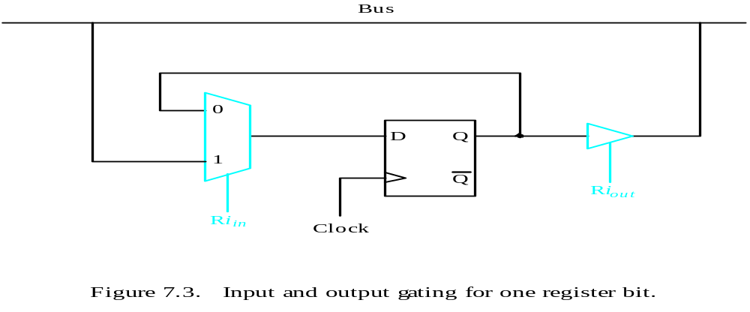
5.2 Performing an arithmetic operation
- The ALU is a combinational circuit that has no internal storage.
- ALU gets the two operands from MUX and bus. The result is temporarily stored in register Z.
- What is the sequence of operations to add the contents of register R1 to those of R2 and store the result in R3?
  - R1out, Yin
  - R2out, SelectY, Add, Zin
  - Zout, R3in

5.3 Fetching a word from memory
- Address into MAR; issue Read operation; data into MDR.
- The response time of each memory access varies (cache miss, memory-mapped I/O).
- To accommodate this, the processor waits until it receives an indication that the requested operation has been completed (Memory-Function-Completed, MFC).

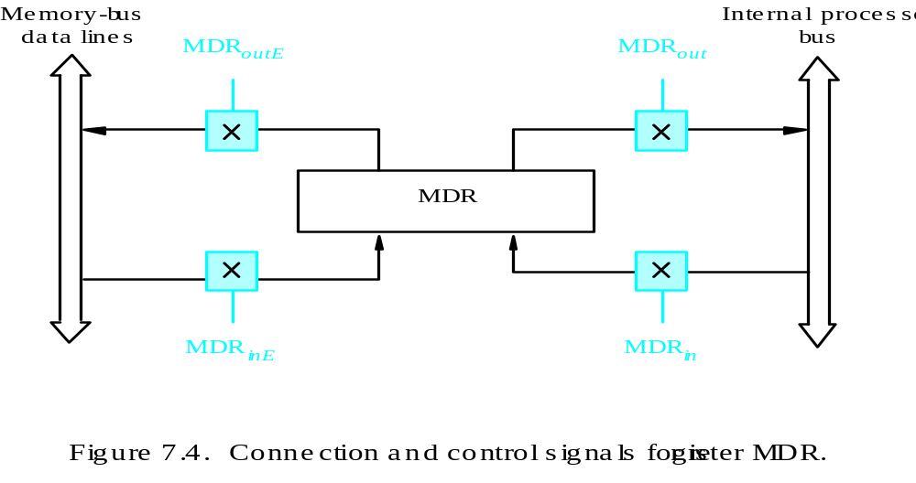

- Move (R1), R2
- MAR ← [R1]
- Start a Read operation on the memory bus
- Wait for the MFC response from the memory
- Load MDR from the memory bus
- R2 ← [MDR]

- Move (R1), R2
- R1out, MARin, Read
- MDRinE, WMFC
- MDRout, R2in

Example : ADD (R3), R1

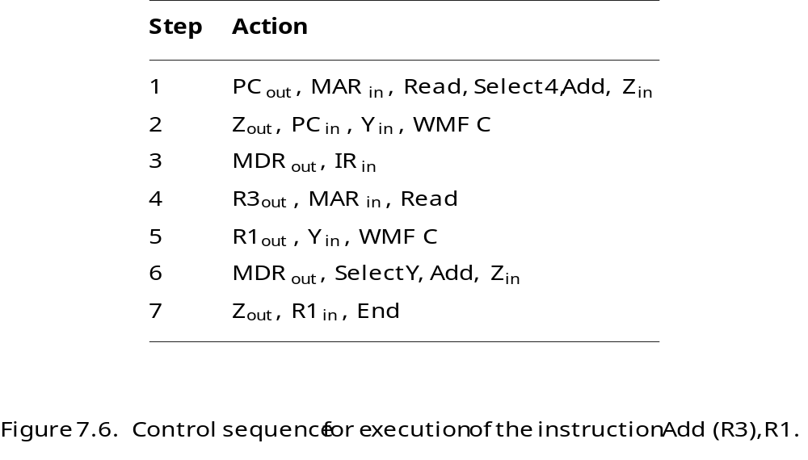

6. EXECUTION OF BRANCH INSTRUCTION

- A branch instruction replaces the contents of PC with the branch target address, which is usually obtained by adding an offset X given in the branch instruction.

- The offset X is usually the difference between the branch target address and the address immediately following the branch instruction.

Step
Action
1
PC
out
,
MAR
in
,
Read,
Select4,
Add,
Z
in
2
Z
out
,
PC
in
,
Y
in
,
WMF
C
3
MDR
out
,
IR
in
4
Offset-field-of-IR
out
,
Add,
Z
in
5
Z
out
,
PC
in
,
End

7. HARDWIRED CONTROL

To execute instructions, the processor must have some means of generating the control signals needed in the proper sequence. The two categories are hardwired control and microprogrammed control. Hardwired system can operate at high speed; but with little flexibility.
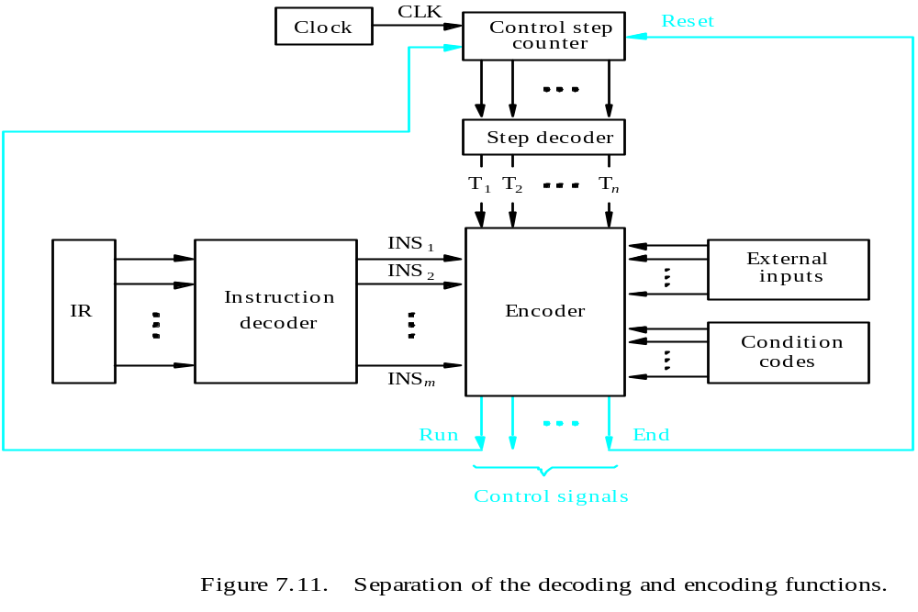

In a hardwired organization, the control logic is implemented with gates, flip-flops, decoders and other digital circuits. Hardwired control received its name because the control was implemented in hardware and could not be easily changed. A hardwired control as the name implies, requires changes in the wiring if the design has to be modified or changed. The control unit is implemented as a state machine, with combinatorial circuits generating each of the control functions on the basis of the current state and certain variables such as the op-code of the user instruction undergoing execution. Its input logic signals are transformed into output logic signals which are the control signals. A hardwired control unit must contain complex logic for sequencing through the many micro-operations of the instruction cycle.
The hardwired implementations were faster, but too costly for most machines. It has the advantage that it can be optimized to produce a fast mode of operation. The situation that arises when the control unit is require to check the status of the condition or status flags in order to choose between alternative courses of action; the hardwired control will handle this situation by including an appropriate logic function like; End=T7.ADD + T6.BR+(T6.N+T4.N). BRN +… in the encoder circuitry. For a given level of technology, hardwired control will be faster, since there is no delay for microinstruction fetch from ROM before the control unit can produce a control word.

8. MICROPROGRAMMED CONTROL

In microprogrammed control, a program generates the control signals. A control word (CW) is a word whose individual bits represent the various control signals. A sequence of CWs corresponding to the control sequence of a machine instruction constitutes the micro routine for that instruction, and the individual control words in this micro routine are referred to as microinstructions. The micro routines for all instructions in the instruction set of a computer are stored in a special memory called the control store. The control unit can generate the control signals for any instruction by sequentially reading the CWs of the corresponding micro routine from the control store. To read the control, words sequentially from the control store, a micro programmed counter is used.
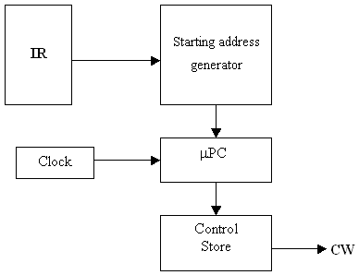
Fig: Basic organization of a micro programmed control unit

Every time a new instruction is loaded into the IR, the output of the block labeled “starting address generator” is loaded into the μPC. The μPC is then automatically incremented by the clock, causing successive microinstructions to be read from the control store. Hence, the control signals are delivered to various parts of the processor in the correct sequence.
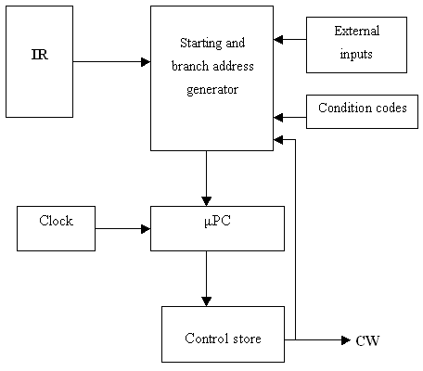
Fig: Organization of the control unit to allow conditional branching in the microprogram.
To support micro program branching, the organization of the control unit should be modified. The starting and branch address generator loads a new address into the μPC.
To allow implementation of a conditional branch, input to this block consists of the external inputs and condition codes as well as the contents of the instruction register. In this control unit, the μPC is incremented every time a new microinstruction is fetched from the micro program memory, except in the following situations:
- When a new instruction is loaded into the IR, the μPC is loaded with the starting address of the micro routine for that instruction.
- When a branch microinstruction is encountered and the branch condition is satisfied, the μPC is loaded with the branch address.
- When an End microinstruction is encountered, the μPC is loaded with the address of the first CW in the micro routine for the instruction fetch cycle.
ADD (Rs) +, Rd
  - PC_{out}, MAR_{in}, Read, Select 4, Add, Z_{in}
  - Z_{out}, PC_{in}, Y_{in}, WMFC
  - MDR_{out}, IR_{in}
  - Rs_{out,} MAR_{in}, Read, Select 4, Add, Z_{in}
  - Z_{out}, Rs_{in}
  - Rd_{out}, Y_{in,} WMFC
  - MDR_{out}, Select Y, Add, Z_{in}
  - Z_{out,} Rd_{in}, End
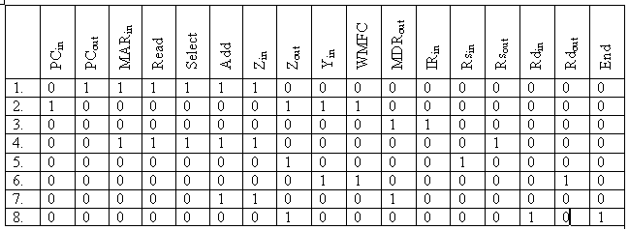

8.1 Horizontal and Vertical Microinstructions

The easiest way of structuring a microinstruction is to assign one bit for each control signal. But this results in very long microinstructions and also only a very few of these will be set to one in a particular clock cycle. So it is better to encode the microinstructions such that a group of bits represent many control sequence, a particular pattern of these bits represents a particular microinstruction. A horizontal microinstruction is a minimally encoded scheme and a vertical microinstruction is a tightly encoded scheme. In general, a horizontal approach involves a wider control store, but is capable of greater speed. The vertical approach requires a narrow control store, but must be decoded in order to drive the actual control lines, thus introducing a delay in driving the control lines.
8.2 Micro program Sequencing
If all microprograms require only straightforward sequential execution of microinstructions except for branches, letting a μPC governs the sequencing would be efficient. However, there are two disadvantages:
- Having a separate microroutine for each machine instruction results in a large total number of microinstructions and a large control store.
- Longer execution time because it takes more time to carry out the required branches.
Example: Add src, Rdst
It has four addressing modes: register, autoincrement, autodecrement, and indexed (with indirect forms).

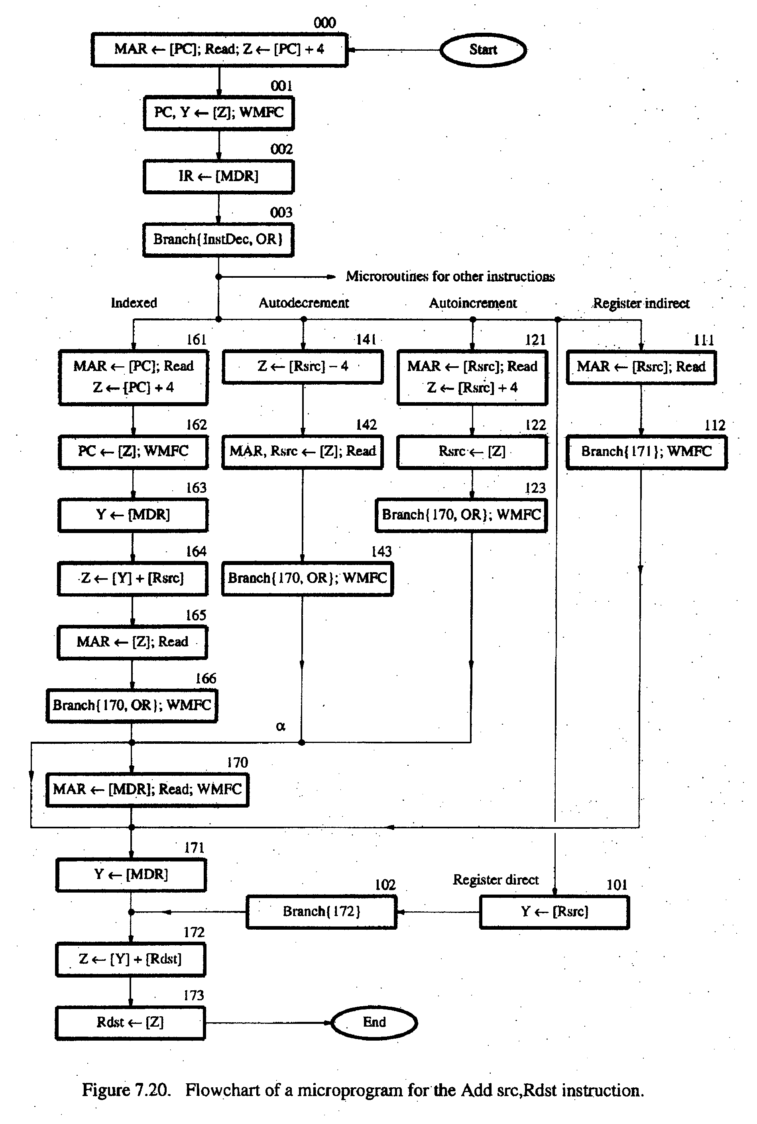
Pg No.436 – Computer Organisation by Carl V Hamacher

OP code
0
1
0
Rsrc
Rdst
Contents of IR
0
3
4
7
8
10
11
Note:
Microinstruction at location 170 is not executed for this addressing mode.
Address
Microinstruction
(octal)
000
PC
out
, MAR
in
, Read, Select
4
, Add, Z
in
001
Z
out
, PC
in
, Y
in
, WMFC
002
MDR
out
, IR
in
003
μ
Branch {
μ
PC
←
101 (from Instruction decoder);
μ
PC
5,4
←
[IR
10,9
];
μ
PC
3
←
121
Rsrc
out
, MAR
in
, Read, Select4, Add, Z
in
122
Z
out
, Rsrc
in
123
170
MDR
out
, MAR
in
, Read, WMFC
171
MDR
out
, Y
in
172
Rdst
out
, SelectY
, Add, Z
in
173
Z
out
, Rdst
in
, End
[IR
10
]
⋅
[IR
9
]
⋅
[IR
8
]}
μ
Branch {
μ
PC
←
170;
μ
PC
0
←
[IR
8
]}, WMFC
Textbook page 439

8.3 Microinstructions with next address field

The microprogram we discussed requires several branch microinstructions, which perform no useful operation in the data path. A powerful alternative approach is to include an address field as a part of every microinstruction to indicate the location of the next microinstruction to be fetched.
- Pros: separate branch microinstructions are virtually eliminated; few limitations in assigning addresses to microinstructions.
- Cons: additional bits for the address field (around 1/6)

