RAJAGIRI SCHOOL OF ENGINEERING
AND TECHNOLOGY
Rajagiri Valley, Kochi -39



T404 -COMPUTER SYSTEM ARCHITECTURE
MODULE III

Prepared by
Gopika S

INDEX

- NUMBER REPRESENTATION
- ADDITION AND SUBTRACTION OF SIGNED NUMBERS
- MULTIPLICATION
- DIVISION USING SEQUENTIAL BINARY CIRCUIT

FLOATING POINT ARITHMETIC
- EXECUTION OF AN INSTRUCTION

- EXECUTION OF BRANCH INSTRUCTION

- HARDWIRED CONTROL

- MICROPROGRAMMED CONTROL

1 NUMBER REPRESENTATION
An n-bit vector B is represented in binary number system as b_{n-1}b_{n-2}……..b₁b₀.
A signed number can be represented in any of the following systems
- Sign and Magnitude form
- 1’s Complement form
- 2’s Complement form

b₃b₂b₁b₀ | Sign & Magnitude | 1’s Complement | 2’s Complement
0111 | +7 | +7 | +7
0110 | +6 | +6 | +6
0101 | +5 | +5 | +5
0100 | +4 | +4 | +4
0011 | +3 | +3 | +3
0010 | +2 | +2 | +2
0001 | +1 | +1 | +1
0000 | +0 | +0 | +0
1000 | -0 | -7 | -8
1001 | -1 | -6 | -7
1010 | -2 | -5 | -6
1011 | -3 | -4 | -5
1100 | -4 | -3 | -4
1101 | -5 | -2 | -3
1110 | -6 | -1 | -2
1111 | -7 | -0 | -1

In sign and magnitude form negative numbers are represented by changing the MSB to 1. In 1’s complement form negative numbers are represented by complementing each bit of the corresponding positive number. This is same as subtracting that number from 2^{n}-1. In 2’s complement form negative numbers are represented by adding one to the 1’s complement of the positive number. (Same as subtracting the number from 2^{n}).

2. Addition and Subtraction of Signed Numbers

1's Complement Addition
1's complement addition allows the mathematical operation of subtraction to be performed by an adder circuit.
It involves representing the number to be subtracted as a negative number in 1's complement notation, and adding this to the other number. The manner in which the result of this operation is interpreted depends upon the sign of the result.
As a first example considers 35 - 22 both represented as 7-bit numbers with a sign bit.
+35 in binary is: 00100011
+22 in binary is: 00010110
-22 in binary is: 10010110
-22 in 1's complement is: 11101001

The sum to be calculated is therefore the sum of the binary for +35 and the 1's complement for -22:
00100011
+ 11101001
100001100
This addition produces a 9th bit. In 1's complement addition, if this occurs, the extra bit is carried to the LSB column and added. Hence:
00001100
+ 1
00001101
The final answer has a 0 for its sign bit. This tells us two things:
- the answer is positive
- the answer is represented in binary notation
Hence the answer is the positive binary number 0001101, which in decimal is 13 - the correct answer!
Let's now consider the subtraction 22 - 35, again both represented as 7-bit numbers with a sign bit.
+22 in binary is: 00010110
+35 in binary is: 00100011
-35 in binary is: 10100011
-35 in 1's complement is: 11011100

The sum to be calculated is now:
00010110
+ 11011100
11110010
This time the addition does not produce a 9th bit, but the sign bit is 1. In this case it again tells us two things:
- the answer is negative
- the answer is represented in 1's complement notation
So to get the final answer we need to turn our answer into binary. If the 1's complement notation is 11110010 then the binary representation is 10001101 (note - the sign bit doesn't change, it's still a negative number!). This is the binary for -13, again, the correct answer.

2's Complement Addition
Two's complement addition follows the same rules as binary addition.

For example,

5 + (-3) = 2 0000 0101 = +5
+ 1111 1101 = -3

--------------------------------------------------------------------------------

0000 0010 = +2
2's Complement Subtraction
Two's complement subtraction is the binary addition of the minuend to the 2's complement of the subtrahend (adding a negative number is the same as subtracting a positive one).

For example,

7 - 12 = (-5) 0000 0111 = +7
+ 1111 0100 = -12

--------------------------------------------------------------------------------

1111 1011 = -5

2) Carry Look Ahead Adder
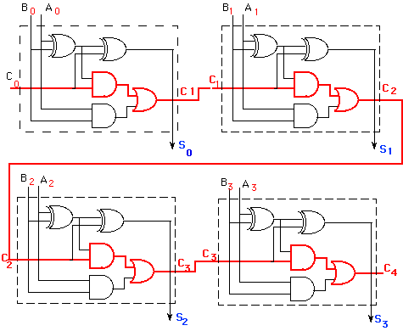
The delay generated by an N-bit adder is proportional to the length N of the two numbers Aand B that are added because the carry signals have to propagate from one full-adder to the next. For large values of N, the delay becomes unacceptably large so that a special solution needs to be adopted to accelerate the calculation of the carry bits. This solution involves a look-ahead carry generator which is a block that simultaneously calculates all the carry bits involved. Once these bits are available to the rest of the circuit, each individual three-bit addition (A_{i}+B_{i}+C_{i}) is implemented by a simple 3-input XOR gate. The design of the look-ahead carry generator involves two Boolean functions named Generate and the Propagate.
For each pair of input bits these functions are defined as:
G_{i} = A_{i}.B_{i}
Pi = (A_{i}  B_{i})
The carry bit carry-out_{i} generated when adding two bits Xi and Yi is '1' if the corresponding function Gi is '1' or if the carry_outi-1='1' and the function Pi = '1' simultaneously. In the first case, the carry bit is activated by the local conditions (the values of Xi and Yi). In the second, the carry bit is received from the less significant elementary addition and is propagated further to the more significant elementary addition. Therefore, the carry-out bit corresponding to a pair of bits Xi and Yi is calculated according to the equation:
C_{OUT} = C_{i+1} = A_{i}.B_{i} + (A_{i} + B_{i}).C_{i.}
For a four-bit adder the carry-outs are calculated as follows
C₁ = G₀ + P₀.C₀
C₂ = G₁ + P₁.C₁ = G₁ + P1.G₀ + P₁.P₀.C₀
C₃ = G₂ + P₂.G₁ + P₂.P₁.G₀ + P₂.P₁.P₀.C₀
C₄ = G₃ + P₃.G₂ + P₃.P₂.G₁ + P₃P₂.P₁.G₀ + P₃P₂.P₁.P₀.C₀
The set of equations above are implemented by the circuit below and a complete adder with a look-ahead carry generator is next. Sum output of this adder is as follows
S₀ = A₀.B₀.Cout₀
S₁ = A₁.B₁.Cout₁
S₀ = A₂.B₂.Cout₂
S₀ = A₃.B₃.Cout₃
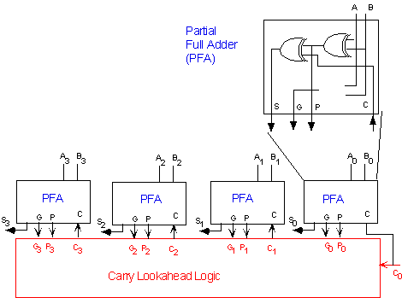

3) Carry Save Addition
There are many cases where it is desired to add more than two numbers together. The straightforward way of adding together m numbers (all n bits wide) is to add the first two, then add that sum to the next, and so on. This requires a total of m − 1 additions.

Using carry save addition, the delay can be reduced further still. The idea is to take 3 numbers that we want to add together, x + y + z, and convert it into 2 numbers c + s such that x + y + z = c + s.

In carry save addition, we refrain from directly passing on the carry information until the very last step. We will first illustrate the general concept with a base 10 example.

To add three numbers by hand, we typically align the three operands, and then proceed column by column in the same fashion that we perform addition with two numbers. The three digits in a row are added, and any overflow goes into the next column. Observe that when there is some non-zero carry, we are really adding four digits (the digits of x,y and z, plus the carry).

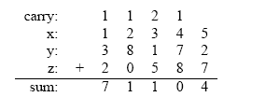
The carry save approach breaks this process down into two steps. The first is to compute the sum ignoring any carries:
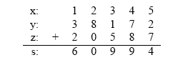

Each si is equal to the sum of xi + yi + zi modulo 10. Now, separately, we can compute the carry on a column by column basis:

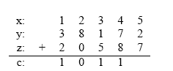
In this case, each ci is the sum of the bits from the previous column divided by 10 (ignoring any remainder). Another way to look at it is that any carry over from one column gets put into the next column. Now, we can add together c and s, and we’ll verify that it indeed is equal to
x + y + z.

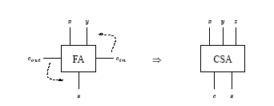

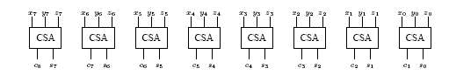

One CSA block is used for each bit. This circuit adds three n = 8 bit numbers together into two new numbers.
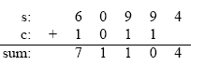
The important point is that c and s can be computed independently, and furthermore, each ci (and si) can be computed independently from all of the other c’s (and s’s).

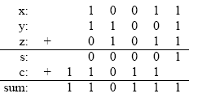
A carry save adder simply is a full adder with the cin input renamed to z, the z output (the original “answer” output) renamed to s, and the cout output renamed to c.
3. MULTIPLICATION
- A number of methods exist to perform integer multiplication.
- Repeated addition: add the multiplicand to itself “multiplier” times.
- Shift and add -- traditional “pen and paper” way of multiplying (extended to binary format)
- High speed (special purpose) hardware multipliers
Repeated addition
  - Least sophisticated method
  - Just use adder over and over again
  - If the multiplier is n bits, can have as many as
  - 2n iterations of addition -- O(2n) !!!!
  - Not used in an ALU
Shift and add – Computer’s version of the pen and paper approach:
1011 (11)
x 1101 (13)
===========
1011
00000 Partial products
101100
1011000
===========
10001111 (143)
The computer version accumulates the partial products into a running (partial) sum as the algorithm progresses. Each partial product generation results in an add and shift operation.

3.1 BOOTHS ALGORITHM
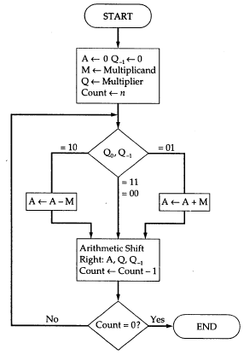
Figure Booths Algorithm for multiplication
Advantages of Booths algorithm
- Treats positive and negative numbers uniformly.
- String of 1’s and 0’s can be skipped with shift operation for faster execution.
  - Let the multiplicand A=110011 and multiplier B=101100.
Multiplier recoded using Booth’s algorithm is –1 +1 0 –1 0 0
1 1 0 0 1 1
-1 +1 0 -1 0 0

0 0 0 0 0 0 1 1 0 1 0 0
1 1 1 1 0 0 1 1 0
0 0 0 0 0 1 1 0 1
0 0 0 1 0 0 0 0 0 1 0 0

3.2 ARRAY MULTIPLIER
Binary multiplication of positive numbers can be implemented using a combinational circuit consisting of two dimensional logic arrays.

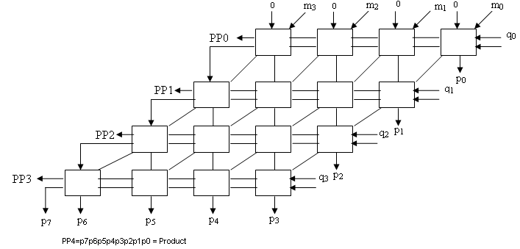

3.3 SEQUENTIAL BINARY MULTIPLIER
The circuit has a register Q to hold the multiplier, a register M to hold the multiplicand, a register A and a flip flop C which is initially cleared to 0. It also consists of an n-bit adder and a control sequencer. One of the inputs to the adder is the contents of register A and the other input is either the contents of register M or a 0. The bit q₀ determines whether an add or a no add operation should take place. If the bit q₀ is a 1 the multiplexer selects the contents of register M as one of the inputs to the n-bit adder, the control sequencer issues an add signal, the addition is performed and the result is stored back in register A. The contents of C, A and Q is shifted one bit position right. If the bit q₀ is a 0 no addition is performed, but shifting takes place. This should be repeated n times for multiplying two n bit numbers. The final product will be in registers A and Q after n cycles.

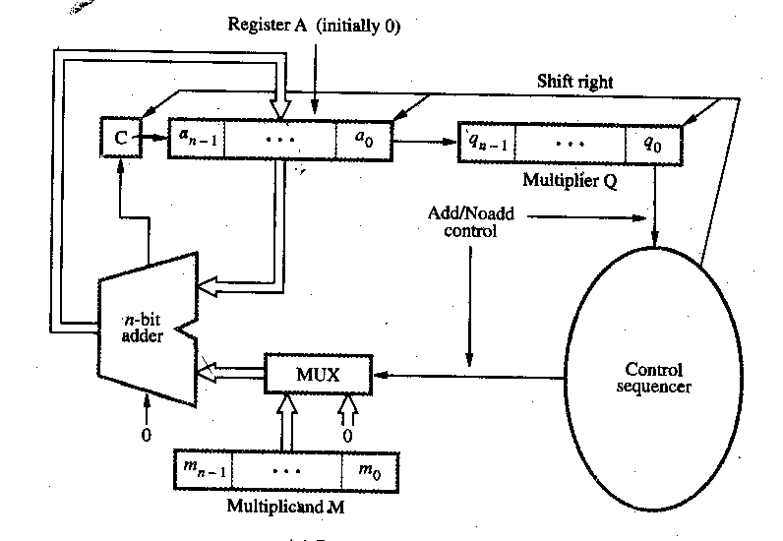

M = 10101
C A Q
0 00000 00101
0 10101 00101 Add I cycle
0 01010 10010 Shift
0 01010 10010 No Add II cycle
0 00101 01001 Shift
0 11010 01001 Add III cycle
0 01101 00100 Shift
0 01101 00100 No Add IV cycle
0 00110 10010 Shift
0 00110 10010 No Add V cycle
0 00011 01001 Shift

4. DIVISION USING SEQUENTIAL BINARY CIRCUIT
Register A is initially loaded with 0 and it consists of n+1 bits, where n is the number of bits in the dividend. Dividend is loaded in register Q and Register M is loaded with the divisor.
4.1 Restoring Algorithm
Do the following n times
Shift A and Q left one bit position. Subtract M from A and place the answer back in A. If the sign of A is 1, set q₀ to 0 and add M back to A (i.e. restore A). Otherwise set q₀ to 1.

4.2 Non-Restoring Algorithm
Step 1: Do the following n times:
If the sign of A is 0, shift A and Q left one bit position and subtract M from A; otherwise shift A and Q left one bit position and add M to A. If the sign of A is 0, set q₀ to 1; otherwise set q₀ to 0.
Step 2: If the sign of A is 1, add M to A
Let
A=0000000
Q=100110 (Dividend)
M=0000101(Divisor)

A Q
0000000 100110
0000001 00110_ Shift left
1111011 Subtract
1111100 001100

1111000 01100_ Shift left
0000101 Add
1111101 011000

1111010 11000_ Shift left
0000101 Add
1111111 110000

1111111 10000_ Shift left
0000101 Add
0000100 100001

0001001 00001_ Shift left
1111011 Subtract
0000100 000011

0001000 00011_ Shift left
1111011 Subtract
0000011 000111
Finally quotient will be in register Q and remainder will be in register A.
Quotient is 0000011 and Remainder is 000111.

5 FLOATING POINT ARITHMETIC
In IEEE single precision format a floating point number is represented using 32 bits. The MSB represents the sign, 1 if negative and 0 if positive. The next eight bits represents the exponent of the scale factor. The exponent is stored in the excess 127 format. The value stored is an unsigned integer E’ = E + 127. The last 23 bits represent the mantissa. The number is stored in this format in the normalized form. So the MSB of the mantissa will always be 1 and this bit is not explicitly represented. The 23 bits stored in the mantissa field represent the fractional part of the mantissa.
For e.g. 1.001010…0 * 2⁻⁸⁷ is represented as
0 | 00101000 | 001010………………….0
- For excess-127 format, 0 ≤ E’ ≤ 255. However, 0 and 255 are used to represent special value. So actually 1 ≤ E’ ≤ 254. That means -126 ≤ E ≤ 127.
- Single precision uses 32-bit. The value range is from 2-126 to 2+127.
- Double precision used 64-bit. The value range is from 2-1022 to 2+1023.

Note the following aspects
- If a number is not normalized, it can always be put in normalized form by shifting the fraction and adjusting the exponent.

- As computations proceed, a number that does not fall in the represent able range of normal numbers might be generated.

- It requires an exponent less than -126 (underflow) or greater than +127 (overflow). Both are exceptions that need to be considered.

Add/Subtract Rule
- Choose the number with the smallest exponent and shift its mantissa right n times where n is the difference between the exponents.
- Set the exponent of the result as that of the larger exponent.
- Perform addition or subtraction on the mantissa and determine the sign of the result.
- Normalize the resulting value is necessary.

Multiply Rule
- Add the exponents and subtract 127.
- Multiply the mantissas and determine the sign of the result.
- Normalize the resulting value is necessary.
Divide Rule
- Subtract the exponents and add 127.
- Divide the mantissas and determine the sign of the result.
- Normalize the resulting value is necessary.

E
X
Magnitude
M
M
M
subtractor
8-bit
sign
subtractor
8-bit
MUX
Mantissa
SHIFTER
SWAP
detector
Normalize and
round
Leading zeros
to right
adder/subtractor
Subtract
Add /
Sign
Add/Sub
n
bits
S
A
S
B
E
A
′
E
B
′
M
A
M
B
n
E
A
′
E
B
′
-
=
E
A
′
E
B
′
S
R
E
′
X
-
E
R
′
M
R
R
:
32-bit
result
R
A
B
+
=
32-bit operands
A :
S
A
E
A
′
M
A
,
,
B :
S
B
E
B
′
M
B
,
,
Combinational
CONTROL
network
′

6. EXECUTION OF A COMPLETE INSTRUCTION
The processor fetches one instruction at a time and performs the operation specified.
Instructions are fetched from successive memory locations until a branch or a jump instruction is encountered. The processor keeps track of the address of the memory location containing the next instruction to be fetched using Program Counter (PC).
For executing an instruction, the following steps are done
- Fetch the contents of the memory location pointed to by the PC. The contents of this location are loaded into the IR (fetch phase).
IR ← [[PC]]
- Assuming that the memory is byte addressable, increment the contents of the PC by 4 (fetch phase).
PC ← [PC] + 4
- Carry out the actions specified by the instruction in the IR (execution phase).

6.1 Processor Organization
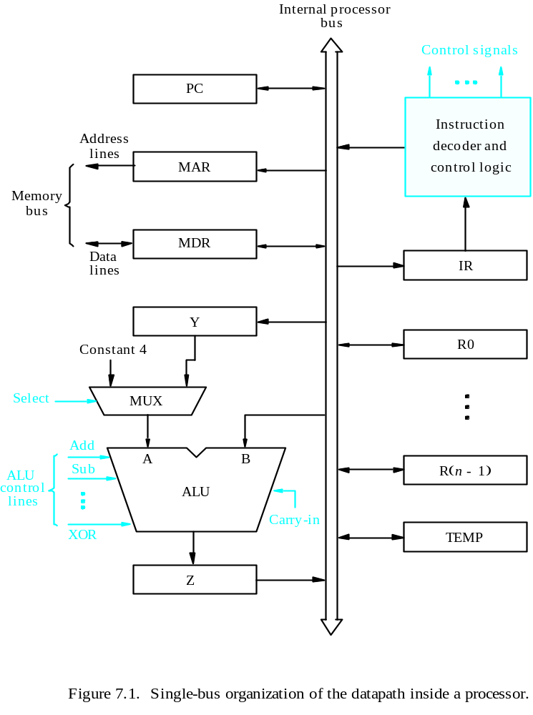
B
A
Z
ALU
Y
in
Y
Z
in
Z
out
R
i
in
R
i
R
i
out
b
us
Internal processor
Constant 4
MUX
Input and output gating for the registers in the above fig.
Select

All operations and data transfer are controlled by the processor clock
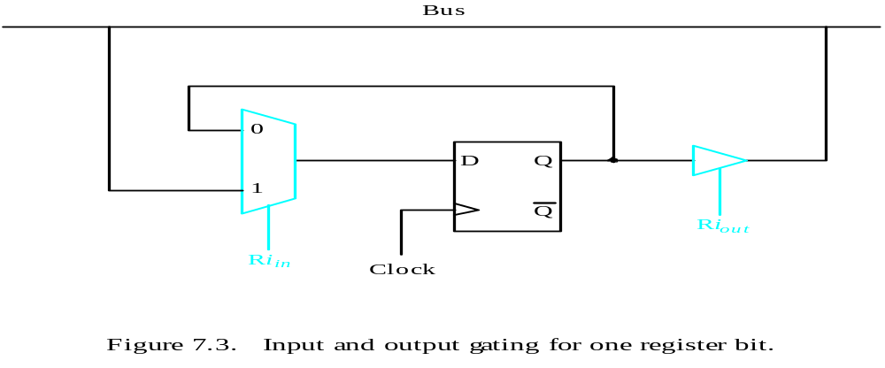
6.2 Performing an arithmetic operation
- The ALU is a combinational circuit that has no internal storage.
- ALU gets the two operands from MUX and bus. The result is temporarily stored in register Z.
- What is the sequence of operations to add the contents of register R1 to those of R2 and store the result in R3?
  - R1out, Yin
  - R2out, SelectY, Add, Zin
  - Zout, R3in

6.3 Fetching a word from memory
- Address into MAR; issue Read operation; data into MDR.
- The response time of each memory access varies (cache miss, memory-mapped I/O).
- To accommodate this, the processor waits until it receives an indication that the requested operation has been completed (Memory-Function-Completed, MFC).

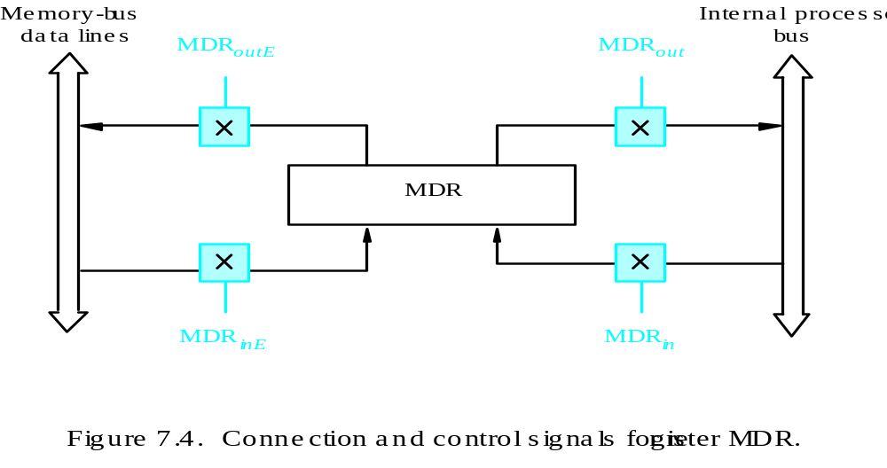

- Move (R1), R2
- MAR ← [R1]
- Start a Read operation on the memory bus
- Wait for the MFC response from the memory
- Load MDR from the memory bus
- R2 ← [MDR]

- Move (R1), R2
- R1out, MARin, Read
- MDRinE, WMFC
- MDRout, R2in

Example : ADD (R3), R1

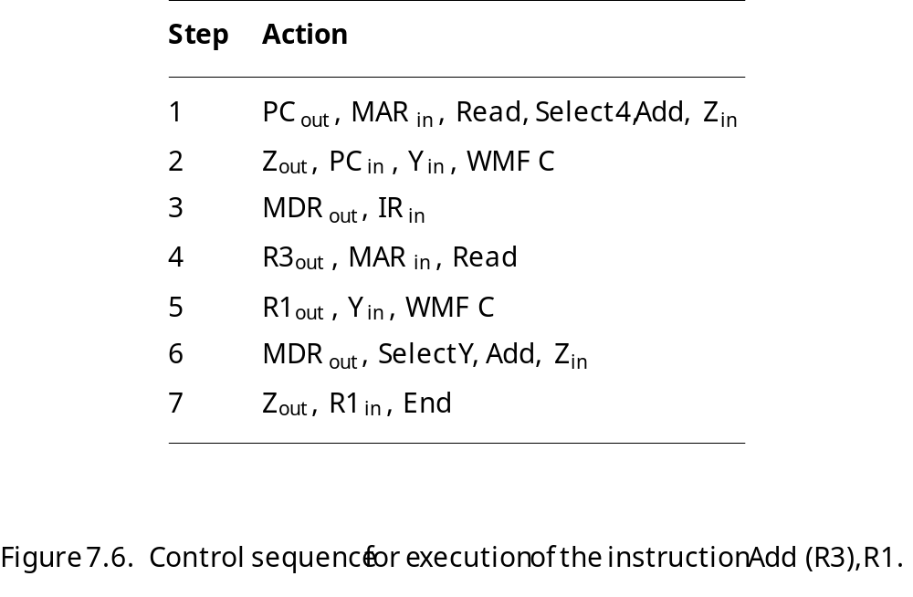

7. EXECUTION OF BRANCH INSTRUCTION

- A branch instruction replaces the contents of PC with the branch target address, which is usually obtained by adding an offset X given in the branch instruction.

- The offset X is usually the difference between the branch target address and the address immediately following the branch instruction.

Step
Action
1
PC
out
,
MAR
in
,
Read,
Select4,
Add,
Z
in
2
Z
out
,
PC
in
,
Y
in
,
WMF
C
3
MDR
out
,
IR
in
4
Offset-field-of-IR
out
,
Add,
Z
in
5
Z
out
,
PC
in
,
End

8. HARDWIRED CONTROL

To execute instructions, the processor must have some means of generating the control signals needed in the proper sequence. The two categories are hardwired control and microprogrammed control. Hardwired system can operate at high speed; but with little flexibility.

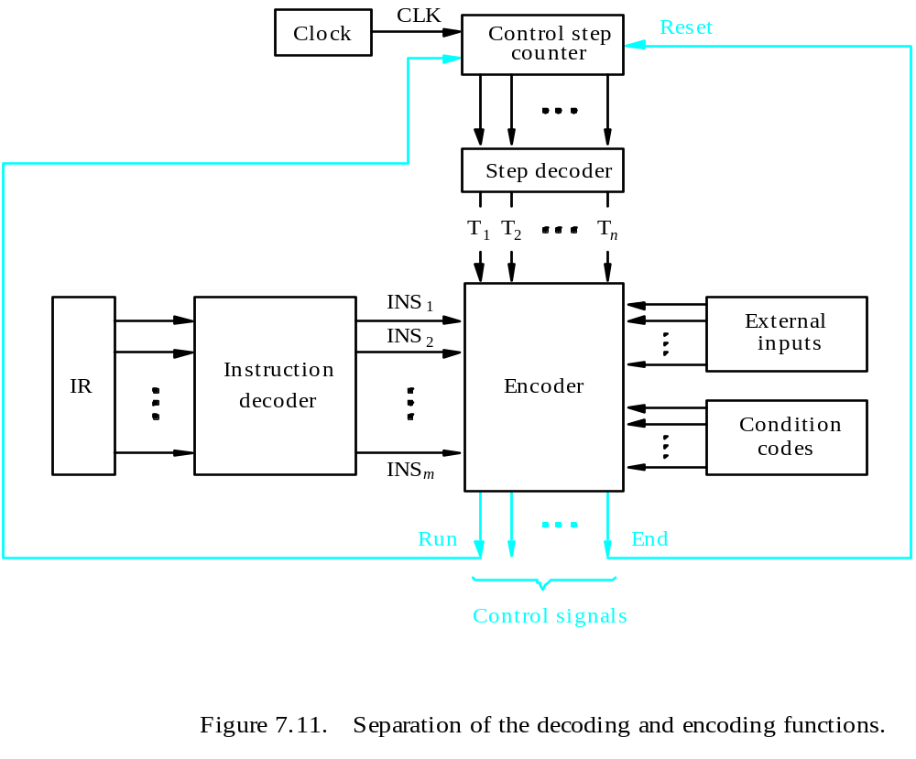

In a hardwired organization, the control logic is implemented with gates, flip-flops, decoders and other digital circuits. Hardwired control received its name because the control was implemented in hardware and could not be easily changed. A hardwired control as the name implies, requires changes in the wiring if the design has to be modified or changed. The control unit is implemented as a state machine, with combinatorial circuits generating each of the control functions on the basis of the current state and certain variables such as the op-code of the user instruction undergoing execution. Its input logic signals are transformed into output logic signals which are the control signals. A hardwired control unit must contain complex logic for sequencing through the many micro-operations of the instruction cycle.
The hardwired implementations were faster, but too costly for most machines. It has the advantage that it can be optimized to produce a fast mode of operation. The situation that arises when the control unit is require to check the status of the condition or status flags in order to choose between alternative courses of action; the hardwired control will handle this situation by including an appropriate logic function like; End=T7.ADD + T6.BR+(T6.N+T4.N). BRN +… in the encoder circuitry. For a given level of technology, hardwired control will be faster, since there is no delay for microinstruction fetch from ROM before the control unit can produce a control word.

9. MICROPROGRAMMED CONTROL

In microprogrammed control, a program generates the control signals. A control word (CW) is a word whose individual bits represent the various control signals. A sequence of CWs corresponding to the control sequence of a machine instruction constitutes the micro routine for that instruction, and the individual control words in this micro routine are referred to as microinstructions. The micro routines for all instructions in the instruction set of a computer are stored in a special memory called the control store. The control unit can generate the control signals for any instruction by sequentially reading the CWs of the corresponding micro routine from the control store. To read the control, words sequentially from the control store, a micro programmed counter is used.
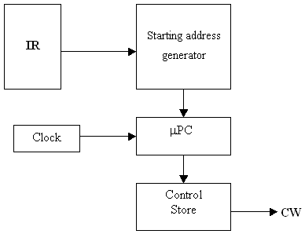
Fig: Basic organization of a micro programmed control unit

Every time a new instruction is loaded into the IR, the output of the block labeled “starting address generator” is loaded into the μPC. The μPC is then automatically incremented by the clock, causing successive microinstructions to be read from the control store. Hence, the control signals are delivered to various parts of the processor in the correct sequence.
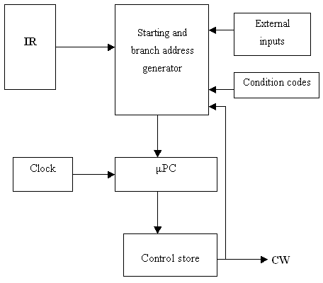
Fig: Organization of the control unit to allow conditional branching in the microprogram.
To support micro program branching, the organization of the control unit should be modified. The starting and branch address generator loads a new address into the μPC.
To allow implementation of a conditional branch, input to this block consists of the external inputs and condition codes as well as the contents of the instruction register. In this control unit, the μPC is incremented every time a new microinstruction is fetched from the micro program memory, except in the following situations:
- When a new instruction is loaded into the IR, the μPC is loaded with the starting address of the micro routine for that instruction.
- When a branch microinstruction is encountered and the branch condition is satisfied, the μPC is loaded with the branch address.
- When an End microinstruction is encountered, the μPC is loaded with the address of the first CW in the micro routine for the instruction fetch cycle.
ADD (Rs) +, Rd
  - PC_{out}, MAR_{in}, Read, Select 4, Add, Z_{in}
  - Z_{out}, PC_{in}, Y_{in}, WMFC
  - MDR_{out}, IR_{in}
  - Rs_{out,} MAR_{in}, Read, Select 4, Add, Z_{in}
  - Z_{out}, Rs_{in}
  - Rd_{out}, Y_{in,} WMFC
  - MDR_{out}, Select Y, Add, Z_{in}
  - Z_{out,} Rd_{in}, End
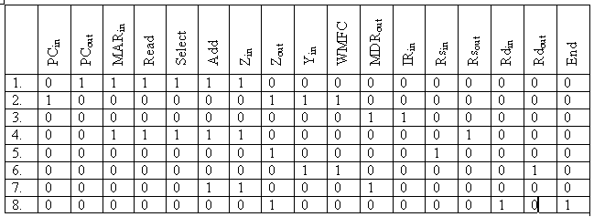

9.1 Horizontal and Vertical Microinstructions

The easiest way of structuring a microinstruction is to assign one bit for each control signal. But this results in very long microinstructions and also only a very few of these will be set to one in a particular clock cycle. So it is better to encode the microinstructions such that a group of bits represent many control sequence, a particular pattern of these bits represents a particular microinstruction. A horizontal microinstruction is a minimally encoded scheme and a vertical microinstruction is a tightly encoded scheme. In general, a horizontal approach involves a wider control store, but is capable of greater speed. The vertical approach requires a narrow control store, but must be decoded in order to drive the actual control lines, thus introducing a delay in driving the control lines.

9.2 Micro program Sequencing

If all microprograms require only straightforward sequential execution of microinstructions except for branches, letting a μPC governs the sequencing would be efficient. However, there are two disadvantages:
- Having a separate microroutine for each machine instruction results in a large total number of microinstructions and a large control store.
- Longer execution time because it takes more time to carry out the required branches.
Example: Add src, Rdst
It has four addressing modes: register, autoincrement, autodecrement, and indexed (with indirect forms).

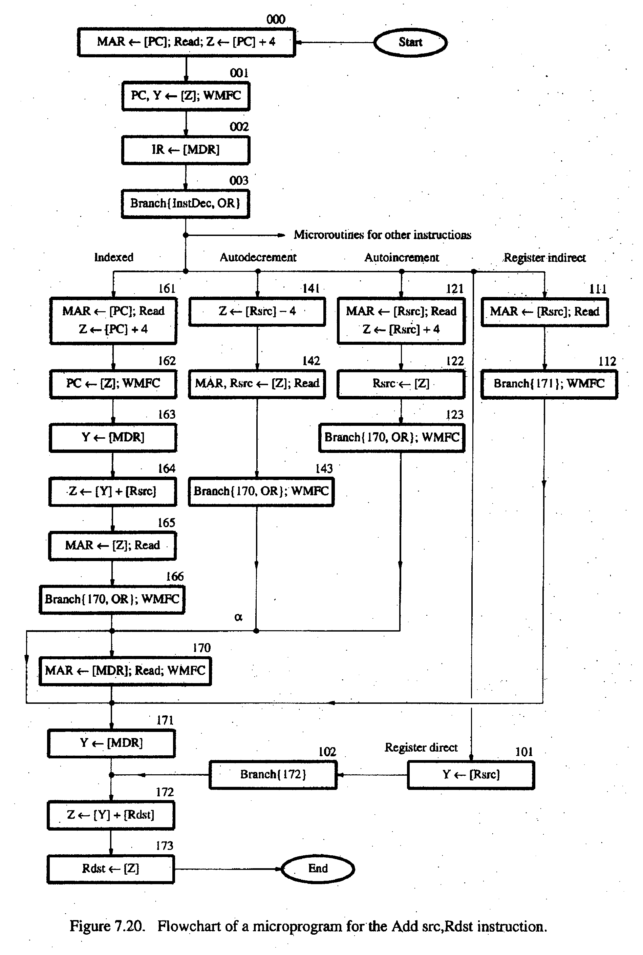
Pg No.436 – Computer Organisation by Carl V Hamacher

OP code
0
1
0
Rsrc
Rdst
Contents of IR
0
3
4
7
8
10
11
Note:
Microinstruction at location 170 is not executed for this addressing mode.
Address
Microinstruction
(octal)
000
PC
out
, MAR
in
, Read, Select
4
, Add, Z
in
001
Z
out
, PC
in
, Y
in
, WMFC
002
MDR
out
, IR
in
003
μ
Branch {
μ
PC
←
101 (from Instruction decoder);
μ
PC
5,4
←
[IR
10,9
];
μ
PC
3
←
121
Rsrc
out
, MAR
in
, Read, Select4, Add, Z
in
122
Z
out
, Rsrc
in
123
170
MDR
out
, MAR
in
, Read, WMFC
171
MDR
out
, Y
in
172
Rdst
out
, SelectY
, Add, Z
in
173
Z
out
, Rdst
in
, End
[IR
10
]
⋅
[IR
9
]
⋅
[IR
8
]}
μ
Branch {
μ
PC
←
170;
μ
PC
0
←
[IR
8
]}, WMFC
Textbook page 439

9.3 Microinstructions with next address field

The microprogram we discussed requires several branch microinstructions, which perform no useful operation in the data path. A powerful alternative approach is to include an address field as a part of every microinstruction to indicate the location of the next microinstruction to be fetched.
- Pros: separate branch microinstructions are virtually eliminated; few limitations in assigning addresses to microinstructions.
- Cons: additional bits for the address field (around 1/6)

