RAJAGIRI SCHOOL OF ENGINEERING
AND TECHNOLOGY
Rajagiri Valley, Kochi -39



T404 -COMPUTER SYSTEM ARCHITECTURE
MODULE IV

Prepared by
Gopika S

Document dated on 1/6/2007

INDEX

- Introduction
- Cache memory
- Associative memory
- Memory Interleaving
- Virtual memory

1. INTRODUCTION
The programs and data reside in main memory of the computer during execution. The speed with which an instruction gets executed is mainly dependent on the speed with which data can be transferred to or from the main memory. In this module, we will deal with the different types of memories, its organization and working, also the various techniques used to increase the effective speed, reduce the cost and size of main memory.

  - MEMORY FUNDAMENTALS
The maximum size of main memory that can be used in any computer is determined by the addressing scheme. For example, a 16-bit computer can generate 16-bit addresses and is capable of addressing up to 2¹⁶ (64 K) memory locations. Similarly, a machine that can generate 32-bit addresses can use 2³² (4G) memory locations. Here 64K, 4G memory locations represent the size of the address space of the computer. The memory address space is divided into number of memory words, where each word represents the smallest addressable unit of information or group of bits that is processed as a unit by the computer.
A computer can be a word-addressable or byte-addressable this depends on the fixed number of characters in the address location. This is shown in figure 1
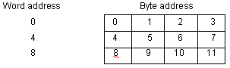
Figure 1 Organization of the Main memory in a 32-bit Byte-addressable computer

1.1.1 Data Transfer between the Main Memory and CPU
Data transfer between the main memory and CPU is through the use of two CPU registers Memory Address Register (MAR) and Memory Data Register (MDR) and it is shown in figure 2
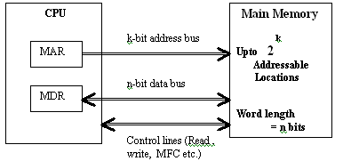
Figure 2 Connection of the main memory to the CPU

Let MAR be k-bits long, MDR be n-nits long. During memory cycle, n-bits of data are transferred between main memory and CPU. This transfer takes place over the memory bus that consists of k address lines and n-data lines. To coordinate the transfer, the control lines Read, Write, Memory Function Complete (MFC) etc. are used.

1.1.2 Memory Access time
It is the time that elapses between the initiation of an operation and the completion of that operation. E.g.: time between Read and MFC
1.1.3 Memory Cycle time
It is the minimum time delay required between the initiations of two independent memory operations. E.g.: two successive Read operations

1.2 TYPES OF MEMORY
1.2.1 Memory Hierarchy
Memory can be classified as
- CPU Registers
- Cache Memory
- Main Memory
- RAM
- ROM
- Secondary Memory
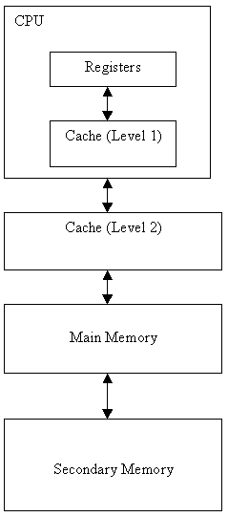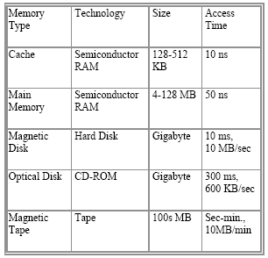
Figure 3 Memory Hierarchy

The size of the memory increases in the order from CPU registers to the secondary memory and the speed decreases in the same order.
1.2.2 Memory System Considerations
The major memory system considerations are speed and size of the memory. An ideal memory system should have optimal size and speed. The apparent speed of the memory can be increased by using techniques like
- Cache Memory
- Associative Memory
- Memory Interleaving
The apparent size of the memory can be increased by using virtual memory technique.

2. CACHE MEMORY
The cache memory is a small and fast memory that is placed between the main memory and the CPU. It holds the currently active and more frequently used segments of program and its data. This is shown if figure 4. In this approach, the CPU need not always fetch the program and data from the main memory instead it can get it from the cache memory. Hence, the total time of execution is considerably reduced and it is more economical.

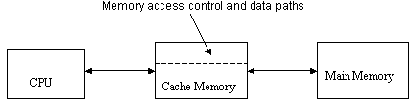
Figure 4 Cache Memory

The cache memory is divided into number of blocks. When the CPU requests for an addressed word, it is transferred from the main memory to the cache. The memory-access control circuitry in the cache, checks whether the requested word currently exists in the cache. If the requested word exists in cache, then the Read or Write hit occurs and the required operation is performed on the appropriate location in the cache. When the operation is Read, the main memory is not involved. However, if the operation is Write, then there are two techniques followed. In the first technique known as write through, the main memory and cache locations are updated simultaneously. In the second technique known as write back, only the cache location is updated and it is marked as updated using dirty or modified bit. The main memory will be updated during swapping.
If the requested word does not exist in cache, then a read or write miss (cache miss) occurs. If the operation is Read, then the block of words that contain the requested word is loaded from the main memory into the cache and the requested word is forwarded to the CPU. This technique is known as load-through. When the operation is Write, and the requested word is not in cache, then it is written directly into the main memory.

The correspondence between the main memory and cache memory blocks are specified through a mapping function. Since each cache line is shared between several blocks of main memory (because the number of memory blocks is much greater than the number of cache lines), when one block is read in, another one should be moved out. Mapping functions minimize the probability that a moved-out block will be referenced again in the near future. There are three mapping functions,
- Direct mapping technique
- Associative mapping technique
- Set associative mapping technique

2.1 DIRECT MAPPING
In direct mapped cache each main memory block is assigned to a specific line in the cache according to the formula i = j modulo N, where i is the cache line number assigned to main memory block j, and N is the number of lines in the cache. Direct mapping cache interprets a main memory address (comprising of s + w bits) as 3 distinct fields. Tag (the most significant s - r bits) is a unique identifier for each memory block.
Line number (middle r bits) specifies which line will hold the referenced address. Line number identify one of the N = 2r lines of cache.
Word (least significant w bits) specifies the offset of a byte within a line or block. Word specifies the specific byte in a cache line that is to be accessed. The block diagram representing direct mapping function is shown in figure 5.
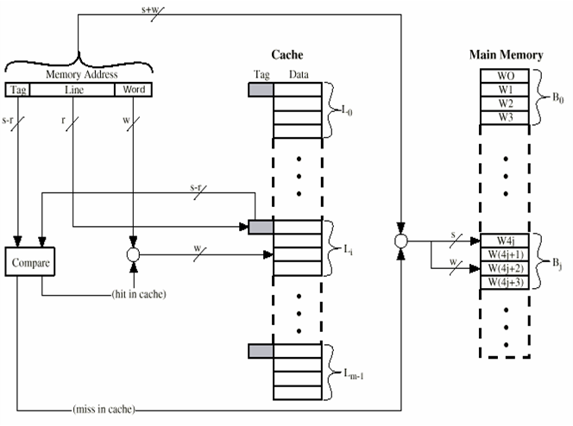
Figure 5. Direct Mapping

2.2 ASSOCIATIVE MAPPING
In associative mapping a block of the main memory can map to any available cache line. Associative mapping cache interprets a main memory address (comprising of s + w bits) as two distinct fields. Tag (the most significant s bits) is a unique identifier for each memory block. Word (least significant w bits) specifies the offset of a byte within a line or block. The block diagram of associative mapping is shown in Figure 6.

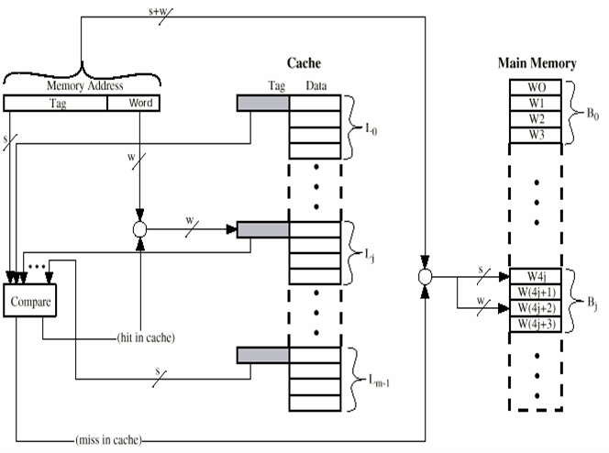
Figure 6. Associative Mapping

2.3 SET ASSOCIATIVE MAPPING
This mapping is compromise between direct mapping and fully associative mapping. It builds on the strengths of both: namely, the easy control of the direct mapped cache and the more flexible mapping of the fully associative cache.
In set associative mapping, cache is divided into a number of smaller direct-mapped areas called sets (v), with each set holding a number of lines (k).The cache is then described in the number of lines each set contains. If a set can hold X lines, the cache is referred to as an X-way set associative cache. A main memory block can be stored in any one of the k lines in a set such that cache set number = j modulo v (where j is the main memory block number). The block diagram for a two way set associative mapping technique is shown in figure 7.

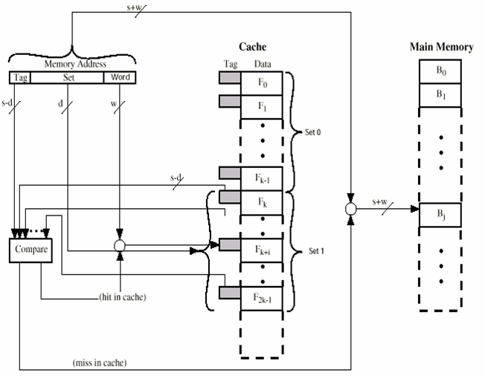
Figure 7 Two way Set Associative Cache

To bring a new block into the cache when the cache is full, the cache controller must decide which old block to overwrite. This is done with the help of replacement algorithms. The commonly used one is Least Recently Used (LRU) algorithm.

3. ASSOCIATIVE MEMORY
A memory unit accessed by content is called an associative memory. This type of memory is accessed simultaneously and in parallel on the basis of data content rather than by specific address or location. When a word is written in an associative memory, no address is given. The memory is capable of finding an empty unused location to store the word. When a word is to be read from an associative memory, the content of the word, or part of the word, is specified. The memory locates all words, which match the specified content and marks them for reading. The organization of associative memory is as shown in figure 8. The comperand register is also known as argument register. The masking register is known as key register.

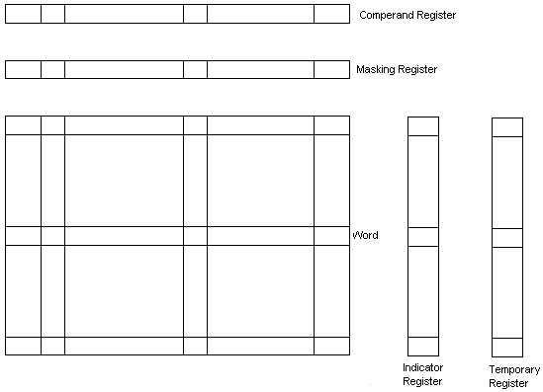
Figure 8. Associative memory organization

4. MEMORY INTERLEAVING
Here instead of organizing the memory as a single unit it is organized as many modules. Each module will have its own Address Buffer Register (ABR) and Data Buffer Register (DBR). Now memory access operations can be done in more than one module at the same time. Thus the rate of transmission of words to and from the main memory can be increased. The number of modules that can be kept busy depends on how the individual addresses are distributed over the modules. If consecutive words are kept in different modules, the rate of transmission can be increased.
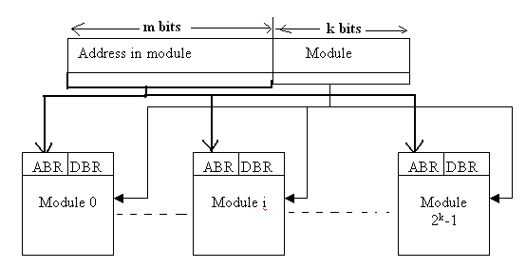
Figure 9 Memory Organization in Memory Interleaving
The low order k bits of the memory address select a module and the high order m bits name a location within that module. So consecutive addresses will be in successive modules. A request for access to consecutive locations can keep several modules busy at the same time resulting in faster access to a block of data and higher average utilization of the memory system.

5. VIRTUAL MEMORY
In any computer system, if programs and data do not fit into the physical main memory, then secondary storage devices such as magnetic disks or tapes are used to hold them. This memory space problem is handled by the operating system. It automatically swaps the program and data between the main memory and the secondary storage, whenever they are required for execution. This technique is known as Virtual memory technique. Thus, the programmer has an infinite size of main memory. The addresses of program and data being generated by the CPU are independent of the main memory. These addresses are referred to as logical or virtual addresses. These virtual addresses are translated into physical addresses by what is known as virtual memory address translation mechanism. This translation is done by a Memory Management Unit (MMU).
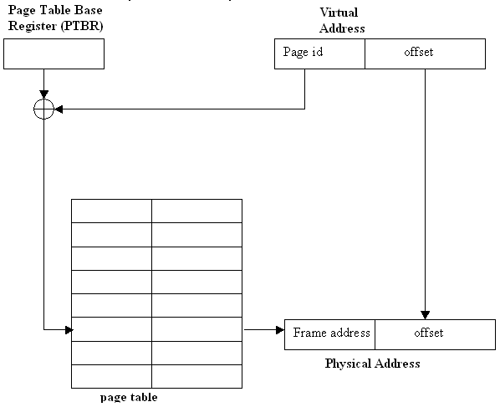
Figure 10 Virtual memory address translation

The block diagram given below is extracted from “Computer Organization and Architecture” by William Stallings.

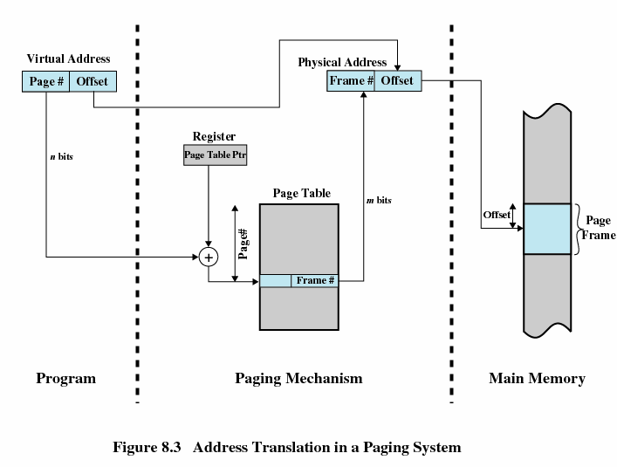
The main memory and the secondary storage are divided into fixed length units called frames and the program is divided into same size blocks called pages. Each page consists of a block of words occupying contiguous memory locations. While swapping, the entire page is swapped between the main memory and the secondary device.
Each virtual address consists of a page number (high-order bits) and an offset (low-order bits). A page table in the main memory specifies the location of the pages that are currently in the main memory. The starting address of page table is kept in a page table base register (PTBR). By adding the page number to the contents of page table base register, the address of the corresponding entry in the page table is obtained. The contents of the page table location gives the starting address of the page in the main memory, if the required page is currently in the main memory, otherwise it gives the starting address of the secondary storage. The control bits are used to indicate the presence or absence of pages in the main memory. It also indicates whether the page has been modified or not. A page fault occurs, when a program generates an access requests to a page that is not in the main memory. In order to overcome this, the corresponding whole page should be brought from the secondary storage device into the main memory before the access request is processed. The page replacement algorithm such as Least Recently Used (LRU) is used to replace pages, in case the main memory is full with the ones in the secondary storage.
5.1 Translation Lookaside Buffer
Translation lookaside buffer (TLB) is a small cache that resides in the memory management unit (MMU). The MMU frequently access the page table to know the information of a page in the main memory. The page table entries of all the recently accessed pages will be kept in the TLB so that the MMU can access the pages faster. Whenever the processes issues the address of a word it is first checked in the TLB, if it is there it is accessed within no time. If it is not in the TLB, then the page table in the main memory is searched, if present in the page table, the entry is copied to the TLB and the page is accessed. If not in the page table, the page is first brought in to the main memory from the secondary memory; an entry for it is made in the TLB and the page table. The TLB entry for a page includes its virtual address, the control bits associated with that page and the address of the page frame in the main memory.
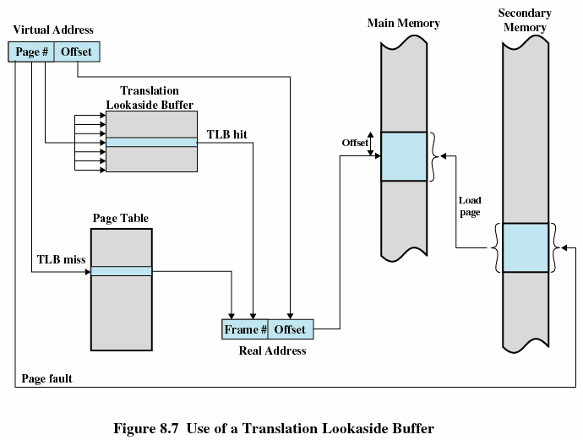
The operation of paging mechanism with the aid of translation lookaside buffer is also illustrated below.
