T 402 Reg.No:_______________
Name:_________________

RAJAGIRI SCHOOL OF ENGINEERING AND TECHNOLOGY

RAJAGIRI VALLEY, KAKKANAD.

B.TECH DEGREE SECOND INTERNAL EXAMINATION, May-2007

Fourth Semester-IT
Data Structures & Algorithms
Answer Key
Time: 2hrs Max Marks: 50

Part A
(All Questions carry 1 Mark each)

- Which of the following is an example of contiguous structure?
- Tree
- Array
- Linked list
- Graph
Ans: c) Array

- Which expression indicates whether the numbers in two nodes (p and q) are the same? Assume that neither p nor q is null.
  - p == q
  - p.data == q.data
  - p.link == q.link
  - None of the above.
Ans: a) p.data == q.data
The Average time complexity of a normal interpolation search is ________
Ans: O(log logn)

- In a selection sort of n elements, how many times is the swap function called in the complete execution of the algorithm?
Ans: n(n-1)/2

- What is the worst-case time for quick sort to sort an array of n elements?
Ans: O(n²)

Part B
(All Questions carry 5 Marks each)

- Compare and Contrast singly linked list and doubly linked list.

Ans: In singly Linked list each node contains only one link which points to the next node in the list.

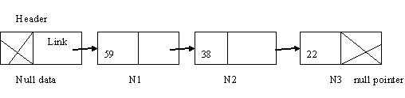

Header stores a pointer to the first node N1. If we know the address of the header, next node can be traced and so on. In singly linked list one can move from left to right only so it is termed as one way list.
In a singly linked list we can traverse in only one direction (forward), i.e. each node stores the address of the next node in the linked list. It has no knowledge about where the previous node lies in the memory. If we are at the 12th node (say) and if we want to reach 11th node in the linked list, we have to traverse right from the first node. This is a cumbersome process. Some applications require us to traverse in both forward and backward directions. Here we can store in each node not only the address of the next node but also the address of the previous node in the linked list. This arrangement is often known as a doubly linked list.
The structure of a node is represented below.
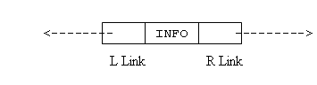
From the figure, it can noticed that, two links L Link (left pointer) and R Link( right pointer) point to the nodes at the right side and left side of the node, respectively. Thus every node except the header node and the last node points to its immediate predecessor and immediate successor.
The doubly linked list is a two-way because one can move in either direction, either from left to right or from right to left.

- Write an algorithm to display the odd numbers in a given list.
Ans: Steps
  - Create a list
  - If list ==NULL
      - print list is empty
  - Else do the following till list=NULL
- if list->data%2!=0
  - print list->data
  - list=list->next
- Else
  - list=list->next
d) End IF
  - End If
  - Stop

- Write an algorithm to perform the insertion and deletion on a double ended queue. Illustrate with suitable examples.
Ans: Adding an element into the queue at the front

Algorithm
Input: New element item to be inserted at the front
Output: Deque with newly inserted element item
Data Structure: Dequeue with two pointers front and rear.

Steps
1. If (front=0&rear=0) then
  - front=1
  - rear=1
  - DQ[front]=item
2. Else
a) If (front=1)then
i. F=length
ii) if (F=rear)
a) Print DQ full
iii) Else
a) front=F
b) DQ[front]=item
iv) EndIF
b) Else
i) F=front-1
ii) ) if(F=rear)
a) Print DQ full
iii) Else
a) Front=F
b) DQ[front]=item
iv) EndIf
c) EndIf
3. EndIf
4. Stop

b) Adding an element into the queue at the rear

Algorithm
Input: An element item that has to be inserted
Output: The item is at the rear of the queue
Data Structure: Array representation of queue with two pointers rear and front.
Steps:

- If(rear=n) then
  - print queue full
  - exit
- Else
  - if rear=0 &front=0
- front=1
  - Endif
  - Rear=rear+1
  - Q[rear]=item
- EndIf
- Stop

Program
void add_queue(int item)
{
if (rear == n)
printf(“Queue full”);
else
{
rear = rear + 1;
q[rear] = item;
}
}
c) Deleting an element from the rear end of the dequeue

Algorithm
Input: A Dequeue with elements.
Output: The item is deleted from the rear if the queue is not empty.
Data Structure: Dequeue with two pointers front and rear

Steps
1. If(front=0) then
  - print queue is empty
  - exit
2. Else
a) If (front=rear) then
- item=DQ[rear]
ii) front=rear=0
b) Else
- If (rear=1) then
  - item=DQ[rear]
  - rear=length
ii) Else
1. item=DQ[rear]
2. rear=rear-1
iii) EndIf
c) EndIf
3. End If
4. Stop

d) Deleting an element from the front end of the dequeue
Algorithm
Input: A Queue with elements
Output: The deleted element is stored in item
Data Structure: Array representation of queue with two pointers rear and front.

Steps:
1. If(front=0) then
  - print queue is empty
  - exit
- Else
  - item=Q[front]
  - If(front=rear)
    - rear=0
ii) front =0
  - Else
i) front =front+1
  - Endif
- EndIf
- Stop

Program
int delete_queue()
{
if (front == rear)
{
printf(“Queue empty”);
return(-1);
}
else
{
front = front + 1;
return(q[front-1]);
}
}

- What is a binary tree? Consider the given binary tree and find the following:
      - Degree of each node
      - Height of the tree
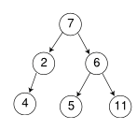
Ans: a) Degree of 7=2, 2=1,4=0,6=2,5=0,11=0
b) Height of the tree=3
- Write and explain the insertion sort algorithm. What is the complexity of this algorithm?
Ans:
- Start
- Read the number of elements in the array say n
- Read the number of elements in the array A
- Declare another array S
- Assign S[0]=A[0], k=1 and i=k-1
- Repeat step 7 to 9 until k<n
- Assign temp=k-1
- Repeat the following steps until (S[i]>temp and i>=0)
    - S[i+1]=S[i]
    - Decrement i by 1
- Increment k by 1
- Assign k=0
- Repeat the steps 12 to 13 until k<n
- Assign X[k]=S[k]
- Increment k by 1
- Stop
Time Complexity
Case I (Best case – List is already sorted):
Only One comparison is needed on each pass. Hence the complexity is O(n).

Case II (Worse case – List is sorted in reverse order):
No. of comparison = n + (n-1) + (n-2) + … + 2
= n(n+1)/2 – 1
= O(n²).

Part C
(All Questions carry 10 Marks each)

- Perform Quick sort on a list A with the following 10 elements, A=31, 15, 59, 51,36,11,35,28,17,49. Write the states of the list at the end of each pass. Also find the Best case, Average case, and Worst case time complexities of Quick sort.
Ans:
First pass: 31, 15, 59, 51,36,11,35,28,17,49.
31, 15, 17, 51,36,11,35,28,59,49.
31, 15, 17, 28,36,11,35,51,59,49.
31, 15, 17,28,11,36,35,51,59,49.
31, 15, 17,28,11,36,35,51,59,49.
[11, 15, 17, 28] 31, [36, 35, 51, 59, 49]
Second Pass: First set in sorted order Call quick sort for second subarray.
Time Complexity
Case1: Avearage case
Assume that the file is of size n, and each time after fixing an element the file is divided into equal partitions.
T(n)= 2T(n/2)+O(n)(to find the pivote element)
= 4 T(n/4)+2 O(n)
…….
=2^{k} T(n/2^{k})+k*O(n) this iteration continued till 2^{k}=n. so k=log₂n =2^{logn}T(1) +logn*O(n)
= O(nlog₂n).
CaseI1 (worse case):
Assume that each time after fixing an element the file is divided into a smaller partition and a bigger partition. Say, during i^{th} partition it is divided into 1 and (i-1).
No. of comparison = n + (n-1) + (n-2) + … + 2
= n(n+1)/2 – 1
= O(n²)
- a) Define the following with suitable examples.
    - Skewed binary tree

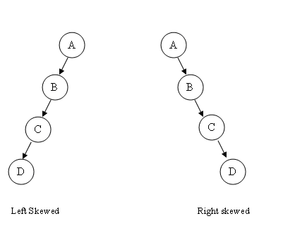
    - Complete binary tree
A binary tree with n nodes and depth k is complete if and only if its nodes correspond to the nodes which are numbered 1 to n in the full binary tree of depth k.

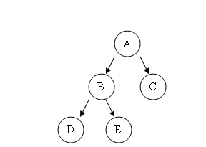

    - Full binary tree

Full binary tree of depth k is a binary tree having 2^{k}-1 nodes k>=0.

The example of full binary tree is given in the following figure.
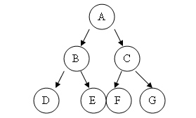

(6 Marks)
b) Write out the inorder, Preorder, and Post order traversals for the given binary tree.
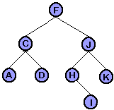
(4 Marks)
Ans: Inorder: A C D F H I J K
Preorder: F C A D J H I K
Postorder: A D C I H K J F

