Module-II

Topics Page Number

LINKED LISTS

2.1 Singly Linked List…………………………………………….. 2
2.1.1 Creating a Singly linked list……………………………… 3
2.1.2 Display a Singly linked list…………………………………. 3
2.1.3 Insertion of a node in to a singly linked list……………….. 4
2.1.3.1 Insert at the end………………………………………. 4
2.1.3.2 Insert at front ………………………………………… 5
2.1.3.2 Insert an element after a given element……………… 5
2.1.3.3 Insert an element before a given element……………. 6
2.1.4 Deletion of a node form the list…………………………….. 7
2.2 Doubly Linked List…………………………………………….. 7
2.2.1 Creating a Doubly linked list………………………………. 9
2.2.2 Display a Doubly linked list…………………………………9
2.2.3 Insertion of a node in to a doubly linked list …………….. 9
2.2.3.1 Insert at the end……………………………………….. 10
2.2.3.2 Insert at front …………………………………………. 10
2.2.3.2 Insert an element after a given element……………… 11
2.2.3.3 Insert an element before a given element……………. 12
2.1.4 Deletion of a node from the list……………………………. 13
2.3 Circular Linked List…………………………………………… 13
2.4 Advantages and Disadvantages of linked list………………… 14
2.5 Applications of linked list……………………………………… 15
2.5.1 Implementation of Stack using linked list………………… 15
2.5.2 Polynomial representation using linked list ……………… 16

LINKED LISTS

Array is a data structure where the elements are stored in consecutive memory locations. So block of memory should allocate before hand. Once the memory is allocated it can not extended. This is called static data structure. Linked list is a dynamic data structure, where amount of memory required can be varied during its use. In this adjacency between the elements are maintained by means of links. This link is a pointer, points to the address of the subsequent element.

In Linked list data (actual content) and link (point to next data) are maintained as a node.

Link
Data
To the next node

A linked list is an ordered collection of finite, homogenous data elements called nodes, where the linear order is maintained by means of links or pointers.
Depending on the requirements, the pointers maintained in the linked list can be classified into three groups.

Singly linked list, doubly linked list, Circular linked list

  - Singly Linked List

Each node contains only one link which points to the next node in the list.

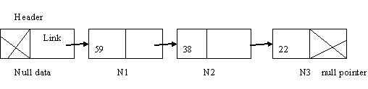

Header stores a pointer to the first node N1. If we know the address of the header, next node can be traced and so on. In singly linked list one can move from left to right only so it is termed as one way list.
It can be represented as

struct name
{
data_type item1;
data_type item2;
.
.
.
data_type item n;
struct name * next_pointer;
};

Possible operations on a singly linked list are listed below.
- Creating a list
- Display the contents of list
- Insertion of a node into a list
- Deletion of a node from the list
- Copy a linked list to make duplicate
- Merging two linked list into a larger list
- Searching for an element in a list

2.1.1 Creating a Singly linked list

Given below is a program to insert 10 elements to a singly linked list.

Program 2.1
struct node{
int data;
struct node * next;
};
void main()
{
struct node *list, *temp, *head;
int i;
list = (struct node *) malloc (sizeof (struct node));
list-> data = 1;
list-> next = NULL;
head = list;

for(i=2; i<11; i++)
{
temp = (struct node*) malloc (sizeof(struct node));
temp-> data = i;
temp-> next = NULL;
list-> next = temp;
list = list-> next;
}
}
2.1.2 Display a Singly linked list

Program 2.2
void display(struct node * list)
{
while (list != NULL)
{
printf(“%d”, list->data);
list = list->next;
}
}

2.1.3 Insertion of a node in to a singly linked list

There are various positions where a node can be inserted:
- Insert at end ( as last element)
- Insert at front (as first element)
- Insert after a given element
- Insert before a given element

2.1.3.1 Insert at the end
Insert an element at the end of the existing list
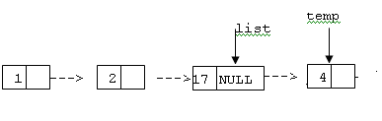
Program 2.3

struct node* insert_end (struct node * list, int item)
{
struct node *temp;
temp = (struct node*) malloc (sizeof(struct node));
temp-> data = item;
temp-> next = NULL;
head=list;
if (list == NULL)
{
list = temp;
head=list;
}
else
{
while (list-> next != NULL)
list = list->next;
list->next = temp;
}
return(head);
}

Call the function “insert_end” from the main program as given below.
head = insert_end (head, new_item, search_item);

2.1.3.2 Insert at front
The following program describes how to insert a node into a singly linked list at the front of the list.
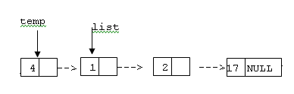
Program 2.4

struct node* insert_front (struct node * list, int item)
{
struct node *temp;
temp = (struct node*) malloc (sizeof(struct node));
temp-> data = item;
temp-> next = NULL;
temp->next = list;
head=temp;
return (head);
}
Call the function “insert_front” from the main program as given below.
head = insert_front (head, new_item, search_item);

2.1.3.2 Insert an element after a given element
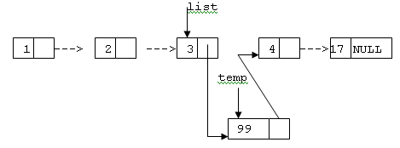

Program 2.5

void insert_after (struct node * list, int new_item, int search_item)
{
struct node *temp;
temp = (struct node*) malloc (sizeof(struct node));
temp->data = item;
temp->next = NULL;
if ( list != NULL)
{
while(list != NULL)
{
if (list->data == search_item)
{
temp->next = list->next;
list->next = temp;
break;
}
else
list = list->next;
}

}
}

2.1.3.3 Insert an element before a given element
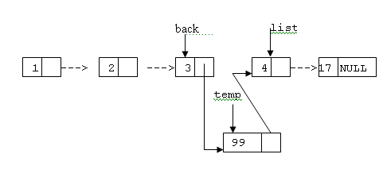
Program 2.6
void insert_before (struct node * list, int new_item, int search_item)
{
node *temp, *back,*head;
temp = (struct node*) malloc (sizeof(struct node));
temp->data = item;
temp->next = NULL;
if ( list != NULL)
{
while(list != NULL)
{
if (list->data == search_item)
{
temp->next = list;
back->next = temp;
break;
}
else
{
back = list;
list = list->next;
}
} // while

}
}

2.1.4 Deletion of a node form the list

The following algorithm is to delete a node from any position in the singly linked list

Program 2.7

struct node* delete (struct node * list, int search_item)
{
node *temp, *back,*head;
head = list;
if ( list != NULL)
{
if (list->data == search_item)
{
temp = list;
list = list->next;
free(temp);
head = list;
}
else
{
while(list != NULL)
{
if (list->data == search_item)
{
temp = list;
back->next = list->next;
free(temp);
} break;
else
{
back = list;
list = list->next;
}
} // while
} //else
} //if
return(head);
}
  - Doubly Linked List

In a singly linked list we can traverse in only one direction (forward), i.e. each node stores the address of the next node in the linked list. It has no knowledge about where the previous node lies in the memory. If we are at the 12th node (say) and if we want to reach 11th node in the linked list, we have to traverse right from the first node. This is a cumbersome process. Some applications require us to traverse in both forward and backward directions. Here we can store in each node not only the address of the next node but also the address of the previous node in the linked list. This arrangement is often known as a doubly linked list. The structure of a node is represented below.
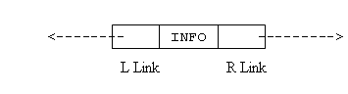
From the figure, it can noticed that, two links L Link (left pointer) and R Link( right pointer) point to the nodes at the right side and left side of the node, respectively. Thus every node except the header node and the last node points to its immediate predecessor and immediate successor.

A doubly linked list with four elements is given below:
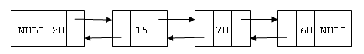

The doubly linked list is a two-way because one can move in either direction, either from left to right or from right to left.
The left pointer of the leftmost node and the right pointer of the rightmost node are NULL indicating the end in each direction. It can be represented as

struct name
{
data_type item1;
data_type item2;
.
.
.
data_type item n;
struct name * llink , * rlink;
};

All the operations as mentioned for a singly linked list can be implemented more efficiently fro doubly linked list.

    - Creating a Doubly linked list

Given below is a program to insert 10 elements to a singly linked list.

Program 2.8
struct node {
int data;
struct node * llink, * rlink;
} ;

void main()
{
struct node *list, *temp, *head;
int i;
list = (struct node *) maloc (sizeof (struct node));
list->data = 1;
list->llink = NULL;
list->rlink = NULL;
head = list;

for(i=2; i<11; i++)
{
temp = (struct node*) malloc (sizeof(struct node));
temp->data = i;
temp-> rlink = NULL;
list-> rlink = temp;
temp->llink = list
list = list-> rlink;
}
}
    - Display a Doubly linked list

Program 2.9
void display(struct node* list)
{
while (list != NULL)
{
printf(“%d”, list->data);
list = list->rlink;
}
}
2.2.3 Insertion of a node in to a doubly linked list

There are various positions where a node can be inserted:
- Insert at end ( as last element)
- Insert at front (as first element)
- Insert after a given element
- Insert before a given element

2.2.3.1 Insert at the end
list temp
1
3 null
nnulluNUNULL nullNU
2
4 null

Program 2.10
struct node* insert_end (struct node * list, int item)
{
struct node *temp,*head;
temp = (struct node*) malloc (sizeof(struct node));
temp->data = item;
temp->llink = NULL;
temp->rlink = NULL;
head=list;
if (list == NULL)
{ list = temp;
head=list
}
else
{
while (list->rlink != NULL)
list = list->rlink;
temp->llink = list;
list->rlink = temp;
}
return(head);
}

2.2.3.2 Insert at front
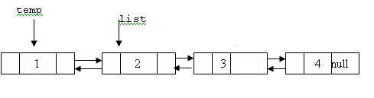
Program 2.11
struct node* insert_front (struct node * list, int item)
{
struct node *temp,*head;
temp = (struct node*) malloc (sizeof(struct node));
temp->data = item;
temp->llink = NULL;
temp->rlink = NULL;
head=temp;

if (list == NULL)
list = temp;
else
{
temp->rlink = list;
list->llink = temp;
}
return(head);
}

2.2.3.2 Insert an element after a given element
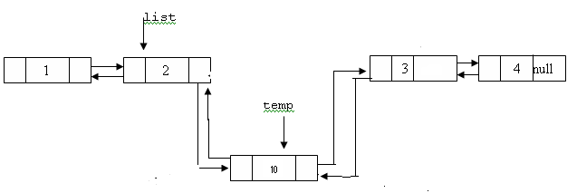
Program 2.12
void insert_after (struct node * list, int new_item, int search_item)
{
struct node *temp;
temp = (struct node*) malloc (sizeof(struct node));
temp->data = item;
temp->llink = NULL;
temp->rlink = NULL;
if ( list != NULL)
{
while(list != NULL)
{
if (list->data == search_item)
{
temp->llink = list;
temp->rlink = list->rlink;
list->rlink->llink = temp;
list->rlink = temp;
break;
}
else
list = list->rlink;
}
}
}

2.2.3.3 Insert an element before a given element

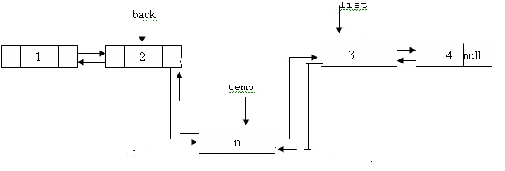

Program 2.13

void insert_before (struct node * list, int new_item, int search_item)
{
struct node *temp;
temp = (struct node*) malloc (sizeof(struct node));
temp->data = item;
temp->llink = NULL;
temp->rlink = NULL;
if ( list != NULL)
{
while(list != NULL)
{
if (list->data == search_item)
{
temp->rlink = list;
temp->llink = list->llink;
list->llink = temp;
list->llink->rlink = temp;
break;
}
else
list = list->rlink;

} // while
} //else
}
}

2.1.4 Deletion of a node from the list

The following algorithm is to delete a node from any position in the doubly linked list

Program 2.14

struct node* delete (struct node * list, int search_item)
{
struct node *temp, *head;
head = list;

if ( list != NULL)
{
if (list->data == search_item)
{
temp = list;
list = list ->rlink;
head = list;
free(temp);
}
else
{
while(list != NULL)
{
if (list->data == search_item)
{
temp = list;
list->rlink->llink = list->llink;
list->llink->rlink = list->rlink;
free(temp);
break;
}
else
list = list->rlink;

} // while
} //else
} //if
return(head);
}

  - Circular Linked List

In the previous two linked lists the link field of the last node is NULL. A linked list where the last node points the header node is called a circular linked list. In a circular linked list, the first and final nodes are linked together. To traverse a circular linked list, you begin at any node and follow the list in either direction until you return to the original node. Viewed another way, circularly-linked lists can be seen as having no beginning or end.

Circular linked list has the following advantages.

This type of list is most useful for managing buffers for data ingest, and in cases where you have one object in a list and wish to see all other objects in the list.

Accessibility of a member node in the list: In an ordinary list, a member node is accessible from a particular node, that is, from the header node only. But in the circular linked list, every member node is accessible from any node.

Null link problem: Null value in the link field may create some problem during the execution of programs if a proper care is not taken.

Circular linked list can be done for both singly and doubly linked lists.

a) Circular singly linked list
In a circular singly linked list, each node has one link, similar to an ordinary singly linked list, except that the link of the last node points back to the first node. As in a singly-linked list, new nodes can only be efficiently inserted after a node we already have a reference to. For this reason, it's usual to retain a reference to only the last element in a singly linked list, as this allows quick insertion at the beginning, and also allows access to the first node through the last node's next pointer.

b) Circular doubly linked list
In a circular doubly linked list, each node has two links, similar to doubly linked list, except that previous link of the first node points to the last node and the next link of the last node points to the first node. As in doubly linked lists, insertions and removals can be done at any point with access to any nearby node.

  - Advantages and Disadvantages of linked list

Advantages
- In case of an array, data are stored in contiguous memory location, so insertion and deletion operation are quite time consuming, as before in insertion we have to make room for the new element at a desired position by shifting down the trailing elements, similarly in case of deletion, in order to fill the location of deleted element, all the trailing elements are required to shift upwards. But in the linked list, it is a matter of changing pointers.
- Array is based on the static allocation of memory (amount of memory required for an array must be known before hand). Once it is allocated we can not expand its size. This is why for an array, general practice is to allocate memory space, which is much more than the memory actually will be used. But this is simply wastage of memory. This problem is not there in the linked lists. Linked list uses the dynamic memory management scheme that is memory allocation is decided during the run time as and when require. Also if a memory is no more needed, it can be returned to free storage space, so that other program can utilize this.
- A program using an array may not execute although the memory required for the data are available but not in contiguous locations rather dispersed. As link structure do not necessarily require to store data in adjacency memory locations. So the program of that kind, using linked list can then executed.

Disadvantages
- Pointers if not managed carefully, may lead to serious errors in execution.
- Linked list consumes extra space than the space for actual data as we are maintaining the links among the nodes.

  - Applications of linked list

The disadvantages of linked list are nothing compared to its advantages. This is why, the linked list is applicable in many situations, wherever it is required to manipulate data. Some of the applications are given below.

    - Implementation of Stack using linked list

a) Push
Algorithm
I/P: The new element item.
O/P: A singly linked list with newly pushed element item
Data structure: A singly linked list whose pointer to the header is known from head and top is the pointer to the first node.
Steps:
  - Create a new node say temp
  - temp->data=item
  - temp->next=top
  - top=temp
5. Stop
Program 2.15
Void push ( int item)
{
Struct node *temp;
temp = (struct node*) malloc (sizeof(struct node));
temp->data = item;
temp->next = NULL;
temp->next=top;
top=temp;
}
b) Pop
Algorithm
I/P: A stack with elements
O/P: Remove item from the top of the stack
Data structure: A singly linked list whose pointer to the header is known from head and top is the pointer to the first node.

Steps:
- If top=NULL
    - Print stack empty
    - Exit
- Else
    - Top is pointing to next data (top=top->next)
- EndIf
- Stop

Program 2.16
Void pop()
{
Struct node *temp;
If (top==NULL)
Printf( “stack empty”);
else
{
Printf(“%d”’top->data);
temp=top;
top=top->next;
free(temp);
}
}

    - Polynomial representation using linked list

Main advantage of linked list for polynomial representation is that it can accommodate a number of polynomials of growing sizes so that their combined size does not exceed the total memory available.
Let us consider a polynomial 5x⁴ +2x³+ 7x² + 8. In this each node should consist of three elements, namely coefficient, exponent and a link to the next item. While maintaining the polynomial it is assumed that the exponent of each successive term is less than that of the previous term. Once we build a linked list to represent the polynomial we can perform operations like addition and multiplication. It can be represented as

struct poly
{
int coeff;
int exp;
struct poly * next;
};
5 4
2 3
7 2
8 0 NULLN

Polynomial addition
Two polynomials P and Q is added and to get the resultant polynomial R. We have to compare their terms starting at the first nodes and moving towards the end one-by one. Two pointers pptr and qptr are used to move along the terms of P and Q. There may be three cases during the comparison.
Case1:
Exponents of terms are equal. In this case coefficients in two nodes are to be added and a new term is created with the values
rptr->coef=pptr->coef + qptr->coef
and
rptr->exp=pptr->exp

Case2:
If pptr->exp>qptr->exp then a duplicate of current term in P is created and to be inserted in the polynomial R

Case3:
If pptr->exp<qptr->exp then duplicate of current term in Q is created and to be inserted in the polynomial R

