Module-IV

Topics Page Number

GRAPHS
4.1 Basic Definitions………………………………………………… 2
4.2 Graph Representations………………………………………… 3
4.3 Graph Traversals…………………………………………. ……. 4
4.3.1 Depth First Search………………………………….. ……. 4
4.3.2 Breadth First search………………………………………. 5
4.4 Hashing…………………………………………………………… 7
4.4.1 Hash Functions…………………………………………….. 8
4.4.2 Collision Resolution……………………………………….. 8
4.5 Dynamic Storage Management…………………………………. 12
4.5.1 Boundary Tag System……………………………………… 13
4.5.2 Garbage Collection and Compaction…………………….. 15

GRAPHS
A graph G is a data structure consisting of two sets V and E. V is a finite non-empty set of vertices. E is a set of pair of vertices; these pairs are called edges represented by V (G) and E(G) respectively. A graph can also be represented as G= (V,E).
There are two types of graphs, directed graph and undirected graph. In a directed graph, and edge is represented by an unordered pair (V₁,V₂). In a directed graph, each edge is represented by a directed pair <V₁,V₂> where, V₁ is the tail and V₂ is the head.

Examples:
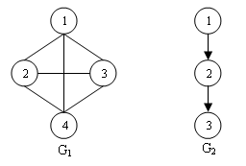
G₁ is an undirected graph and G₂ is a directed graph.
V(G₁) = {1,2,3,4}
E(G₁) = {(1,2), (1,3), (1,4), (2,1), (2,3), (2,4), (3,1), (3,2), (3,4), (4,1), (4,2), (4,3)}

V(G₂) = {1,2,3}
E(G₂) = {<1,2>, <2,3>}

4.1 Basic Definitions
- Multigraph: An object with multiple occurrence of the same edge.

1
3
4
2
- Complete graph: Maximum number of distinct pair (V₁,V₂) in any graph with n vertices is n(n-1)/2. An n vertex undirected graph with exactly n(n-1)/2 edges is called a complete graph.
- Subgraph : Subgraph of G is a graph G’ such that V(G’) V(G) and E(G’) E(G)

e.g, some of the subsets of graph G₁ are given below.
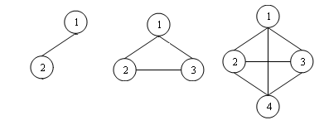
- Path : Path from vertex V_{i} to vertex V_{j} is a sequence of vertices V_{i,} V_{1,} V_{2,….,} V_{n,} V_{j} such that (V_{i}, V_{i}), (V_{1,} V₂),…..( V_{n}, V_{j}) are edges in E(G). If G is a directed graph, then <V_{i}, V_{i}>, <V_{1,} V₂>,….. <V_{n}, V_{j}> should be edges in E(G).
e.g.; (1,2)(2,4)(4,3)
- Length of a path: It is the number of edges in the path.
e.g.; Length of the above path is 3
- Simple path: A path with all vertices except possibly first and last are distinct.
e.g.;1 2 4 3 is a simple path
- Cycle: A simple path with first and last vertices are same.
e.g.; 1,2,3,1 is a cycle
- Connected graph: A graph is connected if or every pair of distinct vertices V_{i}, V_{j} in V(G), there is a path from V_{i} to V_{j} in G.
- Degree of a vertex is the number of edges incident to that vertex.
e.g.; degree of 1 in G1 is 3

4.2 Graph Representations
a) Adjacency matrix
The adjacency matrix of a graph is a matrix with rows and columns labeled by graph vertices, with a 1 or 0 in position (V_{i}, V_{j}) according to whether V_{i} and V_{j} are adjacent or not. In such a matrix when the i^{th} row, j^{th} column element is 1, we say that there is an edge between the i^{th} and j^{th} vertex. When there is no edge the value will be zero. For a simple graph with no self-loops, the adjacency matrix must have 0s on the diagonal. For an undirected graph, the adjacency matrix is symmetric. Adjacency matrix of graph G₁ is given below.
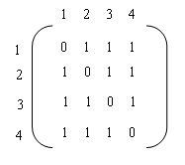
Space needed to represent a graph using adjacency matrix is n² bits.

b) Adjacency List
The adjacency list of a graph is a linked list with one list per vertex. Adjacency list of graph G₁ is given below.

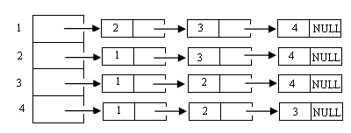

Each list has a head node. Head nodes are sequential.

c) Adjacency Multi List

In adjacency list representation for an undirected graph, each edge (u,v) is represented by two entries, one on the list for u and the other on the list for v. In adjacency multilists (lists in which nodes may be shared among several lists.) for each edge there will be exactly one node, but this node will be in two lists. The node structure is given below.

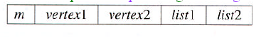
M is the Boolean mark field that may be used to indicate whether or not the edge has been examined.

Example:
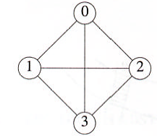
The adjacency multilists for the above graph is
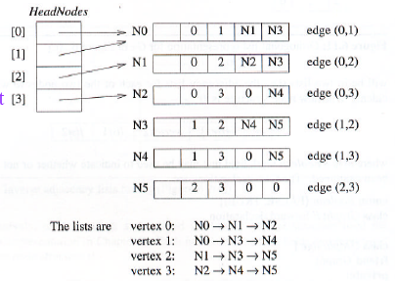

4.3 Graph Traversals
4.3.1 Depth First search

Algorithm
- Start from any vertex V. Make it as visited.
- Select unvisited vertex adjacent to V and perform DFS on that
- When vertex u is reached such that all its adjacent vertices are visited, go back to the last vertex visited which has an unvisited vertex w adjacent to it and perform DFS with w.
- Search terminated when no unvisited vertex can be reached from any of the visited vertex.
Example:
1
2
3
4
5
6
7
8

dfs – 1,2,4,8,5,6,3,7
Program 4.1
void Deapth_ first_ search ()
{
int v;
for (v=1;v<=n;v++)
visited[v]false;
for (v=1;v<=n;v++)
if(!visited[v])
DFS(v);
}
void DFS (int v)
{
int u;
visited[v]=true;
printf(“%d”,v);
for (u=1;u<=n;u++)
{
If(adjmatrix[v][u])
{
if(!visited[u])
DFS(u);
}
}

}

4.3.2 Breadth First search

Suppose the graph is represented as an adjacency matrix, and we are required to have the breadth first search of the graph. Here we will require the starting vertex from which this search will begin. First that vertex will be printed, and then all the vertices, which are adjacent to it, are printed and so on.
If we have a matrix and there are n vertices. Let the starting vertex be j. Now the j^{th} vertex will be printed first, and to find all the vertices adjacent to this vertex, we must travel along j^{th} row of the matrix, and whenever we find 1 we will print the corresponding column number. Next time we will require each of the vertices printed recently so that we can travel level by level. For the same purpose we will push into a queue all the columns with the value one in the j^{th} row. Next time pop the vertex number from the queue and print it. Replace the value of j, which is currently printed. Again push all the vertices that are adjacent to this vertex into the queue and continue the above process until all the vertices are dealt with.

Remember there will be many vertices, which will be connected to more than a vertex, and therefore there are chances that we may repeat some of the vertices or there will be an infinite loop. To avoid this problem, we use what is known as visited array. It will be initially all zeroes. Whenever a vertex is pushed into the queue the corresponding position the visited array is changed to 1. Now we use another rule that we push only those vertices into the queue whose corresponding value in the visited array at that point is zero. When all the vertices are printed we will stop. Sometimes it happens that a particular vertex or a group of vertices is non reachable from the current vertex and in this case the graph is ‘not connected’.

Method
1. Start from any vertex v. Make it as visited.
- Go to all vertices adjacent to v and make it as visited
3. Then unvisited vertices adjacent to these newly visited vertices are then visited and so on.

Algorithm
- Initialize the adjacency matrix p to all zeroes.
- Accept the number of vertices from the user, say n.
- Initialize the visited array v to all zeroes.
- Accept the graph.
  - Initialize i to 0.
  - Accept the vertex adjacent to ith vertex, say j.
  - Make p[i][j] = p[j][i] = 1, as they are adjacent to each other.
  - If more vertices are adjacent to ith vertex then goto step (a).
  - Now consider the next vertex i.e. increment i and repeat from step(a).
- Accept the starting vertex say i.
- Push i to the queue, and mark it as visited, i.e. v[i]=1.
- Pop a vertex from queue, say i.
- Print i.
- Search in ith row for 1,

  - Initialize j to 0.
  - If the jth vertex is adjacent to i and not visited i.e.
If(p[i][j]==1 && v[i] != 1), push j to the queue and mark it as visited, i.e. v[j]=1.
  - Increment j and if the number of vertices is not over then repeat from step(b).

- If queue is not empty repeat from step 7.
- Stop.

Example:
1
2
3
4
5
6
7
8

bfs – 1,2,3,4,5,6,7,8

Program 4.2
void BFS (int v)
{
visited[v] = 1;
printf(“%d”,v);
AddQueue(v); // Add v to queue
while(!IsEmpty()) // Check for empty queue
{
w = Delete(); // Delete from the queue
for(u=1; u<=n; u++)
{
if (a[w][u] == 1 && !visited[u])
{
AddQueue(w);
visited[w] = 1;
printf(“%d”,w);
}
}
}

}

4.4 Hashing
In order to improve the performance while searching, deleting and inserting record, we use a technique called hashing. Memory is divided into bucket and buckets are again divided into slots. A slot can contain n records. A key value is mapped directly to a bucket by performing some arithmetic manipulation of the key by a hash function.
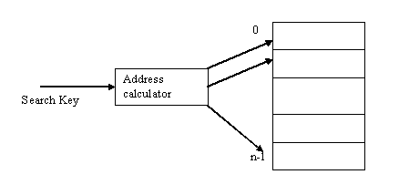
Array
Whenever you want to insert a new item into the table the address calculator finds where you should place it in the array.
Address calculator is also used for retrieve operation and delete operation. If you want to search an item simply ask the address calculator to tell you where it placed in the array. This address calculator is called hash function. This method is called hashing and the array is called hash table. Time complexity for insertion and search is O (1).

A hash function h must take an arbitrary integer x and map it into an integer that you can use an array index.
A hash function to map each x into unique integer i called perfect hash function. A perfect hash function maps each search key into a unique location of the hash table.

    - Hash Functions

Hash function should be
- Easy and find to compute
- Place items evenly throughout the hash table.

1) Selecting Digits

Suppose search key is 9 digit EMP ID 001364825. Select the 4th and last digit then obtain 35.
H(001364825)= 35
So store the item whose search key 001364825 in Table [35].
This method is simple but do not evenly distribute the items in hash table.

2) Folding

Selecting digits and add digits.
H(001364825)= 0+0+1+3+6+4+8+2+5=Table[29] here 0<=h(search key)<=81
To increase the table size, group the digits and add.
001+364+825=1190 here 0<=h(search key)<= 3*999=2997

3) Modulo Arithmetic

This is a simple and effective hash function. H(x) =x mod table size
Eg:, If table size is 101 so H(x) =x mod 101
So integer x ranges from 0 to 100.
H(001364825)= 12

4) Mid square Method

In this method H(x)=k where k is obtained by selecting appropriate number of bits or digits from the square of the key value.
If X=1234 then X²= 1522756
Select 2nd ,4th,and 6th digit
Then H(1234)=525.

In practice one or more search keys x and y into same location. Then collision occurs.

    - Collision Resolution
Suppose search key 4567 wan to insert into hash table.
H(x)= x mod 101
= 4567 mod 101=22
Suppose table[2] already contains an item then collision occurs.

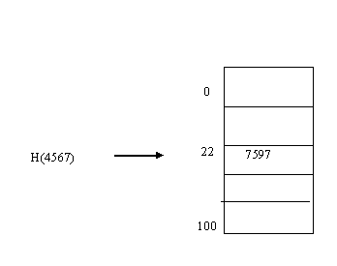
Two general approaches used to avoid collision.
- Allocate another location within the hash table to the new item.
- Change the structure of the hash table so that each location Table[i] can accommodate more than one item

- Approach 1( Open Addressing/ Closed Hashing)
If we try to insert new item into table hash function indicates a location in the hash table that is already exists then probe for some empty space. The sequence of space that we examine is called probe sequence.
The following are the different open addressing schemes.

a) Linear probing
In this method search the hash table sequentially starting from the original hash location.
If Table[H(Search key)] is occupied then check Table[H(Search key)+1], Table[H(Search key)+2] and so on until you find an empty location.
During the retrieve operation same probe sequence is reproduced until find the item or empty space is reached. Each space is in either one of the three states occupied, empty or deleted (once occupied but deleted).

Example:
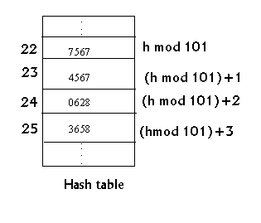

b) Quadratic probing

Instead of probing consecutive locations from the original hash location Table [H9serach key0] check location Table [H(Search key)+1^{2]}, Table[H(Search key)+2²] and so on until you find an empty location.

Example:
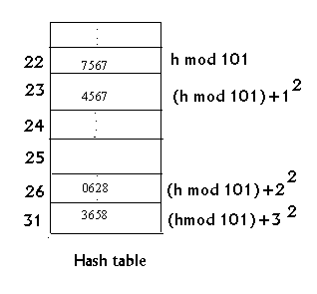
c) Double Hashing
The probe sequence that both linear probing and quadratic probing are key independent. Double hashing defines key dependent probe sequence. In this probe sequence search the table in a linear order starting at the location h1(key) but the second hash function h2 determines the size of steps taken.

Example:
H1(key) =key mod 11
H2(key)=7-(key mod 7)
Consider 58,14,91
H1(58)=3 so insert into Table[3]
H1 (14)=3 to avoid collision find H2(14)= 7-0=7 insert Table[7+3]=Table[10]
H1(91)=3 To avoid collision find H2(91)=7 so find Table[10+7%11]=Table[6]

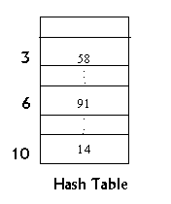
Using more than one hash function is called rehashing.
d) Random Probing
A pseudo random number generator generates a random sequence of locations. This sequence contains positions between 1 to n in the hash table.

Example:
I=(i+m)mod h+1
m=5,h=10 i=2 initially
Then sequence is 8,4,10,6,2………..

With open addressing scheme as the hash table fills then the probability of collision increases. So dynamically allocated array is more desirable for hash table

- Approach 2( Reconstruction the hash table/ Open Hashing)
In this change the hash table so that ot can accommodate more than one item in the same location.
- Use Buckets
If we define the hash table ‘Table’ so that each location Table[i] is itself an array called Bucket. More than one item can be stored into table[i]. Problem with this method is to determine the size of the bucket.
- Separate Chaining

In this each entry Table[i] is a pointer to a linked list. Chain of items that the hash function has mapped into location i.

Example:
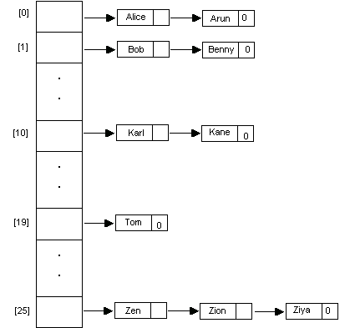

  - Dynamic Storage Management
In a multiprogramming environment, there exist different programs with different memory requirements, not known in advance. Operating systems allocates memory for these programs and free memory when program execution terminates. It also maintains a list of free memory area, from which it perform further memory allocation.

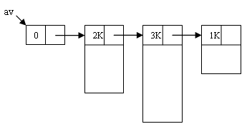
Free Memory Area

Fragmentation is the problem with any dynamic memory management scheme.

External fragmentation
Total storage may be decomposed into large number of small blocks. Enough total memory space exists but not contagious.

Internal Fragmentation
Some portion of the allocated memory is not used. That is slightly larger than the requested memory. So that small fraction of memory is wasted. This is called internal fragmentation.

Storage allocation strategies
- First Fit Allocation
In this list of available memory is searched and the first block whose size>=N(requested size) is allocated. Pointer to that block is sent to the calling program.
Example:
Available memory blocks are 1K,3K,7K,2.5K,5K
If 2K is needed then 3K is returned.
Program 4.3
Firstfit (int n)
{
p = link(av); // av – start address
q = av;
while (p != 0)
{
if (size(p) >= n)
{
Setsize(p, size(p)-n);
if (size(p) == 0)
Setlink(q, link(p));
else
p = p+size(p);
break;
}
q = p;
p = link(p);
}
}

Disadvantages
- Creates many small blocks
- Small blocks accumulate at the front, hence it increases search time later.

- Best Fit Allocation
This will not allocate a block of size >n. Search Continuously and the block whose size is most close to the size requested is allocated.
Example:
Available memory blocks are 1K,3K,7K,2.5K,5K
If 2K is needed then 2.5 K is most suitable then return pointer to the calling program.

- Worst Fit Allocation
Allocates largest block available.
Example:
Available memory blocks are 1K,3K,7K,2.5K,5K
If 2 K is neede then largest block 7K is allocated.

- Next Fit Allocation
This is the modification of first fit. Search begins from where the last allocation is done. Search time can be reduced.

4.5.1 Boundary Tag System
This is the efficient memory system for dynamic memory management.
In this the structure of a free block and an allocated block is different. They are given below.
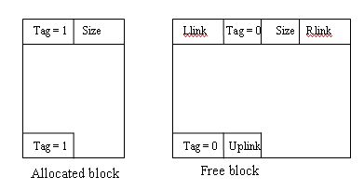
First word and the last word of each block reserved for block information.
Two tag fields in the boundaries of a block, so the name Boundary Tag System.

Llink→Points to the successor
Rlink→Points to the predecessor
Tag=0→ indicate block is free
Tag=1→ indicate allocated block
Uplink→ Points to the starting of the block

BTS maintains a circular doubly linked list of free memory blocks. There is a header node whose size and Tag field is 0.
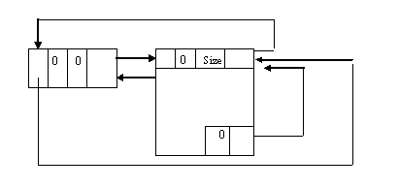

Program 4.4
- Allocate the block which is of size approximately equal to the size of the program. Also if the size of the block after allocation is lesser than a threshold value E, it allocates the whole block so that it would not leave small fragments.
- AVAIL points to the last node from which last allocation was made.
- This uses the next fir allocation scheme.
Void BTS(N,E)
{
Ptr=AVIAL;
Flag=0;
While(flag==0)
{
If(ptr→size>=N)
{
Diff=ptr→size-N
If(diff<E)
{
Ptr1=ptr→llink;
Ptr2=ptr→rlink;
Ptr1→rlink==Ptr2;
Ptr2→llink=Ptr1;
Ptr→flag==1;
(Ptr+Ptr→size-1)→tag=1;
AVAIL=Ptr2;
Return(ptr);
}
Else
{
Ptr→size=diff;
(Ptr+diff-1)→uplink=ptr;
Ptr+diff-1→tag=0;
AVAIL=Ptr;
Ptr=Ptr+Diff;
Ptr→size=N;
Ptr→tag=1;
Ptr+n-1→tag=1;
Falg=1;
}
}
Else
{
If(Ptr→rlink==AVAIL)
{
Printf(insufficient Memory”);
Flag=1;
}
Else
Ptr=Ptr→rlink;

}
}

}
4.5.2 Garbage Collection and Compaction
Garbage collection is the process of collecting all unused nodes and returning them to available space. This process is carried out in essentially two phases. In the first phases, the marking phase, all nodes in use are marked. In the second phase (compaction) all unmarked nodes are returned to the available list. In Compaction we compact memory so that all free nodes form a contiguous block of memory. Compaction reduces the average retrieval time.
- Marking
  - Need a mark field in each node
  - Marking algorithm marks all directly or indirectly accessible nodes.
The structure of a node is as below.

mark | tag | dlink | rlink

Each node regardless of its usage will have two Boolean value, mark and tag. In order to carry out the marking, a mark field is kept in each node. If mark is true, it is a used node else an unused one. If the tag value is false, then the node contains only atomic information in a field called data. If tag = true, then the node has two link values dlink and rlink.

Program 4.5

Mark ( int *x)
{
int *p, *q;, top;
top = 0;
add(x);
while (top > 0)
{
delete(p);
do
{
q = p->rlink;
if (q != null)
{
if ( q->tag and !q->mark)
add(q);
q->mark = true;
}
p = p->dlink;
if (p = = null)
break;
if (p->mark || !p>tag)
break;
p->mark = true;
}
p->mark = true;
}
}

- Storage Compaction
During this phase, all free space form one contiguous block. Since there will, in general, be links from one node to another, storage compaction must update these links to point to the relocated address of the respective nodes.

Storage compaction is done in as three phases.
- Determine the new address for nodes in use.
- Update all links in the nodes in use
- Relocate nodes to new address

Program 4.6

Compact()
{
int i,j,k;

// Phase I
av = 0; i=0;
while ( i <= m)
{
if (mark(i))
{
newaddr(i) = av;
av = av + size(i);
}
i = i + size(i);
}

// Phase II
i=0;
while ( i <= m)
{
if (mark(i))
{
link1(i) = newaddr(link1(i));
link2(i) = newaddr(link2(i));
}
i = i + size(i);
}

// Phase III
i=0;
while ( i <= m)
{
if (mark(i))
{
k = i – newaddr(i);
l = newaddr(i);
for (j=i; j<I+size(i) – 1; j++)
memory[j-k] = memory[j];
i = i + size(l);
}
i = i + size(i);
}
}

