- Graphs

A graph G is a data structure consisting of two sets V and E. V is a finite non-empty set of vertices. E is a set of pair of vertices; these pairs are called edges represented by V(G) and E(G) respectively. A graph can also be represented as G=(V,E).
There are two types of graphs, directed graph and undirected graph. In a directed graph, and edge is represented by an unordered pair (V₁,V₂). In a directed graph, each edge is represented by a directed pair <V₁,V₂> where, V₁ is the tail and V₂ is the head.

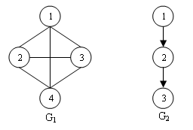

Consider the undirected graph G₁ and directed graph G₂ given above.
V(G₁) = {1,2,3,4}
E(G₁) = {(1,2), (1,3), (1,4), (2,1), (2,3), (2,4), (3,1), (3,2), (3,4), (4,1), (4,2), (4,3)}

V(G₂) = {1,2,3}
E(G₂) = {<1,2>, <2,3>}

Definitions
- Multigraph : An object with multiple occurrence of the same edge.
1
3
4
2
- Complete graph : Maximum number of distinct pair (V₁,V₂) in any graph with n vertices is n(n-1)/2. An n vertex undirected graph with exactly n(n-1)/2 edges is called a complete graph.
- Subgraph : Subgraph of G is a graph G’ such that V(G’) V(G) and E(G’) E(G)
e.g, Some of the subsets of graph G₁ are given below.
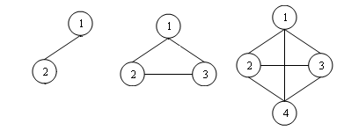
- Path : Path from vertex V_{i} to vertex V_{j} is a sequence of vertices V_{i,} V_{1,} V_{2,….,} V_{n,} V_{j} such that (V_{i}, V_{i}), (V_{1,} V₂),…..( V_{n}, V_{j}) are edges in E(G). If G is a directed graph, then <V_{i}, V_{i}>, <V_{1,} V₂>,….. <V_{n}, V_{j}> should be edges in E(G).
- Length of a path : It is the number of edges in the path.
- Simple path: A path with all vertices except possibly first and last are distinct.
- Cycle : A simple path with first and last vertices are same.
- Connected graph: A graph is connected if or every pair of distinct vertices V_{i}, V_{j} in V(G), there is a path from V_{i} to V_{j} in G.

  - Graph Representations

Adjacency matrix
The adjacency matrix of a graph is a matrix with rows and columns labeled by graph vertices, with a 1 or 0 in position (V_{i}, V_{j}) according to whether V_{i} and V_{j} are adjacent or not. For a simple graph with no self-loops, the adjacency matrix must have 0s on the diagonal. For an undirected graph, the adjacency matrix is symmetric. Adjacency matrix of graph G₁ is given below.
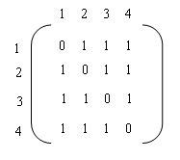
Adjacency List
The adjacency list of a graph is a linked list with one list per vertex.. Adjacency list of graph G₁ is given below.

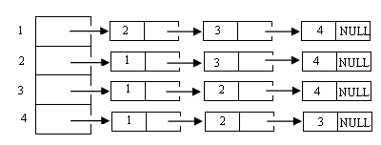

6.2 Graph Traversals

Depth First search

- Start from any vertex. Make it as visited.
- Select unvisited vertex adjacent to V and perform dfs.
- When vertex u is reach such that all its adjacent vertices are visited, go back to the last vertex visited which has an unvisited vertex w adjacent to it and perform dfs with w.
- Search terminated when no unvisited vertex can be reached from any of the visited vertex.

Consider the graph given below.

1
2
3
4
5
6
7
8

dfs – 1,2,4,8,5,6,3,7

Algorithm 6.1
void DFS (int v, int reach[])
{
reach[v] = 1;
print(v);
u = Begin(v); // Get the first head vertex to which v is the tail
while(u)
{
if(!reach[u])
DFS(v, reach);
u = NextVertex(v); // Get the next head vertex to which v is the tail
}

}

Breadth First search

- Start from any vertex v. Make it as visited.
- Go to all vertices w adjacent to v and make it as visited
- Then visit all vertex adjacent to w.

bfs – 1,2,3,4,5,6,7,8

Algorithm 6.2
void BFS (int v, int reach[])
{
reach[v] = 1;
print(v);
AddQueue(v); // Add v to queue
while(!IsEmpty()) // Check for empty queue
{
w = Delete(); // Delete from the queue
for(u=1; u<=n; u++)
{
if (a[w][u] == 1 && !reach[u])
{
AddQueue(w);
reach[w] = 1;
print(w);
}
}
}

}

