4. Sorting

4.1 Selection Sort

Method
- Fix the first element by comparing it with all the remaining elements. Repeat the procedure to fix all the remaining elements.

Program 4.1
Void selection_sort( int a, int n)
{
for(i=0; i<n-1; i++)
for(j=i+1; j<n; j++)
if(a[i] >a[j])
swap(a[i],[j]);
}

Time Complexity
Value of i | No. of comparisons
0 | n-1
1 | n-2
. | .
. | .
n-1 | 1
i.e., (n-1) + (n-2) + … + 1
= n(n-1)/2 – n
= O(n²)

4.2 Bubble Sort

Method
- Fix the last element by comparing 1st element with 2nd, 2nd with 3rd … (n-1)^{st} with n^{th} . Repeat the procedure to fix all the remaining elements.

Program 4.2
Void bubble_sort( int a, int n)
{
for(i=0; i<n-1; i++)
for(j=0; j<n-i-1; j++)
if(a[j] >a[j+1])
swap(a[j],[j+1]);
}

Time Complexity
Value of i | No. of comparisons
0 | n-1
1 | n-2
.
.
n-1 | 1
i.e., (n-1) + (n-2) + … + 1
= n(n-1)/2 – n
= O(n²)

We can modify the above program such that it gives a complexity of O(n) for a sorted list. Modified program is given below.

Program 4.3
Void bubble_sort_modified( int a, int n)
{
int flag = 1;
for(i=0; i<n-1 && flag; i++)
{
flag = 0;
for(j=0; j<n-i-1; j++)
if(a[j] >a[j+1])
{
swap(a[j],[j+1]);
flag = 1;
}
}
}
Time Complexity
If the list is sorted, it won’t enter the if statement. Hence the flag will be false and the program comes out of the for loop during the next pass.

4.3 Quick Sort

Method
- Let x be an array with n elements.
- Select an element a from any position, say from the first position.
- Partition x into two such that a is placed in position j such that
  - Elements from position 0 to j-1 is less than a
  - Elements from position j+1 to n is greater than a
- Hence a is fixed in correct position
- Repeat the steps to get the sorted list.

e.g., Consider 8 elements 25,57,48,37,12,92,86,33

Fix the first element as given below
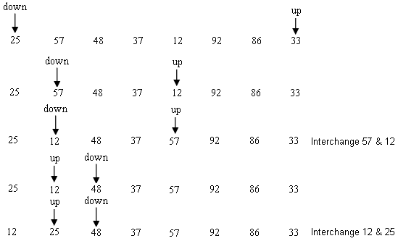

Split into two partitions as given below.
Perform quick sort with each partition and at the end we will the sorted array.

Program 4.4
Void quick_sort ( int a, int m, int n)
{
if(m<n)
{
i=m; j=n+1; k=a[m];
do{
do
i++;
while(a[i]<=k && i<n);
do
j--;
while(a[j]>k);
if (i<j)
swap(a[i],a[j]);
}
while(i<j);
swap(a[j],a[m]);
quitch_sort(a,m,j-1);
quick_sort(a,j+1,n-1);
}//if
}
Time Complexity
Case1:
Assume that the file is of size n, which is a power of 2. And each time after fixing an element the file is divided into equal partitions.
Hence, n = 2^{m}
m = log₂n.
No. of comparisons = n + 2*(n/2) + 4*(n/4) + … +n*(n/n).
= n + n + …. + n (m times)
= n * m
= n * log₂n
= O(nlog₂n).

CaseI1 (worse case):
Assume that each time after fixing an element the file is divided into a smaller partition and a bigger partition. Say, during i^{th} partition it is divided into 1 and (i-1).
No. of comparison = n + (n-1) + (n-2) + … + 2
= n(n-1)/2 – 1
= O(n²)

4.4 Insertion Sort

Method
- Insert the element into a sequence of ordered elements, e₁,e₂..e_{i} such that resultant i+1 are also ordered.

e.g., Consider 6 elements 25,10,6,32,17

Fix 10 in the current position by shifting all elements greater than 10 occurring before 10 in the list.

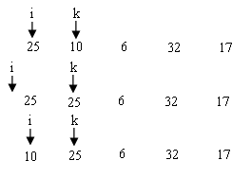
Fix 6 as given below
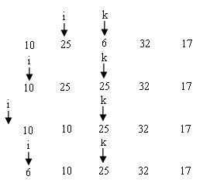
Similarly fix all the other elements.

Program 4.5
Void insertion_sort ( int x[], int n)
{
int i,k,y;
for(k=1; k<n; k++)
{
y = x[k];
for(i=k-1; i>=0 && y<x[i]; i--)
x[i+1] = x[i];
x[i+1] = y;

}
}

Time Complexity

CaseI (Best case – List is already sorted):
One comparison on each pass. Hence complexity is O(n).

CaseII (Worse case – List sorted in reverse order):
No. of comparison = n + (n-1) + (n-2) + … + 2
= n(n-1)/2 – 1
= O(n²)).

4.5 Shell Sort

Method
- Sort sub files of original file.
- Sub files contain every k^{th} element of the original file.
- After first sort, select another value for k which is lesser than the previous value. Continue this till the value of k is 1.
- i^{th} element in the j^{th} sub file can be addressed as x [(i-1)*k + j-1]

Program 4.6
Void Shell_sort ( int x[], int n, int incrmts[], int numinc)
{
int incr,k,y;
for(incr=0; incr<numinc; incr++)
{
span=incrmts[incr];
for(j=span; j<n; j++)
{
y=x[j];
for(k=j-span; k>=0 && y<x[k]; k-=span)
x[k+span] = x[k];
x[k+span] = y;
}
}
}

Time Complexity
- Insertion sort is efficient on sorted file.
- If n is small, O(n²) is better than O(nlog₂n). Because, programs with time complexity O(nlog₂n) will be more complicated than one with time complexity O(n²).
- Since value of span is high at start, size of the sub file will be small. Hence insertion sort is faster. Even though the size of the sub file is increasing after each pass, as the array is getting more and more sorted, it algorithm will give better performance.
- If appropriate increments are selected, Shell sort gives a time complexity of O(n(log₂n)²). In all other cases its complexity is O(n^{1.5}).

4.6 Merge Sort
- Sort two sub files into a single array.
- Select the size of the sub file as multiples of 2, starting from 2⁰.

e.g., Consider 8 elements 25,57,48,37,12,92,86,33

Merge sub arrays as given below.

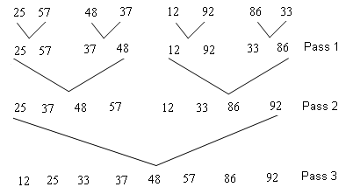

Program 4.7
Void Merge_sort ( int x[], int n)
{
int aux[],i,j,k,l₁,u₁,l₂,u₂,size;

size = 1;
while(size<n)
{
l₁=0; k =0;
while(l₁+size<n)
{
l₂ = l₁+size; u₁= l₂-1;
u₂ = (l₂+size-1<n) ? l₂+size-1 : n-1;
for(i=l₁,j= l₂; i<= u₁ && j<= u₂; k++)
if (x[i]<=x[j])
aux[k] = x[i++];
else
aux[k] = x[j++];
for(; i<= u₁; k++)
aux[k]=x[i++];
for(; j<= u₂; k++)
aux[k]=x[j++];
l₁= u₂+1;
}
for(i= l₁; k<n; i++)
aux[k++]=x[i];
for(i=0; i<n; i++)
x[i]=aux[i];
size *=2;
}
}

Time Complexity
There are log₂n passes, each with n comparisons. Hence the complexity is O(nlog₂n) for all cases. But Quick sort is considered better than Merge sort even though its worse case complexity is O(n²) because Merge sort has twice as many assignment as Quick sort. Also Merge sort needs additional space to store the auxiliary array.

4.7 Radix Sort
- Based on the values of the actual digits in the positional representation of the numbers being considered.
- Partition the numbers into 10 groups depending on the least significant positional value in the order of there arrival. Place the element in the queue for the corresponding digit.
- Restore the elements in each queue to the original file starting with queue for number 0.
- Continue the process till the most significant position.

Program 4.8
Void Radix_sort ( int x[], int n)
{
int front[10],rear[10];
struct{
int info;
int next;
}node[10];
int exp,first,i,j,k,p,q,y;

for(i=0; i<n-1; i++)
{
node[i].info = x[i];
node[i].next = i+1;
}
node[n-1].info = x[n-1];
node[n-1].next = -1;
first = 0;
for(k=1; k<3; k++)
{
for(i=0; i<10; i++)
{
front[i] = -1;
rear[i] = -1;
}

while(first != -1)
{
p = first;
first = node[first].next;
y = node[p].info;
exp = power(10,k-1);
j = (y/exp)%10;
q = rear[j];
if(q==-1)
front[j] = p;
else
node[q].next = p;
rear[j] = p;
}
for(j=0; j<10 && front[j]==-1; j++);
first = front[j];
while(j<=9)
{
for(i=j+1; i<10 && front[i]==-1; i++);
if(i<=9)
{
p=i;
node[rear[j]].next = front[i];
}
j=i;
}
node[rear[p]].next = -1;
}
for(i=0; i<n; i++)
{
x[i] = node[first].info;
first = node[first].next;
}
}

Time Complexity
- Depends on number of digits in the numbers.
- Outer loop executes m times and the inner loop executes n times, once for each element. Hence the complexity on O(mn) or O(n²).

4.8 Heap Sort
- Create a complete binary tree for the elements given.
- Convert the tree to a heap. i.e., a complete binary tree with the property that value of each node is at least as large as value of the child nodes.
- Output sequence is generates in decreasing order by successively outputting the root and reconstructing the remaining into a heap.
- Time complexity of heap sort is O(nlog₂n)

e.g., Consider 10 elements 26,5,77,1,61,11,59,15,48,19.

Form a complete binary tree with these elements as given below.
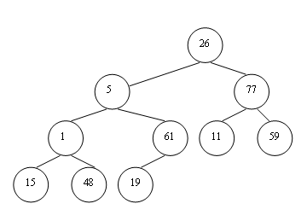

Create a heap by starting from the last parent.

Adjusting 1
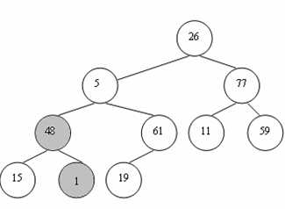

Adjusting 5

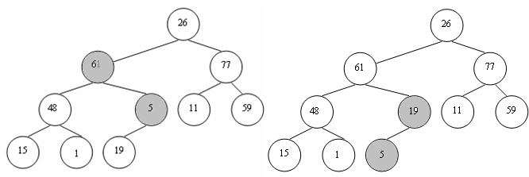

Adjusting 26
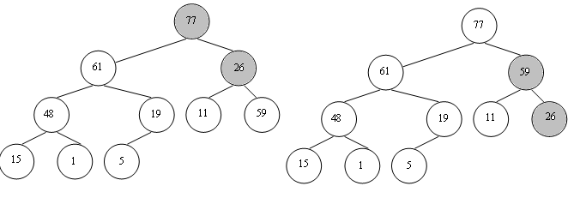

Interchange 77 and 5 (fix 77).
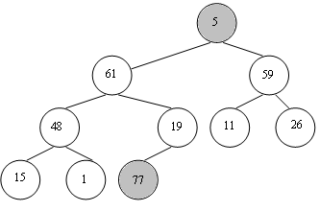

Adjust 5 which is the current root

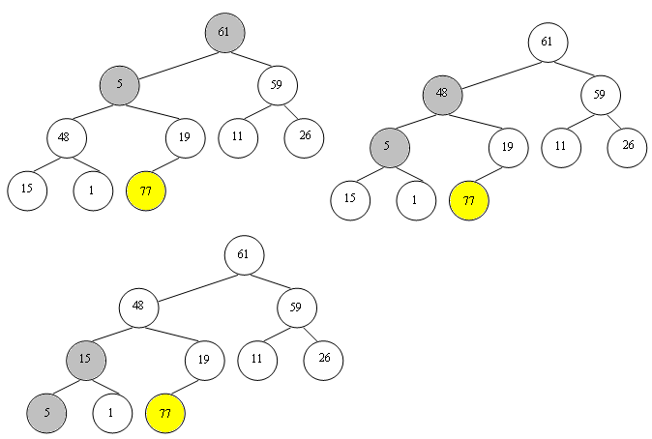

Interchange 61 and 1 (fix 61).
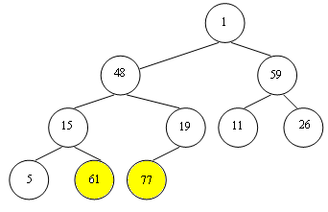

Continuing the same, we get the final tree as given below.
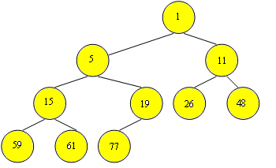

Program 4.9
Void Heap_sort ( int x[], int n)
{
int i;
for(i=ndiv2; i<=1; i--)
adjust(a,i,n);
for(i=n-1; i<=1; i--)
{
interchange(a[i+1],a[1]);
adjust(a,1,i);
}
}

Void adjust(int a[], int i; int n)
{
int j,k,done,r;
done = 0;
r = a[i];
k = a[i];
j = 2*i;
while(j<=n && !done)
{
if (j<n)
if(a[j] < a[j+1])
j = j+1;
if (k>=a[j])
done = 1;
else
{
a[j div 2] = a[j];
j = 2*j;
}
}
a[j div 2] = r;
}

Time Complexity

At each step of the "adjust" algorithm, a node is compared to its children and one of them is chosen as the next root. We drop one level of the tree at each step of this process. Since this is a complete binary tree, there are at most log(n) levels. Thus, the worst case time complexity of "adjust" is O(log(n)). In the Heapsort algorithm, we simply use "adjust" (n/2 times in Phase 1 and (n-1) times in Phase 2. Thus, HeapSort has a worst-case time complexity of O(n*log(n)).

