Lecture 1

1) Synopsis: LOGIC FAMILIES

2) Target: At the completion of this lecture you should be able to answer questions like (a) Give an introduction to logic families (b) Different classification of logic families. You should also be able to explain (a) characteristics of Digital ICs
3) Introduction
As stated above, in this lecture, we will give an introduction to logic families Once we finish this topic we will move towards topics like classification of digital IC and their characteristics .
4) Revision / Prerequisites
You should have basic knowledge about fundamentals of physics and basic electric circuit theory.
5.1) Concept 1- Logic families and their classification
Various digital functions are being fabricated in a variety of forms using bipolar and unipolar technologies. A group of compatible ICs with the same logic levels and supply voltages for various logic functions have been fabricated using a specific circuit configuration which is referred to as a logic family.
Logic circuits make use of logic gates such as NAND and NOR for performing logic operations governed by Boolean Algebra. Logic gates are manufactured in a variety of configuration; structures and technologies. All of these gates are now available as integrated circuits.
Depending on the number of devices integrated on a substrate, we have the following classification for digital logic gates:
1. Small scale integration (SSI) - this consists of a maximum of 100 discrete devices, or 12 logic gates on a single substrate.
2. Medium scale integration (MSI) - In each MSI IC, we have 100 to 1000 components or
12 to 100 gates on a chip.
3. Large scale integration (LSI) - these chips contain 1000 to 10,000 components or 100 to 10000 gates on a single chip. Example: ROM, RAM.
4. Very large scale integration (VLSI) - These chips contain 10,000 to 1, 00,000 or 1000 to 10,000 gates per IC chip. Example 8085, 80356 (Micro processor chips)

5.2) Bipolar logic families

The main elements of a bipolar IC are resistors, diodes and transistors. Basically there are two types of operation in bipolar ICs- Saturated and nonsaturated.
In saturated logic, the transistors are driven to saturation and in the case of non saturated logic; the transistors are not driven into saturation.

The saturated bipolar logic families are:
1. Resistor – transistor logic (RTL)
2. Direct coupled transistor logic (DCTL)
3. Integrated injection logic (I²L)
4. Diode – transistor logic (DTL)
5. High –threshold logic (HTL)
6. Transistor –transistor logic (TTL)

The non-saturated bipolar logic families are:
1. Schottky TTL
2 .Emitter coupled logic (ECL)

5.3) Unipolar logic families

MOS devices are unipolar devices and only MOSFETs are employed in MOS logic circuits. The MOS logic families are :

1. PMOS
2. NMOS
3. CMOS

In PMOS only p-channel MOSFETs are used while in NMOS only n-channel MOSFETs are used and in complementary MOS (CMOS), both p and n channel MOSFETs are employed and are fabricated on the same silicon chip.

5.3)Characteristics of digital ICs
With the widespread use of ICs in digital systems and with the development of various technologies for the fabrication of ICs, it has become necessary to be familiar with the characteristics of IC logic families and their relative advantages and disadvantages. Digital ICs are classified either according to the complexity of the circuit ,as the relative number of individual basic gates it would require to build the circuit to accomplish the same logic function or the number of components fabricated on the chip.
The various characteristics of digital ICs used to compare their performance are
1. Speed of operation
2. Power Dissipation
3. Figure of merit
4. Fan out
5. Current and voltage parameters
6. Noise immunity
7. Operating temperature range
8. Power supply requirements
9. Flexibilities available
6.0) Summary:In this lecture we had a brief introduction to various logic families and their classification and characteristics.
7.0) Exercise questions

1. Give the characteristics of digital ICs
2. . Explain the different classification of logic families.
8.0) Programming / Computational assignments
Lecture 2

1) Synopsis: Characteristics of Digital ICs

2) Target: At the completion of this lecture you should be able to answer questions like (a) What is meant by Noise margin (b) Explain the terms fan in and fan out.
3) Introduction
In lecture1 we have seen the different characteristics of logic families.
There are several properties associated with logic gates that determine the environment in
which a digital system can operate as well as introduce constraints on its topological
structure.
These include
• Noise margins
• Fan-out
• Fan in
In this lecture we will explain these properties in detail.
4) Revision / Prerequisites
You should have attended lecture1 in order to understand this lecture.
5.1) Concept1:- Noise margin
For performance purposes, gate circuits are designed so that V _{H(min)} is different at the input and output terminals of a gate. That is the minimal signal value that is acceptable as logic -1 at the input of gate is different from the minimal logic -1 signal value that a gate produces at its output. A similar situation also occurs for V _{L (max)} .
Thus, manufacturers normally state a V _{IL (max}) , V _{IH (min)} , V _{OL(max)} and V _{OH(min)} in the gate specifications. That is the manufacturer guarantees that any input voltage less than
V _{IL(max)} is recognized by the gate as corresponding to a low range (logic 0) voltage input.
On the other hand, any input voltage greater than V _{IH (min)} is recognized by the gate as
corresponding to a high range (logic 1) voltage input. Further more, the manufacturer guarantees that the low range output voltage of the gate does not exceed V_{0L(max)} and that the high range (logic-1) voltage output of the gate does exceed V _{OH(min)} .
Consider the effect of connecting the output of a gate to another gate as shown below.
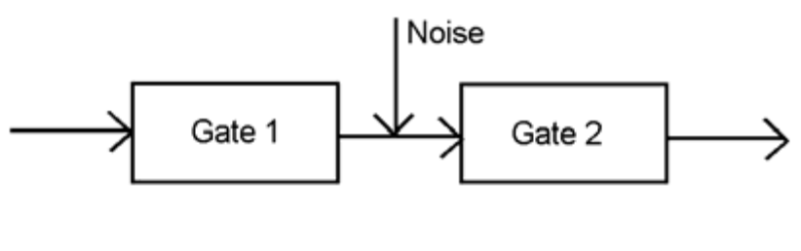
Noise is induced between the gates
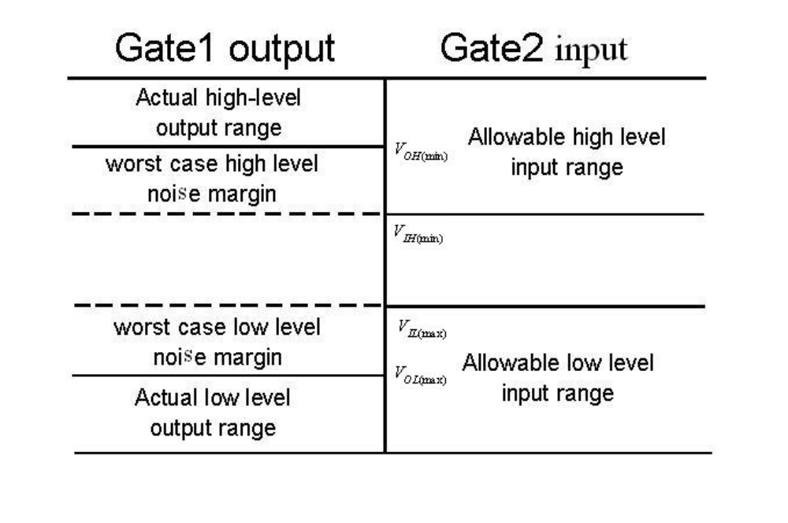 Any additive noise induced between the gates less than V _{IL (max}) - V _{OL(max)} does not affect the logic behavior of the two gates in cascade. This is called the worst-case low level noise margin. In a similar manner, any subtractive noise induced between the gates less than V _{OH(min)} - V _{IH (min)} does not affect the logic behavior of the two gates in cascade. This is called the worst case high level noise margin. Noise margins are a measure of digital circuit’s immunity to the presence of induced electrical noise.
Actual low level noise margin
NM_{L} = V _{IL (max}) –V_{OL1}
V_{OL1} is the actual low level output voltage of gate 1 and V_{OL1} ≤V _{OL(max)}
Actual high level noise margin
NM_{H} = V_{OH1} - V _{IH(min})
V_{OH1}– actual high level output voltage of gate 1 and V_{OH1} ≥ V _{OH(min)}
5.2) Concept2- Fan Out:
When loads are connected to the output of a digital circuit, the output signal levels are affected. This is a consequence of the fact that there is a current flow between gates and hence a power consumption. For reliable operation the amount of this current is limited. The number of circuits (measured in terms of similar gates in the same logic series) connected to the output of a digital gate as loads is called the fan-out of the gate. The maximum number of such loads that can exist without impairing the normal operation of a gate is referred to as the gates fan-out capability.
5.3) Concept3-Fan in
Fan-in is the number of inputs of an electronic logic gate. Logic gates with a large fan-in tend to be slower than those with a small fan-in, because the complexity of the input circuitry increases the input capacitance of the device.
6.0) Summary
In this lecture we have seen 3 major characteristics of a digital IC such as noise margin, fan in and fan out.. We have also defined low level and high level noise margin.
7.0) Exercise questions
1. What do you mean by noise margin?
2. Explain fan in and fan out.

8.0) Programming / Computational assignments

Lecture 3

1) Synopsis: Characteristics of Digital ICs

2) Target: At the completion of this lecture you should be able to answer questions like (a) What is meant by propagation delay (b) Explain power dissipation in an IC.
3) Introduction
In lecture1 we have seen the different characteristics of logic families.
There are several properties associated with logic gates that determine the environment in
which a digital system can operate as well as introduce constraints on its topological
structure.
These include
• Propagation delay
• Power dissipation
In this lecture we will explain these properties in detail.
4) Revision / Prerequisites
You should have attended lecture1 in order to understand this lecture.
5.1) Concept1:- Propagation Delay(Speed of operation)
Digital signals do not change nor do circuits respond instantaneously. For this reason, there is a limitation to the overall speed of operation associated with a gate. Signals do not go between their logic –0 and logic -1 values in zero time. In addition, the effect of a change at the input terminal does not appear immediately as a change at the output terminal. Rather, owing to the physical behavior of the electronic components in the gate, there is a time delay before the output changes.
The waveforms at the input and output terminals of a NOT gate are shown below.
Using a specified reference point, say 50 percent point, on the rise and fall of the signals,
V_{ref} , two delays are indicated in the waveforms below. These are referred to as propagation delays.
t _{p} HL– Time required for the output signal to change from its High level to Low level as a consequence of an input signal change.
t _{p} LH - time required for the output signal to change from its Low level to High level as a consequence of and input signal change.
These two delay times are in general, not equal.
As a general measure of the response speed of a gate, one frequently uses an average
propagation delay time t _{pd} , which is defined as
t _{pd =} ( t _{p} HL + t _{p} LH ) / 2
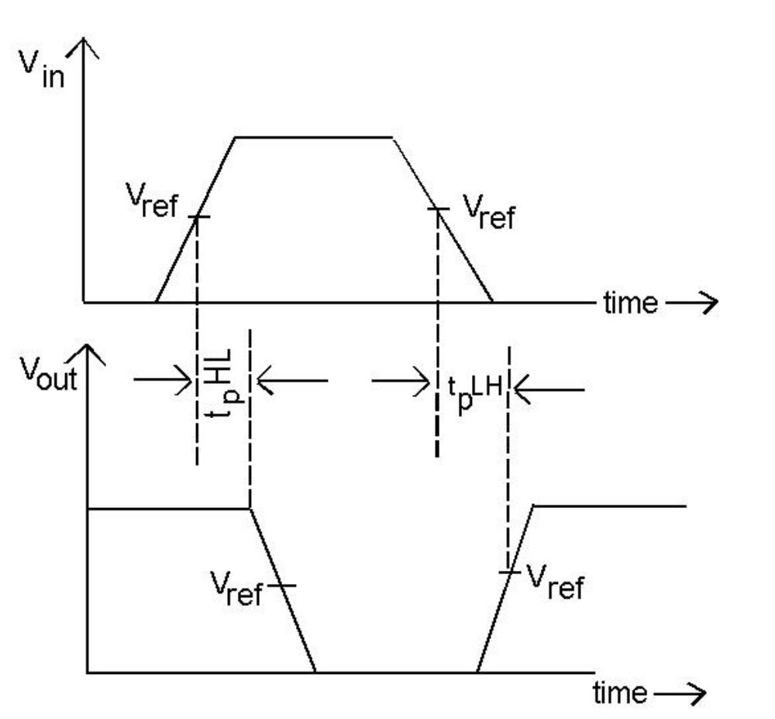

5.2) Concept2:- Power Dissipation
In the course of operation, a digital circuit consumes power as a result of the flow of
current.There are two components to this power dissipation
1. Static power dissipation – occurs as a consequence of the flow of currents while
the circuit is in its steady state.
2. Dynamic power dissipation – occurs as the result current flow due to changes of
the input signals to the circuit.
In both cases, the necessary currents must be provided by the power supply of the digital
system. It is desirable in a digital system to have gates with low power dissipation and high speed of operation (ie low propagation delay times). Unfortunately, the faster a circuit operates, the greater it power requirements. For this reason, a figure of merit of a circuit is its delay-power product, which is the product of the propagation delay time and the power dissipation of the gate.
.
6.0) Summary
In this lecture we have seen the power dissipation and propagation delay of an IC.
7.0) Exercise questions
Explain how propagation delay affects the speed of operation of an IC.
Explain the term propagation delay.

8.0) Programming / Computational assignments

Lecture 4

1) Synopsis: Diode – Transistor Logic (DTL)

2) Target: At the completion of this lecture you should be able to answer questions like (a) Explain the working of a DTL NAND gate.

3) Introduction
In the previous lecture we have seen the characteristics of digital ICs. In this lecture we will see one of the saturated bipolar logic family .i.e. DTL or Diode Transistor Logic. In particular we will explain the working of DTL NAND gate.

4) Revision / Prerequisites
You should have a basic idea of the working of a transistor and diode.You must also know the working of a NAND gate.

5.1) Concept 1- Diode – Transistor Logic (DTL)

Diode – Transistor logic (DTL) was the forerunner to the popular transistor – transistor logic (TTL). Although DTL is no longer in use, an understanding of DTL aids in the understanding of TTL.
The basic DTL NAND gate consists of 3 sections
o An input diode AND gate
o A coupling circuit
o An output inverter
To understand the general operations of the gate, first assure that at least one input x₁, or x₂ is low (at 0.2 V) and any inputs that are high are at 5 V. Also assume that no loads are connected to the output of the DTL gate. Each low input diode is forward biased due to the power supply Vcc. Therefore, the voltage at point P is Vin + VD (On) = 0.2 + 0.7 = 0.9 V. Current flows from Vcc, through R, and through each forward biased input diode. Since the voltage at point P is only 0.9 V, it is not enough to forward bias D1 and D2. A voltage of at least 1.4 V is required to turn on D1 and D2. No current flows through D1 and D2 and correspondingly no current flows into the base of Q1. The net result is that transistor Q1 is in cutoff, no current flows through R2 and the voltage at point ‘f’ is Vcc = 5 V. This situation corresponds to the first three rows of the voltage table.Now consider the case when both the input voltages are high at 5 V. The two input diodes are reverse biased and off. When the voltage at point P gets to 1.4 V, diodes D1 and D2 start to conduct current through R3 to ground. When the voltage at P is sufficiently high to overcome the base-emitter junction voltage of transistor Q1, the base current flows and the transistor starts to conduct. The circuit is designed so that the transistor Q1 operates in saturation.
Voltage at point P = V_{DI(on)} + V_{D2(on)} + V_{BE(sat)} = 0.7 + 0.7 + 0.7 = 2.1 V
Although some current flows through R3, most of the current flows into the base of transistor Q1 to guarantee saturation. With transistor Q1 saturated, the voltage at the output the gate, ie point ‘f’ V_{CE( sat)} =0.2 V. This corresponds to the last line in the voltage table. Resistor R3 is used to improve the speed of performance of the gate. When transistor Q1 is in saturation, it is necessary to remove the minority charge carriers
from the base region of the transistor before it can go into cutoff. As a result of removing these charge carriers, current flows away from the base terminal. Resistor R3 provides a path to ground for this current. If resistor R3 were not present, then it would be necessary to remove the charge carriers by a flow of current though diodes D1 and D2 in the reverse direction. Since current does not flow readily in that direction, the switching time of transistor Q1 would be relatively high. Thus the smaller the value of R3, the faster the output transistor can switch. There is a limit, however, to how small the value of R3 can be made. When transistor Q1 is in saturation, current is diverted from base to resistor R3.
But the fan-out capability of the gate is dependent on the base current. Hence by decreasing R3, the fan out capabilities of the gate is also decreased.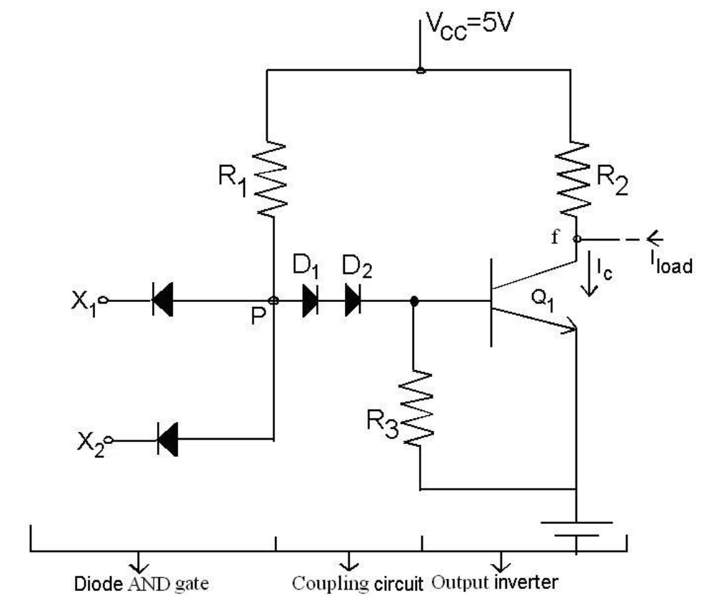

V_{X1} | V_{X2} | V_{f}
L | L | H
L | H | H
H | L | H
H | H | L

L = 0.2 V
H = 5 V

5.2) Concept 2-Loading Effect
For DTL gates, the fan-out of a fact is limited by the amount of current the output
transistor stage is capable of sinking, since it must accept current from the input diodes of
the load gates. Assume that the DTL gate has N identical DTL gates connected to it output as loads. First consider the case when the output of the driving point f , is high at 5 V. This occurs when the transistor Q1 is in cutoff. Therefore, the input diodes of the loads connected to point ‘f’ are reverse biased and have the currents I₁ ……………….I_{N} are zero and no current flows between the driving and load gates. Thus there is no significant loading effect upon the driving gate.Now consider the situation when the output of the driving gate, point f, is low. In this case the transistor Q1, for proper operation is in saturation and the voltage at point f is V _{CE (sat)} = 0.2V. The load diodes connected to point ‘f’ are forward based and a net current of I load = I₁ +…………I_{N} flows from the load network toward the driving gate. This current along with the current component IR2, flows into the collector of transistor Q1. Transistor Q1 stages in saturation as long as β _{F} I _{B} > I _{c} where I _{c} = I _{R2} + I _{load}
Thus for a given β _{F} and I_{B} there is a limit in the number of permissible loads that allows
transistor Q₁ to remain in saturation.
6.0) Summary
In this lecture we have seen the working of a DTL NAND gate.
7.0) Exercise questions
1. Explain the working of a DTL NAND gate.
2.Explain loading effect.

8.0) Programming / Computational assignments

Lecture 5

1) Synopsis: Transistor Transistor logic
2) Target: 2) Target: At the completion of this lecture you should be able to answer questions like (a) Explain the working of a TTL. (b)What are the advantages and disadvantages of TTL and (c) What is meant by wired logic.

3) Introduction
In the previous lecture we have seen the working of DTL. In this lecture we will see another saturated bipolar logic family .i.e. TTL or Transistor Transistor Logic. We will also explain the advantages and disadvantages of TTL. We will also explain wired logic.

4) Revision / Prerequisites
You should have a basic idea of the working of a transistor and diode.You must also know the working of a NAND gate.

3) Introduction
In this lecture we will explain the working of a TTL and its advantages and disadvantages.
4) Revision / Prerequisites
“You should have attended lecture 4 inorder to understand the concepts given in this book”.

5.1) Concept:1 TTL:
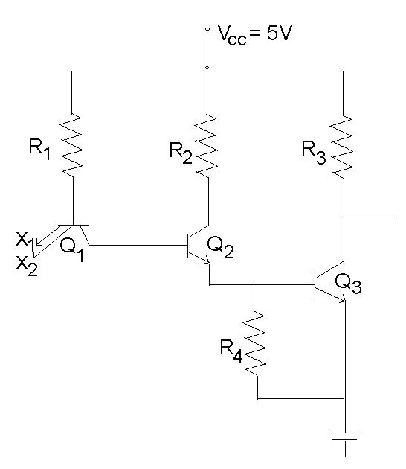
Basic two input TTL NAND Gate
The TTL NAND-gate is a modification of the DTL NAND gate. The first difference is the use of a multi-emitter npn transistor as the input stage in place of the diode AND gate. The multi-emitter junction can be regarded as a collection of pn junction diodes whose
anodes are connected together. From a steady state point of view, this configuration with resistor R1 essentially forms a diode AND gate. The two coupling diodes D1 and D2 of DTL NAND gate are replaced by the Base Collector junction of transistor Q1 and the Base emitter junction of transistor Q2. The final stage, consisting of a transistor inverter is same for both.First assume that both inputs are high at 5V. This causes the base emitter junction to be reverse biased. (for Q1). Like wise, the Base – Collector of Q1 and Base emitter of Q2 and Q3 forward biased. The circuit is designed so that transistors Q2 and Q3 saturate. This causes the out put of the gate to become VCE3 (sat) =0.2V which corresponds to the low level logic value.
Voltage at base Q ₃ = V _{BE3(sat )} =0.7V
Voltage at base Q ₂ = V _{BE3(sat} + V _{BE2(sat )} =0.7+0.7=1.4V
Voltage at base Q ₁= V _{BE3(sat} + V _{BE2(sat )} + V _{BC1 ON} =0.7+0.7+0.5=1.9V
As a consequence of the Base emitter junction of Q1 being reverse biased and its base collector function being forward biased the transistor Q1 is operating in its inverted active mode. Next consider the situation when at least one input is low at 0.2V. The corresponding base emitter junction of transistor Q1 is forward biased.
Voltage at base of Q1= Vin+ V_{BE (sat)} =0.2+0.7 =0.9V
This voltage is insufficient to support the base collector junction drop of Q1+ base emitter junction drops of Q2 +Q3. Therefore Q2 and Q3 are in cut off and the out put voltage is 5V. The transistor Q1 is in saturation.
5.2) CONCEPT2:-Advantages of TTL Gates:

1. It is the fastest saturating logic family. The propagation delay time of a standard TTL gate is approximately 10 ns.
2. It has good noise immunity. Typical noise margin is about 0.4V
3. Compatible with other logic families.
4. Good fan out, can drive up to10 gates.
5. Almost all functions are available in TTL family of gates.
6. Low out put impedance for high/ low states.
5.3) Concept:3 Disadvantages of TTL gates

1. VLSI circuits are not possible because of isolation problems.
2. Power dissipations is much higher than MOS gates.
3. Cost is higher than NMOS/CMOS, when MSI and LSI gates are considered.
4. It generates transient voltages at switching instants.
5.4) CONCEPT4:- Wired Logic

With some logic gate it is possible to connect their outputs together so as to achieve logic behavior at the connection. This is known as wired logic. Consider two TTL NAND-gates. If the outputs are connected together as shown below, then the wired output appears at the collectors of the parallel connection of the two output transistors.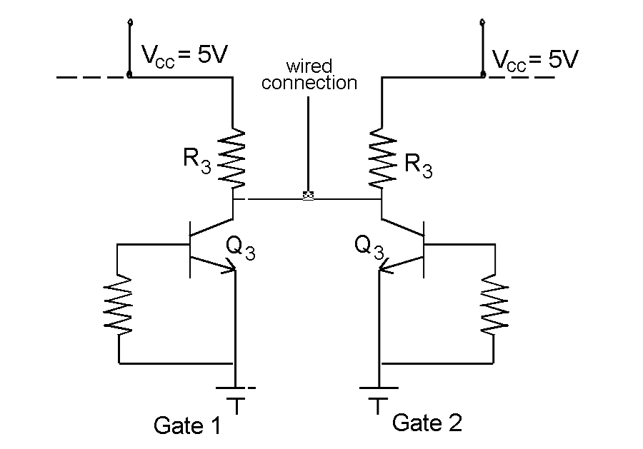 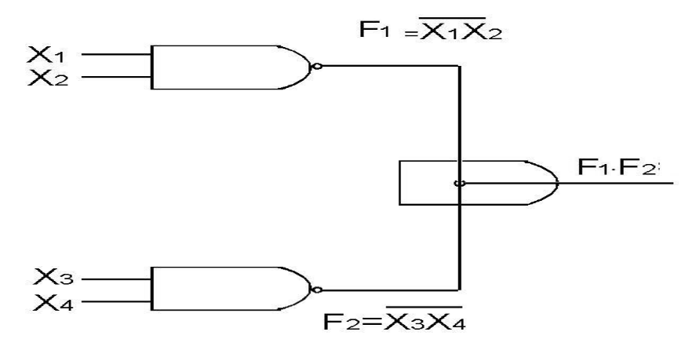

The wired output is high if both output transistors are in cutoff. If at least one output transistor is in saturation, then the wired output is at relatively low voltage
V_{CE3(sat)} = 0.2V
Thus the voltage at the wired connection is high if and only if the outputs of both of the
individual gate are high.Therefore, an AND operation is achieved at the wired connection.
6.0) Summary:In this section we have described a basic TTL NAND gate.We have also seen the advantages and disadvantages of TTL.
7.0) Exercise questions
1.Explain the working of a TTL..
2.What is meant by wired logic?

8.0) Programming / Computational assignments
1.Explain the advantages and disadvantages of TTL.
Lecture 6

1) Synopsis :- TTL with Totem – Pole Output

2) Target: At the completion of this lecture you should be able to answer questions like (a)what is meant by totem pole………(b)What are the advantages of using a totem pole(c)Explain the working of a TTL with totem pole output. You should also be able to explain (a) Why TTL is faster than DTL?

3) Introduction
In lecture 5 we have seen the working of a TTL NAND gate. In this lecture we will see a TTL with totem pole output. We will also explain why TTL is faster than DTL.

4) Revision / Prerequisites

You should have attended lecture5 in order to understand this lecture.

5.1) Concept 1:- TTL with Totem – Pole Output

The speed of operation of a logic gate is also dependent upon the parasitic output capacitance.

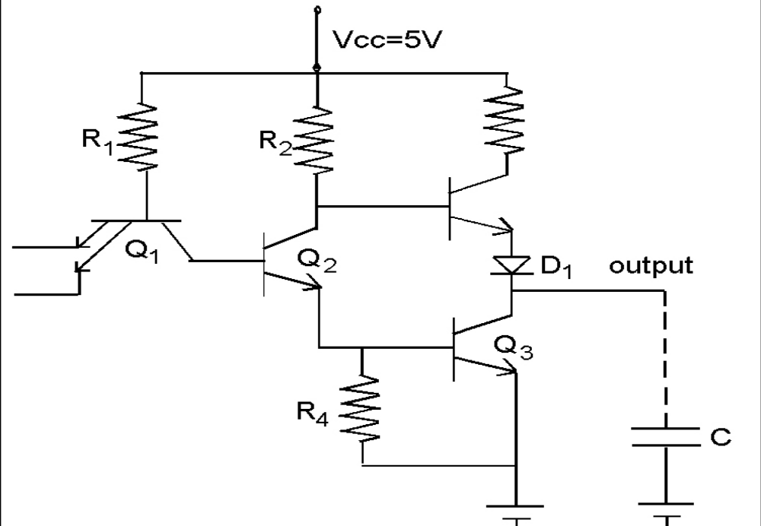.
This capacitance appears as the dotted capacitor C in the figure above and is associated with the wiring capacitance, input diode capacitance of the load gate and the collector emitter capacitance of transistor Q3. The rate at which this parasitic capacitor is charged and discharged affects the switching time of the driving gate. The discharging of capacitor C occurs when the output of the gates goes from its high value to its low value. i.e. Q3 goes cutoff to saturation. The discharge path is through Q3 with a time constant R_{Q3 (on)} C, where R_{Q3 (on)} C is the small conducting resistance of transistor Q3. On the other hand, the capacitor C must be charged when the output of the gate goes from
its low value to high value. In this case, the charging path is through resistor R3 and time constant is R₃C. By reducing the value of R3, output low to high switching time of the gate is decreased. However, a low value of R3 increases the power consumption of the circuit when the output is low. [V_{CC}-V_{CE3sat}] ² /R₃
It is desirable to have R3 as small as possible while the output is switching from its low to high value in order to have a small RC time constant. And have R3 as large as possible when the gate is in its steady state with a low output in order to have low power dissipation. One way this is achieved is by the use of an active pull-up circuit known as a totem pole output. The output is high when Q4 is ON. The collector resistance of resistor R3, the saturation collector emitter resistance of transistor Q4 and the ON resistance of diode D1 along with the parasitic capacitance determine the charging rate of the parasitic capacitance. This time constant is low. The output quickly changes from its low value to its high value. The output is low when Q3 is ON – Q4 and Diode D1 are OFF. With transistor Q4 in cutoff, no current flows through the low valued resistor R3. As a result, the objective of having no power dissipation in this section of the circuit has how been achieved when the output of the gate is low. The circuit is designed in such a way that both Q3 and Q4 can never be on at the same time. When Q3 or Q4 conducts, the output impedance is low.

5.2) Concept 2:- Why TTL is faster than DTL?

When both inputs are high, transistor Q1 is not saturated. (Inverted active mode)
Therefore it is capable of switching quite rapidly. The transistors Q2 and Q3 cannot come out of saturation until the stored charges are removed from their bases. Then when at least one input goes low to 0.2V the base of transistor Q1 quickly goes to 0.9V while the collector remains at 1.4V. Therefore, at the time of switching, the base collector junction of Q1 is reverse biased and the base emitter junction is forward biased. This causes the transistor Q1 to enter its normal active mode, which permits a large collector current to flow. This collector current corresponds to the removal of the stored charges of transistor Q2 and Q3. It is not until these stored charges are removed that transistor Q1 enters saturation. The net effect is the quick removal of the stored charges and correspondingly, rapid switching of transistors Q2 and Q3 from saturation to cutoff. Propagation delay times are one tenth of that in DTL.
6.0) Summary
In this lecture we have seen the working of a TTL with totem pole output. We have seen how totem pole stage affects the speed of operation of TTL.
7.0) Exercise questions
1.Explain the working of a TTL with totem pole output.

2.Explain how totem pole stage affects the speed of operation of TTL.

8.0) Programming / Computational assignments

Lecture 7

1) Synopsis: Open collector output and tri state output TTL
2) Target: At the completion of this lecture you should be able to answer questions like (a) What do you mean by open collector output (b)What is tri state output. 3) Introduction
In lecture 6 we have seen a TTL with totem pole output. In this lecture we will see TTL with open collector output and tri state output.

4) Revision / Prerequisites

You should have attended the lecture 5 inorder to understand the concepts given in this lecture.

5.1) Concept #1-Open collector output

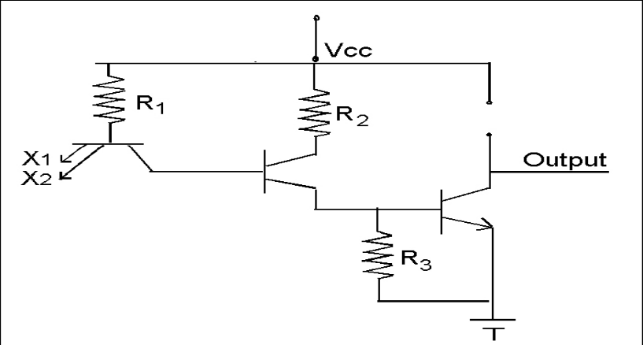

The resistors R3 from the two gates in the above figure are placed in parallel when the
gate outputs are connected. This results in an effective resistance of R3/2 and therefore increases the power dissipation of the gate whose output transistor Q3 is in saturation. For this reason, TTL gates without resistor R3 are available commercially specifically for
applications in which the wired AND capability is desirable. This is known as Open-Collector TTL. Of course, after the outputs of open-collector TTL gate are connected together in a network, a single collector resistor, referred to as a passive pull-up resistor must be added externally.
5.2)Concept#2-Tri-state output

Wired logic is not permissible with the TTL NAND gate having the totem pole output. How ever for a special situation in which several TTL gate outputs one tied together to a common bus, there is a special form of TTL gate that is used, which retains the advantages of the totem pole output. This is shown below the (the logic symbol) and is called TTL with three-state output.
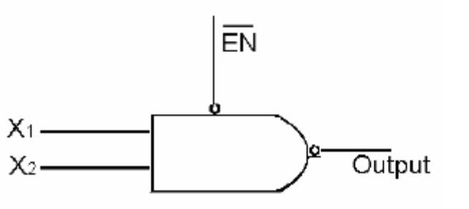
Logic symbol for TTL NAND gate with three state output
Truth Table
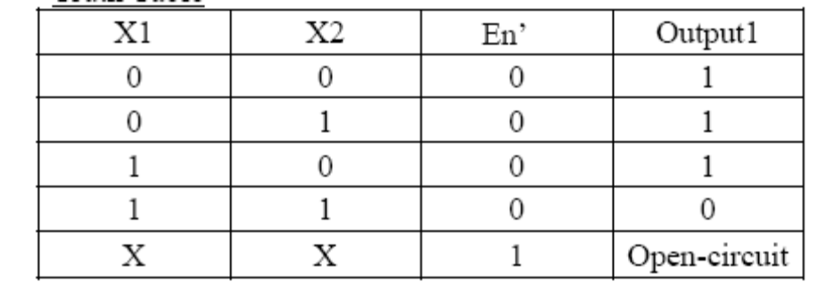
When the control input EN’is at logic 1, both the output transistors Q3 and Q4 of the totem pole are forced into cutoff, with the net effect that the output of the gate appears as an open circuit or equivalently, high impedance. This high impedance condition is regarded as the third state of this TTL gate. When the control input is at logic 0, the output is at logic 0, if the inputs x1 and x2 are both at logic – 1. Transistor Q3 is in saturation and transistor Q4 is cutoff. Also when the control input is at logic-0, the output is at logic-1 if at least one input x1 or x2 is at logic 0. Here transistor Q3 is in cutoff and Q4 is in saturation. The outputs of several three state TTL gate can be wired together if at most only one of the control inputs is allowed to be at logic – 0 at any time. In such a case, the corresponding gate controls the logic output of the wired connection,while all the remaining gates are in their high impedance state

6.0) Summary
In this lecture we have explained the working of a TTL with open collector output and tri state output.
7.0) Exercise questions
1.Explain the working of a TTL with open collector output .

2. Explain the working of a TTL with tri state output.

8.0) Programming / Computational assignments

Lecture 8

1) Synopsis: Emitter-Coupled logic (ECL)

2) Target: At the completion of this lecture you should be able to answer questions like
(a)Explain the working of ECL (b)How ECL works as OR/NOR gate?. You should also be able to explain (a)Characteristics of ECL (b)Uses of ECL.
3) Introduction
In the previous lecture we have concentrated on TTL. In this lecture we will concentrate on one of the non saturated bipolar logic family called the emitter coupled logic. In particular, we will emphasize the following
(a)Working of ECL OR/NOR gate
(b) Characteristics of ECL
4) Revision / Prerequisites
You should have attended lecture 2 in order to understand the concepts given in this book.

5.1) Concept #1- Emitter-Coupled logic (ECL)

Emitter Coupled Logic (ECL) is a Current Mode Logic (CML) or non saturating digital logic family which eliminates the turn off delay of saturated transistors by operating in the active mode. At present, the ECL family has the fastest switching speed among the commercially available digital IC’s.
The basic circuit ECL is a differential amplifier as shown below. (Current Switch)

. 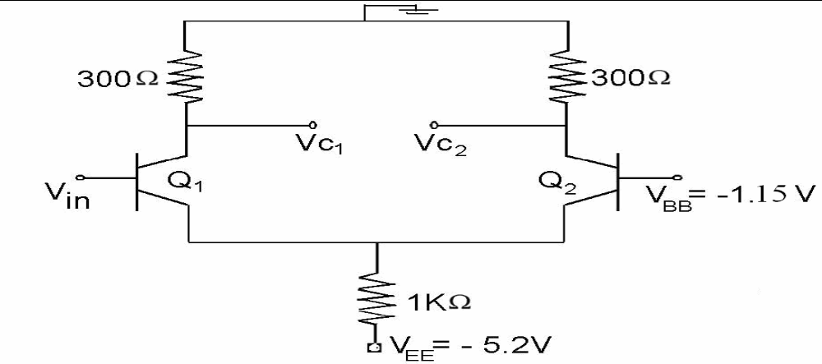

The VEE supply (of – 5.2V) produces a fixed current IE, which remains around 3mA during operation. This current is allowed to flow through Q1 or Q2 depending on the voltage level at Vin. In other words the current switches between the collectors of Q1 and Q2 as Vin switches between its two logic levels of -1.6V (logical 0 for ECL) and -0.7V (logical 1 for ECL). The transistors operate in either their normal active mode or in cut off. The output voltage at the collector of Q2 is in phase with Vin, while the output voltage at the collector of Q1 is out of phase with Vin. Vc1 and Vc2 are the complements of each other and the output voltages are not the same as the input logic levels. Logic level 0 = 0V, Logic level 1 = -0.9V at the collectors of Q1 and Q2. Therefore these output signals from the current switch cannot serve as input signals to another current switch. The output voltage levels are made equal to the input logic level by connecting Vc1 and
Vc2 to emitter follower stages Q3 and Q4 as shown below.
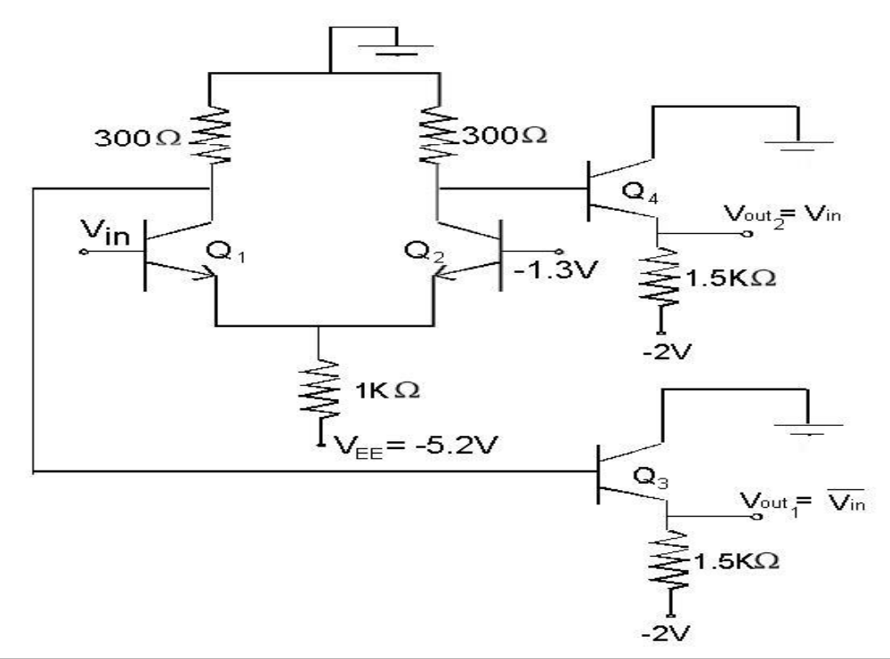

The emitter followers perform two functions
• They subtract approximately 0.7V (base emitter voltage drop of the emitter follower
transistor) from Vc1 and Vc2 to shift the output to the correct ECL logic levels.
• They provide a very low output impedance (typically 7 Ohms), which provides for large
fan out and fast charging of the load capacitance.
This circuit provides low complementary outputs
5.2) Concept #2- ECL OR/NOR Gate
The basic ECL circuit can be used as an inverter if the out put is taken at Vout1.
The basic out put circuit can be expanded to more than one input by making transistor Q1 parallel to other transistors for other inputs. By connecting one more transistor Q in parallel with Q1 as shown below, the circuit becomes a two input ECL OR/NOR gate with inputs A and B.
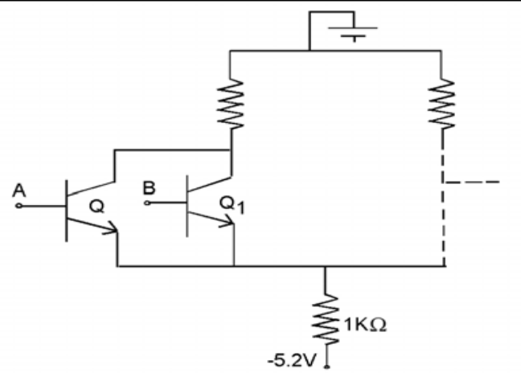

If both the inputs A and B are low, then both transistors Q and Q1 are in the OFF state
while transistor Q2 is in the active region and its collector is in a low state. i.e. Vout2 = Logical 0 and when A= Low and B= Low If either A or B is High, then accordingly either transistor Q or Q1 conducts and the transistor Q2 is in OFF state, resulting in high state at its collector. i.e. Vout2 = Logical 1 (High) when either A or B = High
• Thus Vout2=A+B(OR),Vout1=A+B(NOR)

5.3) Concept #3-ECL Characteristics

1. The logical which are -0.7 V (logical 1) and -1.6V (logic 0) i.e. negative supply voltage
and logic levels.
2. The transistors never saturate i.e. storage delay in ECL circuit is eliminated, and hence
switching speed is very high. Typically propagations delay time is 1ns.
3. Because of low noise margin (250mv) ECL circuits are not reliable in heavy industrial
environments.
4. An ECL logical block usually produces an output and its complement. This eliminates the
need for inverters.
5. Fan outs are typically around 25, owing to the low impedance emitter follower out puts.
Such a small fan out is a limitation compared with other logic families.
6. Power dissipation for a basic ECL gate is 40 mW, some what on the high side. This is
because all the transistors are in the active mode.
7. The total current flow in an ECL circuit remains relatively contact regardless of its logic
state. This helps maintain an unvarying current drain on the circuit power supply even
during switching transitions.
Thus no noise spikes will be internally generated like those produced by TTL totem pole
circuits.
Use - Not as widely used as the TTL and MOS families except in very high frequency
applications, where speed is superior.

6.0) Summary
In this lecture we have mainly concentrated on ECL.We have given due emphasis to ECL OR/NOR gate.We have also discussed the characteristics and uses of ECL.
7.0) Exercise questions
1. Explain the working of ECL OR/NOR Gate.

2.What are characteristics of ECL?

8.0) Programming / Computational assignments

Lecture 8

1) Synopsis: Integrated Injection Logic (I²L)

2) Target: At the completion of this lecture you should be able to answer questions like
(a)Explain the working of I²L (b)What are the advantages and disadvantages of I²L .
3) Introduction
In the previous lecture we have concentrated on ECL. In this lecture we will concentrate on another non saturated bipolar logic family called the integrated injection logic. We will also discuss the advantages and disadvantages of I²L.
4) Revision / Prerequisites
You should have attended lecture 2 in order to understand the concepts given in this book.

5.1) Concept #1- Integrated Injection Logic (I²L)

I²L is a new LSI technique also called Merged Transistor logic (MTL) that uses both up n-p-n and p-n-p bipolar junction transistors to form a large number of IC gates as a chip.
The basic I2 L inverter circuit is shown below:. 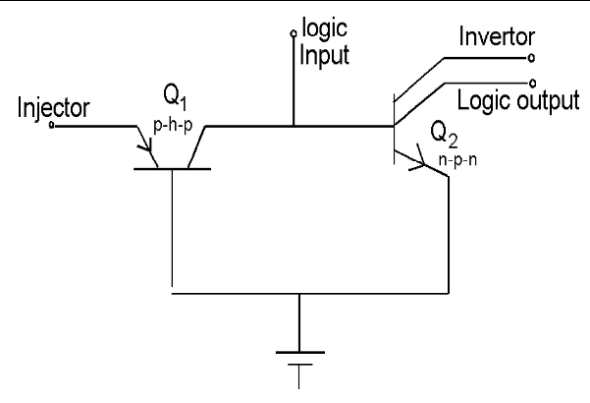

Due to the absence of resistors, the I² L inverter occupies much smaller area than a TTL inverter. The base of Q1 and emitter of Q2 are internally merged. The collector of Q1 and the base of Q2 are merged. Hence only four separate regions are required to form the two transistors. Thus, the entire I2 L gate takes only the space of a single TTL multiple emitter transistor. The p-n-p transistor Q1 as a current source. The multiple collector n-p-n transistor Q2 operation as an inverter. Most of the current leaving from the emitter of Q1 is injected directed into the base of Q2,and hence the emitter of Q1 is known as the Injector.
5.2) Concept #2- Advantages of I²L

1. Since I2 L gates are made up of BJTs, they have high speed of operation.
2. Since only transistors are used for construction, I2 L gates have high packing density, and
are hence suitable for construction of VLSI circuits.
3. Very low power supply requirement.
4. Process steps required are less. Hence cost per gate in low.

5.3) Concept #3- Disadvantages of I²L

1. Very low voltage swing. Only from 0.8V to 0.2V
2. Lower noise margin.
3. External resistance required for proper functioning.
4. Lower packing density than NMOS.
6.0) Summary
In this lecture we have mainly concentrated on I²L.We have also discussed the advantages and disadvantages of I²L.
7.0) Exercise questions
1. Explain the working of I²L Gate.

2.What are advantages and disadvantages of I²L.?

8.0) Programming / Computational assignments

Lecture 9

1) Synopsis: CMOS Logic

2) Target: At the completion of this lecture you should be able to answer questions like
(a)Explain the working of CMOS (b)How CMOS works as an inverter?. You should also be able to explain (a)Characteristics of CMOS (b)Advantages and disadvantages of CMOS.
3) Introduction
In the previous lecture we have concentrated on I²L. In this lecture we will concentrate on one of the unipolar logic family called the CMOS logic. In particular, we will emphasize the following
(a)Working of CMOS inverter
(b) Characteristics of CMOS
(c) Advantages and disadvantages of CMOS
4) Revision / Prerequisites
You should have attended lecture 2 in order to understand the concepts given in this book.

5.1) Concept #1- CMOS Logic

This logic family utilize both n- channel and p- channel enhancement type MOSFETs
within the same circuit. CMOS digital circuits are available as standard small scale and medium scale integrated packages for use in logic design. In addition CMOS circuits are also used for very large scale integrated digital circuits as memories and in microprocessors.
5.2) Concept #2- CMOS Inverter

The basic CMOS inverter is shown below:
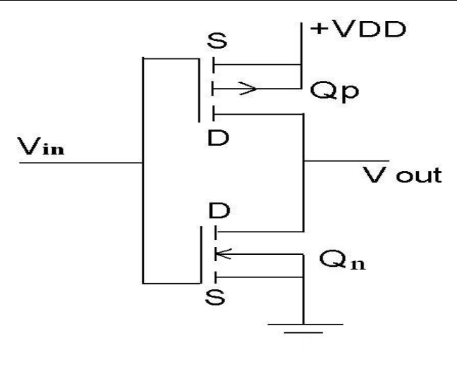

It consists of a p- channel enhancement type MOSFET Qp in series which an n –channel enhancement type MOSFET, Qs. Their drain terminals are connected together as well as their gate terminals. The input to the circuit is the common gate terminal and the out put is the common drain terminal.
To under stand the operation of the invertors, assume Vin is ground i.e. logic 0. In this case the gate to source potential of transistor Qn is zero, which is insufficient to create the n- channel needed for conduction. Therefore the transistor Qn is cut off. On the other hand, the gate to source potential of transistor Qp is – Vdd. Such a large negative potential on the gate terminal off transistor Qp relative to its source terminal causes the p-channel to be formed, which in turn results in transistor Qp being turned On. Since transistors Qn and Qp are in series, the same drain source current, which is very small must flow through both of them. Hence with transistor Qn appearing as a very high resistance and transistor Qp as a relatively low resistance, the voltage drop across transistor Qp is very small and the out put is approximately +Vdd or logic-1.
Now consider the case when the input to the CMOS invertors is +Vdd. i.e. logic-1. The gate to source potential of transistor Qp is zero. This results in no channel being formed in transistor Qp, while a channel is formed in transistor Qn. Thus Qp is on and appears as a relatively low resistance. Therefore the out put becomes approximately ground potential i.e. logic – 0.
5.3) CMOS Characteristics

- Low Down dissipation

From the earlier circuit, we find that only one of the switches remains closed at any instant of consideration, while the other will remain open at that instant. This means that no current will flow through the circuit at any instant of time, and hence no power loss will occur in the circuit. In actual practice, a very small amount of leakage current may flow through the device, especially when the transistors are switched on or off. This is due to the fact, during a transition between states, both MOSFETS, conduct for a small period of time.
2. Noise margin - typically about 45% of the supply voltage VDD.
3. Propagation delay time - ranges from 25 to 150 ms, with the exact value depending on the power supply voltage and other factors.
4. Voltage levels - can be operated over a supply voltage range of 3 to 15V.
5.3) CMOS:- Advantages and disadvantages

Advantages

1. Lowest power dissipation of all gates (nano watts)
2. Very high noise immunity and noise margin (typically VDD/2)
3. Lower propagation delay than NMOS.
4. Large logic swing (= VDD)
5. Large fan- out capability (>50)
6. Directly compatibles with TTL gates.
Disadvantages

1. MOS chips must be protected from acquiring static charges by keeping the leads shorted. Static charges acquired in leads will destroy the chip.
2. Increased cost due to additional processing steps.
6.0) Summary

In this lecture we have mainly concentrated on CMOS logic. We have mainly concentrated on CMOS inverter. We came across the characteristics of CMOS. We have also discussed the advantages and disadvantages of CMOS logic.
7.0) Exercise questions

1. Explain the working of CMOS inverter.

2. What are advantages and disadvantages of CMOS logic?

8.0) Programming / Computational assignments

1. Explain the characteristics of CMOS

