Lecture 1

1) Synopsis: OPERATIONAL AMPLIFIER-BLOCK DIAGRAM, EQUIVALENT CIRCUIT.

2) Target: At the completion of this lecture you should be able to answer questions like (a)What is an Op-amp………(b)Explain the block diagram of an opamp…etc. You should also be able to explain the working of Operational amplifier.

3) Introduction
As stated above, in this lecture, we plan to explore working of operational amplifier and the block diagram representation of operational amplifier. Before we begin on this topic, a revision of the concepts developed earlier (subjects taught earlier etc or previous lectures) may be helpful. Once we finish this aspect, we will proceed towards operational amplifiers characteristics. In particular we will concentrate on
(a) Working of Operational Amplifier
(b) Block diagram representation of Operational amplifier.

4) Revision / Prerequisites
You should have basic knowledge about fundamentals of physics and basic electric circuit theory.
5.1) Concept1:- Operational amplifier
The operational amplifier is a direct coupled high gain amplifier consisting of one or more differential amplifiers and usually followed by a level translator and an output stage. The operational amplifier is available as a single integrated circuit package. The operational amplifier is a versatile device that can be used to amplify dc as well as ac
input signals. It was originally designed for computing such mathematical functions as addition, subtraction, multiplication and integration. Thus the name operational amplifier stems from its original use for these mathematical operations and is abbreviated to Op-Amp. Op-amp is basically a differential amplifier whose function is to amplify the difference between two input signals. Therefore, it is also known as ‘difference amplifier’. The advantage of using differential amplifier in Op-amp is its rejection capability of unwanted signals.
The modern operational amplifier is a high – gain, integrated circuit, direct coupled amplifier capable of performing a large number of linear and non – linear amplification and signal processing functions. If there is any one device that could be called the building block of the analog circuit, it would very likely be the operational amplifier.

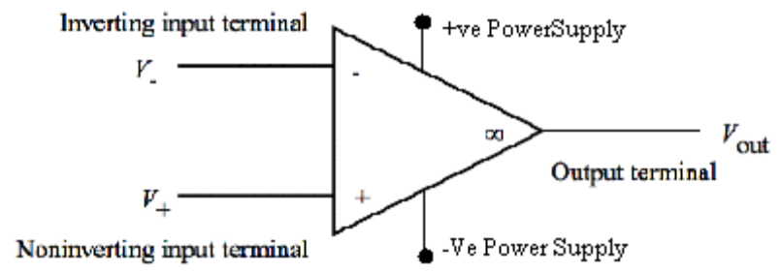

As seen from the figure, the op – amp is provided with two input terminals. One of the terminals labeled ‘– ‘is known as inverting input terminal. The word inverting implies that if a signal is applied to the ‘–‘terminal of the op – amp, it appears with the opposite polarity at the output, i.e., a sinusoidal signal will experience a phase shift of 180⁰. The other input terminal labeled ‘+’ is called the non – inverting terminal. In other words, a signal applied to this terminal of the op – amp is amplified without inversion. The op – amp actually amplifies the difference between the voltages applied to its two input terminals.

5.2) Concept2- Operational Overview: The input circuit of an op – amp, which is driven by inverting and non – inverting inputs is called a differential amplifier. This means that the op – amp amplifies the difference between the voltages applied at the non – inverting input and inverting input. V2 is the voltage applied at the inverting input of the op – amp and V1 is the voltage applied at the non – inverting input. The difference between the two voltages, i.e., V₁ – V₂ acts as an input to the op – amp. Mathematically, the difference voltage that will be applied is,
V_{in} = V₁ – V₂
The output (Vo) from the op – amp for a given pair of input voltages depends upon the factors such as
- a) The gain of the amplifier
- b) The polarity relationship between V1 and V2 and values of supply voltages +V and –V.

5.2) Concept3-BLOCK DIAGRAM OF OPAMP
An operational amplifier is a direct-coupled high gain amplifier usually consisting of one or more differential amplifiers and usually followed by a push pull amplifier.

INPUT
STAGE

INTERMEDIATE STAGE

LEVEL
SHIFTING
STAGE

OUTPUT
STAGE
Input Stage: The input stage is the dual input, balanced-output differential amplifier. This stage generally provides most of the voltage gain of the amplifier and also establishes the input resistance of the op-amp. It has very high input impedance as well as a large voltage gain. When input signals V+ and V- are applied, the difference voltage, E_{d}, is amplified by this stage and appears as the output voltage.
Intermediate Stage: The intermediate stage is usually another differential amplifier, which is driven by the output of the first stage. In most amplifiers, the intermediate stage is dual input, unbalanced (single ended) output. This stage allows input signal to pass nearly unaltered and become the input signal for the level shifting stage.
Level Shifting Stage: Because direct coupling is used, the dc voltage at the output of the intermediate stage is well above ground potential. Therefore, generally, the level translator circuit is used after the intermediate stage to shift the dc level at the output of the intermediate stage downward to zero volts with respect to ground.
Output Stage: The signal voltage at the output of the level shifting stage is coupled directly into the output stage. The most common output stage is a push-pull transistor configuration. Using a push-pull circuit as the final stage allows the op-amp to have a very low output resistance.
5.3)CONCEPT3:-EQUIVALENT CIRUCIT OF OPAMP
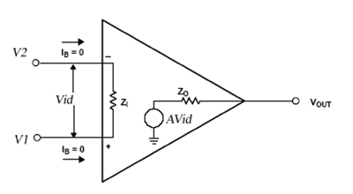
Above figure shows an equivalent circuit of an op-amp. This circuit includes important values: Voltage gain A, Input Impedance Z_{i} and Output Impedance Z_{o}. AV_{id} is an equivalent Thevenin voltage source, and Z_{o} is the Thevenin equivalent resistance looking back into the output terminal of an op-amp.
The equivalent circuit is useful in analyzing the basic operating principles of op-amp. For the output circuit shown in figure, the output voltage is
V_{out}= AV_{id} =A*(V₁-V₂)
where
A = large signal voltage gain
V_{id} = difference input voltage
V₁ = Voltage at the non-inverting input terminal with respect to ground
V₂ = Voltage at the inverting input terminal with respect to ground
This operation indicates that the output voltage V_{o} is directly proportional to the algebraic difference between the two input voltages. In other words, the op-amp amplifies the difference between the two input voltages; it does not amplify the input voltage themselves.
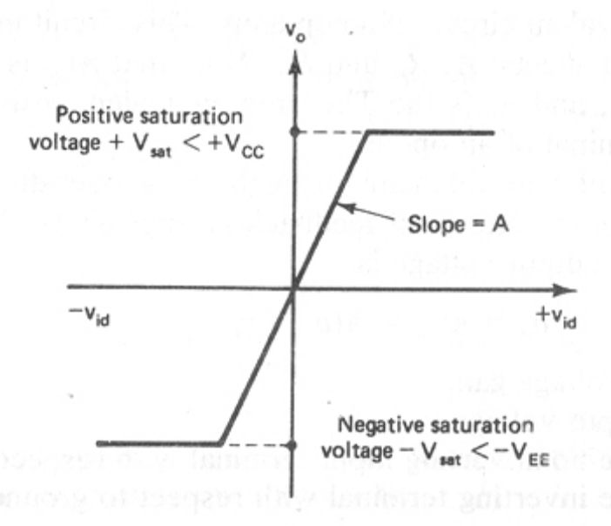
The output voltage cannot exceed the positive and negative saturation voltages. These saturation voltages are specified by an output voltage swing rating of the op-amp for given values of supply voltages. This means that the output voltage is directly proportional to the input difference voltage until it reaches the saturation voltages and that there after output voltage remains constant. The curve shown in figure is called an ideal voltage transfer curve, because output offset voltage is assumed to be zero.

6.0) Summary
In this lecture we have seen what is an operational amplifier and its block diagram. We have also seen the equivalent circuit of operational amplifier.
7.0) Exercise questions
1.Draw the block diagram of an Op-amp.
2.Explain the equivalent circuit of an Op-amp.

8.0) Programming / Computational assignments
I. Write a short note on Operational Amplifier.

Lecture 2

1) Synopsis: IDEAL OPMAP CHARACTERISTICS

2) Target: At the completion of this lecture you should be able to answer questions like (a) What are the ideal op-amp characteristics..

3) Introduction
In lecture1 we have seen what block diagram is and what is the equivalent circuit of op-amp. In this lecture we will see the ideal op-amp characteristics. In particular, we will emphasize the following characteristics
( a ) Infinite open loop gain
( b )Infinite input impedence
( c )zero output impedence
( d ) zero ouput offset voltage
( e )Infinite bandwidth

4) Revision / Prerequisites
You should have attended lecture 1 inorder to understand the concepts given in this lecture.
5.1) Concept1:- Infinite Open Loop Gain
In the case of amplifiers the term open loop indicates that no connection either direct or via another network, exists between the output and input terminals. i.e, the output signal is not fed back in any form as part of the input signal, and the loop that would have been formed with feed back is open.
5.2) Concept2:- Infinite Input Impedance
The input impedance of any amplifier is definable as the ratio of the input voltage and the input current: Z_{in}=V_{in}/I_{in}.
5.3) Concept 3:-ZERO OUTPUT IMPEDENCE
A voltage amplifier ideally has zero output impedance.
5.4)Concept4:-ZERO OUTPUT OFFSET VOLTAGE
Output offset voltage is the output voltage without any input applied. An amplifier connection should produce a zero output voltage when there is no connection. If this voltage is non-zero, there is an output offset voltage present in the circuit. In the ideal op-amp, this output offset voltage is zero.
5.5)Concept5:-INFINITE BAND WIDTH
The ideal op-amp will amplifies all signals ranging from 0 to 20 Hz without attenuation. But in real op-amps, the bandwidth is sharply limited.
6.0) Summary
In this lecture we have seen the ideal operational characteristics.
7.0) Exercise questions
Explain the characteristics of an ideal Op-amp.

8.0) Programming / Computational assignments

Lecture 3

1) Synopsis: NONIDEAL OPAMP CHARACTERISTICS

2) Target: At the completion of this lecture you should be able to answer questions like (a) what are the non ideal op-amp characteristics.

3) Introduction
In the previous lecture we saw the ideal op-amp characteristics such as zero output impendence, infinite input impendence etc. In this lecture we will see the non ideal opamp characteristics. In particular we will emphasis on the following characteristics.
( a ) Input bias current
( b ) Input offset current
( c ) Input offset voltage
( d ) Thermal drift

4) Revision / Prerequisites
You should have attended lecture 2 inorder to understand the concepts given in this lecture.

5.1) Concept 1-INPUT BIAS CURRENT
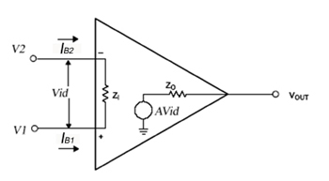

In an ideal op-amp, we assume that no current is drawn from the input terminals.
How ever, practically, input terminals do conduct a small value of dc current (base
currents for the input transistors of the differential amplifier) to bias the input transistors.• Manufacturers, specify input bias current IB as the average value of the bias current.

Input bias current
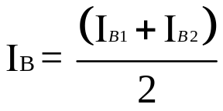
IB = 500 nA maximum for the 741 C, whereas IB for the precision 714C is ±7nA.

5.2) Concept 2-Input Offset Current

The algebraic difference between the currents into the inverting and non-inverting terminals is referred to as input offset current I_{io}.
In the form of an equation
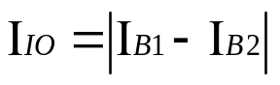
Where I_{B1} is the current into the non-inverting input and I_{B2} is the current into the inverting input.
We know that the input stage of an op-amp is supposed to be a balanced input, balanced output differential amplifier. So we expect that if we supply equal dc currents to the two inputs of an op-amp, then ideally we should have Vo=0. Or, we expect the currents entering into the two input points to be equal, when the output is zero. But this is not so in practice because of the dissimilarities between two transistor parameters. Thus to fix the two transistors at the same operating point, we have to supply dissimilar base currents at the base junctions of the transistors. Or to establish Vo=0 we need to make the input current different by an amount Iio. This difference between the base currents entering the two input terminals with the output at zero volts is termed as input offset current. Iio changes with temperature

5.3)Concept3- Input offset voltage
Ideally, with no input an op-amp should give no output. This is never the practical case. There is always a non-zero output. We can make it zero by giving an input of proper sign and magnitude. It could be positive or negative. The d.c.voltage applied between the input terminals to force the quiescent d.c.output to zero, is called the input offset voltage. It is represented as V_{io}. V_{io} could change with temperature. For a 741 C Op-Amp, the maximum value of Vio is 6mVdc. The smaller the value of Vio, the better the input terminals are matched. For instance, the 714 C precision op-amp has Vio = 150 μV maximum. The input offset voltage is also a function of temperature, and this temperature sensitivity, or drift, does not necessarily go to zero when the input offset is nulled.
Universal Balancing Techniques (External Offset Nulling)
It is often desirable to balance the offset voltage i.e. a small dc voltage should be applied at the input so as to cause the dc output voltage V0 to become zero.

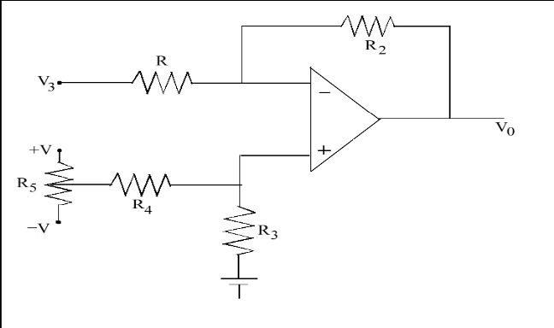

In the circuit above, a small voltage is supplied effectively in series with the non inverting terminal. This will be in the range ± V. R₃ / (R₃+R₄ )Which is equal to ± 15 mv if a 15 volt supply is used along with R4 = 100 k Ω , R3 =100 Ω .
5.4)Concept4-Thermal Drift
Bias current, offset current and offset voltage change with temperature. A circuit carefully nulled at 25ºC may not remain so when the temperature rises to 35ºC. This is called drift. Often offset current drift is expressed in mA/ºC and offset voltage drift in mV/ºC. These indicate the change in offset for each degree Celsius change in temperature.
6.0) Summary
In this lecture we have seen some non ideal opamp characteristics .
7.0) Exercise questions
1. Define the terms bias current and offset current.

8.0) Programming / Computational assignments

1.Briefly explain the non ideal characteristics of an Op-amp.
Lecture 4

1) Synopsis: Frequency Response, Bandwidth, CMRR, Ciruit stability, Slew rate

2) Target: At the completion of this lecture you should be able to answer questions like (a) What is CMMR (b) What is circuit stability (c) What is slew rate. You can also explain the bandwidth and frequency response of an Op-amp

3) Introduction
In the lecture 3 we have seen non-ideal op-amp characteristics. In this lecture we will see things such as CMRR, Ciruit stability, Slew rate. In general we will explain concepts like
1. Frequency Response
2. Bandwidth
3. CMRR
4. Circuit stability
5. Slew rate
4) Revision / Prerequisites
“You should have attended lecture 3 in order to understand the concepts given in this book”.

5.1) Concept:1 Frequency Response: When the op – amp is used in a circuit that amplifies only ac signals. We must consider whether ac output voltages will be small signals (below about 1V peak) or large signals (above 1V peak). If only small ac output signals are present, the important op – amp characteristics that limit performance are noise and frequency response. If large ac output signals are expected, then an op – amp characteristic called slew – rate determines whether distortion will be introduced by the op – amp and may further limit frequency response. Ideally, an op – amp should have an infinite bandwidth. This means that, if its open – loop gain is 100dB with dc signal, its gain should remain the same 100 dB through all other frequency ranges. The practical op – amp gain however, decreases (rolls – off) at higher frequencies. .
If frequency is increased by a factor of 10, the capacitor reactance decreases by a factor of 10. At higher frequency, value of Xc is almost equal to zero. That means, the capacitor will acts as a short circuit, i.e., the capacitor will bypass the load resistor.
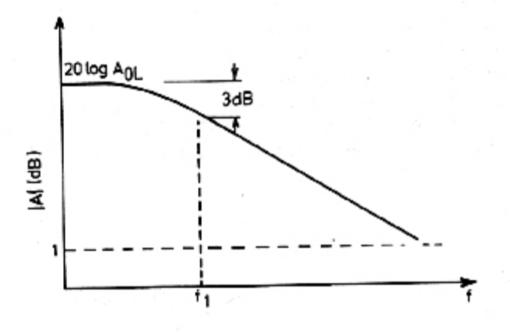
In the above figure, when the frequency f=f1, the gain is 3dB down from the dc value of open loop gain in dB (value at zero Hertz). This frequency is called the break frequency or the corner frequency. At the break frequency, the open loop gain is down 3 dB or 0.707of its value at 0 Hz(dc). The gain remains essentially constant from 0 Hz to the break frequency and there after rolls off at a constant rate, i.e. 20 dB/decade. Another useful parameter is the Unity Gain Bandwidth (UGB) or unity gain cross over frequency.
It is that frequency at which the open loop gain |Av| equals 1. This corresponds to the zero dB crossing, because a gain of 0 dB is the same as a numerical gain of 1. This frequency is used to determine the unity gain bandwidth.

5.2) CONCEPT2:-BANDWIDTH: The open – loop voltage gain of an op –amp is not constant at all frequencies. It falls off at higher frequencies because of capacitive effects. The gain frequency characteristics of op –amps are signified by the manufacturers in two ways.
- 1. The bandwidth for large signals over which less than 5% distortion is obtained
- 2. The frequency at which the gain falls to unity.

Bandwidth is the range of frequency, which an op – amp can amplify without any attenuation or without any gain fall off. From the frequency response curve, we can find that the band width of this particular op – amp is from 1 to f1, where f1 is the corner frequency.
For an op-amp with a single break frequency ‘f1’ the gain bandwidth product is constant
and equal to the unity gain Bandwidth (UGB)
UGB = (Av) x f1

5.3) Concept:3 CMMR
When the same input voltage is applied to both input terminals of an op –amp, the op – amp is said to be operating in a common mode configuration. Since the input voltage applied is common to both the inputs, it is referred to as a common mode voltage , Vcm. A common mode voltage can be a.c., d.c., or a combination of both.

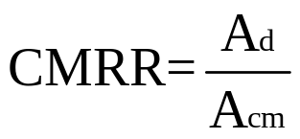
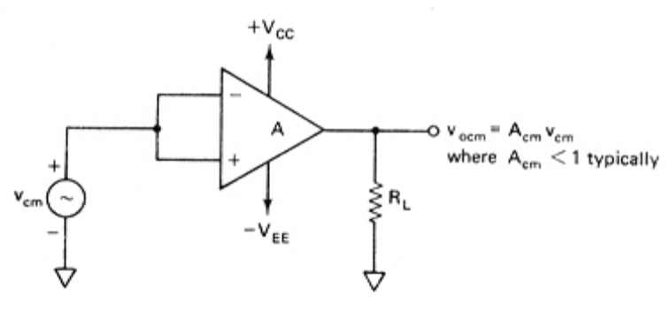
Figure : Common Mode

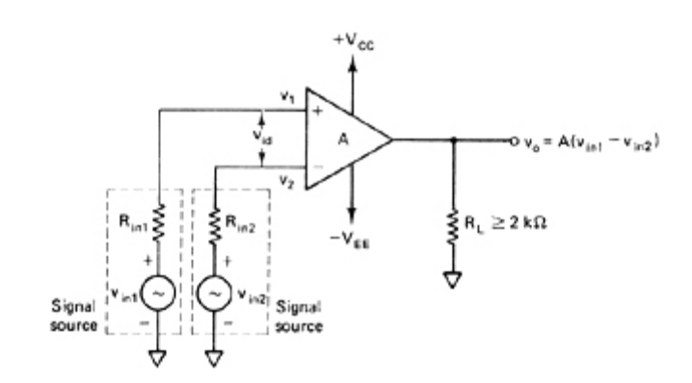
Figure : Differential Mode
Because ideally an op –amp amplifies only differential input voltages. No common – mode output voltage, Vocm, should appear at the output. However, due to imperfection within an actual op –amp, some common – mode voltage, Vocm will appear at the output. The amplitude of this Vocm is very small and often insignificant compared to
Vcm. Therefore, in practice the ratio of the output common – mode voltage Vocm to the input common – mode voltage Vcm, which is called the common – mode voltage gain
Acm, is generally much smaller than 1.

This equation indicates that the higher the value of CMRR, the smaller will be the amplitude of the output common – mode voltage Vocm. Generally, the CMRR value is very large and is therefore usually specified in decibels(dB).

5.2) CONCEPT4:-CIRCUIT STABILITY

A circuit or a group of circuits connected together as a system is said to be stable if its output reaches a fixed value in finite time. On the other hand, a circuit/system is said to be unstable if its output increases with time instead of achieving a fixed value. Infact, the output keeps on increasing until the system breaks down. Therefore, unstable systems are impractical and need to be made stable.

5.3) CONCEPT5:-SLEW RATE .
Slew rate is a large – signal phenomenon. A large signal is one whose amplitude is comparable with the power supply voltages. Typically, the large signal is of the order of volts, while a small signal is in the range of milli or even micro volts. Slew rate is defined as the maximum rate of change of output voltage per unit of time and is expressed in volts per microseconds.

SR = dVo│max V/µS
dt

Slew Rate indicates how rapidly the output of an op – amp can change in response to changes in the input frequency. The slew rate changes with change in voltage gain and is normally specified at unity (+1) gain. The slew rate of an op – amp is fixed: therefore, if the slope requirements of the output signal are greater than slew rate, then distortion occurs.
When a signal at a given frequency is applied to the op-amp, the maximum permissible output voltage is determined by the slew rate. If we try to develop the output voltage higher than the maximum permissible value, the signal waveform will be distorted.
Causes of Slew Rate
Slew rate is caused by current limiting and saturation of internal stages of an op-amp when a high-frequency large amplitude signal is applied. The resulting current is the maximum current available to change the compensation capacitance network. We know that the capacitor require a finite amount of time to change and discharge. This means that internal capacitors prevent the output voltage from responding immediately to a fast changing input.The rate at which the voltage across the capacitor rises:
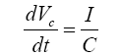
Thus slew rate limiting is caused by this capacitor changing rate, in which the voltage
across the capacitor is the output voltage.
Slew Rate Equation
Assuming that the input is a large amplitude and high frequency sine wave for a voltage follower circuit:
Vin = Vpsin wt
Vo = Vpsin wt
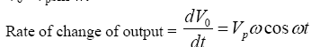
the maximum rate of change of the output occurs when cos wt = 1
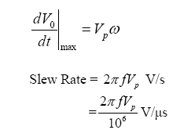
Where f – input frequency V_{P} – peak value of output sine wave
• If either the frequency (f) or amplitude (Vp) of the input signal is increased to exceed the slew rate of the op-amp, the output will distort.
6.0) Summary:In this section we have described certain characteristics of Op-amp such as Frequency Response,Bandwidth,CMRR, Ciruit stability, Slew rate etc.
7.0) Exercise questions
1.Define CMRR & Slew rate.
2.What is the significance of slew rate in an Op-amp.

8.0) Programming / Computational assignments
1. Explain how CMRR is calculated.
2.Give the typical values of CMRR & Slew rate
Lecture 5

1) Synopsis: Open loop opamp configuration
2) Target: At the completion of this lecture you should be able to answer questions like (a) What is open loop configuration (b) which are the major three open loop configurations of opamp. (c) What are the drawbacks of open loop configuration.

3) Introduction
In this lecture we will see the three different open loop configurations of opamp.They are
1.differential amplifier
2.Inverting amplifier
3.Non inverting amplifier
We will also discuss the draw backs of open loop configuration.
4) Revision / Prerequisites
“You should have attended lecture 3 in order to understand the concepts given in this book”.

5.1) Concept:1 Open loop configurations:
In the case of amplifiers the term open loop indicates that no connection, either direct or via another network exists between the output and input terminals. That is, the output signal is not fed back in any form as part of the input signal. When connected in open loop configuration the op-amp simply functions as a high gain amplifier
There are three Open Loop Op-Amp configurations:
1. Differential Amplifier
2. Inverting Amplifier
3. Non Inverting Amplifier
5.2) CONCEPT2:- Differential Amplifier:
The figure below shows the open loop differential amplifier in which input signals Vin1and Vin2 are applied to the positive and negative input terminals. Since the op-amp amplifies the difference between the two input signals, this configuration is called the differential amplifier. The op-amp is a versatile device because it amplifies both ac and dc input signals.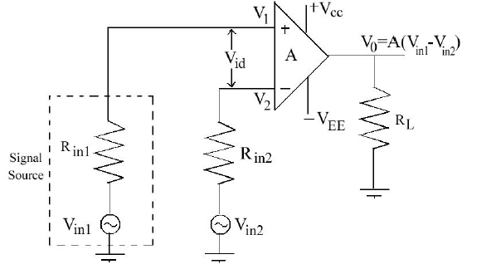

This means that Vin1 and Vin2 could be either ac or dc voltages. The sources resistances Rin1 and Rin2 are normally negligible compared to the resistances R1.Therefore, the voltage drops across theses resistors can be assumed to be zero, which then implies that
V1=Vin1 and V2=Vin2
So V output = A(Vin1-Vin2)
Polarity of output voltage is dependent on the polarity of the input difference voltage
(Vin1-Vins2). In open loop configuration, the gain A is commonly referred to as open loop gain.

5.3) Concept:3 Inverting Amplifier

In inverting amplifier only one input is applied and that is to the inverting input terminal.
The non inverting input terminal is grounded.

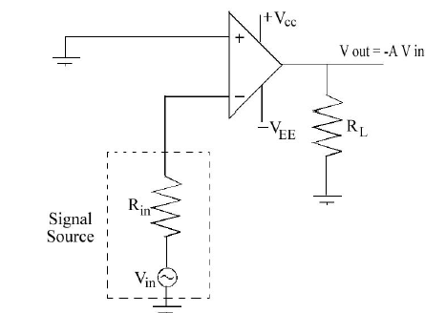

Since V1=0V, and V2=Vin
Voutput= -A Vin
The negative sign indicates that the output is out of phase with respect to the input by
1800 (of opposite polarity). Thus in the inverting amplifier the input signal is amplified by gain A and is also inverted at the output.

5.2) CONCEPT4:- Non Inverting Amplifier

The input is applied to the non inverting input terminal, and the inverting terminal is
connected to ground.
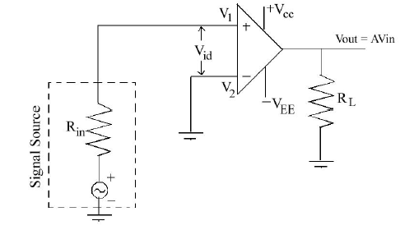

Since V1= Vin , and V2=0V
Voutput= A Vin
This means that the output voltage is larger than the input voltage by gain A and is in
phase with the input signal.

5.3) CONCEPT5:- Drawback of Open Loop Op-Amp configuration
.
• Any input signal that is only slightly greater than zero drives the output to saturation
level.
• This results from the very high gain (A) of the op-amp.
• Thus when operated open–loop, the output of the op-amp is either negative or positive
saturation or switches between these levels.
• For this reason, open loop op-amp configuration is not used in linear applications.
6.0) Summary:In this section we have described the three different open loop configurations of opamp.They are
1.differential amplifier
2.Inverting amplifier
3.Non inverting amplifier
We have also discussed the draw backs of open loop configuration.
7.0) Exercise questions
1.What do you mean by open loop configuration.
2.What are the draw backs of open loop configuration..

8.0) Programming / Computational assignments
1. Explain the different open loop configurations of opamp.

Lecture 6

1) Synopsis: Feed back in amplifiers
2) Target: At the completion of this lecture you should be able to answer questions like (a) What is the need of feedback in amplifiers (b) which are the different types of feed back in an opamp. We will give due emphasis to a negative feedback system.
3) Introduction
In this lecture we will see the two different feedback in an of opamp.They are
1. Positive feedback
2. Negative feedback
We will discuss the negative feedback in detail.
4) Revision / Prerequisites
“You should have attended lecture 3 in order to understand the concepts given in this book”.

5.1) Concept:1 Feedback in Amplifiers

An ideal linear amplifier in the mid frequency region provides an output signal which is an exact replica of the input signal. However the practical amplifiers depart from the ideal for many reasons,E.g. Non linearity of transistor characteristics,Parameter variations, temperature effect etc
Some of these factors can be minimized by improving the involved basic devices.
But there is a limit, beyond which, this approach does not work. The best approach is the use the principle of feedback to achieve desired degree of improvement. The feedback is a process of injecting some energy from the output and returning it back to the input.
The amplifiers, which use the feedback principle, are called feedback amplifiers. A feedback amplifier basically consists of two parts, namely amplifier circuit and feedback circuit.
Depending upon whenever the feedback signal increases of decreases the input signal, there are two basic types of feedback amplifiers:
- Positive Feedback
• The feedback signal is in phase with the input signal and thus increases it.
• Positive feedback increases the gain of amplifier
• Used in oscillators
2. Negative feedback
• The feedback signal is out of phase with the input signal and thus decreases it.
• Negative feedback reduces the gain of the amplifier but improves the amplifier
performances in many other aspects.
• Used in small signal as well as large signal amplifier circuits.

5.2) CONCEPT2:- Negative feedback system
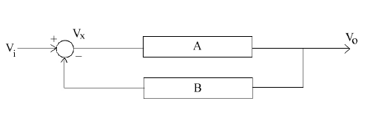

• The output is multiplied by the gain B before it is connected to the summing junction.
• B is known as the feedback factor, and is usually less than 1.

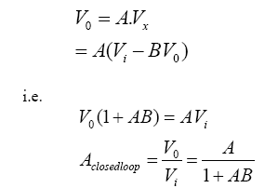

• In op-amp circuits, the forward gain or open-loop gain (A) is very high(A ≈1.5x105 )
This leads to two important results:

1. If A is very large, Then AB>>1
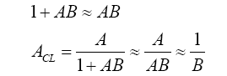
• Thus for an op-amp circuit with negative feedback, the closed loop gain effectively
depends only on the feedback factor B.
• This value is determined from the resistive circuit used to connect the output back to the
input.
• i.e. Gain depends only an external feedback circuit component values.

2. The out put of a real Op-Amp circuit is limited by the supply voltage.
• The maximum output available from the op-amp is known as the saturation voltage.
• Thus if the op-amp connected with negative feedback, the value of Vx is also limited.
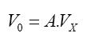
If V0 is limited to +15V,

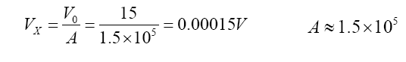This is the maximum possible value for Vx
i.e. Vx ≈0V for as op-amp with negative feedback
i.e. V1=V2 (ideal)
• The voltage at the inverting input terminal of an op-amp is approximately equal to that at
the non inverting terminal, provided gain is very high..
6.0) Summary:In this section we have described the two different feedback configurations of opamp.They are
1.positive feedback
2.Negative feed back

7.0) Exercise questions
1.What is the use of feed back in an opamp..
2.Explain a general negative feedback system

8.0) Programming / Computational assignments

Lecture 7

1) Synopsis:- INVERTING AMPIFIER

2) Target: At the completion of this lecture you should be able to answer questions like (a)what is inverting amplifier………(b)Find the voltage gain of an inverting amplifier. You should also be able to find expressions for input resistance and output resistance of an inverting amplifier with feedback.

3) Introduction
In lecture 4 and 5 we have seen some nonideal-opamp characteristics. In this lecture we we will see some applications of op-amp. The applications include such as inverting amplifier, non-inverting amplifier, integrator etc. Once we finish this topic we will move towards the concept of differential amplifier . In particular, we will emphasize on
Inverting amplifier

4) Revision / Prerequisites

You should have attended lecture 3 in-order to understand this lecture.

5.1) Concept 1:- INVERTING AMPLIFER
Inverting amplifier is an amplifier circuit in which there is no supply at non -inverting terminal and there is supply at inverting terminal.
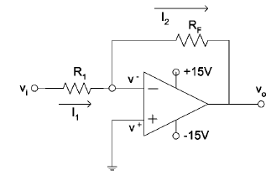
Virtual Ground
V1
V2

Above figure shows the connection method for producing the inverted gain using op – amp. Such a configuration is called inverting amplifier. The op – amp circuit makes use of a single resistor (R₁) and a single feedback resistor (R_{F}). The resistor (R₁) is connected between the input terminal of the amplifier circuit and inverting input terminal (-) of the op –amp. While the feedback resistor (R_{F}) is connected between the inverting input terminal (-) and the output terminal of the op – amp. The non – inverting terminal (+) is connected to the ground. The inverting amplifier produces a 180º phase shift in voltage from input to output. Thus the input and output signals of the inverting amplifier are not in – phase with each other.
The op – amp gain without any feedback (open – loop) is very high. This means that the voltage at the inverting (-) terminal must be very small. In this circuit, the positive terminal of the Op-Amp is grounded. This means,
V1 = 0
We know for proper operation, the feedback system tries to keep the difference voltage Vid (i.e V1 – V2) at approximately 0V.
Vid = 0
V1 – V2 = 0
V2 = 0 – V1, where V1 = 0
Hence
V2 = 0

As seen from the above relation, even though the inverting terminal (-) of the Op-Amp is not connected to physical ground, it is still held at a potential of 0V because of the circuit conditions. Such a point in the circuit is known as virtual ground. Thus, the inverting terminal (–) of Op-Amp in this case behaves as a virtual ground. In other words, the inverting terminal voltage V2 is approximately at ground potential.
Since the inverting terminal is virtual ground, therefore the entire input voltage appears across R₁ and the input current I₁= Vin/ R₁. Moreover, the input resistance (R_{i}) of an op –amp is very high (ideally infinite), so very little current flows into the op – amp. Practically, the current drawn by the op –amp is negligible or nearly zero. Thus all the input current flows through feedback resistor (R_{F}), i.e, I₁ = I₂. And the voltage developed across feedback resistor (R_{F}) is equal to the output voltage (Vo) of the circuit.

In the circuit
I₁ = I₂
( V_{in} -V₂)/ R₁=(V₂- V_{out})/ R_{f}
However,
V₁ = V₂ = 0V

Therefore, V_{in} / R₁=- V_{out} / R_{f}

A_{CL}= V_{out} / V_{in} =- R_{f} / R₁

5.2) Concept 2:-Input resistance with feedback
Although, op–amp has an extremely high input resistance (ideally infinite) yet the inverting amplifier does not have that high value. In the inverting amplifier circuit, we can see that input resistance (R1) is parallel with the input resistance of op–amp. Since input resistance of an op–amp is very high, therefore, input resistance of an inverting amplifier with feedback is,
Rif = R1
It may be noted that the value of R1 will always be much less than the input resistance of
the op – amp. Therefore, the overall input resistance of an inverting amplifier will be much lower than the op– amp input resistance.
5.3) Concept 3:-Output resistance with feedback

Referring the figure, we can find that output resistance with feedback for an inverting amplifier is the parallel combination of Rf and the output resistance of op–amp itself. Since the output resistance of an op–amp is usually very low, the presence of Rf reduces the overall output resistance with feedback of the inverting amplifier.
The output resistance with feedback
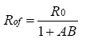
where
Ro = Output impedance of the op – amp
A = Open Loop gain
B = Gain of Feedback circuit
6.0) Summary
In this lecture we have seen what is inverting amplifier, the voltage gain,input resistance and output resistance of inverting amplifier.
7.0) Exercise questions
1.Explain the working of an inverting amplifier

2.Find expression for voltage gain of an inverting amplifier..

8.0) Programming / Computational assignments
1.Derive expressions for input resistance and output resistance of inverting amplifier.

Lecture 8

1) Synopsis:- INVERTING AND NON INVERTING AMPIFIER,INTEGRATOR

2) Target: At the completion of this lecture you should be able to answer questions like (a)what is inverting amplifier………(b)What is non inverting amplifier(c)What is integrator. You should also be able to explain the working of (a) Inverting amplifier(b)non inverting amplifier(c)integrator.

3) Introduction
In lecture 4 and 5 we have seen some nonideal-opamp characteristics. In this lecture we we will see some applications of op-amp. The applications include such as inverting amplifier, non-inverting amplifier, integrator etc. Once we finish this topic we will move towards the concept of differential amplifier and integrating amplifier. . In particular, we will emphasize on the following in this lecture
(a) Inverting amplifier
(b) Non inverting amplifier
(c ) Integrator

4) Revision / Prerequisites

You should have attended lecture 3 inorder to understand this lecture.

5.1) Concept 1:-NONINVERTING AMPLIFER

The circuit shown in below is commonly known as a non – inverting amplifier with feedback. The input signal is applied to the non inverting input terminal (+) of the op – amp, and the output is fed back to the inverting terminal ( - ) through RF and R1.
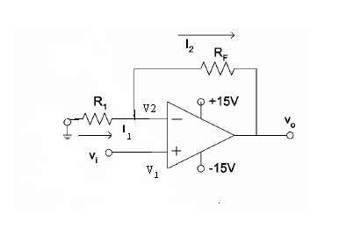
An op –amp always amplifies the difference input voltage Vid. This difference voltage is equal to the input voltage Vin minus the feedback voltage Vf. In other words, the feedback voltage always oppose the input voltage(or is out of phase by 180⁰ with respect to the input voltage); hence the feedback is said to be negative.
We have seen that for proper feedback operation, the feedback circuit of RF and R1 should ensure that
Vid = 0, or
V1 – V2 = 0
As,
V1 = V2
Where
V1 = Vin and V2 = Vf
Therefore,
Vin = Vf
Remember that because of the very high input resistance of Op-Amp, almost no current flows into the inverting or non-inverting terminals of the Op-Amp.
To find the value of Vf, consider the feedback circuit. As no current flows into the Op-Amp inverting terminal, the feedback circuit forms a voltage divider supplied by Vo.

V_{f} = V_{out} x(R₁/( R₁+ R_{f}))

V_{in} =V_{f}

V_{in} = V_{out} x(R₁/( R₁+ R_{f}))

V_{out}/V_{in}=(R1+R_{f})/R₁

That is A_{CL}=(1+R_{f})/ R₁

5.2) Concept 2:-INVERTING AMPLIFIER
Inverting amplifier is an amplifier circuit in which there is no supply at non -inverting terminal and there is supply at inverting terminal.
Virtual Ground
V1
V2

Above figure shows the connection method for producing the inverted gain using op – amp. Such a configuration is called inverting amplifier. The op – amp circuit makes use of a single resistor (R₁) and a single feedback resistor (R_{F}). The resistor (R₁) is connected between the input terminal of the amplifier circuit and inverting input terminal (-) of the op –amp. While the feedback resistor (R_{F}) is connected between the inverting input terminal (-) and the output terminal of the op – amp. The non – inverting terminal (+) is connected to the ground. The inverting amplifier produces a 180º phase shift in voltage from input to output. Thus the input and output signals of the inverting amplifier are not in – phase with each other.
The op – amp gain without any feedback (open – loop) is very high. This means that the voltage at the inverting (-) terminal must be very small. In this circuit, the positive terminal of the Op-Amp is grounded. This means,
V1 = 0
We know for proper operation, the feedback system tries to keep the difference voltage Vid (i.e V1 – V2) at approximately 0V.
Vid = 0
V1 – V2 = 0
V2 = 0 – V1, where V1 = 0
Hence
V2 = 0

As seen from the above relation, even though the inverting terminal (-) of the Op-Amp is not connected to physical ground, it is still held at a potential of 0V because of the circuit conditions. Such a point in the circuit is known as virtual ground. Thus, the inverting terminal (–) of Op-Amp in this case behaves as a virtual ground. In other words, the inverting terminal voltage V2 is approximately at ground potential.
Since the inverting terminal is virtual ground, therefore the entire input voltage appears across R₁ and the input current I₁= Vin/ R₁. Moreover, the input resistance (R_{i}) of an op –amp is very high (ideally infinite), so very little current flows into the op – amp. Practically, the current drawn by the op –amp is negligible or nearly zero. Thus all the input current flows through feedback resistor (R_{F}), i.e, I₁ = I₂. And the voltage developed across feedback resistor (R_{F}) is equal to the output voltage (Vo) of the circuit.

In the circuit
I₁ = I₂
( V_{in} -V₂)/ R₁=(V₂- V_{out})/ R_{f}
However,
V₁ = V₂ = 0V

Therefore, V_{in} / R₁=- V_{out} / R_{f}

A_{CL}= V_{out} / V_{in} =- R_{f} / R₁

Lecture 8

1) Synopsis:- NONINVERTING AMPIFIER

2) Target: At the completion of this lecture you should be able to answer questions like (a)what is a non inverting amplifier………(b)Find the voltage gain of a non inverting amplifier. You should also be able to find expressions for input resistance and output resistance of a noninverting amplifier with feedback.

3) Introduction
In lecture 4 and 5 we have seen some nonideal-opamp characteristics. In this lecture we we will see some applications of op-amp. The applications include such as inverting amplifier, non-inverting amplifier, integrator etc. Once we finish this topic we will move towards the concept of differential amplifier . In particular, we will emphasize on
noninverting amplifier

4) Revision / Prerequisites

You should have attended lecture 3 in-order to understand this lecture.

5.1) Concept 1:-NON INVERTING AMPLIFER
The circuit shown in below is commonly known as a non – inverting amplifier with feedback. The input signal is applied to the non inverting input terminal (+) of the op – amp, and the output is fed back to the inverting terminal ( - ) through RF and R1.
An op –amp always amplifies the difference input voltage Vid. This difference voltage is equal to the input voltage Vin minus the feedback voltage Vf. In other words, the feedback voltage always oppose the input voltage(or is out of phase by 180⁰ with respect to the input voltage); hence the feedback is said to be negative.
We have seen that for proper feedback operation, the feedback circuit of RF and R1 should ensure that
Vid = 0, or
V1 – V2 = 0
As,
V1 = V2
Where
V1 = Vin and V2 = Vf
Therefore,
Vin = Vf
Remember that because of the very high input resistance of Op-Amp, almost no current flows into the inverting or non-inverting terminals of the Op-Amp.
To find the value of Vf, consider the feedback circuit. As no current flows into the Op-Amp inverting terminal, the feedback circuit forms a voltage divider supplied by Vo.

V_{f} = V_{out} x(R₁/( R₁+ R_{f}))

V_{in} =V_{f}

V_{in} = V_{out} x(R₁/( R₁+ R_{f}))

V_{out}/V_{in}=(R1+R_{f})/R₁

That is A_{CL}=(1+R_{f})/ R₁

5.2) Concept 2:-Input resistance with feedback
The non – inverting amplifier has extremely high input resistance because the input signal is applied directly to the op–amp (i.e., not through a resistor R1 as it happens in the case of inverting amplifier).
As a matter of fact, the presence of feedback network causes the amplifier input
resistance to be greater than the input resistance of the op–amp itself.
Input resistance with feedback,
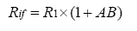
where
Ri = Input impedance of the op – amp
A = Open Loop gain
B = Gain of feedback circuit

5.3) Concept 3:-Output resistance with feedback

The output resistance of a non – inverting amplifier is lower than the output resistance of
the op – amp itself. This characteristic is similar to that of the inverting amplifier.
The output resistance with feedback

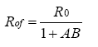
where
Ro = Output impedance of the op – amp
A = Open Loop gain
B = Gain of Feedback circuit

6.0) Summary
In this lecture we have seen what is a non inverting amplifier, the voltage gain,input resistance and output resistance of non inverting amplifier.
7.0) Exercise questions
1.Explain the working of a non inverting amplifier

2.Find expression for voltage gain of a non inverting amplifier..

8.0) Programming / Computational assignments
1.Derive expressions for input resistance and output resistance of non inverting amplifier.

Lecture 9

1) Synopsis: DIFFERENTIAL AMPLIFIER

2) Target: At the completion of this lecture you should be able to answer questions like (a) What you mean by differential amplifier (b)What is voltage follower. You should also be able to explain the working of (a) differential amplifier (b)voltage follower
3) Introduction
In lecture 6 we have seen what is inverting amplifier, what is non inverting amplifier what is integrator etc. In this lecture we will see what differential amplifier is. Once we finish this topic we will move towards the concept of voltage follower. In particular we will emphasize on

( a ) Differential amplifier
( b ) voltage follower.

4) Revision / Prerequisites

You should have attended the lecture 6 inorder to understand the concepts given in this lecture.

5.1) Concept #1-Differential Amplifier
A circuit that amplifies the difference between two signals is called a differential amplifier. This type of the amplifier is very useful in instrumentation circuits. A typical circuit is shown in the figure.
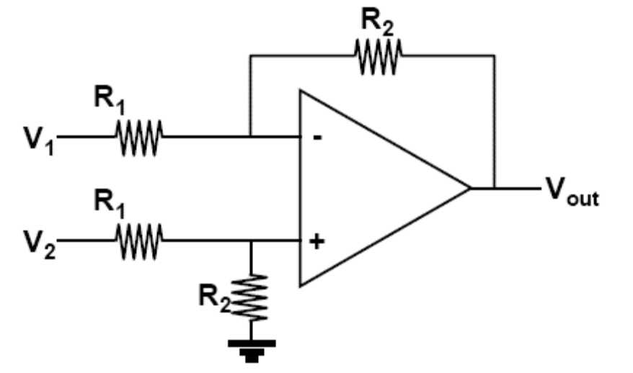

Since, the differential voltage at the input terminals of the op –amp is zero, nodes ‘a’ and ‘b’ are at the same potential, designated as V3.
The node equation at ‘a’ is
(V₃-V₂)R₁+(V₃-V₀)/R₂=0----------------------------------(1)
The node equation at ‘b’ is
(V₃-V₁)R₁+V₃/R₂=0---------------------------------- (2)
Rearranging equation 1, we get
[(1/R₁)+(1/R₂)]xV₃-(V₂/R₁)=V₀/R₂----------------------------------(3)
Rearranging equation 2, we get
[(1/R₁)+(1/R₂)]xV₃-(V₁/R₁)=0 ----------------------------------(4)
Subtracting equation – 4 from equation – 3, we get
1/R_{1x}(V₁-V₂)=V₀/R₂

Therfore,

V₀=(R₂ /R₁)x(V₁-V₂)
Such a circuit is very useful in detecting very small differences in signals, since the gain R2/R1 can be chosen to be very large.

5.2)Concept#2-Voltage follower

The voltage follower circuit can be obtained from the non – inverting amplifier by
removing resistors R1 and Rf.
The resulting circuit is shown in the figure given below:
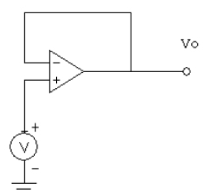

Notice that the input voltage is applied at the non – inverting input of an op –amp, and the inverting input is connected to the op – amp output. Because of the direct connection between the inverting input and output terminals, a 100% voltage series feedback is applied.• The voltage gain of a voltage follower may be obtained by using the equation of a non –
inverting amplifier,
i.e.,

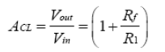
Where Rf = 0 and R1 = 0
Therefore,
A = 1
• The voltage follower has a very high input resistance and a very low output resistance.
• The main application of a voltage follower is as an interface between a source with high
input resistance to a load with low output resistance, i.e., to act as a buffer amplifier.

6.0) Summary
In this lecture we have explained the working of differential amplifier and voltage follower.
7.0) Exercise questions
1.Explain the working of a differential amplifier,

2.What do you mean by an voltage follower.

8.0) Programming / Computational assignments
What are the applications of voltage follower.

