OP AMP Reading Material Part 2
Model of op amp
For the ideal op amp:
A_{ol} = ∞ ; Zi = ∞ ; I_{B+} = I_{B-} = 0 ; Vos = 0
An idealized simplified model could be given as in the following figure:
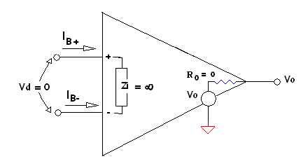
Now we will try to improve this model step by step including practical functional elements one by one. Figure below shows a model including bias currents, input impedance and output resistance. Input impedance depends to a very small extent on the signal frequency which is represented in the model by the parallel capacitor, Ci. Value of Ci is so small that, for all practical purposes, it can be neglected. The output impedance is very small, and it is, very closely, resistive. Thevenin equivalent of the output circuit is also shown. If a load resistance, R_{L} is connected at the output the output voltage across it is
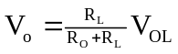
Ro is so small that, for most practical circuits, drop across Ro is negligible, and full Vo_{L} is available across R_{L}.
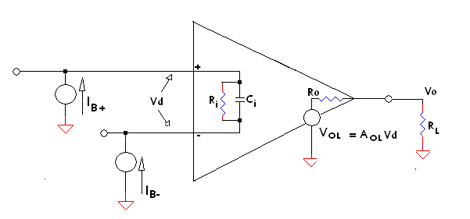
Now we will consider the input offset voltage and the common mode effects. Input offset voltage appears as a voltage source in series with the noninverting input terminal. To show the common mode effects, we split the input differential mode impedance into two parts: one from the noninverting input terminal to the ground, and the second from the inverting input terminal to the ground, both through a common mode impedance. With these, the op amp model gets modified as in the following figure.
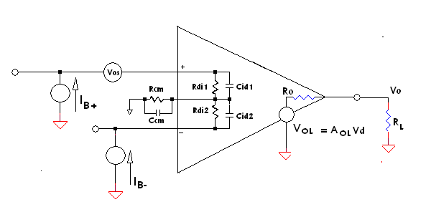
Now we will try to introduce noise contributions. Both voltage sources and current sources are to be included. We will not take up a detailed discussion of the op amp noise now. Like thermal noise of resistors op amps also generate broad band noise. In addition to the broad band noise, op amps often show a low frequency noise spectrum whose power varies as 1/f. It is called 1/f noise. It is also called flicker noise. Both the broad spectrum noise and the flicker noise together, referred to the input, can be represented by a noise voltage source e_{n} connected in series with the noninverting input terminal. In a similar manner we can talk of broad band current noise and flicker current noise. We split the current noise sources, referred to input, into two: 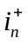, connected at the noninverting input and 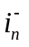, connected at the inverting input. With the introduction of the noise sources referred to input the op amp model gets revised as shown in the following figure.
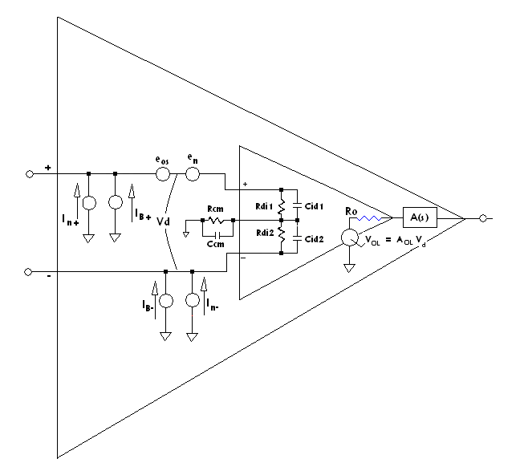We have already discussed the frequency response of op amp. We can introduce this also in the model with a block showing dependence of output on frequency in series with the output. Block A(s) represents the frequency dependence of open loop gain.

Voltage Transfer Function
Let us now address the question, how to draw the input to output transfer relation as a function of input voltage. Our intention is to generate an output versus input graph. We can easily say that it is a straight line, since we already know that the op amp is linear to a very good level of accuracy, provided we are operating within limits. What are these limits? One is naturally the frequency. Another is a constraint introduced by the slew rate limitation. A third one is due to the saturation levels of the op amp. The op amp output cannot vary beyond the positive and negative saturation output levels. Thus, when we consider open loop characteristics, i.e. an op amp without feedback, the maximum input up to which we can expect proportional output is V_{SAT}/A_{OL}. But, what about the impact of offset voltage and offset current? Impact of offset current naturally depends on the impedances presented at the input terminals. We will not consider it now. But let us try to see the effect of offset voltage. If V_{i} is the input differential voltage, V_{OS} the offset voltage, and A_{OL} the open loop gain, the output voltage V_{o} can be given as
V_{o} = A_{OL} x(V_{i} + V_{OS}), -V_{SAT} < V_{o} < + V_{SAT}
For the case where V_{OS} is positive, the output reaches + V_{SAT} at a lower input, than with no offset. But the output reaches -V_{SAT} at a higher negative input level than with no offset. We can state the input conditions for output saturation as follows:
With positive input offset voltage:
Vim + V_{OS} = +V_{SAT}/ A_{OL}, for positive saturation, and
- Vim + V_{OS} = -V_{SAT}/ A_{OL}, for negative saturation.
With negative input offset voltage:
Vim - V_{OS} = +V_{SAT}/ A_{OL}, for positive saturation, and
- Vim - V_{OS} = -V_{SAT}/ A_{OL}, for negative saturation.
The three cases, with zero offset, positive offset, and negative offset, are represented graphically in the following figure.
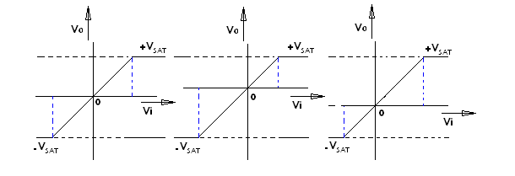
Zero offset Positive offset Negative offset
Note: The above discussion on the voltage transfer function in the open loop configuration does not have much practical significance. Take the case of 741 for example. Typical value of input offset voltage ranges from 0.5 mV to 10 mV. Take typical value of A_{OL} as 2x10⁵. Even with the minimum value of input offset, the output gets saturated. Open loop configurations are generally of no practical use. There are many disadvantages. Most important of the disadvantages is lack of noise immunity. Still we will discuss a few points about the open loop configuration in the following section.
Open loop Configuration
Connect proper power supplies to the op amp. Connect the inverting input to the common of the power supply. Connect the noninverting input terminal to a signal source. What do you get at the output?
Or, connect the noninverting input to the common of the power supply. Connect the inverting input terminal to a signal source. What do you get at the output?
The following figure represents the above two cases.
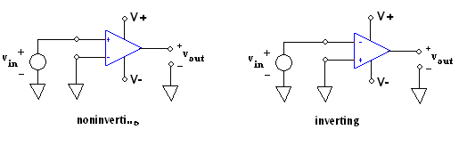
We will neglect the presence of input offset voltage. Let us also assume that the open loop gain of the op amp is infinity. Then at every point where the input crosses zero the output switches to either of the saturation levels; to +VSAT when the input moves to positive, and to –VSAT when the input moves to negative, in the case of noninverting configuration. Output switching is just in the opposite sense in the case of inverting configuration. The cases are illustrated in the following figures. It is obvious that the function of the circuit is detection of the instants at which the input crosses zero level.
At every zero crossing the output changes sign.
Exercise: What is shown in the figure is for ideal situation. Discuss what happens in the presence of noise signals of the order of a few tens of µV. Also include rise time and fall time of output because of the slew rate. As a third step include the impact of input offset voltage.

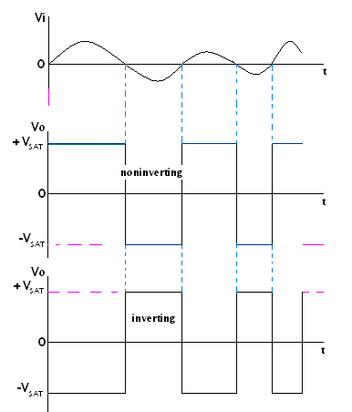

To be seen:
Question: Discuss the effect of input bias current wrt an amplifier circuit. current flowing through the input res—
Question: Discuss the significance of input offset current.
Question: Discuss the significance of drift of input offset current. (ref:p281Charles F Wojslaw)
Question: Discuss the significance of input offset voltage.
Question: Discuss the significance of drift of input offset voltage.
Question: Represent graphically the effect of input offset voltage
Take later: Input noise current density, input noise voltage density, input referred noise.
______________________________________________________________________
Introduction to operational amplifiers – Basic differential amplifier - dual input balanced output and unbalanced output- Internal block schematic of op amp – Pin identification- power supply requirements - typical data sheet - Op-amp
parameters - ideal op amp - transfer curve - equivalent circuit- open loop
configurations - frequency response of op amps - compensating networks - slew
rate and its effect.

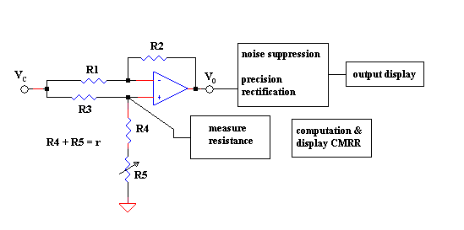
Note: Use precision low temperature coefficient resistances.

