R 404 Name : …………………
Reg. No :……………….

RAJAGIRI SCHOOL OF ENGINEERING AND TECHNOLOGY
FIRST INTERNAL EXAMINATION – 2008
FOURTH SEMESTER – Computer Science
Integrated Circuits
Max.Marks : 50 Time : 2 hours
PART A
- In an ideal op – amp circuit, input impedance is ……………and output impedance is……………
Ans: Infinite,Zero
- In an inverting amplifier, the inverting terminal is at virtual ground because
Ans:The open – loop gain of the op – amp is infinity
- If the voltage gain of an inverting amplifier is 50; then the equivalent gain in dB
is
Ans: 34 dB
- Input bias current in an op-amp is defined as

Ans:The average of two bias currents

- Schmitt trigger is an example of

Ans: Comparator with positive feedback

PART B
6. Design a non inverting amplifier with a gain of 10 using an op – amp.
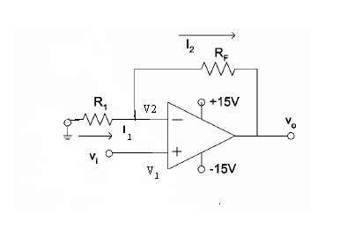

A_{CL}=1+R_{f}/ R₁
Given A_{CL} =10
Choose R₁ ₌ 1K, Then R_{f=} 9K (select a 10 K pot)
7. Show that the voltage gain of a non - inverting amplifier is A_{CL}=1+R_{F}/R₁.
An op –amp always amplifies the difference input voltage Vid. This difference voltage is equal to the input voltage Vin minus the feedback voltage Vf. In other words, the feedback voltage always opposes the input voltage (or is out of phase by 180⁰ with respect to the input voltage); hence the feedback is said to be negative.
We have seen that for proper feedback operation, the feedback circuit of RF and R1 should ensure that
Vid = 0, or
V1 – V2 = 0
As,
V1 = V2
Where
V1 = Vin and V2 = Vf
Therefore,
Vin = Vf
Remember that because of the very high input resistance of Op-Amp, almost no current flows into the inverting or non-inverting terminals of the Op-Amp.
To find the value of Vf, consider the feedback circuit. As no current flows into the Op-Amp inverting terminal, the feedback circuit forms a voltage divider supplied by Vo.

V_{f} = V_{out} x (R₁/ (R1+ R_{f}))
V_{in} =V_{f}
V_{in} = V_{out} x (R₁/ (R1+ R_{f}))
V_{out}/V_{in}=(R1+R_{f})/R₁
That is ACL=(1+R_{f})/ R₁
8. For the given inverting amplifier R1=470Ω and R2=4.7 KΩ .Calculate the values of
A_{F},R_{IF}and R_{OF}.Assume that the op-amp is 741.
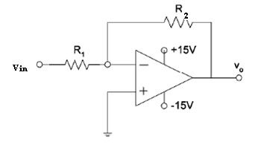
AF=-RF/R1=-(4700/470)=-10
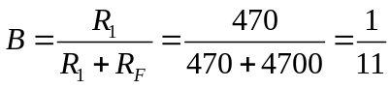
R_{i}= 2M
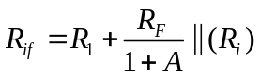=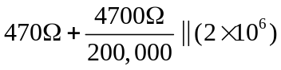
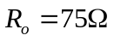

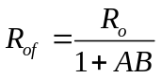=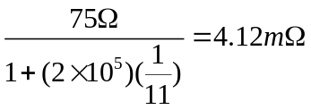
9. Draw and explain a square wave generator using op-amp. Find the frequency of the output wave.

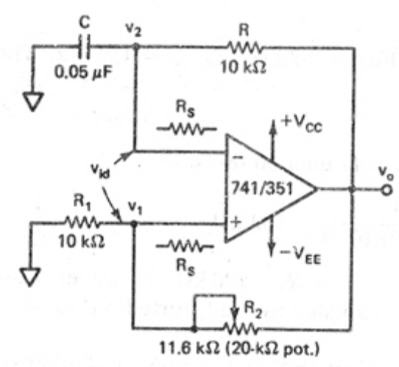
Square wave outputs are generated when the op – amp is forced to operated in the saturation region. That is, the output of the op –amp is forced to swing repetitively between positive saturation +Vsat and negative saturation –Vsat, resulting in the square wave output. This square wave generator is also called a free – running or astable multivibrator. The output of the op – amp in this circuit will be in positive or negative saturation.
Assume that the voltage across capacitor C is zero volts at the instant the dc supply voltages +Vcc and –Vee are applied. This means that the voltage at the inverting terminal is zero initially. At the same instant, the voltage V1 at the non inverting terminal is a very small finite value that is a function of the output offset voltage. Thus the differential input voltage Vid is equal to the voltage V1 at the non inverting terminal. Although very small, voltage V1 will start to drive the op – amp into saturation. For example, suppose that the output offset voltage is positive. Therefore, voltage V1 is also positive. Since initially the capacitor C acts as a short circuit, inverting terminal is at ground potential, V2=0 and gain of the op – amp is very large. The output equation of the op amp is; Vo = A x (V1-V2). Hence voltage at non inverting terminal, V1 drives the output of the op – amp to its positive saturation +Vsat. With the output voltage of the op – amp at +Vsat, the capacitor C starts charging toward +Vsat. However, as soon as the voltage V2 across the capacitor C is slightly more positive than V1, the output of the op – amp is forced to switch to a negative saturation, -Vsat.
With the op – amp’s output voltage at negative saturation, -Vsat, the voltage V1 across R1 is also negative, since
V₁=-Vsat [R1/ (R1+R2)]

Thus the net differential voltage Vid = V1 – V2 is negative, which holds the output of the op – amp in negative saturation. The output remains in negative saturation until the capacitor C discharges and then recharges to a negative voltage slightly higher than –V1. Now, as soon as the capacitor’s voltage V2 becomes more negative than –V1, the net differential voltage Vid becomes positive and hence drives the output of the op – amp back to its positive saturation +Vsat. This completes one cycle. With output at +Vsat, voltage V1 at the non inverting input is
V₁=Vsat [R1/ (R1+R2)]
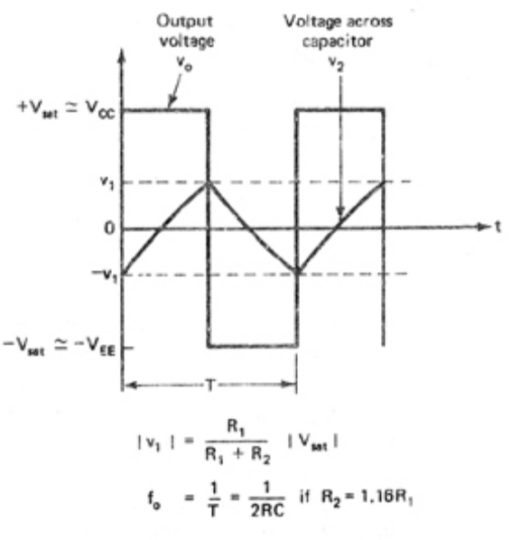

The frequency of the output can be calculated as follows:
The instantaneous voltage across the capacitor at any time t is given by
V _{c}(t)=V _{final} +(V _{initial} - V _{final ) e} ^{–t/RC ……………….(1)}

Taking one half cycle of the output(T1)
V _{c} (t) =V _{c} (T1) = β V _{sat}
V _{final =} V _{sat}

V _{initial =} -β V _{sat}

Substituting these values in equation (1)
β V _{sat =} V _{sat -} V _{sat}(1+β) ) e –T1/RC

V _{sat} (1+β) e ^{–T1/RC} = V _{sat -} β V _{sat}

e ^{–T1/RC} =(1- β)/ (1+β)

T1=RC ln(1+ β)/ (1-β)

Period=2T1=2RC ln(1+ β)/ (1-β)
Frequency =1 / (2RC ln(1+ β)/ (1-β)) where β=R1/(R1+R2)

10. Draw and explain the circuit of integrator using op-amp. What is its practical limitation? What modification in the circuit is done to overcome it?
A circuit in which the output voltage waveform is the integral of the input voltage waveform is the integrator or the integration amplifier. Such a circuit is obtained by using a basic inverting amplifier configuration if the feedback resistor R_{f} is replaced by a capacitor C_{f.}
Integrator is a circuit whose output is proportional to the area of its input waveform. Figure depicted below is an op – amp integrator.
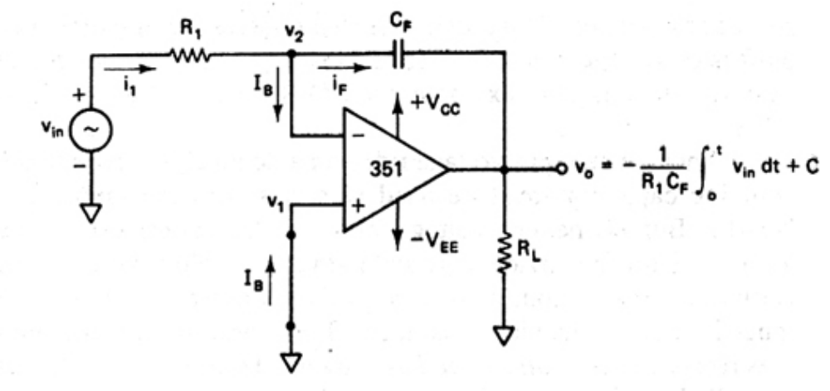
Practical Integrator
• When Vin =0, the basic integrator works as an open loop amplifier.
• This is because the capacitor C, acts as an open circuit to the input offset voltage.
• In other words, the input offset voltage and the part of the input current charging
capacitor ‘C’ produces the error voltage at the output of the integrator.
• Therefore, in the practical integrator shown below, to reduce the error voltage at the
output, a resistor Rf is connected across the feedback capacitor C.
• Thus, Rf limits the low-frequency gain and hence minimizes the variations in the output
voltage.

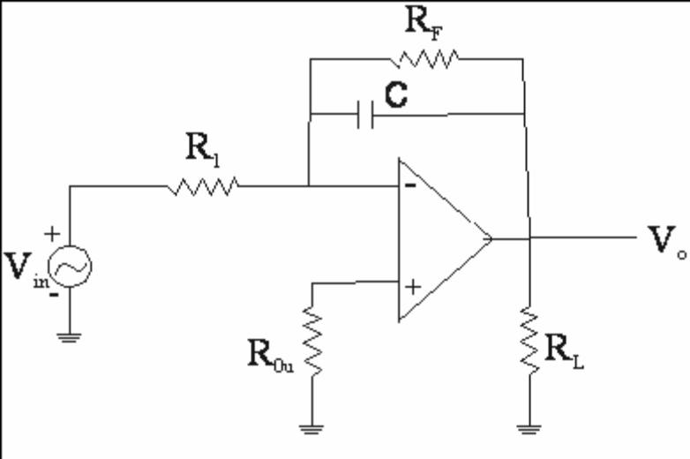

Frequency Response
The frequency response of the basic integrator is shown below:
• In this figure, fb is the frequency at which the gain is 0dB and is given by
f _{b}=1/2ΠRC
• Both the stability and the low-frequency roll-off problems can be corrected by the
addition of a resistor Rf as shown in the practical integrator.
• The frequency response of the practical integrator is shown in the figure above by dashed
line.
• In the figure, for frequencies f to fa the gain RF/R1 is constant.
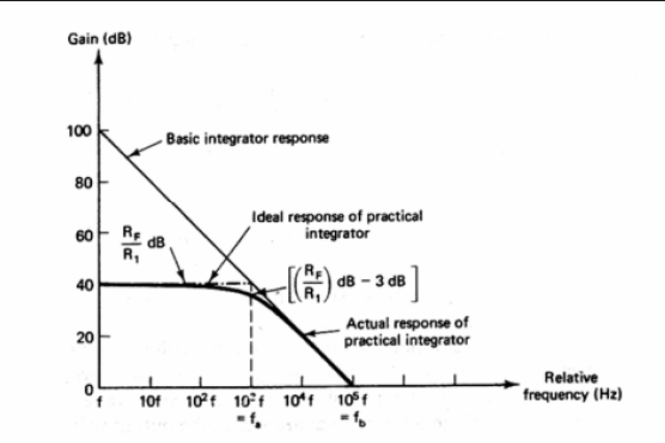
• However, after fa, the gain decreases at a rate of 20dB/decade.
• In other words, between fa and fb the circuit (practical integrator) acts as an integrator.
• The gain-limiting frequency fa is given by

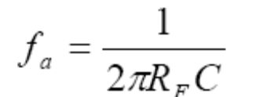

PART C
(All Questions carry 4 Marks)

11. Discuss the properties of an ideal op – amp.
( a ) Infinite open loop gain
( b )Infinite input impedence
( c )zero output impedence
( d ) zero ouput offset voltage
( e )Infinite bandwidth
(f) Infinite CMRR
(g) Infinite Slew rate

12. With circuit diagram explain the working of a regenerative comparator.

• The circuit below shows an inverting comparator with positive feedback, which converts an irregular shaped waveform to a square wave or pulse.
• The circuit is known as the Schmitt Trigger or squaring circuit

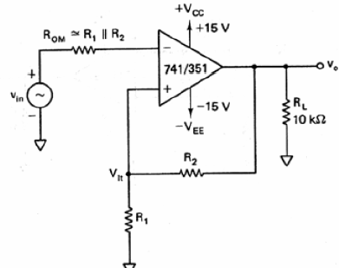

• The input voltage Vin triggers the output V0 every time it exceeds certain voltage level
called the upper threshold voltage Vut and lower threshold voltage Vlt.
• The voltage across R1 is fed back to the (+) input and is a variable reference threshold
voltage that depends as the value and polarity of the output voltage V0.
• When V0 = + Vsat, the voltage across R1 is called the upper threshold voltage, Vut
V ut=V satx(R1/R1+R2)

• On other hand, when V0 = - Vsat, the voltage across R1 is referred to as lower threshold
voltage.
• When the input voltage is slightly more than Vut, the output V0 will switch from +Vsat to –Vsat
• Therefore, as long as Vin < Vut, V0 is at +Vsat.
• When Vin is slightly more negative than Vlt, V0 will switch from - Vsat to +Vsat.
• Therefore, as long as Vin >Vlt, V0 is at –Vsat.

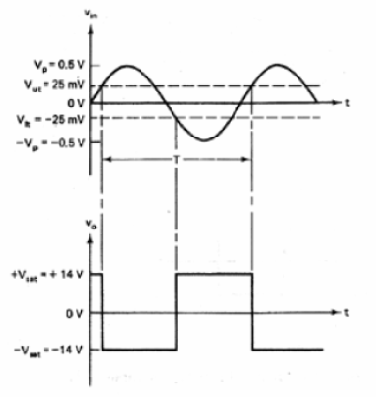
The comparator with positive feed back is said to exhibit hysteresis, a dead band condition.

• That is, when the input of the comparator exceeds Vut its output switches from +Vsat to
–Vsat and reverts back to +Vsat when the input goes below Vlt.
• The hysteresis voltage is equal to the difference between Vut an Vlt
• Therefore,
Vhysterisis = Vut – Vlt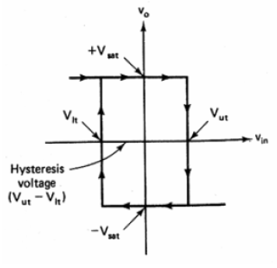

13. Discuss CMRR and slew rate of an op-amp.

CMRR:When the same input voltage is applied to both input terminals of an op –amp, the op – amp is said to be operating in a common mode configuration. Since the input voltage applied is common to both the inputs, it is referred to as a common mode voltage , Vcm. A common mode voltage can be a.c., d.c., or a combination of both.

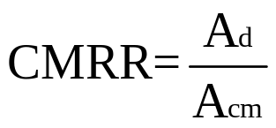
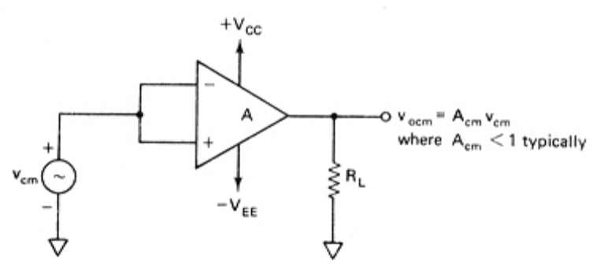
Figure : Common Mode

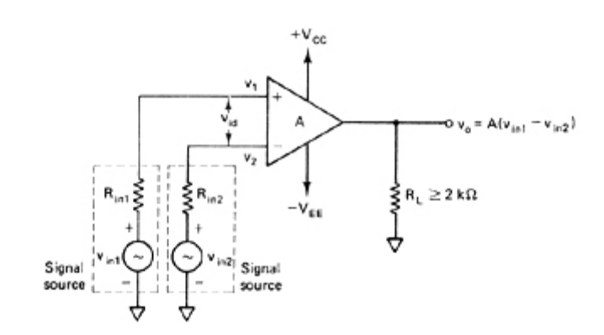
Figure : Differential Mode
Because ideally an op –amp amplifies only differential input voltages. No common – mode output voltage, Vocm, should appear at the output. However, due to imperfection within an actual op –amp, some common – mode voltage, Vocm will appear at the output. The amplitude of this Vocm is very small and often insignificant compared to
Vcm. Therefore, in practice the ratio of the output common – mode voltage Vocm to the input common – mode voltage Vcm, which is called the common – mode voltage gain
Acm, is generally much smaller than 1.

This equation indicates that the higher the value of CMRR, the smaller will be the amplitude of the output common – mode voltage Vocm. Generally, the CMRR value is very large and is therefore usually specified in decibels(dB).
Slew Rate: Slew Rate is defined as the maximum rate of change of output voltage per unit of time and is expressed in volts per microseconds.

In equation form,
SR = dVo│max V/µS
dt

Slew Rate indicates how rapidly the output of an op – amp can change in response to changes in the input frequency. The slew rate changes with change in voltage gain and is normally specified at unity (+1) gain. The slew rate of an op – amp is fixed: therefore, if the slope requirements of the output signal are greater than slew rate, then distortion occurs.
PART D
(8 Marks)
14. With figure explain a differential summing amplifier using op-amp for four inputs V_{A},V_{B},V_{C} and V_{D} to get output V_{O}=-2 V_{A} +2 V_{C} -3V_{B}+3 V_{D} .
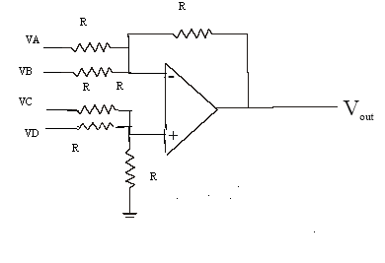

Figure above shows the circuit of a simple differential amplifier in which all the resistances are equal and hence the gain with which each input is amplified is also unity.
But in the given question each input are amplified by different gain .Hence we have to correspondingly adjust the series resistors and feedback resistors to obtain the desired gain.
Initially let us fix the feedback resistor at R.
The net output voltage can be obtained using superposition theorem.
V_{o} = V _{OA} + V _{OB} + V _{OC} + V _{OD ,} Where V _{OA} + V _{OB} + V _{OC} + V _{OD} are the outputs due to V _{A} , V _{B} , V _{C} , V _{D} respectively with all other inputs grounded.

Output due to V _{A}

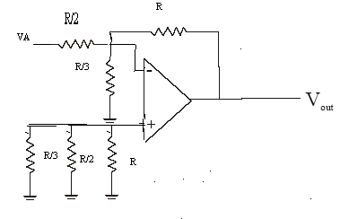
When we are considering V _{A} alone V _{B}, V _{C} and V _{D} are grounded.
Let the feedback resistor value be fixed at R.Now by varying the value of series resistance at the different inputs we can obtain the desired gain.
Since V _{A IS} amplified twice and V _{B} is amplified thrice we can select the value of series resistor for V _{A} as R/2 and V _{B} as R/3.Similarly since V _{C IS} amplified twice and V _{B} is amplified thrice we can select the value of series resistor for V _{C} as R/2 and V _{D} as R/3.

The modified circuit then acts as an inverting amplifier in which the inverting input is at virtual ground. (V2=0) where V2 is the voltage at the inverting terminal and V1 is the voltage at the noninverting terminal.

Since the inverting input is at virtual ground both ends of R/3 are at ground potential. So it may be omitted when we calculate V2.

V _{OA} = - R V _{A} = -2 V_{A} (gain of an inverting amplifier is –Rf/R1)
R/2
Output due to V _{B}
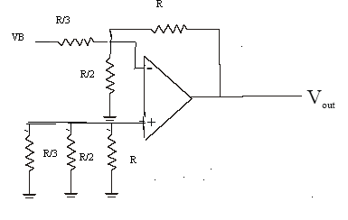

When we are considering V _{B} alone V _{A}, V _{C} and V _{D} are grounded.
The modified circuit then acts as an inverting amplifier in which the inverting input is at virtual ground. (V2=0) where V2 is the voltage at the inverting terminal and V1 is the voltage at the noninverting terminal.
Since the inverting input is at virtual ground both ends of R/2 are at ground potential. So it may be omitted when we calculate V2.

V _{OB} = - R V _{B} = -3 V_{B}
R/3

Output due to V _{C}

At the non inverting terminal R/3 || R = R/4
R/4
V1=V_{C} ₌ Vc/3
R/2 +R/4

V_{OC} = (1+Rf/R1).V1
Here R f=R and R= R/2 || R/3=R/5
Therefore V_{OC} = (1+R/(R/5)).V1=6 V1=6 Vc/3=2 Vc

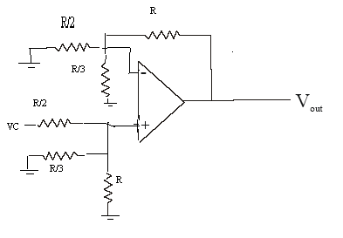

Output due to V _{D}
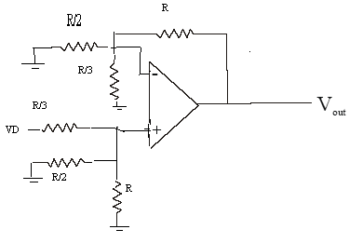

At the non inverting terminal R/2 || R = R/3
R/3
V1=V_{D} ₌ V_{D}/2
R/3 +R/3

V_{OD} = (1+Rf/R1).V1
Here R f=R and R= R/2 || R/3=R/5
Therefore V_{OD} = (1+R/(R/5)).V1=6 V1=6 V_{D}/2=3 V_{D}
Net output voltage V_{o} = V _{OA} + V _{OB} + V _{OC} + V _{OD}
Substituting the values of V _{OA} , V _{OB} , V _{OC} and V _{OD} in the above equation we get

V_{O}=-2 V_{A} +2 V_{C} -3V_{B}+3 V_{D}

