Voltage Regulator LM 723

LM723/LM723C
Voltage Regulator

General Description

The LM723/LM723C is a voltage regulator designed primarily for series regulator applications. By itself, it will supply output currents up to 150 mA; but external transistors can be added to provide any desired load current. The circuit features extremely low standby current drain, and provision is made for either linear or foldback current limiting.
The LM723/LM723C is also useful in a wide range of other applications such as a shunt regulator, a current regulator ora temperature controller.The LM723C is identical to the LM723 except that the LM723C has its performance guaranteed over a 0°C to +70°C temperature range, instead of −55°C to +125°C.

Features

- 150 mA output current without external pass transistor
- Output currents in excess of 10A possible by adding
- external transistors
- Input voltage 40V max
- Output voltage adjustable from 2V to 37V
- Can be used as either a linear or a switching regulator
Connection Diagrams

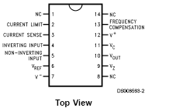
Equivalent Circuit

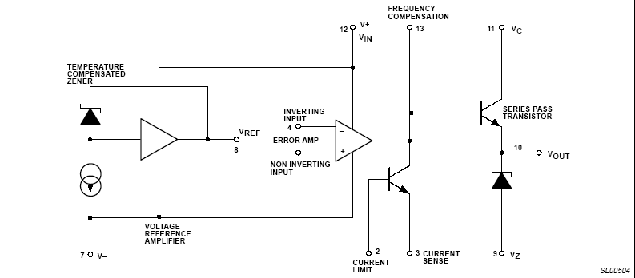

Typical Application

LOW VOLTAGE REGULATOR
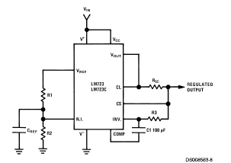

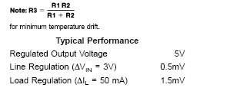

HIGH VOLTAGE REGULATOR
