T 403 Name: …………………
Reg. No: ………………

RAJAGIRI SCHOOL OF ENGINEERING AND TECHNOLOGY
SECOND INTERNAL EXAMINATION – 2007
FOURTH SEMESTER – INFORMATION TECHNOLOGY
Linear Integrated Circuits & Applications
Max.Marks: 50 Time: 2 hours
Answer All Questions
PART A
(All Questions carry 1 Mark)
- 1. The number of comparators in a parallel conversion type 8 bit Analog-to-Digital converter is ……………

- Ans: 2 ^{N}-1 =2 ⁸-1 =255
2. A 3 bit weighted resistor DAC has V_{R} = 2V and R _{f} /R = 2, where R _{f} is the feedback resistor and R is the resistor corresponding to MSB. For an input of 100, the output will be ……………..
Ans: V_{out} = -I R _{f} = - V_{R} (b₂ / R + b₁ / 2R + b₀ / 4R) R _{f}
₌ - V_{R} (b₂ / R) R _{f}
₌ - V_{R} (R _{f} / R) =-4V
- 3. A 12 bit ADC is operating with a 1µsec clock period and total conversion time is seen to be 13 µsec. The ADC must be of the …………….
- Ans:d. Successive approximation
  - For an n-bit Successive approximation total conversion time is seen to be n clock period
- 4. Dual slope integrating type ADC provide:
- Ans: b. Very good accuracy without putting extreme requirement on component stability
- 5. In a 4-bit weighted resistor DAC, the resistor value corresponding to LSB is 32KΩ. The resistor value corresponding to MSB is ……………
Ans: R / 2 ^{n-1}=R/2 ³=4 KΩ
PART B
(All Questions carry 5 Marks)
6. The simplified block diagram of a 10-bit ADC of dual slope integrator type is shown below. The 10-bit counter at the output is clocked by a 1 MHz clock. Assuming negligible timing overhead for the control logic, what is the maximum frequency of the analog signal that can be converted using this ADC?

I/P sample Digital
Integrator, Comparator &
Control Logic
10-bit binary counter
O/P

Reference Input

Ans:
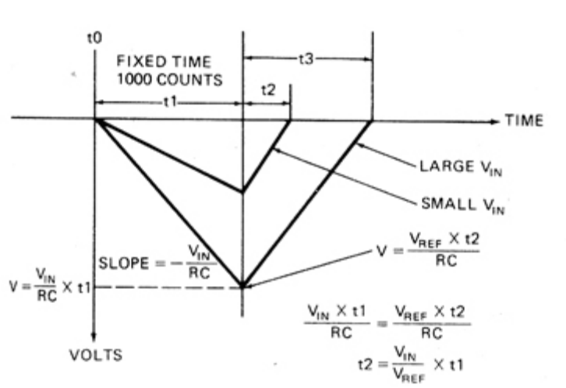

The waveform for dual slope integrator is shown. The maximum frequency that can be attained when t2-t1 =0 and as t1=2 ^{N} T _{c} ,( T _{c} is the clock period) is F _{max} given by

F _{max}= 1/ (2 ^{N} T _{c}) =fc/2 ^{N}
= 1 MHz /2 ¹⁰ =10 ⁶ / 1024 = 1 KHz (approximately)
7. With the help of necessary waveforms explain the working of an op-amp monostable multivibrator.
Ans: Monostable multivibrator has one stable state and one quasistable state. It is used for generating single output pulse of adjustable duration in response to a triggering signal. 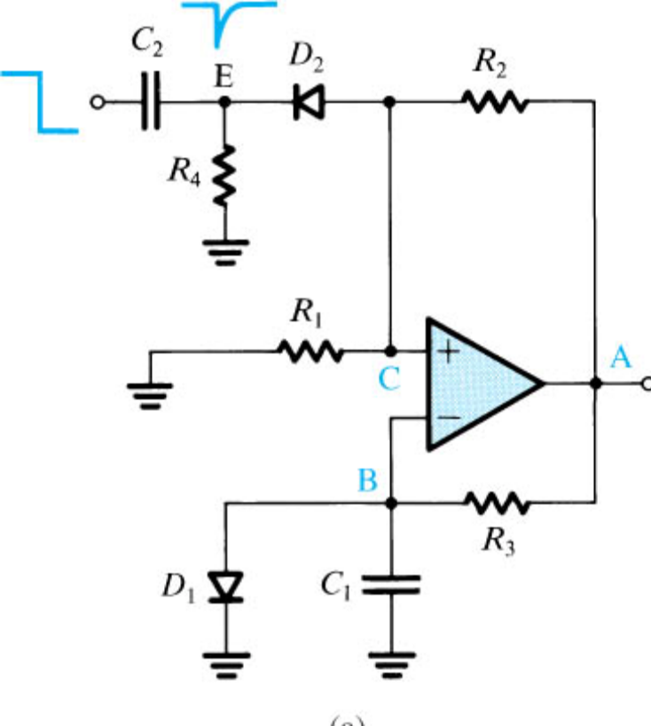

Diode D₁ clamps the capacitor voltage to 0.7 V when the output is at + V_{sat.} A negative going pulse passing through R4-C2 differentiator produces a negative going trigger pulse and is applied to the non inverting input.
Assume that in the stable state the output is at + V_{sat.} D₁ conducts and Vc gets clamped to 0.7 V.Voltage at the noninverting input through R1-R2 is βV_{sat,} where
β = R₁/ (R₁+R₂)
If a negative trigger of proper magnitude is applied to the non-inverting input so that effective signal at this terminal is less than 0.7 V the output of the op-amp is switched from + V_{sat} to ₋ V_{sat.} D₁ will get reverse biased and capacitor starts charging exponentially through R to ₋ V_{sat.} Now the voltage at the non inverting input is ₋ βV_{sat}. When the capacitor voltage becomes more negative than- βVsat the output switches back to + Vsat.C₁ starts charging to + Vsat through R until C₁ gets clamped to 0.7 V.
The voltage waveforms at points A, B, C, and E in the circuit are shown below :( L ₊ and L ₋ represent + Vsat and - Vsat respectively.)

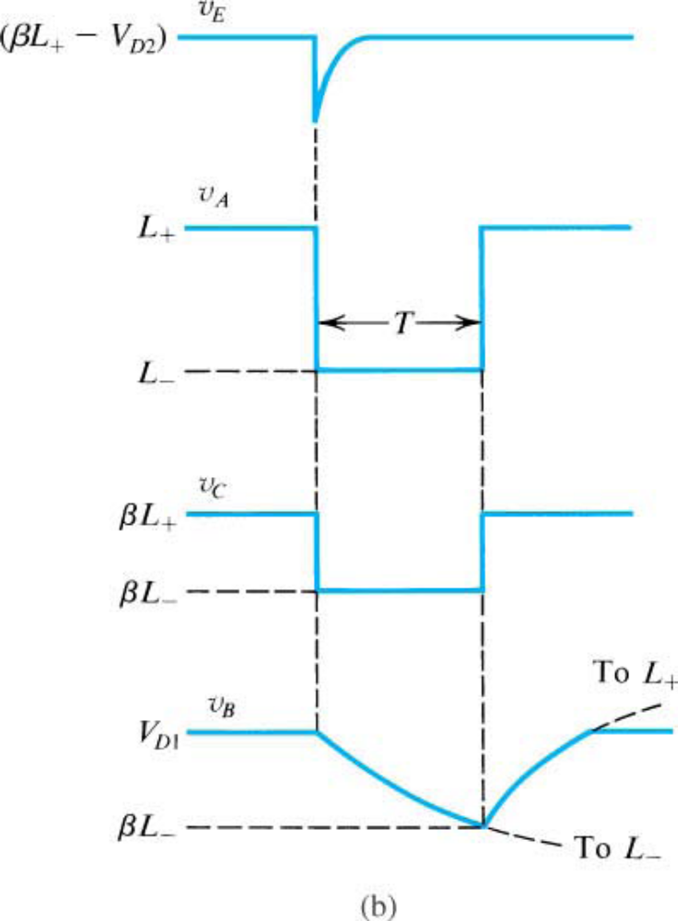

8. What are the advantages and disadvantages of Switching regulator compared to Series regulator?

Linear regulator Vs Switching regulator

 | Linear regulator | Switching regulator
1 | Based on devices that operate in the linear region | Based on devices those are forced to operate in the saturation/cut-off region (ON/OFF switch).
2 | Usually consist of a transistor operating in the active region which operates as a variable resistor. | Consist of a switch and a controller which regulates the rate at which energy is transferred.
3 | The difference between unregulated input voltage and regulated output voltage is dropped across series pass transistor | Works by taking small chunks of energy bit by bit from the input source and moving them to the output
4 | Used for powering low powered devices | Used when power efficiency is critical.
5 | Wastage of power is more.So efficiency is of the order of 40% | Energy loss is negligible. So efficiency may be as high as 85%
6 | Conversion efficiency decreases as input-output differential increases. | Efficiency is independent of input voltage.
7 | Easy to use, cheap and popular | Complex to design.
8 | Less amount of noise | Noise is more.
9 | Fast response to input and output disturbances. | Slower response
10 | Cheaper for lower power levels | Cheaper for higher power levels
11 | Can only step down the input voltage | Also can step up the input voltage
12 | Only related to input voltage | Duty cycle of the switch sets the amount of charge delivered to the load
9. Find the current through resistance ‘r’ in the circuit shown below: 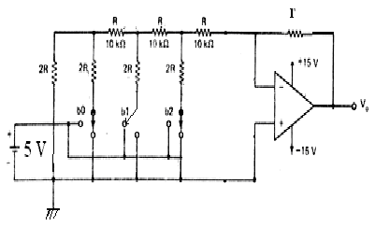

Ans:
Starting the analysis from the left
2R 2R =R,Then R+R=2R
5 V(b₁) and two 2R resistors in parallel can be thevenized into a 2.5 V source in series with the parallel combination of 2R and 2R.i.e.R.This R and the next series resistor R makes 2R.Now 2.5 V with two 2R resistors in parallel can be thevenized into a 1.25 V source in series with R.Now the equivalent circuit consist of a 1.25 V source in series with 2R and the feedback resistor “ r “.
By the property of virtual ground, since the non inverting terminal of the op-amp is at ground potential, the voltage at the inverting input terminal is also zero.
Therefore, Current through “r “= Current through 2R (since current flowing into the op-
amp is zero)
=1.25/2R

=1.25/20 K
=0.0625 mA
10. The output V₀ of an N bit DAC is given by

V₀= (2 ^{N-1}a_{N-1}+ 2_{N-2}a _{N-2}+…..2²a₂+2¹ a₁+a₀) K
A six bit DAC gives V₀=3.6 V for the word 100100.What is the value of V₀ for the word 110011?
Ans:
The output voltage is given by
V₀= (2 ^{N-1}a_{N-1}+ 2_{N-2}a _{N-2}+…..2²a₂+2¹ a₁+a₀) K
For the word 100100
V₀= (2 ⁵+2²) K=3.6 V
36 K=3.6
K=0.1
For the word 110011
V₀= (2 ⁵+2 ⁴+2¹+2⁰) K
=51 K=5.1V
PART C
(All Questions carry 4 Marks)
11. What is the hysterisis voltage of the Schmitt trigger shown if Vsat = + 10V:
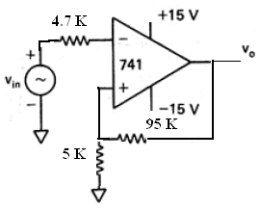

Ans:
V _{UTP} = +Vsat( R₂ / (R₁+R₂) )
= 10( 5K / (5K+95K) )
= 10(5/100) =0.5V

V _{LTP} = -Vsat( R₂ / (R₁+R₂) )
= -10( 5K / (5K+95K) )
= - 10(5/100) = -0.5V

Hysteresis voltage= V _{UTP} - V _{LTP =}0.5-(-0.5) =1V

12. What is a hybrid converter?
As the number of inputs of binary – weighted DAC or R – 2R ladder DAC, is increased beyond four, both DAC circuits get complex and their accuracy degenerates. Therefore, in critical applications an integrated circuit specially designed as a DAC should be used.
At present, 8, 10, 12, 14, 16 bit D/A converters are available with either a current output, a voltage output, or both current and voltage output. The MC1408L is a common 8 – bit monolithic D/A converter with a current output that can be converted to a voltage type by using a current – to – voltage op – amp.
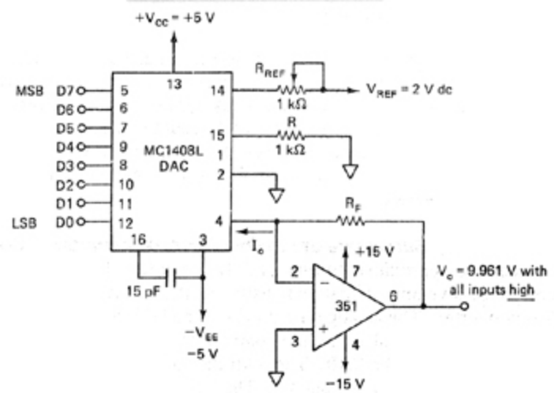

Output voltage equation of MC1408L is
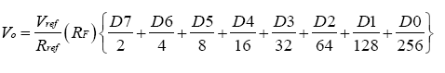
Typical application for D/A converters include microcomputer interfacing, CRT graphics generation, programmable power supplies, digitally controlled gain circuits, digital filters and others.

13. Explain the working of a triangular wave generator using op amp.

Ans:
A triangular wave generator can be formed by simply connecting an integrator to the square wave generator. The resultant circuit is shown below. The output of the square wave generator is applied as the input to the integrator. The output of an integrator is a triangular wave.
Another triangular wave generator, shown in figure given below, consists of a comparator and an integrator. The comparator compares the output voltage at point P continuously with the inverting input that is at 0V. When the voltage at P goes slightly below or above 0V, the output of the comparator is at the negative or positive saturation level, respectively.
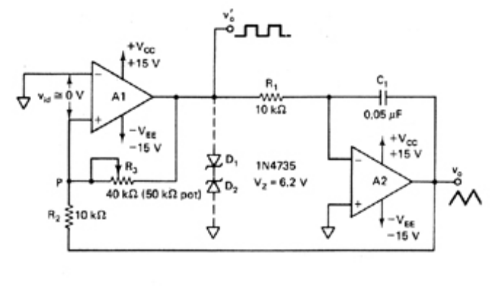
Assume that the output of comparator at positive saturation +Vsat. This +Vsat is an input of the integrator. The output of integrator therefore will be a negative – going ramp. Thus one end of the voltage divider R2-R3 is the positive saturation voltage +Vsat of comparator and the other is the negative – going ramp of integrator. When the negative – going ramp attains a certain value – Vramp, point P is slightly below 0V; hence the output of comparator will switch from positive saturation to negative saturation – Vsat. This means that the output of integrator will now stop going negatively and will begin to go positively. The output of integrator will continue to increase until it reaches +Vramp. At this time the point P is slightly above 0V; therefore, the output of comparator is switched back to the positive saturation level +Vsat. The sequence then repeats.
PART D
(8 Marks)
14. With an example, explain the working of a successive approximation ADC.
The successive approximation technique uses a very efficient code search strategy to complete n – bit conversion in just n – clock periods. An eight bit converter would require eight clock pulses to obtain a digital output. The circuit uses a successive approximation register (SAR) to find the required value of each bit by trial and error method. The SAR output is applied to an 8 – bit D/A converter. The analog output (Vd) of the D/A converter is then compared to an analog input signal Va by the comparator. The output of the comparator is a serial data input to the SAR. The SAR then adjusts its digital output (8 bits) until it is equivalent to analog input Va. The 8 – bit latch at the end of conversion holds onto the resultant digital data output.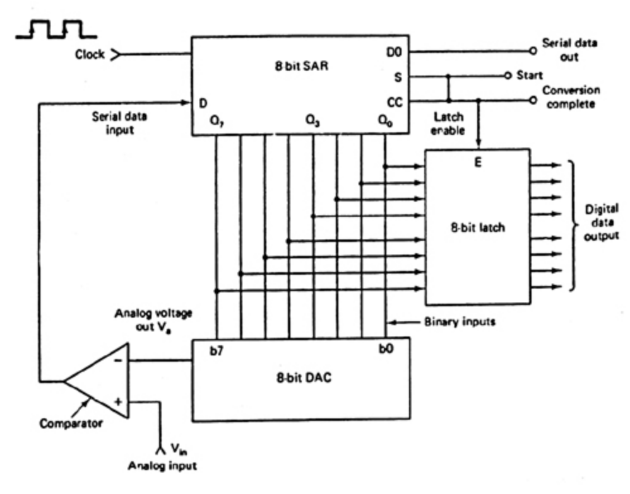
The circuit operates as follows. With the arrival of the START signal, the SAR sets the MSB Q₇=1 with all other bits to zero so that the trial code is 10000000. The output Vd of the DAC is now compared with analog input Va. If Va is greater than the DAC output Vd then 10000000 is less than the correct digital representation. The MSB is left at ‘1’ and the next lower significant bit is made ‘1’ and further tested.
However, if Va is less than the DAC output, then 10000000 is greater than the correct digital representation. So reset MSB to ‘0’ and go on to the next lower significant bit. This procedure is repeated for all subsequent bits, one at a time, until all bit positions have been tested. As soon as the LSB Q₀ is tried, the SAR forces the conversion complete
(CC) signal HIGH to indicate that the parallel output lines contains valid data. The CC signal in turn enables the latch, and digital data appear at the output of the latch.
The table given below shows a typical conversion sequence of Successive Approximation ADC. 