T404

RAJAGIRI SCHOOL OF ENGINEERING AND TECHNOLOGY
B. TECH DEGREE FOURTH SEMSTER FIRST SERIES EXAMINATION
APRIL 2007

COMPUTER SYSTEM ARCHITECTURE – ANSWER KEY
Branch: Information Technology
PART A

- interrupt
- Instruction register
- operating system
- Memory Function Complete
- 1010101
- instruction fetch and instruction execution
- -1
PART B
- a. Z=Y
b. Z=M[Y]
c. Z=Y+X

- A. Index
b. Autodecrement
c. Immediate

- a. Single address
b. Zero address
c. Two address

- The expression for s_{i} and c_{i+1} of stage i are
s_{i} = x_{i} y_{i} z_{i}
c_{i+1} = x_{i}y_{i} + (x_{i} + y_{i})c_{i}
c_{i+1} = G_{i} + P_{i}c_{i} where G_{i} = x_{i}y_{i} and P_{i} = x_{i} + y_{i}
c_{i+1} = G_{i} + P_{i}G_{i+1} + P_{i}P_{i-1}G_{i-2} + ….. + P_{i}P_{i-1} … P₁G₀ + P_{i}P_{i-1 …….} P₀c₀
c₄ = G₃ + P₃G₂ + P₃P₂G₁ + P₃P₂P₁G₀ + P₃P₂P₁P₀c₀
c₄ = 1 + 1.0 + 1.0.1 + 1.0.1.0 + 1.0.1.1.0 = 1

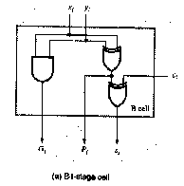
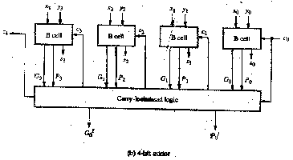

- With a crossbar full connectivity is given, i.e. all processors can communicate with each other simultaneously without reduction of bandwidth. The connection of n processors with m memory modules (as in a shared memory system) is shown. Certainly crossbars can also be used to connect processors with each other. In that case the memory modules are connected directly to the processors (which results in a distributed memory system), and the lines that were connected to the memory modules Mi are now connected to the processors Pi. To connect n processors to n memory modules n² switches are needed. Consequently, crossbar networks can not be scaled to any arbitrary size. Today's commercially available crossbars can connect up to 256 units.

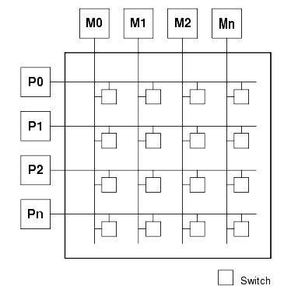

PART C

M = 10101
C A Q
0 00000 00101
0 10101 00101 Add I cycle
0 01010 10010 Shift
0 01010 10010 No Add II cycle
0 00101 01001 Shift
0 11010 01001 Add III cycle
0 01101 00100 Shift
0 01101 00100 No Add IV cycle
0 00110 10010 Shift
0 00110 10010 No Add V cycle
0 00011 01001 Shift
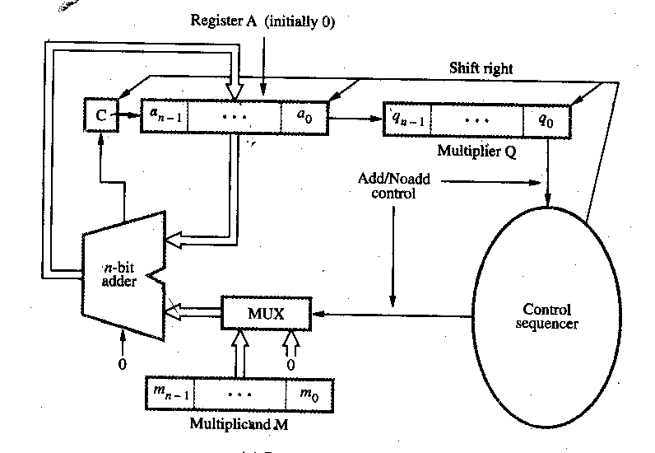
- Quotient : 0010
Remainder: 00010
PART D

- (a) Add the contents of the memory location whose address is at memory location NUM to register R1.
- PC_{out}, MAR_{in}, Read, Select 4, Add, Z_{in}
- Z_{out}, PC_{in}, Y_{in}, WMFC
- MDR_{out}, IR_{in}
- Address field of IR_{out}, MAR_{in}, Read
- R2_{out}, Y_{in}, WMFC
- MDR_{out}, MAR_{in}, Read
- WMFC
- MDR_{out}, Select Y, Add, Z_{in}
- Z_{out}, R2_{in}, End
  - Store R2, LOC where LOC is a memory address.
- PC_{out}, MAR_{in}, Read, Select 4, Add, Z_{in}
- Z_{out}, PC_{in}, Y_{in}, WMFC
- MDR_{out}, IR_{in}
- Address field of IR_{out}, MAR_{in},
- R2_{out}, MDR_{in}, Write, WMFC

Flowchart for Booth’s algorithm
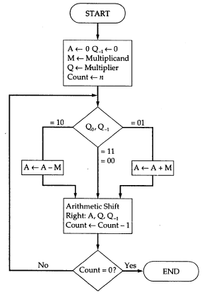
Multiplier recoded using Booth’s algorithm is 0 –1 +1 0 –1 0
0 1 0 1 1 1
0 -1 +1 0 -1 0

1 1 1 1 1 1 0 1 0 0 1 0
0 0 0 0 1 0 1 1 1
1 1 1 0 1 0 0 1
1 1 1 1 0 0 0 1 1 0 1 0

