RAJAGIRI SCHOOL OF ENGINEERING AND TECHNOLOGY
Rajagiri Valley, Kochi -39


TEACHING NOTES
RT503 – DATABASE MANAGEMENT SYSTEMS
MODULE 1 – DBMS Basic Concepts

for

B.TECH. COMPUTER SCIENCE & ENGINEERING BRANCH
FIFTH SEMESTER

June 2009

Prepared By

K. S. Mathew,
Associate Professor, Dept. of CSE

Table of Contents

1. Introduction to Database Systems 3
1.1 Basic Concepts 3
1.2 History of DBMS 4
1.3 Disadvantages of file system 7
1.4 Advantages of DBMS 8
1.5 Disadvantages of DBMS 9
1.6 DBMS Facilities 10
1.7 DBMS Users 10
1.8 DBMS Components 12
1.9 Data Models 14
1.10 DBMS Architecture and Data Independence 17
1.11 Entity Relationship Model 19

Introduction to Database Systems

Basic Concepts
Data are raw facts and figures that constitute building blocks of some information. Database is a collection of information or “persistent data” and a means to manipulate data in a useful way, which must provide proper storage for large amounts of data, easy and fast access and facilitate the processing of data. Database Management System (DBMS) is a set of software that is used to define, store, manipulate and control the data in a database.

A Database System is a computerized record keeping system whose overall purpose is to store information and to allow users to retrieve and update that information on demand. Database system consists of a Database, Database Management System and an Application program.

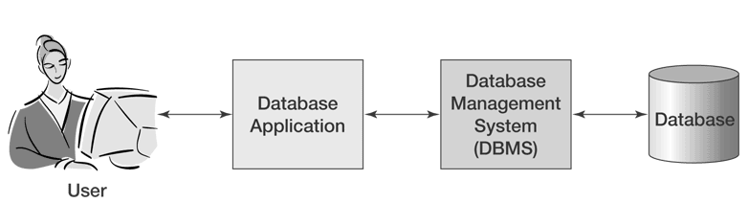
Fig. 1.1 – A Database System

The database is used by the database system (record keeping application system) of some organization. Examples of organizations are: a manufacturing company, a bank, a hospital, a university or a government department. The data in the database could be product data, account data, patient data, student data or planning data. A database has the following implicit properties:

- A database represents some aspect of the real world
- A database is a logically coherent collection of data
- A database is designed, built and populated with data for a specific purpose

For example: Student database

Roll No. | Name | Branch | % of Marks | Grade

In a database system, users access the database through an intermediate layer of software known as a Database Management System (DBMS). The objective of the DBMS is to provide a convenient and effective method of defining, storing, and retrieving the information contained in the database. The DBMS interfaces with application programs, so that the data contained in the database can be used by multiple applications and users. The popular DBMS are Oracle, IBM DB2, Microsoft SQL Server, Sybase, MySQL etc.

History of DBMS
Databases have been in use since the earliest days of electronic computing. But, the vast majority of older systems were tightly linked to the custom databases in order to gain speed at the expense of flexibility. Originally DBMSs were found only in large organizations with the computer hardware needed to support large data sets. As computers grew in capacity, this trade-off became unnecessary and many general purpose flexible database systems emerged. By mid-1960’s, there were a number of such systems in commercial use. Since then, database technology has gone through several transformations from flat-file system, to relational and object-relational systems during the last 40 years.
The Evolution of the Database
Ancient History: Data are not stored on disk; programmer defines both logical data structure and physical structure, such as storage structure, access methods, I/O modes etc. One data set per program: high data redundancy. There is no persistence; Random access memory (RAM) is expensive and limited, programmer productivity low.
1968 File-Based: Predecessor of database, Data maintained in a flat file. Processing characteristics determined by common use of magnetic tape medium.
- Data are stored in files with interface between programs and files. Mapping happens between logical files and physical file, one file usually corresponds to one programs
- Various access methods exits, e.g., sequential, indexed, random
- Requires extensive programming in third-generation language such as COBOL, BASIC.
- Limitations:
- Separation and isolation: Each program maintains its own set of data, users of one program may not aware of holding or blocking by other programs.
- Duplication: Same data is held by different programs, thus, wastes space and resources.
- High maintenance costs such as ensuing data consistency and controlling access
- Sharing granularity is very coarse
- Weak Security
Era of non-relational (Navigational) database: A database provides integrated and structured collection of stored operational data which can be used or shared by application systems. Prominent hierarchical database model was IBM’s first DBMS called IMS (Information Management System). Prominent network database model was CODASYL DBTG model - IDS (Integrated Data Store) developed by Charles Bachmann at Honeywell and IDMS (Integrated Database Management System) owned by Computer Associates were the most popular network DBMS.
Hierarchical data model
- Mid 1960s Rockwell partner with IBM to create information Management System (IMS), IMS lead the mainframe database market in 70’s and early 80’s.
- Based on binary trees. Logically represented by an upside down tree, one-to many relationship between parent and child records.
- Efficient searching; Less redundant data; Data independence; Database security and integrity
- Disadvantages:
- Complex implementation
- Difficult to manage and lack of standards, such as problem to add empty nodes and can’t easily handle many-many relationships.
- Lacks structural independence, and hence adds up application programming complexity.
Network data model
- Early 1960s, Charles Bachmann developed first DBMS at Honeywell, Integrated Data Store ( IDS)
- It was standardized in 1971 by the CODASYL group (Conference on Data Systems Languages)
- Identified 3 database component: Network schema—database organization; Subschema—view s of database per user; Data management language -- at low level and procedural
- Each record can have multiple parents:
  - Composed of sets relationships, a set represents a one--many relationship between the owner and the member
  - Each set has owner record and member record
  - Member may have several owners
- Main problem:
  - System complexity and difficult to design and maintain; Lack of structural independence
The distinction of storing data in files and databases is that databases are intended to be used by multiple programs and types of users.
1970-present Era of relational database and Database Management System (DBMS): Based on relational calculus, shared collection of logically related data and a description of this data, designed to meet the information needs of an organization; System catalog/metadata provides description of data to enable program-data independence; logically related data comprises entities, attributes, and relationships of an organization’s information. Data abstraction allows view level, a way of presenting data to a group of users and logical level, how data is understood to be when writing queries.
- 1970: Ted Codd at IBM’s San Jose Lab proposed relational models.
- 1974-79: System R at IBM san Jose Lab, later evolved into SQL/DS (in 1979) and then to DB2 (in 1983), which became one of the first DBMS product based on the relational model & SQL.
- 1976: Peter Chen defined the Entity-relationship(ER) model
- 1978: Larry Ellison released first version of Oracle (based on IBMs papers on System R) just prior to IBM’s SQL/DS & DB2.
- 1979: INGRES at University of California, Berkeley became commercial and followed by POSTGRES which was incorporated into Informix.
- 1980s: Maturation of the relational database technology, more relational based DBMS were developed and SQL standard adopted by ISO and ANSI.
- 1985: Object-oriented DBMS (OODBMS) develops. Little success commercially because advantages did not justify the cost of converting billions of bytes of data to new format.
- 1990s: incorporation of object-orientation in relational DBMSs, new application areas, such as data warehousing and OLAP, web and Internet, Interest in text and multimedia, enterprise resource planning (ERP) and management resource planning (MRP)
- 1991: Microsoft ships access, a personal DBMS created as element of Windows gradually supplanted all other personal DBMS products.
- 1995: First Internet database applications
- 1997: XML applied to database processing, which solves long-standing database problems. Major vendors begin to integrate XML into DBMS products.

Disadvantages of file system
In traditional application programs using file system, the data is stored in different files. Each application program will have its own set of files. The traditional file system approach has following disadvantages:

Difficulty in accessing information: It is not easy to get a list of data satisfying certain conditions from a file system. Specific program needs to be developed in order to get the data satisfying the specified conditions. Suppose, a teacher needs a list of students from the student file whose mark is greater than 500. In order to access this information, either we have to develop a program to satisfy this new request or take the list of students from the file system and extract the list needed manually. These methods are very time consuming and difficult.

Data redundancy & inconsistency: In file systems, the data may be duplicated. Consider a customer having two accounts – a savings bank account and a fixed account – with a bank. In this case, the address of the customer is stored in two account files. This duplication will result in need of high storage space and this will also lead to inconsistency. That is, if the address of a customer changes then the change may be updated only in one account file.

Data isolation: Data are stored in different files and files are in different formats. So, it is difficult to extract appropriate data from different files.

Integrity problems: It is difficult to maintain data integrity in file system approach. The data constraints are implemented using programs. Hence, programs have to be written to add new constraints. The data integrity problems may arise if the application programs didn’t take care of all data constraints.

Atomicity problems: Atomicity of transactions cannot be maintained in file system approach. If any failure occurs during execution of a transaction program, then the execution stops. This leads to inconsistency of data in the database.

Concurrent access anomalies: Concurrent updates of files by multiple users will result in inconsistency of data.

Security problems: Difficult to enforce security constraint because application programs are added to the system in ad-hoc manner.

Advantages of DBMS
In a database system, the data is managed by the DBMS and all access to the data is through the DBMS facilitating effective data processing. In conventional data processing systems, each application program has direct access to the data it reads or manipulates.

In the conventional data processing application programs, the programs usually are based on a considerable knowledge of data structure and format. In such environment any change of data structure or format would require appropriate changes to the application programs. If major changes were to be made to the data, the application programs may need to be rewritten. In a database system, the database management system provides the interface between the application programs and the data. When changes are made to the data representation, the metadata maintained by the DBMS is changed but the DBMS continues to provide data to application programs in the previously used way. The DBMS handles the task of transformation of data wherever necessary.

Most of the disadvantages of file system discussed in section 1.2 are addressed in the DBMS approach. The specific advantages of using DBMS are listed below:

Centralized Data Management: The DBMS approach enables the organization to manage all its data centrally which will bring more control over the data. The database administrator (DBA) is the focus of the centralized control. Any changes required by the application in a data structure shall be taken-up with DBA so that he/she will ensure that the change won’t affect other applications.

Easy to access information: DBMS enables application programs to access data satisfying any conditions, from the database. So, it can satisfy the needs of different application programs without the need for writing specific application programs for accessing the data. The data access also becomes effective with the use of DBMS and hence it provides better services to the users.

Data redundancy & inconsistency can be removed: The use of DBMS allows sharing of data stored in a database by multiple application programs. So, the data need not be duplicated and only one copy of data needs to be maintained for use by different application programs. This helps in saving the storage space as well as maintaining the consistency of data. Consider a customer having two accounts – a savings bank account and a fixed account – with a bank. In this case, the basic customer details including address of the customer is stored only once in the bank’s database. This data will be shared by both Savings Bank & Fixed Deposit applications.

Data integrity can be improved: The data integrity means that the data contained in the database is both accurate and consistent. The integrity constraints on data/information are reasonably enforced by the DBMS. Thus, DBMS relieves the application programs from the responsibility of maintaining the data integrity. For example, the value for the age of a student may be in the range of 17 to 25. Another integrity check that can be incorporated in the database is to ensure that if there is a reference to certain object, that object must exist. For example, the database won’t allow a user to add a student in a non-existent ‘Branch’ of study.

Security can be improved: Some of the data may be very vital and confidential (eg. Financial and Salary data) for an organization. Such confidential data must not be accessed by unauthorized persons. DBMS provides security and authorization mechanisms for data access. Different levels of security could be implemented for various types of data and operations.

Data Independence: Three levels of abstraction in a database system help in providing data independence. Ie. Any changes in the physical storage device or organization of files can be made without requiring any changes in the application programs using the database. Similarly, application programs need not be changed if fields are added to an existing record or if a not used field is deleted from the record. This is not the case with file system approach. In file system approach, application programs need to be modified whenever a new field is added or removed.

Disadvantages of DBMS
In a high level view, the DBMS approach is better than the file system approach. However, there are few disadvantages in using and maintaining a DBMS which are explained below:

Cost of maintaining a database: The cost of developing and maintaining an application program using DBMS is lower than that in developing applications using file system. But, the hardware and software price for deploying and maintaining a DBMS is significant. Also, there would be an additional cost for migration of data from the traditional file system to database system.

Confidentiality, Privacy and Security: The data of an entire organization is centralized and is shared by all the employees of the organization. This increases the potential severity of security breaches and disruption of operation of the organization because of downtimes and failures. To reduce the chances of unauthorized users accessing sensitive information, it is necessary to take technical, administrative and, possibly, legal measures. DBMS facilitates implementing mechanisms for confidentiality, privacy and security of data in the database. However, the processing overhead introduced by the DBMS to implement security & confidentiality of data causes a degradation of the response and through-put times.

The replacement of a monolithic centralized database by a group of independent and cooperating distributed databases resolves some of the problems resulting from failures and downtimes.

Complexity of Backup and Recovery: The central database approach reduces duplication. This lack of duplication requires that the database be adequately backed up so that in case of failure the data can be recovered. Backup and recovery operations are fairly complex in a DBMS environment, and this is aggravated in a concurrent multi-user database system.

DBMS Facilities
DBMS provides two main types of facilities called data definition facilities and data manipulation facilities. The list of data definition and data manipulation facilities provided by DBMS are given below:

- Create database, tables and supporting structures
- Maintain database structures
- Read and maintain database data
- Enforce data integrity rules
- Control concurrent data access
- Provide data security
- Perform backup and recovery

DBMS Users
The people/users involved in a database system environment can be classified into two groups namely (a) Actors on the scene and (b) Actors behind the scene. The actors on the scene include: database administrators, database designers, end users and application programmers/system analyst (software engineers). The actors behind the scene include: DBMS system designers and implementers, Tool developers and operators & maintenance personnel.

Database Administrators: Since many people use database resources concurrently in a database environment, there is a need for a chief administrator to oversee and manage these resources. In a database environment, the primary resource is the database itself and secondary resource is the DBMS and related software. Administering these resources is the responsibility of database administrator (DBA). The DBA is responsible for authorizing access to the database, for coordinating and monitoring its use, and for acquiring software and hardware resources as needed. The DBA is accountable for problems such as breach of security or poor system response time.

Database Designers: Database designers are responsible for identifying the data to be stored in the database and for choosing appropriate structures to represent and store this data. Database designers interact with each potential group of database users, in order to understand their requirements and come up with a design that meets the data and processing requirements of this group. The final database design must be capable of supporting the requirements of all user groups.

End Users: End users are categories of people who require access to the database for querying, updating and generating reports; the database primarily exists for their use. There are several categories of end users, which are listed below:

Casual end users: They are occasional database users, typically middle or high level managers, who need different information each time. Hence, they use sophisticated query language to get the information they need. Casual users learn only a few facilities that they may use repeatedly.

Naïve or parametric end users: Majority of database users fall under this category. Their main job function is to constantly querying and updating the database using standard types of queries and updates (called canned transactions) carefully programmed and tested in the application programs. These users include Bank tellers, Reservation clerks for railways, airline etc. Naïve users have to understand only the types of standard transactions designed and implemented for their use and they need to know only very little about the facilities provided by DBMS.

Sophisticated end users: These users include engineers, scientists, business analysts, and others who thoroughly familiarize themselves with the facilities of the DBMS so as to implement their applications to meet their complex requirements. Sophisticated users try to learn most of the DBMS facilities in order to achieve their complex requirements.

Stand-alone users: These are individuals who maintain personal databases by using functions provided by ready-made program packages through user friendly/simple interfaces. An example is the user of a tax package that stores a variety of personal financial data for tax purposes. Stand-alone users typically become very proficient in using a specific software package.

System Analysts and Application Programmers (Software Engineers): System Analysts determine the requirements of end users, especially naïve users, and develop specifications for canned transactions that meet these requirements. Application programmers implement these specifications by writing & testing programs. Such analysts and programmers (nowadays called software engineers) should be familiar with the full range of capabilities provided by the DBMS to accomplish their tasks.

DBMS people behind the scenes who are instrumental in making the database system available to end users, but not interested in database as such are given below:

DBMS System Designers and Implementers: They are people who design and implement DBMS software. They are not interested in the database as such.

Tool Developers: They are people who design and implement tools and software packages that facilitate database system design and use, and help improve performance. Tools include packages for database design, performance monitoring, natural language or graphical interfaces, prototyping, simulation, and test data generation.

Operators and Maintenance Personnel: They are the system administration people who are responsible for the actual running and maintenance of the hardware and software environment for the database system.

DBMS Components

The major components of a Database Management System are Data Manager, File Manager, Disk Manager, Query Processor, Data Files and Data Dictionary. A block diagram showing the interaction of various users with DBMS & its components is given below:

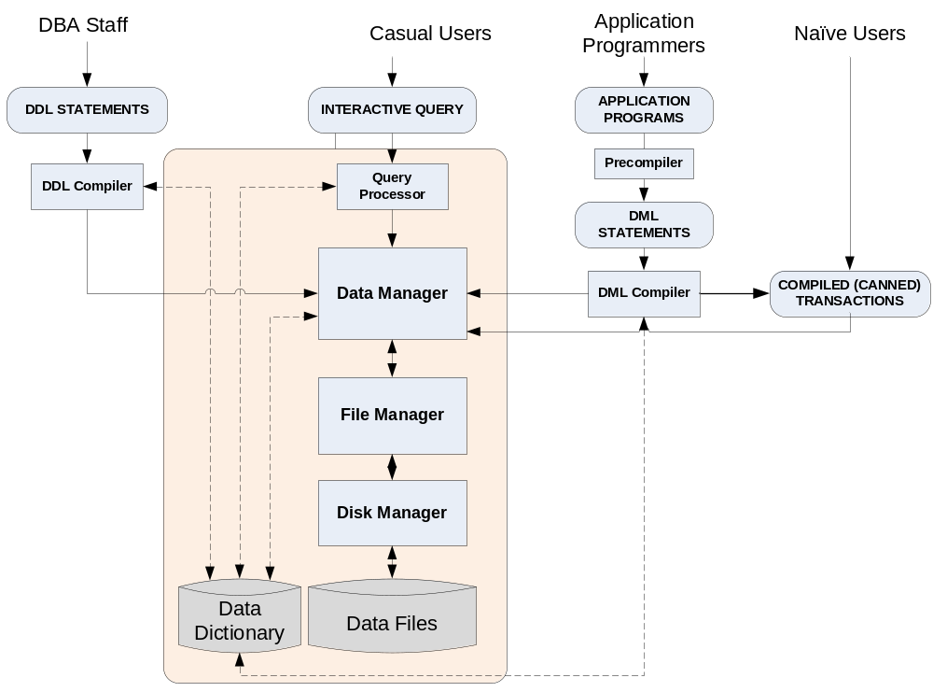
Fig. 1.2 – Structure of a DBMS

Data Manager: The data manager is the central software component of the DBMS. It is sometimes referred to as the database control system. Data Manager converts the user requests coming via query processor, DDL compiler, DML compiler or the canned transactions in an application from the user’s logical view to a physical file system. The data manager is responsible for interfacing with the file system on user’s behalf. In addition, enforcing data consistency, integrity and security, backup and recovery, concurrency control etc. are also the functions of Data Manager.

File Manager: The file manager is responsible for the structure of the file and managing the file space. It locates the block containing the required record, and requests this block from the disk manager and returns the requested record to the data manager. The file manager could be the OS file manager or a DBMS specific file manager.

Disk Manager: The disk manager is part of the operating system and all physical input and output operations are performed by it. The disk manager interfaces with the physical storage media and transfers the block or page requested by the file manager.

Query Processor: The query processor is used to interpret the online users query and convert it into an efficient series of operations & send it to data manager for execution. The query processor uses the data dictionary to find the structure of the relevant portion of the database and uses this information in modifying the query and preparing an optimal plan to access the database.

Data Files: The data files contain the data portion of the database.

Data Dictionary: The information of database structure and usage of data contained in the database, the metadata, is maintained in a data dictionary. The term system catalog also describes this metadata. The data dictionary stores information concerning the external, conceptual and internal levels of database. It contains the source of each data field value, the frequency of its use, and an audit trail about updates including who and when of each update.

The block diagram below shows various steps in data access:

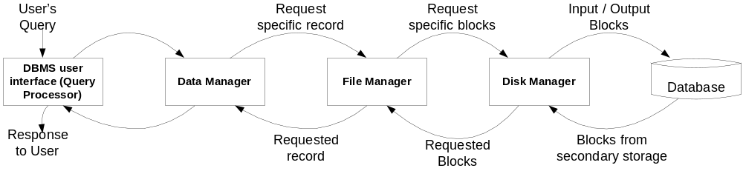
Fig. 1.3 – Steps in Data Access

A user’s request for data is received by the data manager, which determines the physical record required. The decision as to which physical record is needed is taken by referring to the data dictionary. The data manager sends the request for a specific physical record to the file manager. The file manager decides which physical block of secondary storage contains the required record and sends the request for the appropriate block to the disk manager. The disk manager retrieves the block and sends it to the file manager, which in turn sends the required record to the data manager.

Data Models
Data modeling is the process of creating a logical representation of the structure of the database. This is the most important task in database development. A data model is a plan for building a database. The model represents data conceptually, the way the user sees it, rather than how computers store it. Data models focus on required data elements and associations most often they are expressed graphically using entity-relationship diagrams.

A data model is more generalized and abstract than a database design. It is easier to change a data model than it is to change a database design, so it is the appropriate place to work through conceptual database problems.

The four most common data models are: (i) Hierarchical model (ii) Network model (iii) Relational model and (iv) Object model. A given DBMS may provide one or more of the four models.

Hierarchical Model: Hierarchical data model is the first model proposed to resolve the data integrity and other problems associated with traditional file systems. A hierarchical data model organizes the data into a tree like structure. The structure allows repeating information using parent/child relationships: each parent can have many children but each child only has one parent. This model was implemented primarily by IBM’s Information Management System (IMS) database. IMS only allows one-to-one or one-to-many relationships between entities. Ie. Any entity at the many end of the relationship can be related to only one entity at the one end.
Customer
Order 1
Order 2
Order 3
Fig. 1.4 – Hierarchical Model

Advantages
• Hierarchical Model is simple to construct and operate on
• Corresponds to a number of natural hierarchically organized domains - e.g., assemblies in manufacturing, personnel organization in companies
• Language is simple; uses constructs like GET, GET UNIQUE, GET NEXT, GET NEXT WITHIN PARENT etc.

Disadvantages
- Navigational and procedural nature of processing
- Database is visualized as a linear arrangement of records
- Little scope for "query optimization"
- Data Inconsistency
- Wastage of Space

Network Model: The network model is a database model conceived as a flexible way of representing objects and their relationships. In hierarchical model, data is structured as a tree of records with each record having one parent and zero or many children whereas network model allows each record to have multiple parent and child records. This model was eventually replaced by the relational model. An example of a database that implemented network model is Integrated Database Management System (IDMS).

Advantages
• Network Model is able to model complex relationships and represents semantics of add/delete on the relationships.
• It can handle most situations for modeling using record types and relationship types.
• Language is navigational; uses constructs like FIND, FIND member, FIND owner, FIND NEXT within set, GET etc. Programmers can do optimal navigation through the database.
Disadvantages
• Navigational and procedural nature of processing
• Database contains a complex array of pointers that thread through a set of records.
• Little scope for automated "query optimization"

Relational Model: The relational model describes the database as a collection of tables or relations to represent data and relations. Each table has multiple columns and each column has a unique name. Rows of the relation or table are referred to as tuples of the relation and the columns are its attributes. In the relational model, the related records are linked together with a key. Examples of relational DBMS are: Oracle, MS SQL Server etc.

Employee Id | First Name | Last Name | Dept. Id
0001 | Ashok | Shenoy | 01
0002 | Biju | Krishnan | 01
0003 | Joseph | John | 02

Employee Id | Address
0001 | 112, Gandhi Nagar, Calicut
0002 | 1/1167, Mangalam, Alleppey
0003 | ‘Anugraha’, Ashramam Road, Quilon

Dept. Id | Dept. Name
01 | Accounts
02 | Administration
Fig. 1.5 – Relational Model

Object Model: The object model is a database model in which data is represented in the form of objects as used in object oriented programming. Object DBMS add database functionality to object oriented languages and it makes database objects appear as programming language objects in one or more object oriented programming languages. Examples of object database management system are: db4objects, Perst.

DBMS Architecture and Data Independence

The database systems has a three schema architecture that helps to achieve the data independence, support of multiple user views and data dictionary.

Three-schema architecture
The Three-schema architecture is to separate the user applications and the physical database. In this architecture, the schemas can be defined at three levels as shown below.
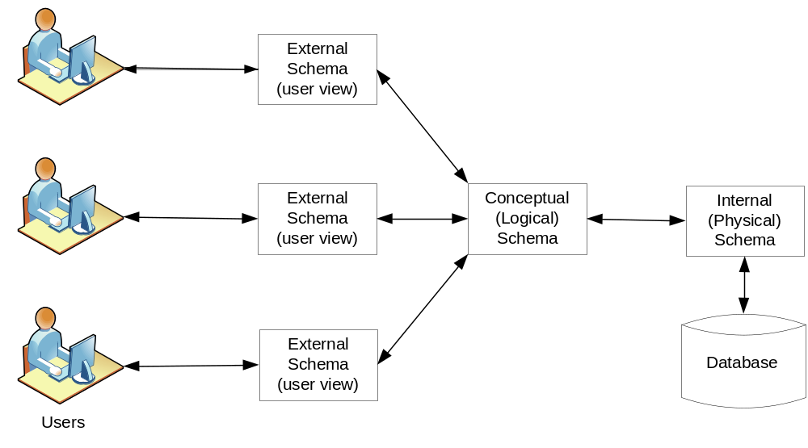
Fig. 1.6 – Three Schema Architecture

- External schema (or user view)
The external schema represents how a particular user group views the database. It exposes the data that a particular user group is interested in and hides the rest of the data from that user group. There could be multiple external schemas, one for each user group, for a database.
- Conceptual schema
The conceptual schema represents a logical view of the database containing a description of all the data and relationships. It hides the details of physical storage structures and concentrates on describing entities, data types, relationships and constraints. One conceptual schema usually contains many different external schemas.

- Internal schema
The internal schema is a representation of a conceptual schema as physically stored on a particular product. It describes the complete details of data storage and access paths for the database. A conceptual schema can be represented by many different internal schemas. DBMS maintains mappings between external schema and conceptual schema and between conceptual schema and internal schema in order to transform requests and results between external, conceptual and internal schemas.

Data Independence

Three levels of abstraction in a database system explained in section 1.9 help in providing data independence. ie. The ability to change the schema at one level of a database without requiring any changes in the schema at next higher level. Two types of data independence can be defined: Logical data independence and Physical data independence.

Logical data independence is the capacity to change the conceptual schema without having to change external schemas or application programs. We may change the conceptual schema to expand the database (by adding a new record type or a new data item in an existing record type) or to reduce the database (by removing a record type or data item) without affecting the external schemas and application programs. In case of removing a record type or data item, the external schemas that refer only to the remaining data should not be affected. Only the view definition and the mappings need be changed in a DBMS that supports logical data independence.

Physical data independence is the capacity to change the internal schema without having to change the conceptual (or external) schemas. Changes to the internal schema may be needed because some physical files had to be reorganized – for example, by creating additional access structures – to improve the performance of retrieval or update. If the same data as before remains in the database, we should not have to change the conceptual schema. For e.g.: We need not change the Query to retrieve a student progress report even though the DBMS take a new method to store the student record.

Entity Relationship Model

This is based on the perception of the real world that consists of a collection of basic objects called entities and the relationship among entities. Relationship is the association among several entities. Each entity has its own properties called its attributes. The relationship between entity sets is represented by a named E-R relationship and is 1:1, 1:M or M:N, mapping from one entity set to another. The database structure, employing the E-R model is usually shown pictorially using entity-relationship (ER) diagrams. The entities and the relationships between them are shown in figure using the following conventions:

- An entity set is shown as a rectangle.
- A diamond represents the relationship among a number of entities, which are connected to the entities by lines.
- The attributes, shown as ovals, are connected to the entities or relationships by lines.
- Diamonds, ovals, and rectangles are labeled. The type of relationship existing between the entities is represented by giving the cardinality of the relationship on the line joining the relationship to the entity.

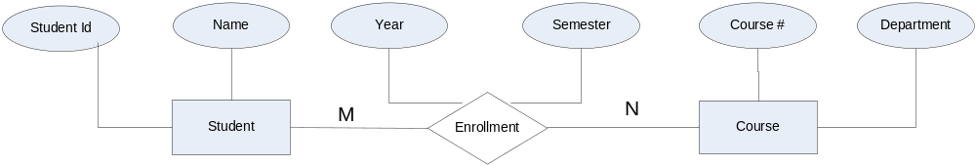
Fig. 1.7 – ER-Diagram

Entities: An entity is an object that is of interest to an organization. Objects of similar types are characterized by the same set of attributes or properties. Such similar objects form an entity set or entity type. For example, each of the students is an entity and the rectangle Student in the above diagram represents the Student entity set. A subset of attributes for uniquely identifying an entity is called a key or primary key. An entity set that has a primary key is termed as a strong entity set. The entity set Student in above ER diagram would qualify as strong entity because it has an attribute Student Id that uniquely identifies an instance of the entity Student; no two instances of the entity have the same value for the attribute Student Id. An entity set that doesn’t have sufficient attributes to form a primary key is called weak entity set. For example, the Parent or Guardian entity set may not have any attributes that uniquely identifies an entity. So, Parent or Guardian is a weak entity set. An entity set in an ER-diagram will be represented by a table (called relation in relational model) in a database that contains a column for each of its attributes and a row for each instance of the entity (called tuple in relational model).

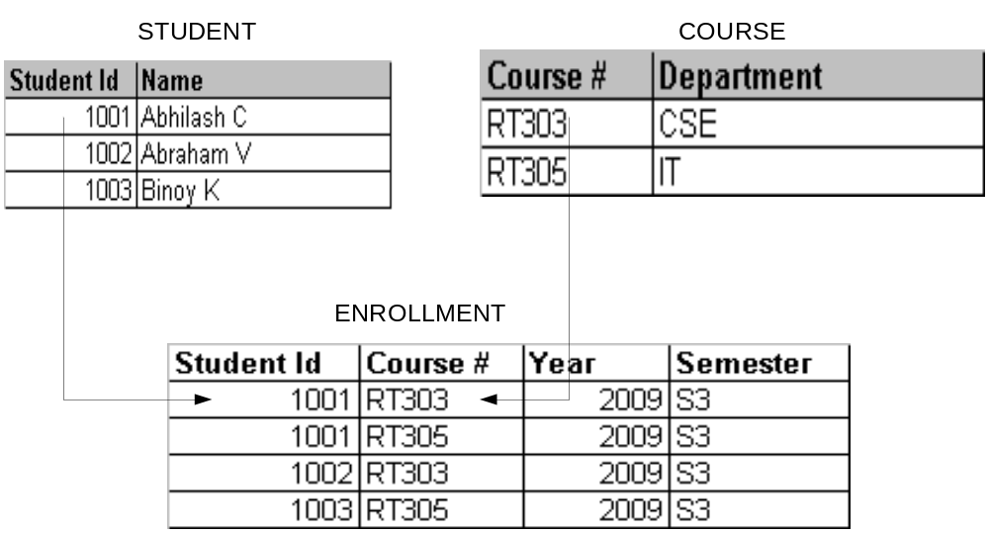 Fig. 1.8 – Representation of Relationship

Eg. Student table will have two attributes Student Id and Name. Similarly Course table will have two attributes Course# and Department.

Different types of keys for entity sets are Super key, Candidate key and Primary key.

Super key is a set of attributes that, taken collectively, to uniquely identify an entity in the entity set. For eg: the social_security_no attribute of the entity set employee is sufficient to distinguish one employee entity from another. Thus social_security_no is a superkey for the entity set employee.
Candidate key: Superkeys with minimal subset is known as the candidate key. For eg: it is possible to combine the attributes, employee_id & organization_name to form a superkey. But the social_security_no is sufficient to distinguish the two employees. Thus social_security_no is a candidate key.
Primary key is used to denote the candidate key that is chosen by the database designer to identify an entity from an entity set.

A key (super, candidate and primary) is a property of the entity set rather than the individual entities.

A Foreign key in an entity set is a set of attributes that refer to a unique entity in another entity set.

Relationships: An association among entities is called a relationship. A collection of relationships of the same type is called a relationship set. A relationship is a binary relationship if the number of entity sets involved in the relationship is two. A relationship that involves N entity sets is called an N-ary relationship. For example, if a relationship involves three entity sets, it is called a ternary relationship. The relationship Enrollment in the above ER diagram is an example of a binary relationship involving two distinct entity sets. However, the entities need not be from distinct entity sets. Number of entities to which another entity that can be associated is called cardinality of the relationship which is represented by M:N in the above diagram.

Different types of cardinalities possible are:
- One : One (1:1) - An entity in set A is associated with at most one entity in set B and an entity in set B is associated with at most one entity in set A.
- One : Many (1: M) - An entity in set A is associated with any number of entities in set B and an entity in set B is associated with at most one entity in set A.
- Many : One (M:1) - An entity in set A is associated with at most one entity in set B and an entity in set B is associated with any number of entities in set A.
- Many : Many (M:N) - An entity in set A is associated with any number of entities in set B and an entity in set B is associated with any number of entities in set A.

Examples of different types of cardinalities:
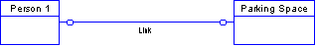
LINK This is a 0:0 optional relationship basically stating that a person can occupy one parking space, that I don't need a person to have a space and I don't need a space to have a person. Although the concept is fairly simple, a database can't express it directly. You would need to nominate one entity to become the dominant table and use triggers or programs to limit the number of related records in the other table.
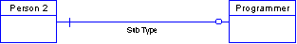
SubType This is a 1:0 relationship; optional only on one side. This would indicate that a person might be a programmer, but a programmer must be a person. It is assumed that the mandatory side of the relationship is the dominant. Again, triggers or programs must be used to control the database.
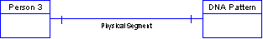
Physical Segment This is a 1:1 mandatory relationship and demonstrates a segmentation denormalization. A person must have one and only one DNA pattern and that pattern must apply to one and only one person. This is difficult to implement in a database, since declarative referential integrity will get caught in a "Chicken and the Egg" situation. Basically, this is a single entity.
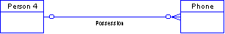
Possession This is a 0:M (zero to many) optional relationship indicating that a person might have no phone, one phone or lots of phones, and that a phone might be un-owned, but can only be owned by a maximum of one person. This is implemented in a database as a nullable foreign key column in the phone table that references the person table.
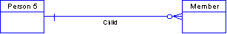
Child This is a 1:M mandatory relationship, the most common one seen in databases. A person might be a member or might not, but could be found multiple times (if the member entity represents membership in multiple clubs, for instance). A member must be a person, no questions asked. The foreign key in the member table would be mandatory, or not-null.
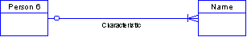
Characteristic This is a 0:M relationship that is mandatory on the many side. It indicates that a person must have at least one name, but possibly many names, and that a name might be assigned to a person (might not) but at most to one person. In a database you would have the the name table with a nullable foreign key to the person table and triggers or programs to force a person to have at least one name.
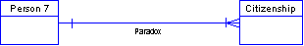
Paradox This is a 1:M relationship mandatory on both sides. As with the physical segment situation, the "Chicken and the Egg" is involved since you have to have a person to have citizenship, but citizenship to have a person.
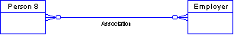
Association This is a M:M (many to many) optional relationship. Conceptually, it means that a person might or might not work for an employer, but could certainly moonlight for multiple companies. An employer might have no employees, but could have any number of them. Again, not hard to visualize, but hard to implement. Most solutions of this situation involve creating a third "Associative Entity" to resolve the M:M into two 0:M relationships. This might be an entity called employee because it does link the person to the employer the person works for.
A relationship in an ER-diagram will also be represented by a table in a database which contains the primary keys of all entity sets involved in the relationship along with the attributes of the relationship. Eg. The Enrollment table will have the primary keys of Student & Course table – Student Id and Course # respectively along with its own attributes Year and Semester.

